Course report of
Industrial Organization and Quality Control – MDP 421- Spring 2021
University: Ain Shams | Faculty: Engineering

Basic Information
- Title and code :
Industrial Organization and Quality Control – MDP 421
- Program on which the course is given :
Automotive

- Year/Level of programs :
Spring 2020
- Units/Credit Hours
( i ) Lecture : | 3

( ii ) Tutorial/Practical : | 2

( iii ) Total : | 5
- Names of lecturers contributing to delivery of the course :
i - | Prof. Dr. Nahid H. Afia
 | Dr. Ghada E. Shedeed

External evaluator: | --- --- ---

Statistical Information
No. of students attending the course: | 33

Very Weak | Weak | Pass | Good | Excellent
7 | 11 | 10 | 4 | 1

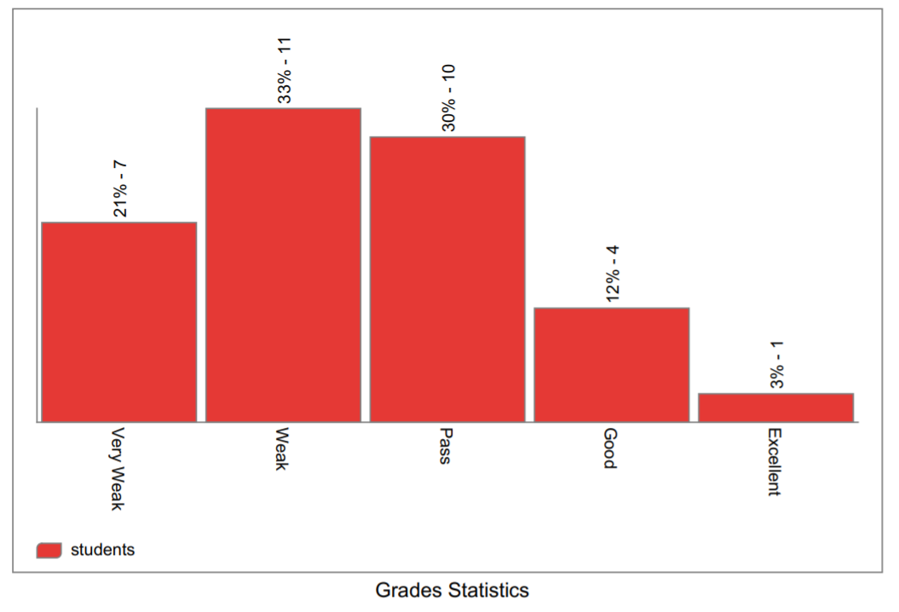

Professional Information

Course Teaching:
Course Content | No. of lecture Hours | Lecturer
Introduction &Productivity | 3 | Prof. Dr. Nahid Afia
Forecasting | 10 | Prof. Dr. Nahid Afia
Inventory control | 8 | Prof. Dr. Nahid Afia
Introduction to quality, Magnificent seven statistical quality control tools | 7 | Dr. Ghada Shedeed
Theory of control charts, control chart for attributes and variables | 6 | Dr. Ghada Shedeed
Sampling Plans | 2 | Dr. Ghada Shedeed

Lecture and tutorial Microsoft Teams, sample of recorded activities
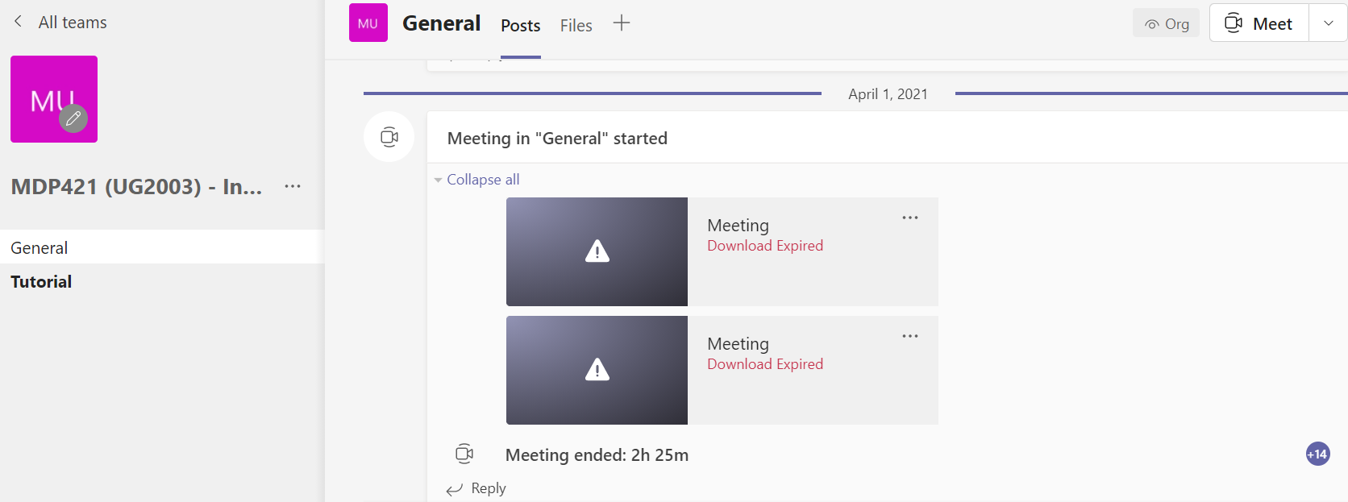
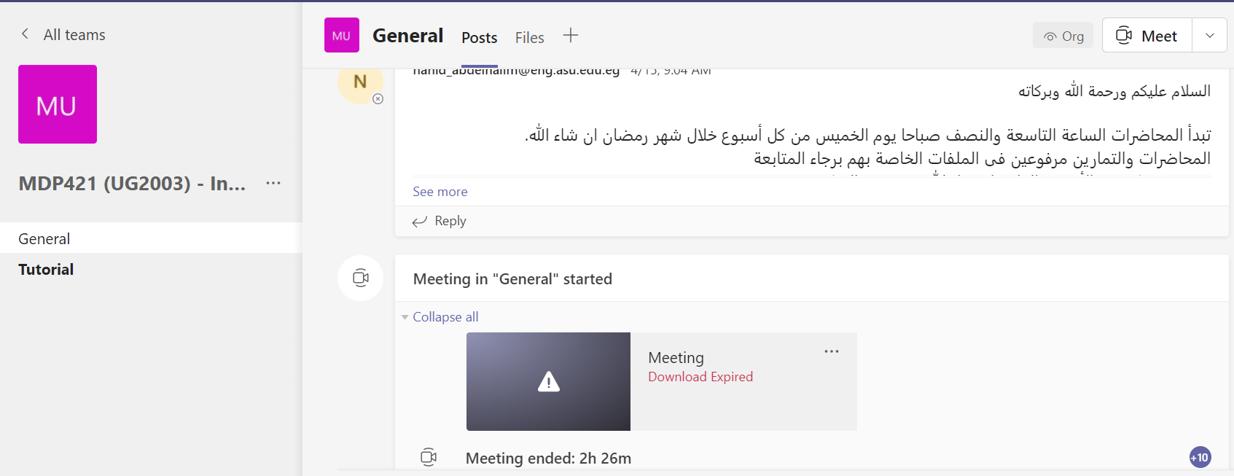
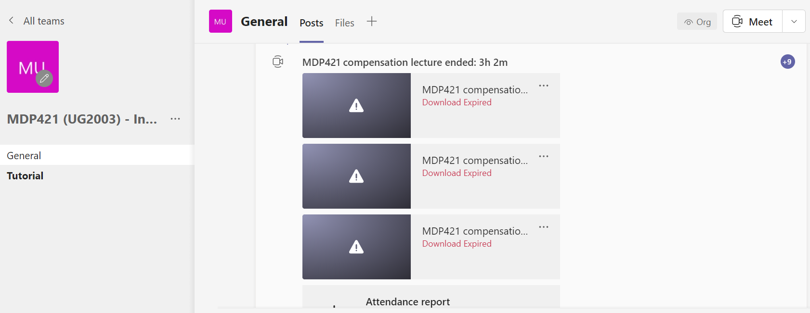

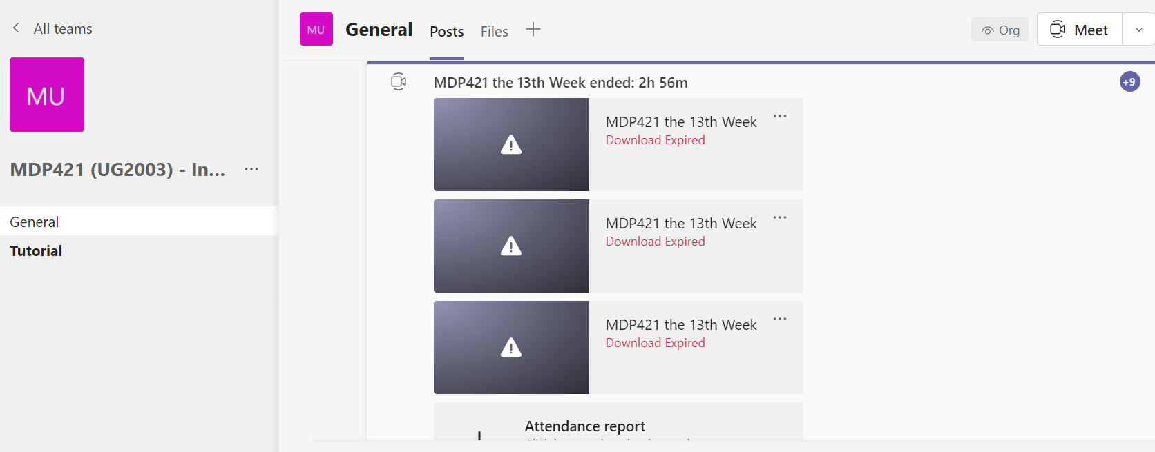

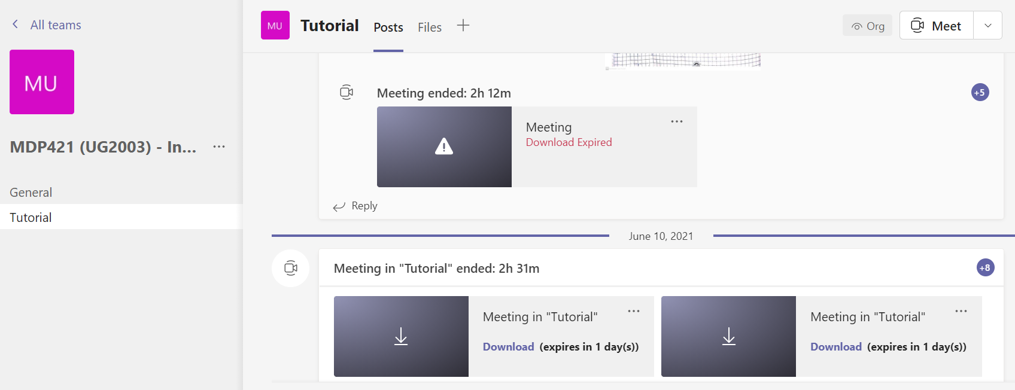

For more details, you can access the course team:
https://teams.microsoft.com/l/team/19%3a798774f6144e46cb8314b383ec6f9ed0%40thread.tacv2/conversations?groupId=130647ae-bc35-4b49-a5aa-fd66de1c945c&tenantId=ad2a8324-bef7-46a8-adb4-fe51b6613b24

Sample of student attendance:
Full Name | User Action | Timestamp
Ghada E. Shedid | Joined | 27/05/2021, 09:52:32
Mostafa Mohamed Maomon Hosany 1601432 | Joined | 27/05/2021, 09:53:49
Mahmoud Sabry Fathy Mostafa 14T0273 | Joined | 27/05/2021, 09:58:55
Mahmoud Sabry Fathy Mostafa 14T0273 | Left | 27/05/2021, 12:30:11
Mahmoud Sabry Fathy Mostafa 14T0273 | Joined | 27/05/2021, 12:31:04
مارك حازم نصحى اسطفانوس 17X0503 | Joined | 27/05/2021, 10:01:45
وائل بليدى يونس شعبان 0001413 | Joined | 27/05/2021, 10:01:46
وائل بليدى يونس شعبان 0001413 | Left | 27/05/2021, 10:37:49
محمد رضا توغان محمد 16X0098 | Joined | 27/05/2021, 10:02:31
محمد رضا توغان محمد 16X0098 | Left | 27/05/2021, 10:07:33
محمد رضا توغان محمد 16X0098 | Joined | 27/05/2021, 10:20:47
محمد رضا توغان محمد 16X0098 | Left | 27/05/2021, 11:08:53
محمد رضا توغان محمد 16X0098 | Joined | 27/05/2021, 11:31:16
محمد رضا توغان محمد 16X0098 | Left | 27/05/2021, 12:39:29
Marko Alaa Youssef Solmain 1501082 | Joined | 27/05/2021, 10:04:40
Mohamed Kamal Abdelaziz 16T0218 | Joined | 27/05/2021, 10:05:28
Fady Ezzat William Tadros 1600958 | Joined | 27/05/2021, 10:13:36
Fady Ezzat William Tadros 1600958 | Left | 27/05/2021, 11:07:50
Mustafa Ali Hassan Ali 16T0112 | Joined | 27/05/2021, 10:18:59
Mustafa Ali Hassan Ali 16T0112 | Left | 27/05/2021, 11:13:59
Mustafa Ali Hassan Ali 16T0112 | Joined | 27/05/2021, 11:27:44
Mustafa Ali Hassan Ali 16T0112 | Left | 27/05/2021, 12:00:31
Mustafa Ali Hassan Ali 16T0112 | Joined | 27/05/2021, 12:01:05
ابراهيم حسام حسن محمود محمد 1500013 | Joined | 27/05/2021, 10:44:50
ابراهيم حسام حسن محمود محمد 1500013 | Left | 27/05/2021, 11:04:43
Ali Mohamed Ahmed Mohamed Abozaid 14T0211 | Joined | 27/05/2021, 10:48:35
Ali Mohamed Ahmed Mohamed Abozaid 14T0211 | Left | 27/05/2021, 11:14:43
Ali Mohamed Ahmed Mohamed Abozaid 14T0211 | Joined | 27/05/2021, 11:14:56
Ali Mohamed Ahmed Mohamed Abozaid 14T0211 | Left | 27/05/2021, 11:15:10
Ali Mohamed Ahmed Mohamed Abozaid 14T0211 | Joined | 27/05/2021, 11:19:12
اسلام محمد سعيد محمد على 14T0036 | Joined | 27/05/2021, 10:51:10
اسلام محمد سعيد محمد على 14T0036 | Left | 27/05/2021, 11:16:28
اسلام محمد سعيد محمد على 14T0036 | Joined | 27/05/2021, 11:23:11
اسلام محمد سعيد محمد على 14T0036 | Left | 27/05/2021, 11:59:19
اسلام محمد سعيد محمد على 14T0036 | Joined | 27/05/2021, 12:00:03
احمد محمد امين حسونه 14T0021 | Joined | 27/05/2021, 11:19:28

Topics taught as a percentage of the content specified:

>90 % v 70-90 % <70%

Reasons in detail for not teaching any topic
Last topic was given with fewer details due to the official 13 weeks semester.

If any topics were taught which are not specified, give reasons in detail
N/A………………………………………………………………………………………….

Teaching and learning methods:
Lectures: v
(Using LMS and interactive online lectures using Microsoft Teams)
Practical training/ laboratory:
Seminar/Workshop:
Class Activity: (Tutorials)
v

(using interactive online tutorials using Microsoft Teams beside the LMS)

Case Study:
Other assignments/homework:
If teaching and learning methods were used other than those specified, list and give reasons:
………………………………………………………………………………………………
………………………………………………………………………………………………

Student assessment:

Assessment Method | No | Description | Week No. | Weight (grade)
Assignments and participation |  |  | 2-13 | 5
Quizzes |  |  | 6, 11,13 | 10
Written exams (mid-term) to assess, understanding and scientific knowledge. |  | Mid-term exam | Week 8 | 20
Written exams (final) |  | Final term exam | Week 15 | 90
Total |  |  |  | 125

Members of examination committee
- Prof. Dr. Nahid H. Afia
- Dr. Ghada E. Shedeed

Role of external evaluator
………………………………………………………………………………………….
………………………………………………………………………………………………

Facilities and teaching materials:

Totally adequate

Adequate to some extent x

Inadequate

List any inadequacies

Administrative constraints:
List any difficulties encountered

Student evaluation of the course:

All above 50%
الماده مكثفه جدا و لا تفيدنى فى مجال تخصصى ووصلنا لدرجه انه احيانا نأخذ محاضرتين فى نفس اليوم و سيكشنين فى نفس اليوم يعنى حوالى ساعات والمنهج
كبير وصعب جدا ويوجد مواد اخرى تفيدنى اكثر من هذه الماده ولا ناخذ نفس الكم مثل ماده التنظيم ومراقبه الجوده وكان يجب ان تنقسم الى ترمين
Powered by

Response of Course Team
The official vacation days have been compensated The course is 3 hours lecture total 120 point The course is essential to any mechanical student

Comments from external evaluator(s): Response of course team
………………………. …………………………….
……….……………..……. …………………………….

