Course report of
Industrial Robotics – MDP453– Spring 2021
University: Ain Shams | Faculty: Engineering

Basic Information
- Title and code :
Roboticss - MDP 453
- Program on which the course is given :
Chep: Manufacturing program

- Year/Level of programs :
- Units/Credit Hours
( i ) Lecture : | 3

( ii ) Tutorial: | 2
( iii ) Lab: | 0

( v) Total : | 5
- Names of lecturers contributing to delivery of the course :
i - | Dr. Shady Ahmed Maged  Dr. Ismail Hafez

Course coordinator: | Dr. Shady Ahmed Maged

External evaluator: | NA

Statistical Information
114

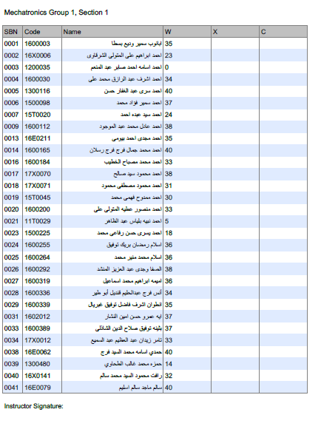
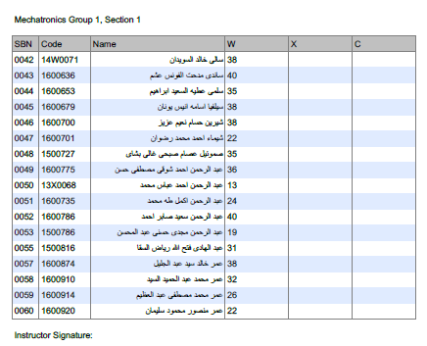
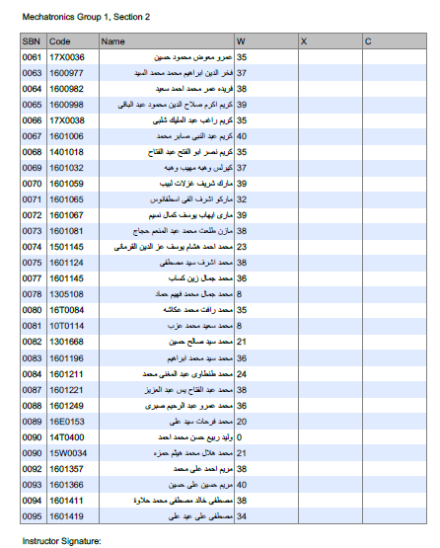
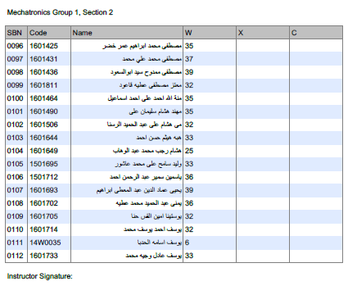
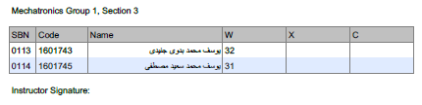

Professional Information

Course Teaching:
Course Content | No. of Hours | Lecture | Tutorial | Lab | Lecturer
Introduction to Robotics (Serial, parallel, humanoid, mobile) | 5 | 3 | 2 | 0 | Dr. Shady Ahmed
Robot kinematics (position, orientation, homogeneous transformation matrix) | 10 | 6 | 4 | 0 | Dr. Shady Ahmed Maged
Forward Kinematics (D-H parameters) | 10 | 6 | 4 | 0 | Dr. Shady Ahmed Maged
Inverse Kinematics (trigonometric method and analytical method) | 10 | 6 | 4 | 0 | Dr. Shady Ahmed Maged
Velocity Kinematics (Differential operator, forward instantaneous kinematics, inverse instantaneous kinematic, Jacobian) | 10 | 6 | 4 | 0 | Dr. Shady Ahmed Maged
Trajectory planning (path and trajectory) | 10 | 6 | 4 | 0 | Dr. Shady Ahmed Maged
Forward and inverse Dynamics (euler method, lagrange method) | 10 | 6 | 4 | 0 | Dr. Shady Ahmed Maged
Robot position and force control (Computed torque controller, PID) | 10 | 6 | 4 | 0 | Dr. Shady Ahmed Maged
Total |  |  |  | 0

Topics taught as a percentage of the content specified:

>90 % X 70-90 % <70%

Reasons in detail for not teaching any topic
All topics were taught ……………………………………….

If any topics were taught which are not specified, give reasons in detail
N/A………………………………………………………………………………………….

Teaching and learning methods:
Lectures: X
Practical training/ laboratory:
Seminar/Workshop:
Class Activity: (Tutorials) X
Online platform (Zoom and LMS) X

Case Study:
Other assignments/homework:
If teaching and learning methods were used other than those specified, list and give reasons:
………………………………………………………………………………………………
………………………………………………………………………………………………

Student assessment:
Assessment method | Description | Week No | Weight (marks)
Assignment +midterm | To Assess understanding of Robotics | Week 8, 15 | 40
Final Exam | Written exam | Week 15 | 110
Total |  |  | 150 marks

**The assessment methods are changed in this semester due to the COVID19

Members of examination committee
II- Dr. Shady Ahmed Maged

Role of external evaluator
N/A………………………………………………………………………………………….

Facilities and teaching materials:
Totally adequate
X
Adequate to some extent

Inadequate

List any inadequacies

Administrative constraints:
List any difficulties encountered
No difficulties

Student evaluation of the course:

Student evaluation of the course: all over 50 % except the following

Instructor feedback: we will encourage and pay attention during the online sessions with students

Student Comments:
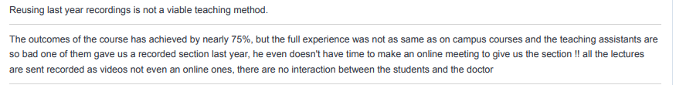
For the first comment yes I sent them a recorded video that was made before but I made an online session every week during the lecture time for them and explained all lectures live/online so I think this student didn’t attend the online sessions

Student Comments:

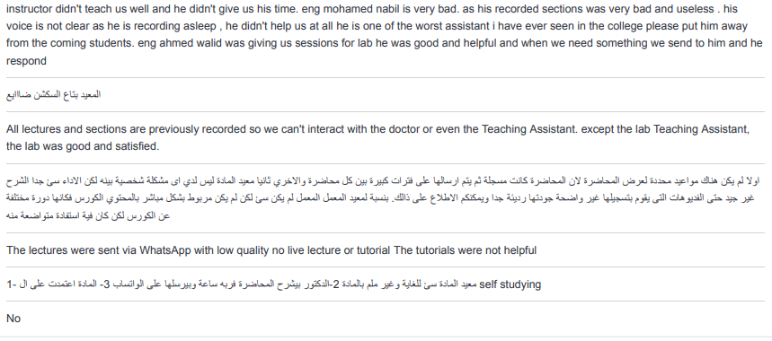
We will encourage the TA eng Mohamed nabil to be more active with students next year

Comments from external evaluator(s): Response of course team
……N/A… ………………. …………………………….
……….……………..……. …………………………….

