Course report of
Hydraulic and pneumatic control- MDP 452– Fall2020
University: Ain Shams | Faculty: Engineering

Basic Information
- Title and code :
Hydraulic and pneumatic control - MDP 452
- Program on which the course is given :
Mechatronic Engineering

- Year/Level of programs :
5th
- Units/Credit Hours
( i ) Lecture : | 4

( ii ) Tutorial: | 2
( iii ) Lab:

( v) Total : | 6
- Names of lecturers contributing to delivery of the course :
i - | Dr. Shady Ahmed Maged  Dr. Ismail Hafez
 | Dr. Mohamed Ibrahim

Course coordinator: | Dr. Shady Ahmed Maged

External evaluator: | NA

Statistical Information

Professional Information

Course Teaching:
 | No | Course Content | Lectures | Tutorial | Total
 | 1 | Introduction to pneumatic and hydraulic control systems: physical principles, electrical versus hydraulic versus pneumatic systems | 4 | 2 | 6
 | 2 | Applications of pneumatic and hydraulic systems, electro-hydraulic and electro-pneumatics systems. | 8 | 4 | 12
 | 3 | Hydraulic system: power units, reservoirs, filters, piping and hoses, accumulators | 8 | 4 | 12
 | 4 | Pumps (constant displacement pumps, vane pumps, gear pumps, variable displacement pumps, piston pumps, eccentric plate pumps, pumps control systems) | 8 | 4 | 12
 | 5 | valves (spool valve, poppet valve, pilot-operated valves, pressure control valves, flow control valves, check valves, sequence valves) | 8 | 4 | 12
 | 6 | Actuators (rotary (motors) and linear (cylinders), hydraulic circuits. | 8 | 4 | 12
 | 7 | Pneumatic systems: service unit, compressors (piston, screw, rotary), filters, air dryers, lubricators, pressure regulation valves, control valves, actuators, pneumatic circuits. | 4 | 4 | 8
 | 8 | (proportional valves, servo valves, cartridge valves, modular valves) | 12 | 4 | 16
 |  | Total Hours | 60 | 30 | 90

Topics taught as a percentage of the content specified:

>90 % X 70-90 % <70%

Reasons in detail for not teaching any topic
All topics were taught ……………………………………….

If any topics were taught which are not specified, give reasons in detail
N/A………………………………………………………………………………………….

Teaching and learning methods:
Lectures: X
Practical training/ laboratory: X
Seminar/Workshop:
Class Activity: (Tutorials) X
Online Lectures by Microsoft teams
Face to face tutorials

Online teaching activities
Link for teams: https://teams.microsoft.com/l/team/19%3ad780b9dee1f34bee9a992f1df6f9e5bf%40thread.tacv2/conversations?groupId=d3e564b3-ba4b-450b-962a-3116421451af&tenantId=ad2a8324-bef7-46a8-adb4-fe51b6613b24

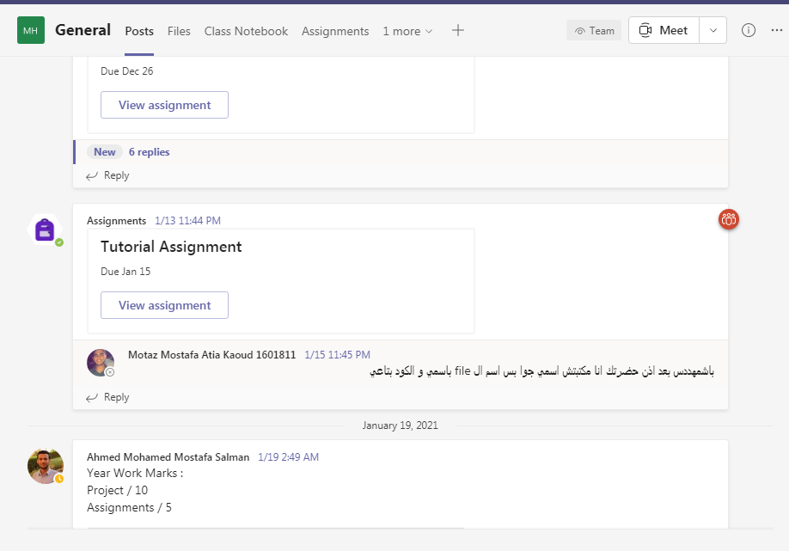

Case Study:
Other assignments/homework:
If teaching and learning methods were used other than those specified, list and give reasons:
………………………………………………………………………………………………
………………………………………………………………………………………………

Student assessment:
Assessment method | Description | Week No | Weight (%)
Attendance +Part. |  |  | 2.5
Assignments and Reports | To Assess understanding of Hydraulics and pneumatics | Week 4&14 | 2.5
Mid Term Exam | Written exam | Week 8 | 25
Final Exam | Written exam | Week 15 | 70
Total |  |  | 100 %

Members of examination committee
I - Dr. Mohamed Ibrahim
II- Dr. Shady Ahmed Maged

Role of external evaluator
N/A………………………………………………………………………………………….

Facilities and teaching materials:
Totally adequate
X
Adequate to some extent

Inadequate

List any inadequacies

Administrative constraints:
List any difficulties encountered
No difficulties

Student evaluation of the course:

No comments

Instructor feedback:
We will try to change the TA.

Comments from external evaluator(s): Response of course team
……N/A… ………………. …………………………….
……….……………..……. …………………………….

