Course report of
Tool Design– MDP451 - Fall 2020-2021

University: Ain Shams | Faculty: Engineering

Basic Information
- Title and code :
Tool Design– MDP 451
- Programme on which the course is given :
B.Sc. in Mechanical Eng. - Production.

- Year/Level of Program :
4 Year
- Units/Credit Hours
( i ) Lecture : | 3

( ii ) Tutorial/Practical : | 3

( iii ) Total : | 6
- Names of lecturers contributing to delivery of the course :
i - | Prof. Dr. Mohammed Abdel Mohsen

ii - | Dr. Tayseer Attia

iii - | Dr. M. Adel Rizk

Course coordinator: | Dr. M. Adel Rizk

External evaluator: | --- --- ---

Statistical Information

Total No of Students =51

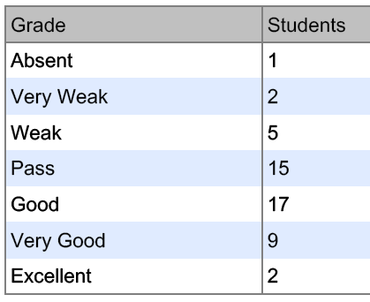

Professional Information

Course Teaching:
Course Content | No. of Hours | Lecturer
Tool Design | 35 | Dr. M. Adel Rizk
Jigs and Fixtures | 35 | Prof. Dr. Mohammed Abdel Mohsen
Injection Molding | 20 | Dr. Tayseer
Total | 90

Topics taught as a percentage of the content specified:

>90 % √ 70-90 % <70%

Reasons in detail for not teaching any topic
All topics were taught ……………………………………….

If any topics were taught which are not specified, give reasons in detail
N/A………………………………………………………………………………………….
Teaching and learning methods:
Lectures: √
Practical training/ laboratory:
Seminar/Workshop:
Class Activity: (Tutorials) √

Online Lectures and Online Tutorial Activities
LMS and online meeting through MS Team (suspension of studying in campus due to covid-19) .
Link to Course Group in Microsoft Teams

https://teams.microsoft.com/l/team/19%3a73e01f34712b4543a3f2404f018e8039%40thread.tacv2/conversations?groupId=e9a29e1a-8a43-443e-b9f0-1122964f30b2&tenantId=ad2a8324-bef7-46a8-adb4-fe51b6613b24

Online Lectures and Attendance
A complete copy of the given lectures, required assignments, required reports, quizzes and model answers of quizzes, mid- term exam and its model answers as well as students evaluation are available on the LMS (https://lms.eng.asu.edu.eg/course/view.php?id=6656)

A sample of the online meeting student attendance are available on Google drive (https://drive.google.com/drive/folders/1tt7KLG5OfCTGY3258L6v8HpMzPYNB2aX?usp=sharing)
And A sample of the online meeting lectures are available on Google drive (https://drive.google.com/drive/folders/1toIeDf2Te_sx7DPTfcRISExxSIbxPJnB?usp=sharing
)
- Student Assessment:
Assessment Method | Weight
Class work | 26.7
Final Exam | 73.3%
Total | 100%

Members of examination committee
- Prof. Dr. Mohammed Abdel Mohsen
- Dr. Tayseer Attia
- Dr. M. Adel Rizk

Role of external evaluator
N/A………………………………………………………………………….

Facilities and teaching materials:
Totally adequate √

Adequate to some extent

Inadequate

List any inadequacies

Administrative constraints:
Suspension of studying in the campus results in canceling the written quizzes and replaced it by reports.

Student evaluation of the course:

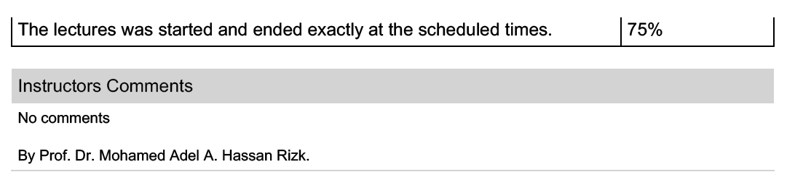

Response of Course Team

List any criticisms
… …….………..……………………………….

Comments from external evaluator(s): Response of course team

……………….

