Ain Shams University – Faculty of Engineering

A. Basic Information
- Title and Code: | Casting & Welding (1)  MDP 251
- Program in which the course is given: | All Departments except Automotive Engineering B.Sc. Program
- Year/ Level of program | 2nd year Mechanical Engineering
- Units/ Credit Hours  - Lecture  - Tutorial  - Lab  - Total | 2  2  1  5
- Lecture:
- Names of Lecturers contributing to the delivery of the course: | Dr. Ahmed Farid A.G. Youssef  Dr. Tarek M. Moussa
- Course coordinator: | Dr. Ahmed Farid A.G. Youssef  Dr. Tarek M. Moussa
- External Evaluator:

B. Statistical Information
No. of students attending the course | 370

 |  | Number | Percentage
Students completing the course |  | 370 | 100 %
Results | Passed |  | 94.1 %
Results | Failed |  | 5.9 %
Grading of successful students | A | 3 | 0.8 %
Grading of successful students | A- | 19 | 5.1 %
Grading of successful students | B+ | 59 | 15.9 %
Grading of successful students | B | 48 | 12.9 %
Grading of successful students | B- | 61 | 16.5 %
Grading of successful students | C+ | 34 | 9.2 %
Grading of successful students | C | 45 | 12.2 %
Grading of successful students | C- | 19 | 5.1 %
Grading of successful students | D+ | 27 | 7.3 %
Grading of successful students | D | 13 | 5.5 %
Grading of successful students | P | 20 | 5.4 %
Grading of successful students | F | 22 | 5.9 %
C. Professional Information
- Course Teaching
Topic | No. of Hours | Lecturer
Introduction to solidification and casting processes, Casting of wrought alloys, continuous casting | 4 | Dr. Tarek Moussa
Principles of shaped casting, alloys & products, and processes | 5 | Dr. Tarek Moussa
Sand, moulding and core-making processes, Liquid metal behaviour & fluid dynamics | 4 | Dr. Tarek Moussa
Casting design, pattern, gating, feeding systems | 9 | Dr. Tarek Moussa
Heat extraction & solidification, Melt treatment & melting equipment | 4 | Dr. Tarek Moussa
Casting defects & finishing  Quality control, environment, safety, computer application | 5 | Dr. Tarek Moussa
Classification of welding processes  Design of weld joints and constructions | 4 | Dr. Ahmed Farid
Thermal welding: oxy-acetylene welding, | 5 | Dr. Ahmed Farid
Arc welding, resistance welding, submerged arc welding, spot and seam welding, plasm | 9 | Dr. Ahmed Farid
Heat Flow & Fluid Flow in welding | 4 | Dr. Ahmed Farid
Weld Solidification & Cracking | 5 | Dr. Ahmed Farid
Welding Defects & Testing of welded joints | 4 | Dr. Ahmed Farid
Casting project | 4 | Dr. Tarek Moussa

Topics Taught as a percentage of the content specified 90%
Reasons in detail for not teaching any topic
- Lots of holidays
- Lack of labs and equipment
If any topics were taught which are not specified, give reasons in detail
- Quality control, environment, safety, computer application
- Teaching and learning methods:
  - Power point presentations
  - Samples and products
  - Experiments & lab test
  - Educational videos
Online Learning
Complete Set of Videos for All Lectures are available offline at
https://drive.google.com/drive/folders/1y7X7yMu1iSumKs9ngKXySjc31XYFAIYk?usp=sharing
Link to MS-Teams MDP251
https://teams.microsoft.com/l/team/19%3af96fea6f722546f0bc0f7bed40e8b9dc%40thread.tacv2/conversations?groupId=5d028871-03dc-4560-8082-d428f3b886a3&tenantId=ad2a8324-bef7-46a8-adb4-fe51b6613b24

Sample of On Line MS-Teams is attached
File name = ((07-MDP_251_meetingAttendanceList.xls))
Sample of On Line MS-Teams Snapshot
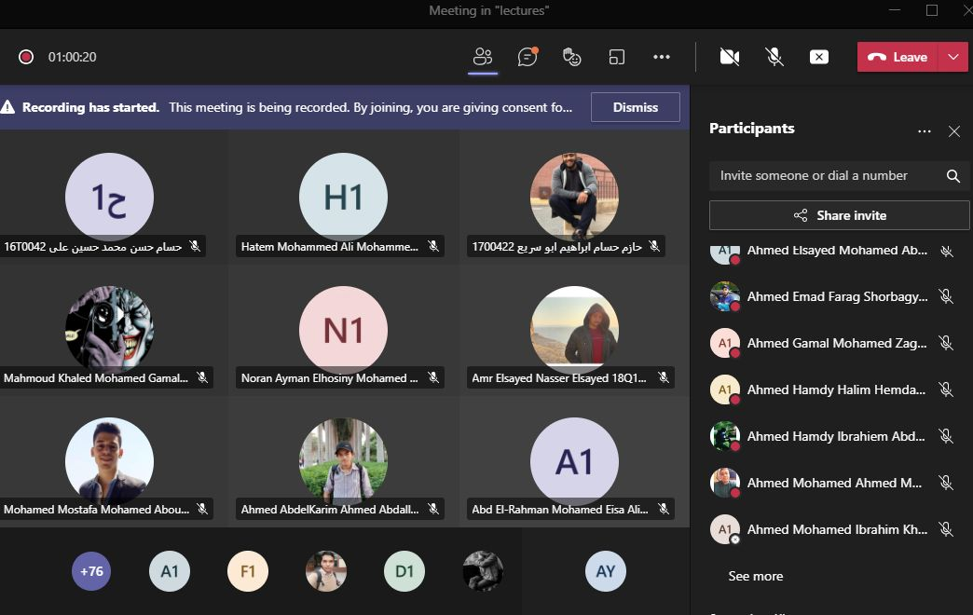
Case Study:
Other assignments/homework
If teaching and learning methods were used other than, those specified, list and give reasons
- Student assessment:

Assessment method | No | Description | Week No | Weight (%)
Reports  Assignments |  | Reports (10)  Assignments (10) | Weekly | 20
Written exam |  | Mid-term | Week 8 | 10
Practical Exam |  | Discussion | Week 15 | 10
Written exam |  | Final exam | Week 16 | 60
Total |  |  |  | 100

Members of examination committee

Dr. Ahmed Farid
Dr. Tarek Moussa

Role of external evaluator:

- Facilities and teaching materials:
Power point presentations
Samples and products
Experiments & lab test
Educational videos

List any inadequacies:

- Administrative constraints:

- Student evaluation of the course:
Course Evaluation (218 Participants) | 62 %

Question | Score
The course syllabus was clearly explained at the beginning of the semester | 61%
I am aware of the course learning outcomes (LOs) | 65%
The teaching methods used helped and supported me to learn | 58%
Course topics are explained well in the teaching sessions. | 64%
The course activities helped me to achieve the learning outcomes (LOs) efficiently. | 63%
The course assessments were clear and their distribution were clearly announced and organized | 61%
I felt well supported on this course from instructor and teaching assistant (if any). | 62%
I have been able to contact instructor when I needed to. | 59%
The course focused on what was set out in the course specification and all are presented. | 66%
The instructor provided well written laboratory instructions (if any). | 63%
Adequate technical support and supervision were provided during the laboratory sessions (if any). | 66%
The laboratory was well integrated with the course pacing (if any). | 66%
The course digital materials on LMS are helpful in supporting my learning. | 64%
Overall, I was satisfied with my experience of this course. | 60%
I learn from online teaching activities, similar to on campus teaching activities. | 60%
The instructor used appropriate communication tools for online teaching. | 61%
The instructor pays attention to the student's achievement during online class. | 56%
The instructor encouraged active participation and discussion during online class. | 56%
I could pass the online course without any staff assistance. | 62%
The instructor respected to start / finish online lectures on scheduled times | 59%

Some Comments | Response of course Team
نتمنى من ادارة الكلية انها تخلي المادة في الكلية مش اونلاين لانها مهمة و كانت تجربة مش لطيفة اما كانت المحاضرات كلها اونلاين ، بنحتاج دايماً نقابل الدكتور في الكلية عشان التفاعل | قبل بداية الفصل الدراسى تم تحديد ان يكون جميع محتوى المقرر داخل الكلية وان يتم التفاعل مع الطلاب بشكل دائم ومستمر ولكن لظروف جائحة كورونا تم نقل المحاضرات والتمارين ونصف المعامل لتكون اونلاين.  نامل ان تنتهى الجائحة ويتغير الحال خلال الفصل الدراسى القادم.
كان نفسي المادة دي تبقي اوفلاين مش اونلاين، حتي الاونلاين مكنش تفاعلي كان عبارة عن فيديوهات متسجلة
المادة دي مينفعش تبقي فيديوهات او محاضره اونلاين بتاتا لأنها مادة عمليه بحته
نلغي الاونلاين
The course started inconspicuously at the beginning, but became better and improved later. The doctors and assistants were very helpful. | No Comment

- Comments from external evaluator(s)
Comment | Response of course Team
No Comments

- Course enhancement: Progress on actions identified in the previous year’s action plan:

- Action plan
Action required | Completion date | Person responsible

