Course report of
Mechanics of Machines – MDP 311
University: Ain Shams | Faculty: Engineering

Basic Information
- Title and code:
Mechanics of Machines – MDP 311
- Program on which the course is given:
Mechatronics Engineering Program
- Year/Level of programs:
Junior
- Units/Credit Hours
( i ) Lecture : | 3

( ii ) Tutorial/ : | 2
( iii ) Practical | 1

( iv ) Total : | 6
- Names of lecturers contributing to delivery of the course:
i - | Prof. Adel Moneeeb

ii - | Dr. Mohammed Mohammed Hedaya

Course coordinator: | Prof. Adel Moneeeb

External evaluator: | --- --- ---

Statistical Information
No. of students attending the course: | 253

Professional Information

Course Teaching:

No. | Course Content | Lecture  Hours | Tutorial  Hours | Lab Hours
1 | Introduction | 6 | 4 | 1
2 | Free Vibration of Undamped Single Degree of Freedom Systems | 3 | 2 | 2
3 | Free Vibration of Damped Single Degree of Freedom Systems | 6 | 4 | 4
4 | Harmonically Excited Vibration of Single Degree of Freedom Systems | 9 | 6 | 4
5 | Vibration of Undamped Two-Degree of Freedom Systems: Free vibrations | 9 | 6 | 2
6 | Vibration of Undamped Multi-Degree of Freedom | 3 | 2
7 | Free Lateral Vibration of Beams and Critical Speeds of Rotating Shafts: Beam vibrations | 3 | 2 | 2
8 | Free Lateral Vibration of Beams and Critical Speeds of Rotating Shafts: Whirling of shafts | 3 | 2
9 | Balancing of Shafts | 3 | 2
Total Number of Hours |  | 45 | 30 | 15

Laboratory Activities:
No | Title of Experiment | Laboratory  Hours
1 | Vibration measurements systems | 1
2 | Natural Frequency Measurement | 2
3 | Free-damped vibrations | 4
4 | Forced vibrations | 2
5 | Transmissibility | 2
6 | Two degree of freedom systems | 2
Total Number of Hours |  | 13

Topics taught as a percentage of the content specified:

>90 % 70-90 % <70%

X

Reasons in detail for not teaching any topic
The shortening of this term limited the depth of some contents.
If any topics were taught which are not specified, give reasons in detail
Beam experiment is cancelled

Teaching and learning methods:
The teaching is done in online for lectures, and the tutorials most are in Campus and some interactive using Microsoft Teams platform. Labs are in Campus
Lectures: X
Practical training/ laboratory: X
Seminar/Workshop:
Class Activity: (Tutorials) X
Lectures:
https://teams.microsoft.com/l/channel/19%3abed6ba66be5c43b7aad99a623fa55da3%40thread.tacv2/Lectures?groupId=3ad08697-e05f-4661-96f6-b9f4cce512bf&tenantId=ad2a8324-bef7-46a8-adb4-fe51b6613b24

Tutorials:
https://teams.microsoft.com/l/channel/19%3a07017cf684864b9a99fc4f5e96d234b6%40thread.tacv2/Tutorials?groupId=3ad08697-e05f-4661-96f6-b9f4cce512bf&tenantId=ad2a8324-bef7-46a8-adb4-fe51b6613b24

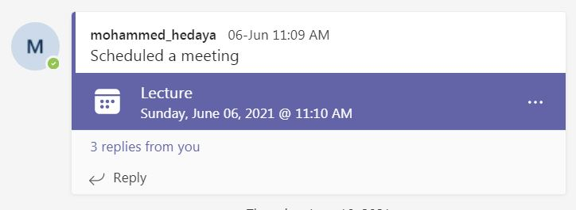

Student assessment:

Method of assessment | Percentage of total
Quizzes | 10 %
Midterm | 15 %
Final examination | 60 %
Assignments | 5%
Practical/laboratory work | 10 %

Members of examination committee
i - | Prof. Adel Moneeeb

ii - | Dr. Mohammed Mohammed Hedaya

Facilities and teaching materials:

Adequate to some extent

Inadequate

List any inadequacies:
. More stable internet and teaching platform

Administrative constraints:
There should be a stable internet for students and instructors.

Student evaluation of the course:

Response of Course Team
The student evaluation is more than 50%. There are common comments of large number of formulas to be remembered. It will be considered to reduce the essential formulas.

Comments from external evaluator(s): Response of course team

