Course report of
Machine Construction (MDP 211) Fall 2020

University: Ain Shams | Faculty: Engineering

Basic Information
- Title and code:
Machine Elements Design MDP 211 (2-2-2)
- Programs on which the course is given:
Mechanical Engineering

- Year/Level of programs:
Juinior Level
- Units/Credit Hours
( i ) Lecture : | 2

( ii ) Tutorial/Practical : | 2/2

( iii ) Total : | 6
- Names of lecturers contributing to delivery of the course:
i - | Prof. Hisham Senbol

ii - | Prof. Tamer Elnady

iii - | Associate Prof. Ayman Aly Abd El-Wahab
 | Dr. Amr Shaaban

Course coordinator: | Prof. Tamer Elnady

External evaluator:

Statistical Information

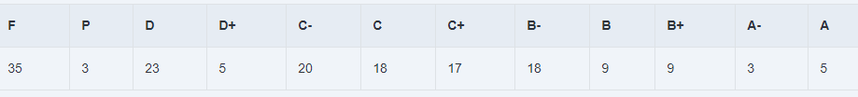

Professional Information

Course Teaching:
Course Content | No. of Hours | Lecturer
Deflection | 6 | Dr. Ayman | Dr. Amr
Buckling | 6 | Dr. Ayman | Dr. Amr
Thermal Stresses | 6 | Dr. Ayman | Dr. Amr
Design under Fatigue Loading | 6 | Dr. Ayman | Dr. Amr
Machine Elements Design | 24 | Prof. Tamer | Dr. Amr
Rolling Bearings | 12 | Prof. Hisham | Dr. Amr
Power Transmission Elements Design | 24 | Prof. Hisham | Dr. Amr
Gearboxes Construction | 6 | Prof. Hisham | Dr. Amr

Topics taught as a percentage of the content specified:

>90 % X 70-90 % <70%

Reasons in detail for not teaching any topic
All topics were taught ………………………………………………………………………
………………………………………………………………………………………………
………………………………………………………………………………………………
………………………………………………………………………………………………

If any topics were taught which are not specified, give reasons in detail
N/A………………………………………………………………………………………….

Teaching and learning methods:
Lectures: X
Practical training/ laboratory: X
Seminar/Workshop:
Class Activity: (Tutorials) X

Case Study:
Other assignments/homework:
If teaching and learning methods were used other than those specified, list and give reasons:
………………………………………………………………………………………………

Student assessment:
Assessment method | Description | Week No | Weight (%)
Assignments | Assignments | 2,3, 6,7,8,10,11,12&15 | 10
Lab Reports | Reports | 15 | 10
Quiz | Unannounced Quizzes | 5-13 | 10
Written Exam | Mid-Term Exam | 8 | 20
Project | Prototype | 15 | 10
Written Exam | Final Exam | 16 | 40
Total |  |  | 100

Members of examination committee
- Prof. Hisham Senbol
- Prof. Tamer Elnady
- Associate Prof. Ayman Aly Abd El-Wahab
- Dr. Amr Shaaban

Role of external evaluator
N/A…………………………………………………………………………………………

Facilities and teaching materials:
Totally adequate
X

Adequate to some extent

Inadequate

List any inadequacies

Administrative constraints:
List any difficulties encountered
No difficulties

Student evaluation of the course:
Question | Score
The course syllabus was clearly explained at the beginning of the semester | 56%
I am aware of the course learning outcomes (ILOs). | 69%
The teaching methods used helped and supported me to learn | 62%
Course topics are explained well in the teaching sessions. | 56%
The course activities helped me to achieve the learning outcomes (ILOs) efficiently. | 50%
The course assessments were clear and their distribution were clearly announced and organized. | 45%
I felt well supported on this course from instructor and teaching assistant (if any). | 58%
I have been able to contact instructor when I needed to. | 75%
The course focused on what was set out in the course specification and all are presented. | 50%
The instructor provided well written laboratory instructions (if any). | 62%
Adequate technical support and supervision were provided during the laboratory sessions (if any). | 69%
The laboratory was well integrated with the course pacing (if any). | 75%
The course digital materials on LMS are helpful in supporting my learning. | 44%
Overall, I was satisfied with my experience of this course. | 44%
I learn from online teaching activities, similar to on campus teaching activities. | 50%
The instructor used appropriate communication tools for online teaching. | 50%
The instructor pays attention to the student's achievement during online class. | 56%
The instructor encouraged active participation and discussion during online class. | 55%
I could pass the online course without any staff assistance. | 30%
The instructor respected to start / finish online lectures on scheduled times | 56%

Response of Course Team
All comments shaded by yellow color are not correct. The assessment is clear and is according to the bylaw. Also, all materials resources are uploaded to LMS continuously. Moreover, I think the reason for the third & fourth comments refer to that the course contents need more efforts and practice from the students to understand.

Screen shot from an online lecture as an example

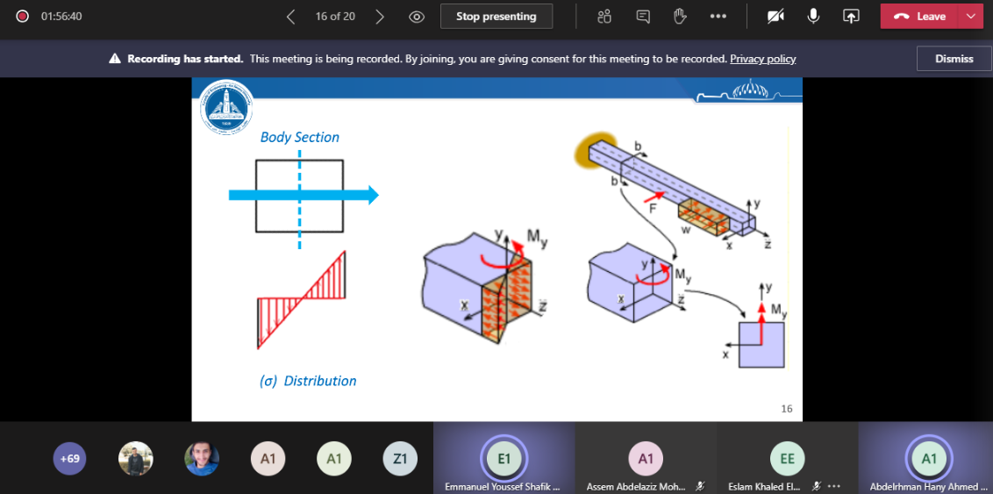

Comments from external evaluator(s): Response of course team
………N/A ………………. …………………………….
……….……………..……. …………………………….

