Course report of
Machine Construction (MDP 112) Spring 2021

University: Ain Shams | Faculty: Engineering

Basic Information
- Title and code:
Machine Construction MDP 112 (2-2-0)
- Programs on which the course is given:
Mechanical Engineering

- Year/Level of programs:
Sophomore Level
- Units/Credit Hours
( i ) Lecture : | 2

( ii ) Tutorial/Practical : | 2/0

( iii ) Total : | 4
- Names of lecturers contributing to delivery of the course:
i - | Associate Prof. Wagdi Eldesouki

ii - | Prof. Tamer Elnady

iii - | Associate Prof. Ayman Aly Abd El-Wahab
 | Dr. Amr Shaaban

Course coordinator: | Prof. Tamer Elnady

External evaluator:

Statistical Information

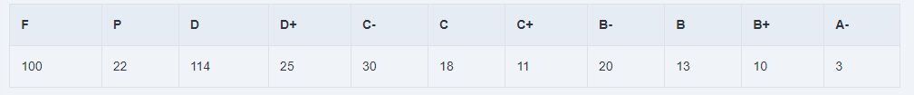

Professional Information

Course Teaching:
Course Content | No. of Hours | Lecturer
Principles of statics and its application on deformable bodies. | 4 | Dr. Wagdy
Loading Diagrams | 4 | Dr. Wagdy
Stress and Strain | 4 | Dr. Wagdy
Normal Stresses | 4 | Dr. Wagdy
Shear Stresses | 4 | Dr. Wagdy
Combined stresses | 4 | Dr. Wagdy
Theories of Elastic Failure | 4 | Dr. Wagdy
Safety Factor | 4 | Dr. Ayman/ Dr. Amr
Construction Details | 8 | Dr. Ayman/ Dr. Amr
Connections | 8 | Dr. Ayman/ Dr. Amr
Power Screw | 4 | Dr. Tamer
Stress Concentration | 4 | Dr. Tamer
Reverse Engineering | 4 | Dr. Tamer

Teaching and Learning Methods
- Lectures (online using Microsoft Teams platform)
- Tutorial (on campus & online using Microsoft Teams platform)

Topics taught as a percentage of the content specified:

>90 % X 70-90 % <70%

Reasons in detail for not teaching any topic
All topics were taught ………………………………………………………………………
………………………………………………………………………………………………
………………………………………………………………………………………………
………………………………………………………………………………………………

If any topics were taught which are not specified, give reasons in detail
N/A………………………………………………………………………………………….

Teaching and learning methods:
Lectures: X
Practical training/ laboratory:
Seminar/Workshop:
Class Activity: (Tutorials) X

Case Study:
Other assignments/homework:
If teaching and learning methods were used other than those specified, list and give reasons:
………………………………………………………………………………………………

Student assessment:
Assessment method | Description | Week No | Weight (%)
Assignments | Assignments | 2,3, 6,7,8,10,11,12&13 | 10
Quiz | Unannounced Quizzes | 5-13 | 10
Written Exam | Mid-Term Exam | 8 | 25
Participation | In Class Activity | 1-13 | 5
Written Exam | Final Exam | 14 | 50
Total |  |  | 100

Assessment and Feedback Strategy
- Assignments and project reports (online & written)
- Quizzes (online & written)
- Written examinations (midterm & final term)

Members of examination committee
- Associate Prof. Associate Prof. Wagdi Eldesouki
- Prof. Tamer Elnady
- Associate Prof. Ayman Aly Abd El-Wahab
- Dr. Amr Shaaban

Role of external evaluator
N/A…………………………………………………………………………………………

Facilities and teaching materials:
Totally adequate
X

Adequate to some extent

Inadequate

List any inadequacies

Administrative constraints:
List any difficulties encountered
No difficulties

Student evaluation of the course:
The course syllabus was clearly explained at the beginning of the semester | 64%
I am aware of the course learning outcomes (LOs) | 66%
The teaching methods used helped and supported me to learn | 63%
Course topics are explained well in the teaching sessions. | 66%
The course activities helped me to achieve the learning outcomes (LOs) efficiently. | 63%
The course assessments were clear and their distribution were clearly announced and organized | 62%
I felt well supported on this course from instructor and teaching assistant (if any). | 63%
I have been able to contact instructor when I needed to. | 62%
The course focused on what was set out in the course specification and all are presented. | 66%
The instructor provided well written laboratory instructions (if any). | 59%
Adequate technical support and supervision were provided during the laboratory sessions (if any). | 58%
The laboratory was well integrated with the course pacing (if any). | 59%
The course digital materials on LMS are helpful in supporting my learning. | 59%
Overall, I was satisfied with my experience of this course. | 62%
I learn from online teaching activities, similar to on campus teaching activities. | 59%
The instructor used appropriate communication tools for online teaching. | 66%
The instructor pays attention to the student's achievement during online class. | 65%
The instructor encouraged active participation and discussion during online class. | 67%
I could pass the online course without any staff assistance. | 52%
The instructor respected to start / finish online lectures on scheduled times | 64%

Response of Course Team
This survey is satisfactory as all scores are above 50%. All scores are between 50% to 70% this may be due to the tough nature of the course which required more effort exerted by the students

Team Link for the course:
https://teams.microsoft.com/l/team/19%3afJbmav2H01cM5YJBK8CgyynAQmy73Mll7ImkFFPLdD81%40thread.tacv2/conversations?groupId=a774072c-ad7a-4bf7-b20c-3e0589a1dc64&tenantId=ad2a8324-bef7-46a8-adb4-fe51b6613b24

Screen shot from an online lecture as an example

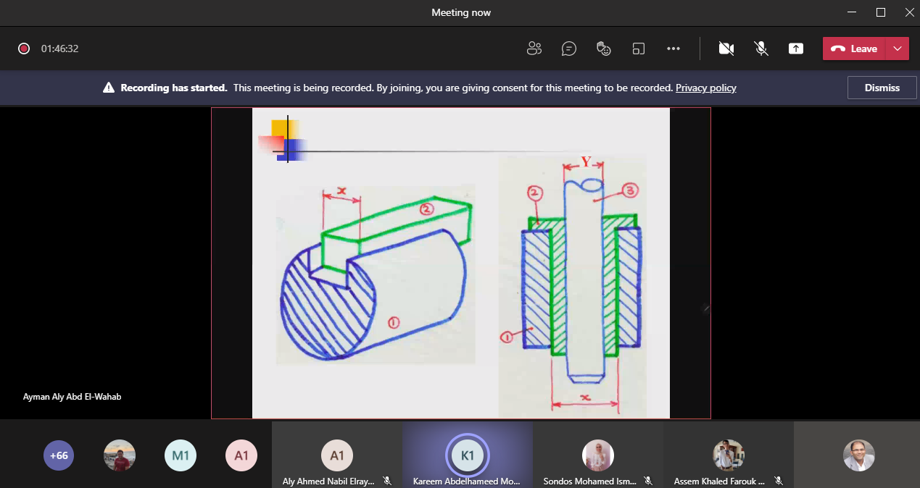

Comments from external evaluator(s): Response of course team
………N/A ………………. …………………………….
……….……………..……. …………………………….

