Course report of
Machine Design – MDP 361 – 2020-2021

University: Ain Shams | Faculty: Engineering

Basic Information
- Title and code:
Machine Design - MDP361
- Programme on which the course is given:
B. Sc. Mechanical Engineering (Production Engineering)

- Year/Level of programmes:
4th year, First/Second semesters
- Units/Credit Hours
( i ) Lecture: | 2

( ii ) Tutorial/Practical: | 2/0

( iii ) Total: | 4
- Names of lecturers contributing to delivery of the course:
i - | Prof. Samy J. Ebeid

ii - | Dr. Moustafa M. Sayed

Course coordinator: | Prof. Samy J. Ebeid

External evaluator: | --- --- ---

Statistical Information
No. of students attending the course: | 37

 | Excellent | Very Good | Good | Pass | Weak | Very Weak | SUM
Students No. | 4 | 11 | 9 | 6 | 3 | 4 | 37
Percentage (%) | 10.8 | 29.7 | 24.3 | 16.2 | 8 | 10.8

Professional Information

Course Teaching:
No | Course Content | Lecture  (hrs) | Tutorial  (hrs) | Total  (hrs) | Lecturer
1 | Clutches | 9 | 9 | 18 | Prof. SJ Ebeid
2 | Flat Belt Drives | 2 | 2 | 4 | Prof. SJ Ebeid
3 | V-Belt Drives | 2 | 2 | 4 | Prof. SJ Ebeid
4 | Belt Drives - Tensioning Devices | 3 | 3 | 6 | Prof. SJ Ebeid
5 | Variable Speed Drives | 10 | 10 | 20 | Prof. SJ Ebeid
6 | Antifriction Bearings | 6 | 6 | 12 | Prof. SJ Ebeid
7 | Sliding Bearings | 6 | 6 | 12 | Dr. M Mahmoud
8 | Gearing | 2 | 2 | 4 | Dr. M Mahmoud
9 | Gearing - Spur Gears | 5 | 5 | 10 | Dr. M Mahmoud
10 | Gearing - Helical Gears | 3 | 3 | 6 | Dr. M Mahmoud
11 | Gearing - Bevel Gears | 5 | 5 | 10 | Dr. M Mahmoud
12 | Gearing - Worm Drives | 3 | 3 | 6 | Dr. M Mahmoud
13 | Gear Units | 4 |  | 4 | Prof. SJ Ebeid
13 | Computer Aided Design | 0 | 4 | 4 | Prof. SJ Ebeid
 | Total | 60 | 60 | 120

MS Teams Link: https://teams.microsoft.com/l/team/19%3a3b40299334334371bc8d2a84a71ff9f7%40thread.tacv2/conversations?groupId=9f621182-7a3a-409b-8226-e4640ed434d9&tenantId=ad2a8324-bef7-46a8-adb4-fe51b6613b24

MS Teams Code: w34xriu

 | Lecture | Video Link
1 | Rolling Bearings – Part 1_1 | https://youtu.be/TM6EvpCd3Dw
2 | Rolling Bearings – Part 1_2 | https://youtu.be/zHHsXlVOnAM
3 | Rolling Bearings – Tut 1 | https://youtu.be/U8eUflP-gP0
4 | V1 Spherical Roller Bearings | https://youtu.be/WHQqsf87yQM
5 | V2 Tapered Roller Bearing | https://youtu.be/d-2VAR9nGTw
6 | V3 Taper Roller Bearings | https://youtu.be/En-64Dstmxo
7 | V6 Introduction to SKF Rolling Bearings | https://youtu.be/cky5ockNQKU
8 | Rolling Bearings – Part 1_3 | https://youtu.be/zVA3z9xcJiU
9 | Rolling Bearings – Tut 2 | https://youtu.be/HPMPL54oLiw
10 | Rolling Bearings – Part 2 | https://youtu.be/iGs5Ip1_nEY
11 | Rolling Bearings – Tut 3 | https://youtu.be/QJpy9Y7n5TY
12 | Clutches – Part 1 | Sent to students due to problem with LMS
13 | V9 Anti-Friction Bearings (Ball and Roller Bearings) | https://youtu.be/vRtzL1oKY14
14 | V10 Tapered roller bearings installation | https://youtu.be/lA1913OUaGs
15 | Flat Belts_1 - 15 Dec 2020 | https://youtu.be/vKudWyP9vBQ
16 | Tutorial Clutches – 15 Dec 2020 | https://youtu.be/JiF1KfUp-wk
17 | Flat Belts_2 - 22 Dec 2020 | https://youtu.be/PSib2g0nVk8
18 | Flat Belts_3 - 22 Dec 2020 | https://youtu.be/cGbK11kk9cE
19 | Tutorial Flat Belts_4 - 22 Dec 2020 | https://youtu.be/ufyS3oFj7mE
20 | V03 Flat belt compressor | https://youtu.be/zsoLcC3ir4A
21 | V04 Antique Drill Press with Flat Belt Drive | https://youtu.be/UaNxcHpjsbw
22 | V05 Mercedes Unimog 411 Flat Belt Pulley | https://youtu.be/fvcqDv_c5CE
23 | V2 V Belts double angled | https://youtu.be/O0GgC8Yt3-w
24 | V5 Banded V Belts | https://youtu.be/--csxq9U30k
25 | V1 Timing Belt | https://youtu.be/AqL7k54JO68
26 | V7 C3 Timing Belt Drive for Ski Doo | https://youtu.be/q30gxVAOGaU
27 | V Belts 29 Dec 2020 | https://youtu.be/VRbYfwmykC8
28 | Tutorial Flat Belts_5 - 29 Dec 2020 | https://youtu.be/S7SrvSWCtHg
29 | VSD_1 - 5 Jan 2021 | https://youtu.be/BkwLHNA2aZM
30 | VSD_2 - 5 Jan 2021 | https://youtu.be/gj0Yt0UODXM
31 | Tut 5 Jan 2021 | https://youtu.be/ZWoS_nT04cI
32 | V10 Gearless Scooter Transmission System Animation | https://youtu.be/XF9rkzbFtm4
33 | VSD 3 12 Jan 2021 | https://youtu.be/wZyIUgFdSe8
34 | Tutorial - 12 Jan 2021 | https://youtu.be/HLDWI8bA-wM
35 | Tutorial Project Submission 20 Apr 2021 | https://youtu.be/r_U622FYdEk
36 | Lect1Journal Bearings_part1 | https://youtu.be/sbbwm4FT5e0
37 | Lect1Journal Bearings_part2 | https://youtu.be/UVKoT94JnyQ
38 | Lecture 2_Introduction to Gear Drives_Part1_1 | https://youtu.be/9cS7DVMW9VY
39 | Lecture 2_Introduction to Gear Drives_Part2 | https://youtu.be/c5WxfAX9Hys
40 | Lecture 2_spur gear design_part3 | https://youtu.be/7kM18sgj0N0
41 | Lecture 2_spur gear design_part4 | https://youtu.be/H4DgnQL5C34
42 | Lecture 2_spur gear design_part5 | https://youtu.be/9jzsKYhr1Yg
43 | Lecture 4_Helical Gear Design | https://youtu.be/J0XXiV4kmi4
44 | Lecture 6_Bevel gears | https://youtu.be/J0hvGd6zuio
45 | Lect7_worm drives_part1 | https://youtu.be/MbElEHG2Flg
46 | Tutorial – 27 Apr 2021 | https://youtu.be/kSe9hDWUM44
47 | Tutorial - 18 May 2021 | https://youtu.be/gLWbQNCJRtQ
48 | Tutorial - 25 May 2021 | https://youtu.be/HyKinizOeWw
49 | Lec 01 Jun 2021 | https://youtu.be/N-QWZKePfnw
50 | Lec contd 01 Jun 2021 | https://youtu.be/TSlLKmb7Bng
51 | Tutorial 01 Jun 2021 | https://youtu.be/TSlLKmb7Bng
52 | Lec 08 Jun 2021 | https://youtu.be/KLx8cUKwmzc

MS Teams Meeting Links

Date | MS Teams Meeting Links
20 Oct 2020 | https://teams.microsoft.com/l/meetup-join/19%3a3b40299334334371bc8d2a84a71ff9f7%40thread.tacv2/1603139665952?context=%7b%22Tid%22%3a%22ad2a8324-bef7-46a8-adb4-fe51b6613b24%22%2c%22Oid%22%3a%221846db9e-46dd-4eda-85a9-f893b5060690%22%7d  https://teams.microsoft.com/meetingOptions/?organizerId=1846db9e-46dd-4eda-85a9-f893b5060690&tenantId=ad2a8324-bef7-46a8-adb4-fe51b6613b24&threadId=19_3b40299334334371bc8d2a84a71ff9f7@thread.tacv2&messageId=1603139665952&language=en-US
27 Oct 2020 | https://teams.microsoft.com/meetingOptions/?organizerId=1846db9e-46dd-4eda-85a9-f893b5060690&tenantId=ad2a8324-bef7-46a8-adb4-fe51b6613b24&threadId=19_3b40299334334371bc8d2a84a71ff9f7@thread.tacv2&messageId=1603745971180&language=en-US
27 Oct 2020 | https://teams.microsoft.com/meetingOptions/?organizerId=1846db9e-46dd-4eda-85a9-f893b5060690&tenantId=ad2a8324-bef7-46a8-adb4-fe51b6613b24&threadId=19_3b40299334334371bc8d2a84a71ff9f7@thread.tacv2&messageId=1603746082560&language=en-US
03 Nov 2020 | https://teams.microsoft.com/meetingOptions/?organizerId=1846db9e-46dd-4eda-85a9-f893b5060690&tenantId=ad2a8324-bef7-46a8-adb4-fe51b6613b24&threadId=19_3b40299334334371bc8d2a84a71ff9f7@thread.tacv2&messageId=1604350072952&language=en-US
03 Nov 2020 | https://teams.microsoft.com/meetingOptions/?organizerId=1846db9e-46dd-4eda-85a9-f893b5060690&tenantId=ad2a8324-bef7-46a8-adb4-fe51b6613b24&threadId=19_3b40299334334371bc8d2a84a71ff9f7@thread.tacv2&messageId=1604350414314&language=en-US
10 Nov 2020 | https://teams.microsoft.com/meetingOptions/?organizerId=1846db9e-46dd-4eda-85a9-f893b5060690&tenantId=ad2a8324-bef7-46a8-adb4-fe51b6613b24&threadId=19_3b40299334334371bc8d2a84a71ff9f7@thread.tacv2&messageId=1604956197363&language=en-US
10 Nov 2020 | https://teams.microsoft.com/meetingOptions/?organizerId=1846db9e-46dd-4eda-85a9-f893b5060690&tenantId=ad2a8324-bef7-46a8-adb4-fe51b6613b24&threadId=19_3b40299334334371bc8d2a84a71ff9f7@thread.tacv2&messageId=1604956327801&language=en-US
17 Nov 2020 | https://teams.microsoft.com/meetingOptions/?organizerId=ae9db12d-e882-4036-92a4-7d86bd12ce1a&tenantId=ad2a8324-bef7-46a8-adb4-fe51b6613b24&threadId=19_3b40299334334371bc8d2a84a71ff9f7@thread.tacv2&messageId=1605551745088&language=en-US
17 Nov 2020 | https://teams.microsoft.com/meetingOptions/?organizerId=ae9db12d-e882-4036-92a4-7d86bd12ce1a&tenantId=ad2a8324-bef7-46a8-adb4-fe51b6613b24&threadId=19_3b40299334334371bc8d2a84a71ff9f7@thread.tacv2&messageId=1605600066873&language=en-US
24 Nov 2020 | https://teams.microsoft.com/meetingOptions/?organizerId=ae9db12d-e882-4036-92a4-7d86bd12ce1a&tenantId=ad2a8324-bef7-46a8-adb4-fe51b6613b24&threadId=19_3b40299334334371bc8d2a84a71ff9f7@thread.tacv2&messageId=1606144742384&language=en-US
24 Nov 2020 | https://teams.microsoft.com/meetingOptions/?organizerId=ae9db12d-e882-4036-92a4-7d86bd12ce1a&tenantId=ad2a8324-bef7-46a8-adb4-fe51b6613b24&threadId=19_3b40299334334371bc8d2a84a71ff9f7@thread.tacv2&messageId=1606144871230&language=en-US
8 Dec 2020 | https://teams.microsoft.com/meetingOptions/?organizerId=ae9db12d-e882-4036-92a4-7d86bd12ce1a&tenantId=ad2a8324-bef7-46a8-adb4-fe51b6613b24&threadId=19_3b40299334334371bc8d2a84a71ff9f7@thread.tacv2&messageId=1607368749405&language=en-US
8 Dec 2020 | https://teams.microsoft.com/meetingOptions/?organizerId=ae9db12d-e882-4036-92a4-7d86bd12ce1a&tenantId=ad2a8324-bef7-46a8-adb4-fe51b6613b24&threadId=19_3b40299334334371bc8d2a84a71ff9f7@thread.tacv2&messageId=1607368791783&language=en-US
15 Dec 2020 | https://teams.microsoft.com/meetingOptions/?organizerId=1846db9e-46dd-4eda-85a9-f893b5060690&tenantId=ad2a8324-bef7-46a8-adb4-fe51b6613b24&threadId=19_3b40299334334371bc8d2a84a71ff9f7@thread.tacv2&messageId=1607948302810&language=en-US
22 Dec 2020 | https://teams.microsoft.com/meetingOptions/?organizerId=1846db9e-46dd-4eda-85a9-f893b5060690&tenantId=ad2a8324-bef7-46a8-adb4-fe51b6613b24&threadId=19_3b40299334334371bc8d2a84a71ff9f7@thread.tacv2&messageId=1608568861588&language=en-US
22 Dec 2020 | https://teams.microsoft.com/meetingOptions/?organizerId=1846db9e-46dd-4eda-85a9-f893b5060690&tenantId=ad2a8324-bef7-46a8-adb4-fe51b6613b24&threadId=19_3b40299334334371bc8d2a84a71ff9f7@thread.tacv2&messageId=1608628461834&language=en-US
29 Dec 2020 | https://teams.microsoft.com/meetingOptions/?organizerId=1846db9e-46dd-4eda-85a9-f893b5060690&tenantId=ad2a8324-bef7-46a8-adb4-fe51b6613b24&threadId=19_3b40299334334371bc8d2a84a71ff9f7@thread.tacv2&messageId=1609152603841&language=en-US
5 Jan 2021 | https://teams.microsoft.com/meetingOptions/?organizerId=1846db9e-46dd-4eda-85a9-f893b5060690&tenantId=ad2a8324-bef7-46a8-adb4-fe51b6613b24&threadId=19_3b40299334334371bc8d2a84a71ff9f7@thread.tacv2&messageId=1609780001418&language=en-US
5 Jan 2021 | https://teams.microsoft.com/meetingOptions/?organizerId=1846db9e-46dd-4eda-85a9-f893b5060690&tenantId=ad2a8324-bef7-46a8-adb4-fe51b6613b24&threadId=19_3b40299334334371bc8d2a84a71ff9f7@thread.tacv2&messageId=1609836860171&language=en-US
12 Jan 2021 | https://teams.microsoft.com/meetingOptions/?organizerId=1846db9e-46dd-4eda-85a9-f893b5060690&tenantId=ad2a8324-bef7-46a8-adb4-fe51b6613b24&threadId=19_3b40299334334371bc8d2a84a71ff9f7@thread.tacv2&messageId=1610386953740&language=en-US
23 Mar 2021 | https://teams.microsoft.com/meetingOptions/?organizerId=ae9db12d-e882-4036-92a4-7d86bd12ce1a&tenantId=ad2a8324-bef7-46a8-adb4-fe51b6613b24&threadId=19_3b40299334334371bc8d2a84a71ff9f7@thread.tacv2&messageId=1616316497162&language=en-US
30 Mar 2021 | https://teams.microsoft.com/meetingOptions/?organizerId=ae9db12d-e882-4036-92a4-7d86bd12ce1a&tenantId=ad2a8324-bef7-46a8-adb4-fe51b6613b24&threadId=19_3b40299334334371bc8d2a84a71ff9f7@thread.tacv2&messageId=1617023564677&language=en-US
30 Mar 2021 | https://teams.microsoft.com/meetingOptions/?organizerId=d752578d-6dcb-401d-bffb-28ee8881bc06&tenantId=ad2a8324-bef7-46a8-adb4-fe51b6613b24&threadId=19_3b40299334334371bc8d2a84a71ff9f7@thread.tacv2&messageId=1617097100514&language=en-US
06 Apr 2021 | https://teams.microsoft.com/meetingOptions/?organizerId=ae9db12d-e882-4036-92a4-7d86bd12ce1a&tenantId=ad2a8324-bef7-46a8-adb4-fe51b6613b24&threadId=19_3b40299334334371bc8d2a84a71ff9f7@thread.tacv2&messageId=1617634113974&language=en-US
 | https://teams.microsoft.com/meetingOptions/?organizerId=d752578d-6dcb-401d-bffb-28ee8881bc06&tenantId=ad2a8324-bef7-46a8-adb4-fe51b6613b24&threadId=19_3b40299334334371bc8d2a84a71ff9f7@thread.tacv2&messageId=1617097100514&language=en-US
13 Apr 2021 | https://teams.microsoft.com/meetingOptions/?organizerId=ae9db12d-e882-4036-92a4-7d86bd12ce1a&tenantId=ad2a8324-bef7-46a8-adb4-fe51b6613b24&threadId=19_3b40299334334371bc8d2a84a71ff9f7@thread.tacv2&messageId=1618047208172&language=en-US
20 Apr 2021 | https://teams.microsoft.com/meetingOptions/?organizerId=d752578d-6dcb-401d-bffb-28ee8881bc06&tenantId=ad2a8324-bef7-46a8-adb4-fe51b6613b24&threadId=19_3b40299334334371bc8d2a84a71ff9f7@thread.tacv2&messageId=1618885484396&language=en-US
27 Apr 2021 | https://teams.microsoft.com/meetingOptions/?organizerId=ae9db12d-e882-4036-92a4-7d86bd12ce1a&tenantId=ad2a8324-bef7-46a8-adb4-fe51b6613b24&threadId=19_3b40299334334371bc8d2a84a71ff9f7@thread.tacv2&messageId=1619467324685&language=en-US
18 May 2021 | https://teams.microsoft.com/meetingOptions/?organizerId=ae9db12d-e882-4036-92a4-7d86bd12ce1a&tenantId=ad2a8324-bef7-46a8-adb4-fe51b6613b24&threadId=19_3b40299334334371bc8d2a84a71ff9f7@thread.tacv2&messageId=1621264621234&language=en-US
25 May 2021 | https://teams.microsoft.com/meetingOptions/?organizerId=d752578d-6dcb-401d-bffb-28ee8881bc06&tenantId=ad2a8324-bef7-46a8-adb4-fe51b6613b24&threadId=19_3b40299334334371bc8d2a84a71ff9f7@thread.tacv2&messageId=1621930671361&language=en-US
01 Jun 2021 | https://teams.microsoft.com/meetingOptions/?organizerId=1846db9e-46dd-4eda-85a9-f893b5060690&tenantId=ad2a8324-bef7-46a8-adb4-fe51b6613b24&threadId=19_3b40299334334371bc8d2a84a71ff9f7@thread.tacv2&messageId=1622450572089&language=en-US
08 Jun 2021 | https://teams.microsoft.com/meetingOptions/?organizerId=1846db9e-46dd-4eda-85a9-f893b5060690&tenantId=ad2a8324-bef7-46a8-adb4-fe51b6613b24&threadId=19_3b40299334334371bc8d2a84a71ff9f7@thread.tacv2&messageId=1623059966305&language=en-US

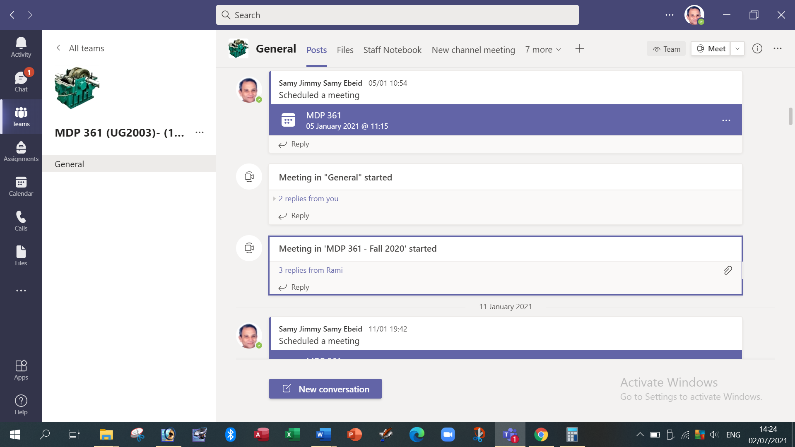

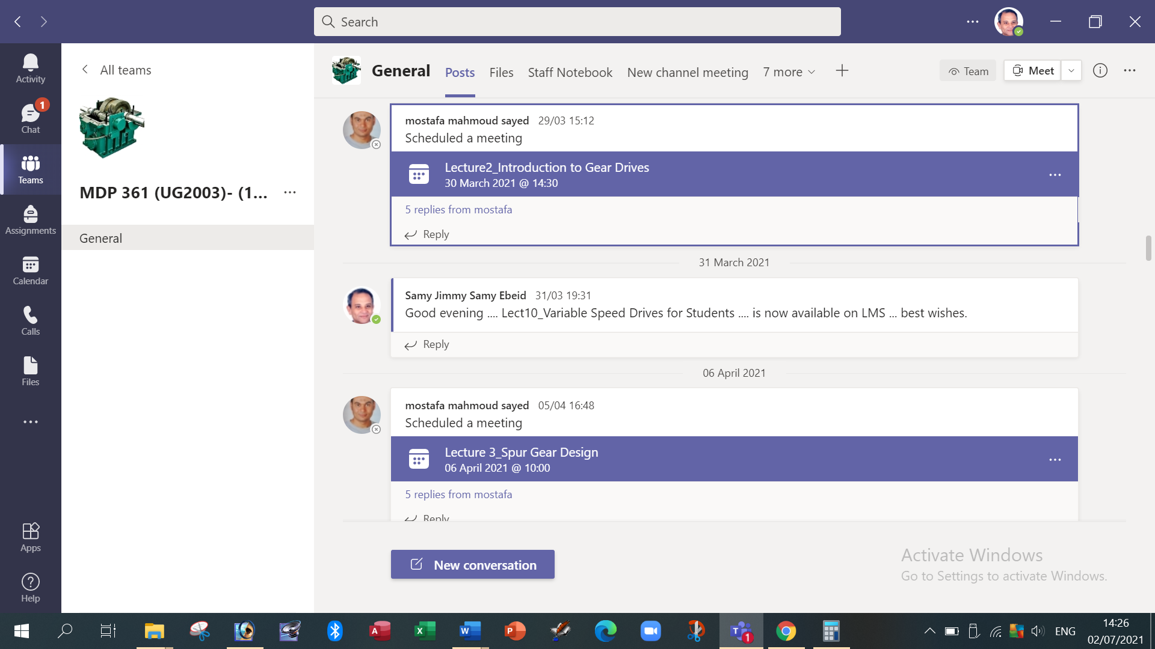

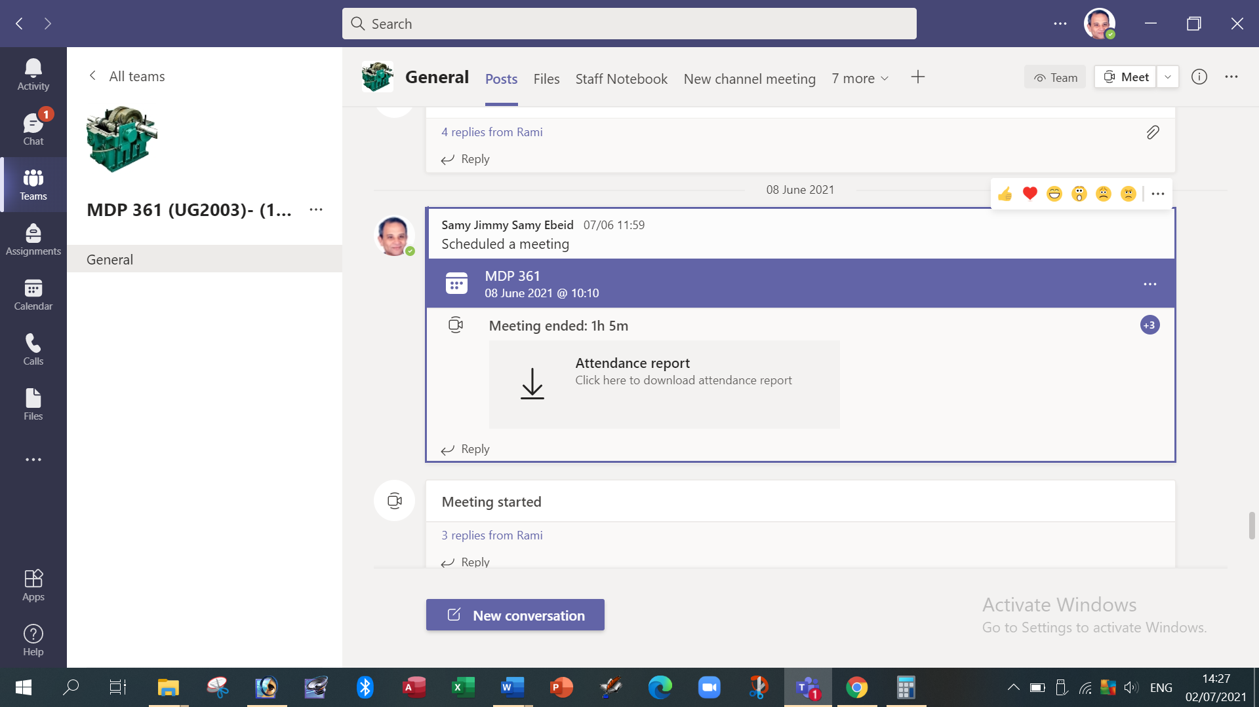

Due to the pandemic of COVID19 during 2020-2021, the lectures were conducted on MS Teams platform. In addition, the lectures were recorded as videos and added on LMS. Nearly all topics were taught.

Topics taught as a percentage of the content specified:

>90 % X 70-90 % <70%

Reasons in detail for not teaching any topic
Nearly all topics were taught.

If any topics were taught which are not specified, give reasons in detail
……………………………………………………………………………

Teaching and learning methods:
Lectures: X
Practical training/ laboratory:
Seminar/Workshop: X
Class Activity: (Tutorials) X

Case Study:
Other assignments/homework:
If teaching and learning methods were used other than those specified, list and give reasons:

Student assessment:
Method of assessment | Percentage of total
Written examination | 60 %
Oral examination | 0 %
Practical/laboratory work | 0 %
Other assignments/class work | 40 %

Members of examination committee
i - Prof. Samy J. Ebeid
ii - Dr. Moustafa M. Sayed

Role of external evaluator
N/A……………….

Facilities and teaching materials:
Totally adequate
X
Adequate to some extent

Inadequate

List any inadequacies:

Due to the pandemic of COVID19 during 2020-2021, the lectures were conducted on MS Teams platform. In addition, the lectures were recorded as videos and added on LMS. Nearly all topics were taught.
Teaching Lectures during 2020-2021 were fully 100 % Online Teaching.

Administrative constraints:
List any difficulties encountered
No difficulties

Student evaluation of the course:

The student’s evaluation of Spring 2020/2021 is not available on the system.

Response of Course Team
List any criticisms
Teaching facilities: The available facilities were the computer, MS Teams and LMS.

Comments from external evaluator(s): Response of course team
N/A………………. …………………………….
……….……………..……. …………………………….

