Course Report of

Thermal Physics – MEP 111– Fall 2020
University: Ain Shams Faculty: Engineering

Basic Information

Title and code:

Thermal Physics – MEP 111

Program on which the course is given:

Mechanical Power Engineering

  - Year / Level of program(s) 2019-2020 / Mechanical Engineering Students – Level 1

Units / Credit Hours:

i. | Lecture (online through Microsoft Teams) | 1
ii. Tutorial / Practical: 2
iii. Total: 2 CH
Link to the meeting:
https://teams.microsoft.com/l/meetup-join/19%3a3e118ffb5a0d4d96b8cf9922682d9efd%40thread.tacv2/1607248224635?context=%7b%22Tid%22%3a%22ad2a8324-bef7-46a8-adb4-fe51b6613b24%22%2c%22Oid%22%3a%226555c604-e2f9-4c8d-adbd-46dcf3328ace%22%7d

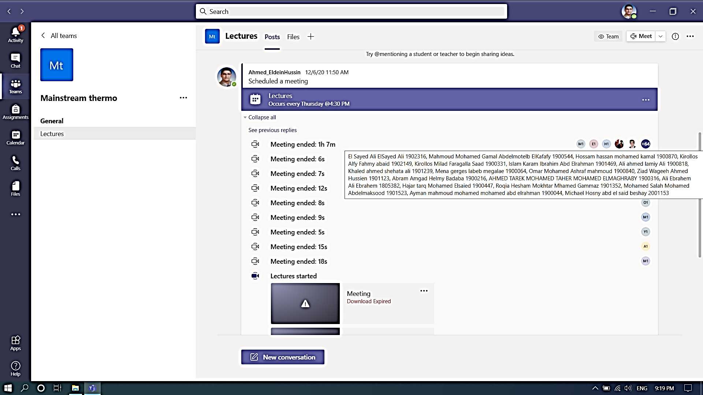

- Names of lecturers contributing to the delivery of the course:

Dr. Walid Aboelsoud
Dr. Nashwa Abbas
Dr. Ahmed Taher

Course coordinator: Dr. Walid Aboelsoud

External evaluator: -------------

Statistical Information

No of students attending the course:383

 |  | Number | Percentage (%)
Students completing the course
Results | Passed | 370 | 97
Results | Failed | 13 | 3
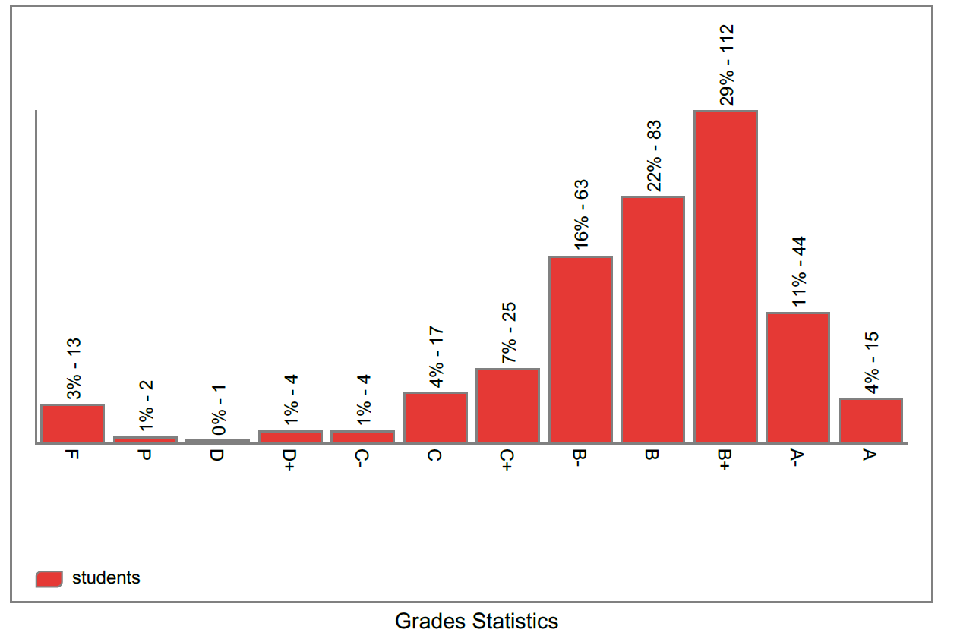

Professional Information

1- Course Teaching:

Week | Course Content | Lecture  Hours | Tutorial  Hours
1 | Introduction (Chapter 1). | 1 | 2
2 | Basic concepts: Temperature and pressure (Chapter 1). | 1 | 2
3 | Energy, energy transfer (Chapter 2). | 1 | 2
4 | Energy analysis: Work and heat (Chapter 2). | 1 | 2
5 | First law of thermodynamics (Chapter 2). | 1 | 2
6 | Properties of pure substances: phase change, property diagrams (Chapter 3). | 1 | 2
7 | Properties of pure substances: property tables, EES software and the ideal gas equation of state (Chapter 3). | 1 | 2
8 | Energy analysis of closed systems: energy balance, internal energy, enthalpy (Chapter 4). | 1 | 2
9 | Energy analysis of closed systems: specific heats (Chapter 4). | 1 | 2
10 | Mass and energy analysis of control volumes: conservation of mass, flow work, energy analysis of steady-flow systems (Chapter 5). | 1 | 2
11 | Thermodynamics’ applications: Nozzles & Diffusers (Chapter 5). | 1 | 2
12 | Thermodynamics’ applications: Turbines & Compressors (Chapter 5). | 1 | 2
13 | Thermodynamics’ applications: Mixing & Heat exchangers (Chapter 5). | 1 | 2
14 | Simple-ideal power cycles: Brayton cycle (Chapter 9&10). | 1 | 2
15 | Simple-ideal power cycles: Rankine cycle (Chapter 9&10). | 1 | 2
Total Number of Hours |  | 15 | 30

Topics taught as percentage of the content specified:

ʘ > 90% Ο 70% - 90%
Ο < 70%

Reasons in details for not teaching any topic:

If any topics were taught which are not specified, give reasons in details:

None

  - Teaching and learning methods:

Lectures
√

Practical training/laboratory

Seminar / workshop

Class activity √

Case study:

Other assignments / homework

If teaching and learning methods were used other than those specified, list and give reasons: N/A - - - - - - - - - - - - - - - - - - - - - - - - - - - - - - - - - - - - - - - - - - - - - - - - - - - - - - - - - - - - -

Student assessment:

Method of assessment | Percentage of total
Assignments | 10%
Quizzes | 20%
Written midterm exam | 25 %
Participation in class | 5 %
Written final exam | 40%
Total | 100%

Members of examination committee:

Dr. Walid Aboelsoud

Dr. Nashwa Abbas

Role of the external evaluator

To express his views on the course - - - - - - - - - - - NONE- - - - - - - - - - - -
- - - - - - - - - - - - - - - - - - - - - - - - - - - - - - - - - - - - - - - - - - - - - - - - - - - - - - - - - - - - - - - -

Facilities and teaching materials:

Totally adequate

Adequate to some extent √

Inadequate

List any inadequacies

  - Administrative constraints

List any difficulties encountered

None - - - - - - - - - - - - - - - - - - - - - - - - - - - - - - - - - - - - - - - - - - - - - - - - - -
- - - - - - - - - - - - - - - - - - - - - - - - - - - - - - - - - - - - - - - - - - - - - - - - - - - - - -

Student evaluation of the course:

Comments from external evaluator(s)

Comments | Response of Course team
- - - - - - - - - - - - - - - - - - - - - - - - - - - | - - - - - - - - - - - - - - - - - - - - - - - - - - -
- - - - - - - - - - - - - - - - - - - - - - - - - - - | - - - - - - - - - - - - - - - - - - - - - - - - - - -
- - - - - - - - - - - - - - - - - - - - - - - - - - - | - - - - - - - - - - - - - - - - - - - - - - - - - - -
- - - - - - - - - - - - - - - - - - - - - - - - - - - | - - - - - - - - - - - - - - - - - - - - - - - - - - -
- - - - - - - - - - - - - - - - - - - - - - - - - - - | - - - - - - - - - - - - - - - - - - - - - - - - - - -
- - - - - - - - - - - - - - - - - - - - - - - - - - - | - - - - - - - - - - - - - - - - - - - - - - - - - - -
- - - - - - - - - - - - - - - - - - - - - - - - - - - | - - - - - - - - - - - - - - - - - - - - - - - - - - -
- - - - - - - - - - - - - - - - - - - - - - - - - - - | - - - - - - - - - - - - - - - - - - - - - - - - - - -

Course enhancement:

Progress on actions identified in the previous year's action plane:

Action | State whether or not completed and give reasons for any non-completion
N/A - - - - - - - - - - - - - - - - - - - - - -  - - - - - - - - - - - - - - - - - - - - - - - - - -  - - - - - - - - - - - - - - - - - - - - - - - - - - | - - - - - - - - - - - - - - - - - - - - - - - - - - -  - - - - - - - - - - - - - - - - - - - - - - - - - - -  - - - - - - - - - - - - - - - - - - - - - - - - - - -

  - Action plan for academic year 2016-2017

Actions required | Completion date | Person responsible
- - - - - - - - - - - - - - - - - - - -  - - - - - - - - - - - - - - - - - | - - - - - - - - - - - - - - - - - -  - - - - - - - - - - - - - - - - - - - -  - - - - - - - - - - - - - - - - - - | - - - - - - - - - - - - - - - - - -  - - - - - - - - - - - - - - - - - - - -  - - - - - - - - - - - - - - - - -

Course Content/ILO Matrix

Wk | Course Content | a1 | a2 | a3 | a4 | b1 | b2 | b3 | c1 | c2 | d1 | d2 | d3
1 | Introduction. | • |  |  |  |  | •
2 | Basic concepts: Temperature and pressure. | • |  |  |  |  | •
3 | Energy, energy transfer. |  | • |  |  | •
4 | Energy analysis: Work and heat. |  | • |  |  | • |  |  |  | •
5 | First law of thermodynamics. |  |  |  | • | • |  |  |  |  | • | •
6 | Properties of pure substances: phase change, property diagrams. | • |  |  |  |  | • |  | • | •
7 | Properties of pure substances: property tables, EES software and the ideal gas equation of state. | • |  | • |  |  | • |  | • | • | •
8 | Energy analysis of closed systems: energy balance, internal energy, enthalpy. | • | • | • |  | • |  | • |  | • |  |  | •
9 | Energy analysis of closed systems: specific heats. | • | • | • |  | • |  | • |  |  |  |  | •
10 | Mass and energy analysis of control volumes: conservation of mass, flow work, energy analysis of steady-flow systems. |  | • | • | • | • |  | • |  |  | • |  | •
11 | Thermodynamics’ applications: Nozzles & Diffusers. |  |  |  | • | • |  | • | • |  |  |  | •
12 | Thermodynamics’ applications: Turbines & Compressors |  |  |  | • | • |  | • | • |  |  |  | •
13 | Thermodynamics’ applications: Mixing & Heat exchangers. |  |  |  | • | • |  | • | • |  |  |  | •
14 | Simple-ideal power cycles: Brayton cycle. |  | • |  | • | • |  | • |  |  | • | • | •
15 | Simple-ideal power cycles: Rankine cycle. |  |  |  | • | • |  | • | • |  | • | • | •

