Course report of
Rigid Body Dynamics – PHM_131s Spring 2021
University: Ain Shams | Faculty: Engineering

Basic Information
- Title and code:
Rigid Body Dynamics – PHM_131s
- Program on which the course is given:
Mechanical Engineering Programs

- Year/Level of programs:
1st Level
- Units/Credit Hours
( i ) Lecture : | 2

( ii ) Tutorial/Practical : | 2

( iii ) Total : | 4
- Names of lecturers contributing to delivery of the course:
i - | Dr. Eslam Nabil El-Ganzoury

Course coordinator: | Dr. Eslam Nabil El-Ganzoury

External evaluator: | --- --- ---

Statistical Information

No. of students attending the course: | 418
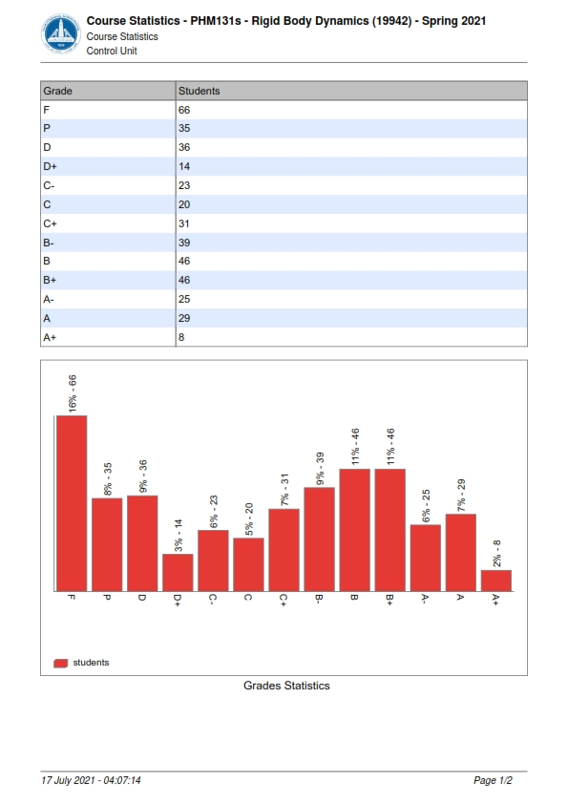
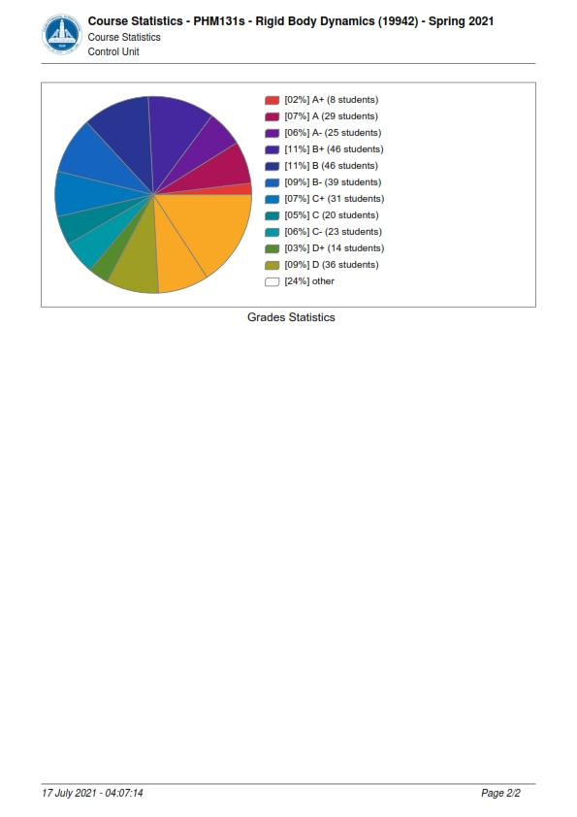

Professional Information

Course Teaching:
Course Content | Total No. of Hours | Lecturer
Planar kinematics of a rigid body, Translation, rotation and general motion | 2 | Dr. Eslam Nabil El-Ganzoury
Rotation about a fixed axis. Angular measurements. | 2 | Dr. Eslam Nabil El-Ganzoury
Velocity analysis: Vector analysis. | 2 | Dr. Eslam Nabil El-Ganzoury
Velocity analysis: instantaneous center of rotation. | 2 | Dr. Eslam Nabil El-Ganzoury
Acceleration analysis. | 2 | Dr. Eslam Nabil El-Ganzoury
Kinematics of rolling motion: Theory and analysis | 2 | Dr. Eslam Nabil El-Ganzoury
Rolling motion: Applications (Slipping and no slipping). | 2 | Dr. Eslam Nabil El-Ganzoury
Kinetics of a rigid body. Force-Acceleration method. | 2 | Dr. Eslam Nabil El-Ganzoury
Equations of motion: translation, rotation. | 2 | Dr. Eslam Nabil El-Ganzoury
Equations of motion: general plane motion. | 2 | Dr. Eslam Nabil El-Ganzoury
Kinetics of rolling problems. | 2 | Dr. Eslam Nabil El-Ganzoury
Kinetics of a rigid body. Work-energy method. | 2 | Dr. Eslam Nabil El-Ganzoury
Conservative and non-conservative field of forces. | 2 | Dr. Eslam Nabil El-Ganzoury
Kinetics of a rigid body. Impulse-momentum method. | 2 | Dr. Eslam Nabil El-Ganzoury
Impact problems. | 2 | Dr. Eslam Nabil El-Ganzoury
Total | 30

Topics taught as a percentage of the content specified:

>90 % $x$ 70-90 % <70%

Reasons in detail for not teaching any topic
N/A ………………………………………………………………………………………………
………………………………………………………………………………………………
………………………………………………………………………………………………

If any topics were taught which are not specified, give reasons in detail
N/A………………………………………………………………………………………….
………………………………………………………………………………………………
………………………………………………………………………………………………

Teaching and learning methods:
Lectures: $x$
Practical training/ laboratory:
Seminar/Workshop:
Class Activity: (Tutorials) X

Online details:

Teaching and Learning Methods as online
  - Teaching and in‐class discussion using “Microsoft Teams” online interactive program, by performing PowerPoint presentations with writing illustration.
  - Tutorial using “Microsoft Teams” online interactive program, by performing PowerPoint presentations with writing illustration.
  - The Quizzes were held online and written.
  - Assignments submitted online or written.
  - Final and Midterm exams are written on compus.

All lectures videos and data were linked to the LMS of the faculty and YouTube channel:

1.LMS link
https://lms.eng.asu.edu.eg/course/view.php?id=7485

2.Microsoft teams link
https://teams.microsoft.com/l/team/19%3ad1dcfc8f237f485ab6d0395b67ccefbc%40thread.tacv2/conversations?groupId=f1a9ce08-3d78-4aaf-b474-b61678666f11&tenantId=ad2a8324-bef7-46a8-adb4-fe51b6613b24

3.YouTube channel
https://youtube.com/playlist?list=PLK3yhbMyGsXI1QFOj7F5goMzBTGyYs9Ag
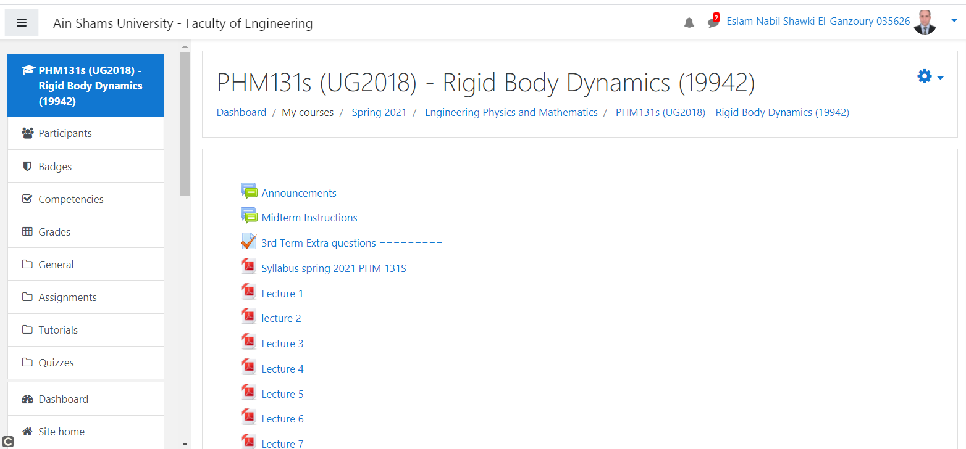
And the Power point lectures and tutorials are also uploaded with link:
https://lms.eng.asu.edu.eg/course/view.php?id=7485

Case Study:
Other assignments/homework:
If teaching and learning methods were used other than those specified, list and give reasons:
………………………………………………………………………………………………
………………………………………………………………………………………………

Student assessment:
Method of assessment | Percentage of total
Student activities | 5 %
Quizzes | 10 %
Midterm | 25 %
Final | 60 %
Total | 100 %

- Formative Assessment Methods:
  - Teaching and in‐class discussion using “Microsoft Teams” online interactive program, with mutual communication.

- Summative Assessment Methods:
- Assignments delivered online to the LMS of the faculty and marked online.
- Two Quizzes and two repeated for excuses performed online on the LMS of the faculty and marked online.
- Mid-Term Exam performed written at the faculty.
- Final Exam performed written at the faculty.

Members of examination committee
i–Dr. Eslam Nabil El-Ganzoury and Role of external evaluator
N/A………………………………………………………………………………………….
………………………………………………………………………………………………

Facilities and teaching materials:
Totally adequate
x

Adequate to some extent

Inadequate

List any inadequacies: N/A

Administrative constraints:
List any difficulties encountered
Participation of the students to the lectures online was lame and must be forced in future.

Student evaluation of the course:
