Course report of

Engineering Economy – MDP231 – Spring 2021

University: Ain Shams Faculty: Engineering

A- Basic Information

1- Title and code:

Engineering Economy – MDP231

2- Program on which the course is given:

All

3- Year/Level of program:

All levels

1- Units/Credit Hours

( i ) Lecture : | 2
( ii ) Tutorial/Practical : | 1/0
( iii ) Total : | 3
Credit hour | 2

2- Names of lecturers contributing to delivery of the course :
i - Dr. Ghada E. Shedeed

ii - Dr. Nessren M. Zamzam

iii -

Course coordinator: Dr. Ghada Shedeed and Dr. Nessren Zamzam

External evaluator: --- --- ---

B- Statistical Information

No. of students attending the MDP231 course: 215

F | P | D | D+ | C- | C | C+ | B- | B | B+ | A- | A | A+
12 | 17 | 6 | 11 | 12 | 9 | 15 | 18 | 24 | 36 | 24 | 24 | 7

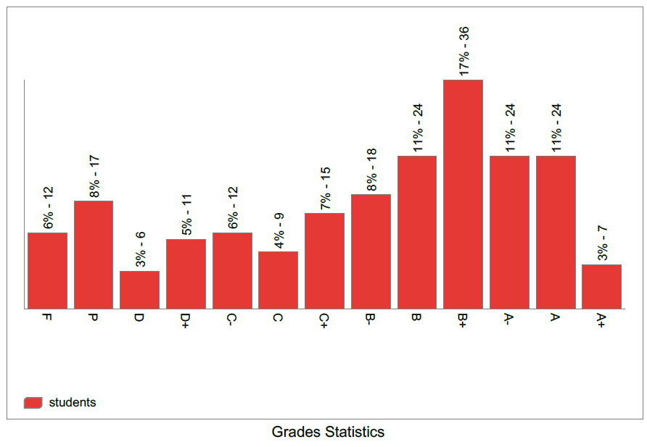

C- Professional Information

1- Course Teaching:
No | Course Content | Lectures | Lecturer
1 | Introduction, general discussion and new terminologies (time value of money) | 2 | Dr. Ghada E. Shedeed
2 | Simple, compound interest rates, payment types, equivalence, and cash flow diagram representation. | 2 | Dr. Ghada E. Shedeed
3 | Factors, effect of time and interest on money (F/P, P/F, P/A, A/P, F/A and A/F factors) | 2 | Dr. Ghada E. Shedeed
4 | Combining factors, shifted series and single cash flows | 2 | Dr. Ghada E. Shedeed
5 | Factors, effect of time and interest on money (P/G and A/G and Geometric gradient payments). | 2 | Dr. Ghada E. Shedeed
6 | Combining factors for shifted gradient. | 2 | Dr. Ghada E. Shedeed
7 | Nominal and effective interest rates (differences, terminologies, and different cases) | 2 | Dr. Nessren Zamzam
8 | Nominal and effective interest rates (continuous compounding) and introduction to evaluating alternatives. | 2 | Dr. Nessren Zamzam
9 | Evaluating Alternatives (present worth analysis using LCM and study periods) | 2 | Dr. Nessren Zamzam
10 | Evaluating Alternatives (Future worth and annual worth analysis) and Capitalized cost. | 2 | Dr. Nessren Zamzam
11 | Benefit and cost analysis for a single project, Incremental benefit and cost analysis for multiple projects | 2 | Dr. Nessren Zamzam
12 | Breakeven analysis for a single and multiple projects. | 2 | Dr. Nessren Zamzam

Lecture and tutorial Microsoft Teams, sample of recorded activities
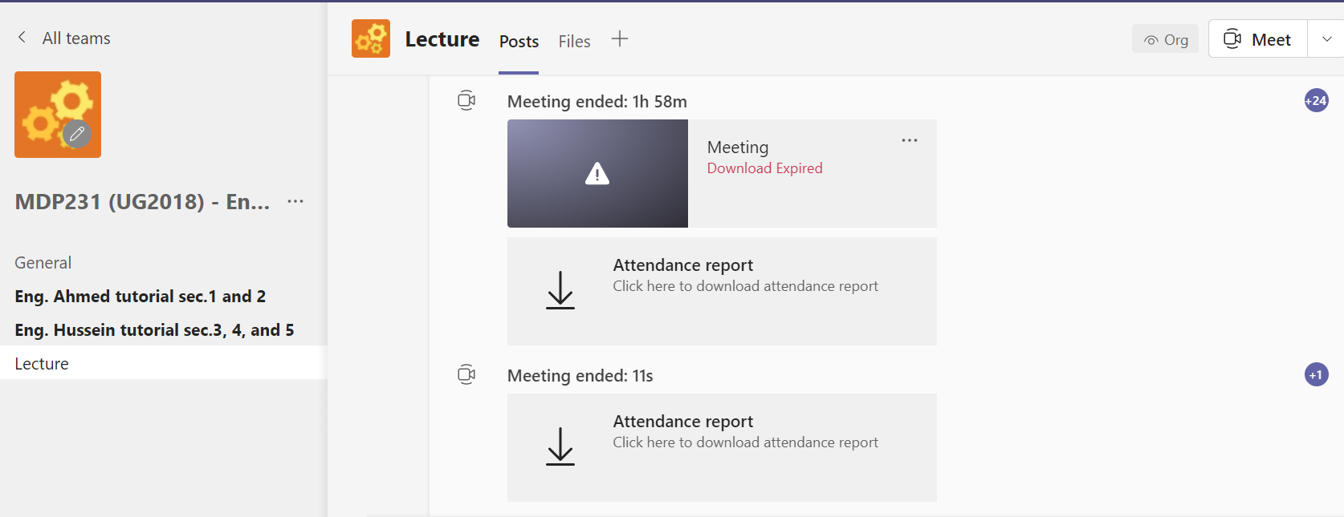
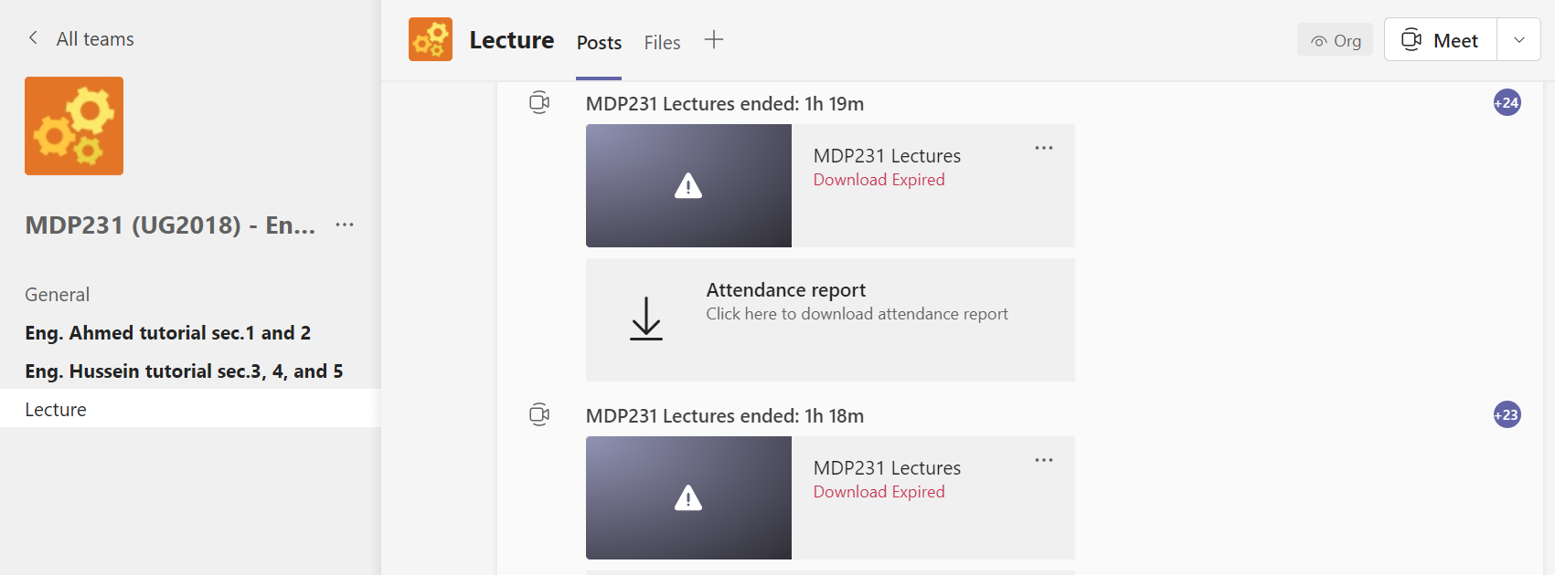
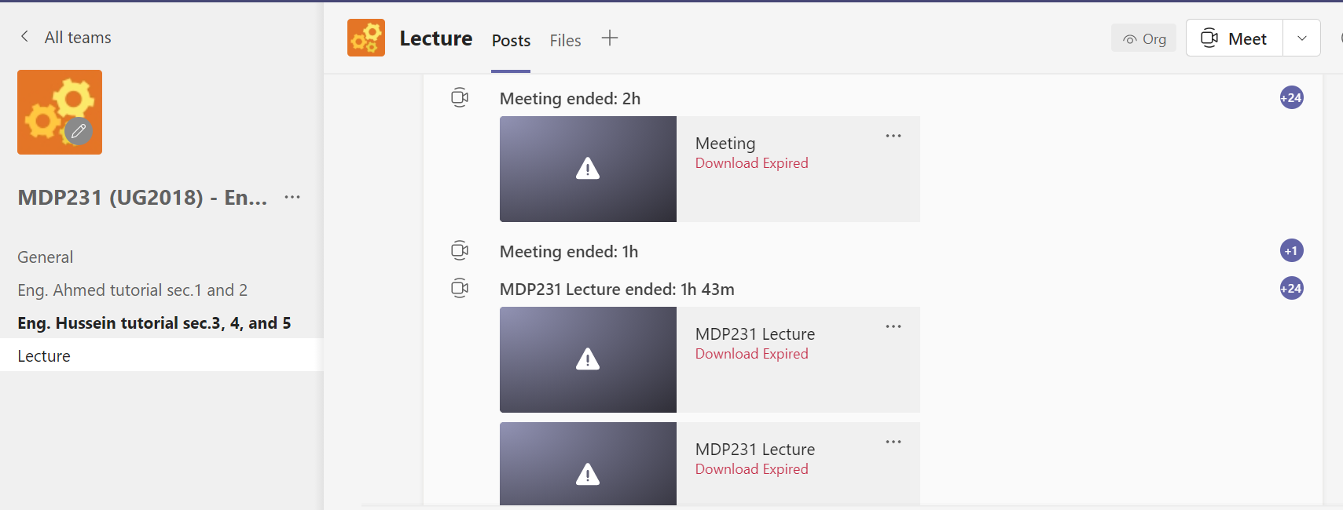
For more details, you can access the course team:
https://teams.microsoft.com/l/team/19%3a55a434e67bca4c468e7acecdbb1d2fe1%40thread.tacv2/conversations?groupId=eefe328d-515d-412e-8b87-abcd43d5d778&tenantId=ad2a8324-bef7-46a8-adb4-fe51b6613b24

Topics taught as a percentage of the content specified:
>90 % X 70-90 % <70% Reasons in detail for not teaching any topic

Due to COVID circumstances, this semester has been officially 13 weeks so last topics Payback, depreciation intro, ROR have not been given ……………………………………….

If any topics were taught which are not specified, give reasons in detail

N/A………………………………………………………………………………………….

Teaching and learning methods: Online Lectures: X Practical training/ laboratory:
Seminar/Workshop:
Online Class Activity: (Tutorials) X
Self-reading x

Interactive online sessions (lectures and tutorials) using Microsoft Teams, and video links to the recorded Microsoft videos beside using the LMS.

Other assignments/homework:

If teaching and learning methods were used other than those specified, list and give reasons:
………………………………………………………………………………………………

2- Student assessment:

Assessment method | No. | Description | Week no. | Weight
Assignments |  | (solving problems), participation, and report |  | 20
Exam | 1 | Sit-in Mid-term | 7 | 25
Written examination |  | Online Quizzes |  | 15
Exam | 1 | Final Exam |  | 40
Total |  |  |  | 100

Members of examination committee

Role of external evaluator

………………………………………………………………………………………….

3- Facilities and teaching materials:

Totally adequate

Adequate to some extent X

Inadequate

List any inadequacies

4- Administrative constraints:

List any difficulties encountered

5- Student evaluation of the course:
Positive feedback and all above 50%.
Response of Course Team

6- Comments from external evaluator(s): Response of course team

……… ………………. ……………… ………….

