Course report of

Quality Systems - MDP323 spring 2021

University: Ain Shams Faculty: Engineering

Basic Information
- Title and code :

Quality Systems - MDP323

- Programme on which the course is given :

B. Sc. Mechanical Engineering (Production Engineering)

- Year/ Level of programmes :
4th year, Second semester

  - Units/Credit Hours
( i ) Lecture :
30
30
60

( ii ) Tutorial /Practical : ( iii ) Total :

- Names of lecturers contributing to the delivery of the course :
  - -
Dr Nessren Mohamed Zamzam
--------------------------------
-------------------------------
-------------------------------
-------------------------------
-------------------------------
-------------------------------
-------------------------------

  - -
  - -
  - -
  - -
  - -
  - - viii -

Course coordinator: External evaluator:
Dr. Nessren Zamzam
---- ---- ----

Statistical Information
No. of students attending the course:
37

 |  | Number | Percentage (%)
Students completing the course
Results | Attend | 35 | 94.5%
Results | Absent | 2 | 5.5%
Grading Of successful students | Excellent | 18 | 48%
Grading Of successful students | Very Good | 11 | 29.7%
Grading Of successful students | Good | 5 | 13.5%
Grading Of successful students | Pass | 1 | 2%

Professional Information

1-- Course Teaching:

No | Course Content | lecture | tutorial | Total
1 | basic concepts: definition; terminology of the quality system | 2 | 2 | 4
2 | quality function | 4 | 4 | 8
3 | development and design of systems | 2 | 2 | 4
4 | quality policies and objectives | 4 | 4 | 8
5 | Quality planning | 4 | 4 | 8
6 | Organization for quality | 4 | 4 | 8
7 | Quality costs | 4 | 4 | 8
8 | Quality tools | 2 | 2 | 4
9 | Quality manual (didn’t teach) | 0 | 0 | 0
Total Hours |  | 26 | 26 | 52

- Snapshot of Microsoft team

https://teams.microsoft.com/l/channel/19%3a175eadb8e2054411866d18a9893a0060%40thread.tacv2/General?groupId=f381ab37-5d68-49df-9972-4a80e5f46c99&tenantId=ad2a8324-bef7-46a8-adb4-fe51b6613b24
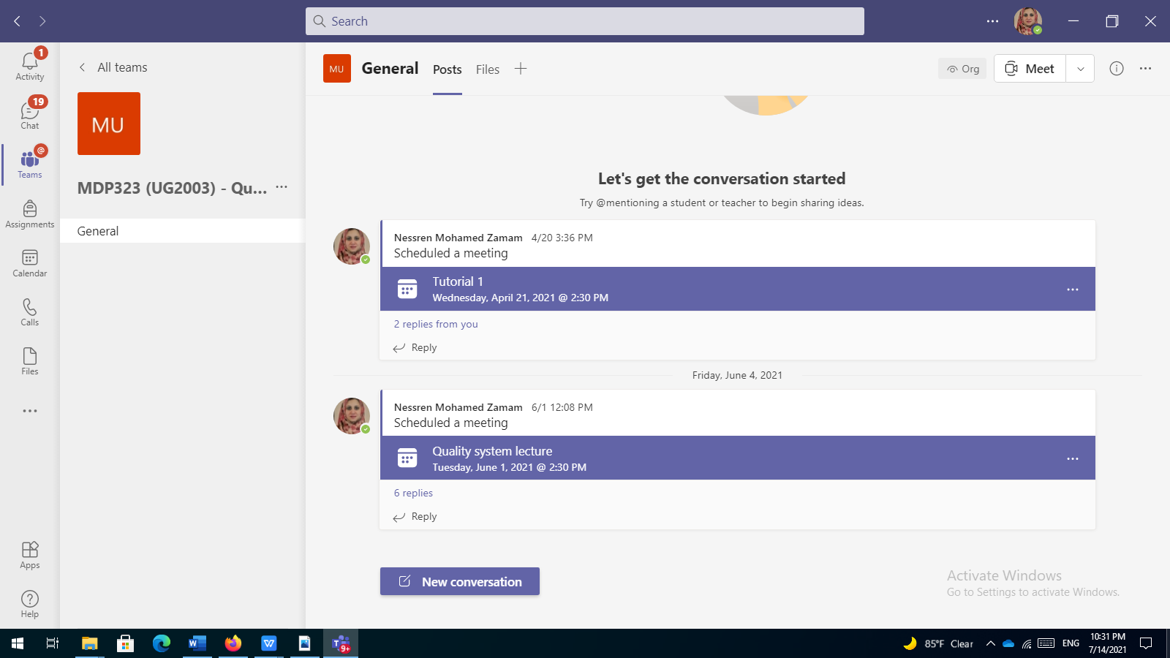

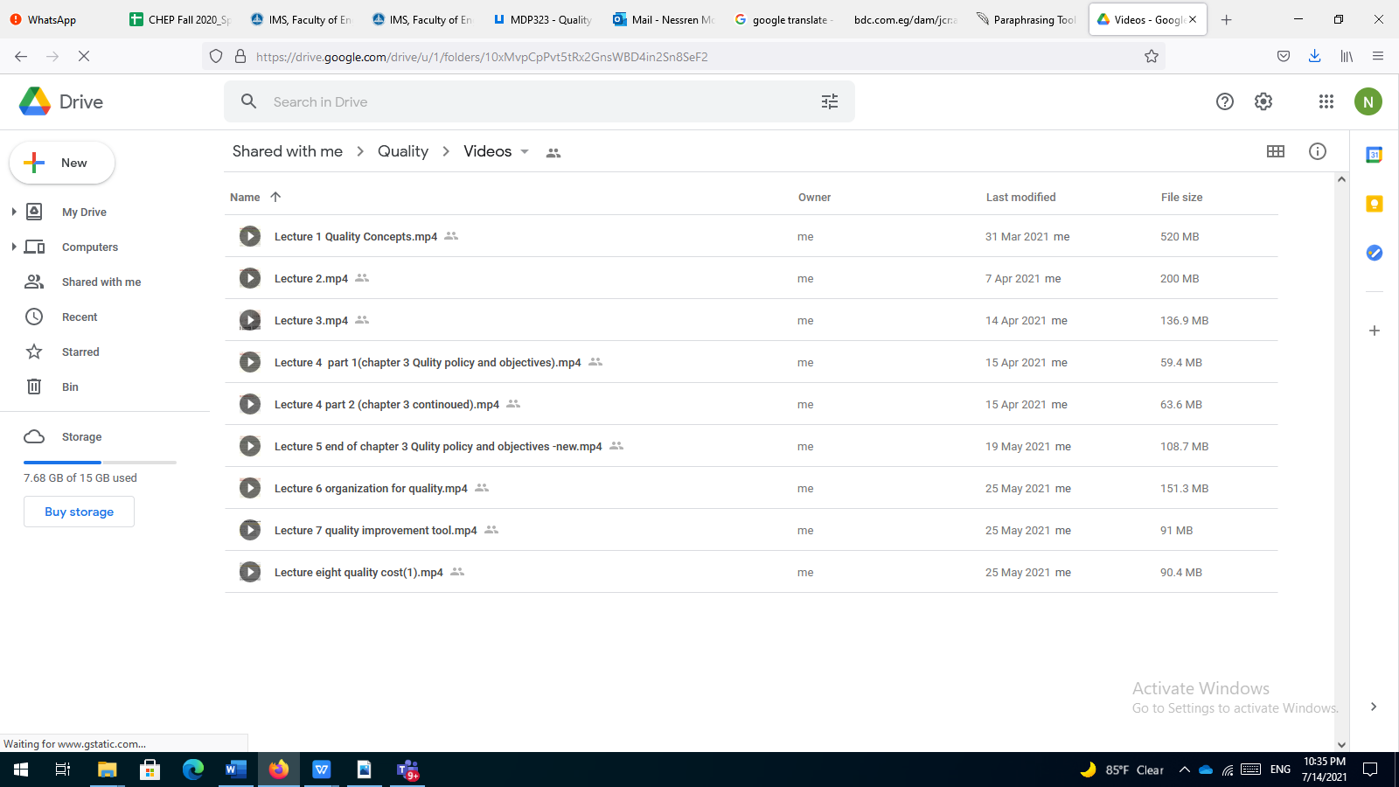

- Snap shot of LMS
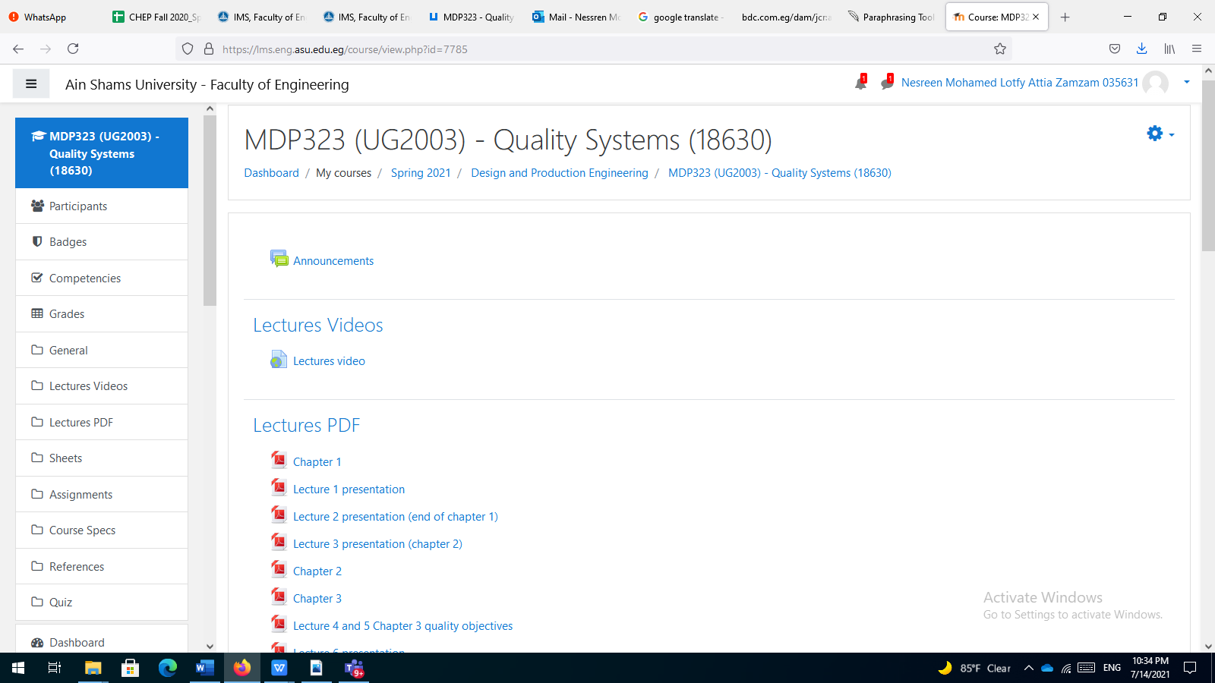
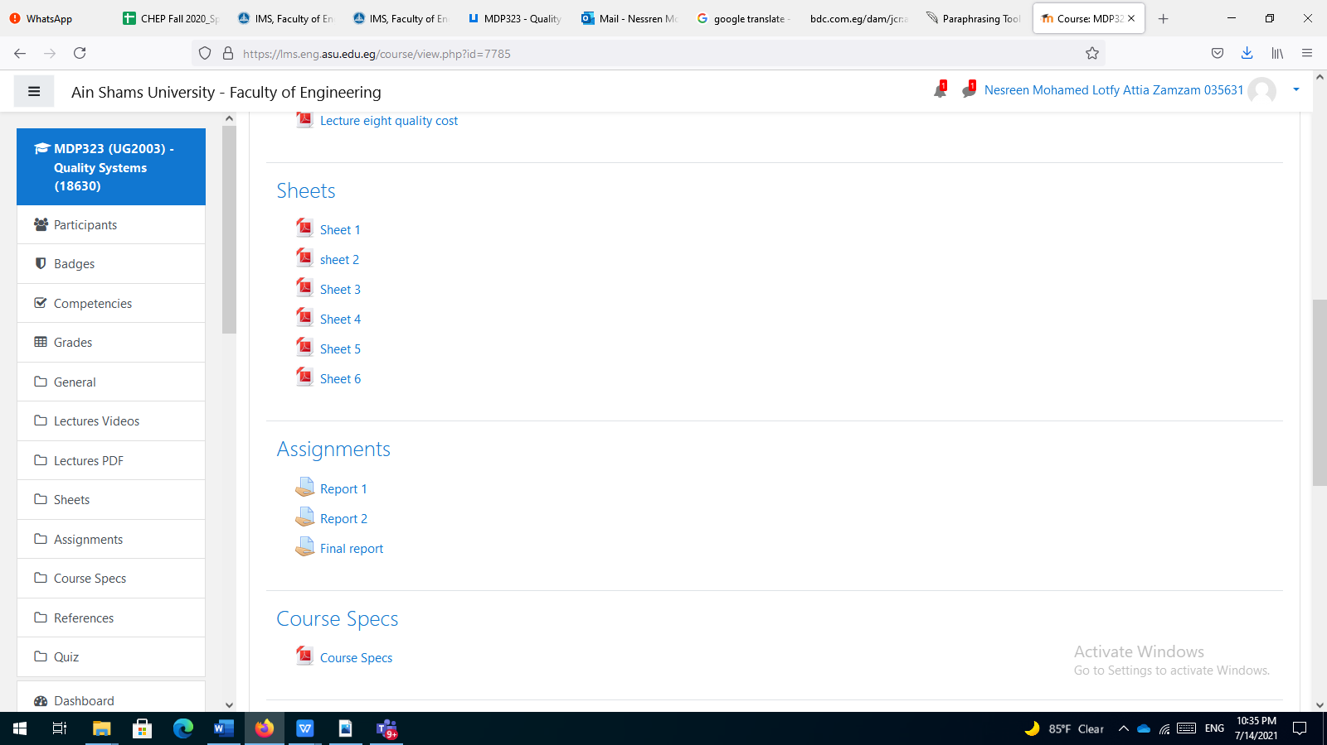

- Attendees list
Meeting Summary
Total Number of Participants | 29
Meeting Title | General
Meeting Start Time | 4/21/2021, 2:28:40 PM
Meeting End Time | 4/21/2021, 4:11:17 PM
Full Name | Join Time | Leave Time | Duration
Nessren Mohamed Zamam | 4/21/2021, 2:28:40 PM | 4/21/2021, 3:44:40 PM | 1h 15m
Ahmed Hazem Mohamed Sayed Ghanem 1700051 | 4/21/2021, 2:28:54 PM | 4/21/2021, 3:46:17 PM | 1h 17m
Hana Adel Zaki Orabi 1701654 | 4/21/2021, 2:29:00 PM | 4/21/2021, 3:45:29 PM | 1h 16m
Amr Mohamed Mostafa Hassan 17T0099 | 4/21/2021, 2:29:06 PM | 4/21/2021, 3:45:03 PM | 1h 15m
Mostafa shaker ibrahim lawendy 1701428 | 4/21/2021, 2:29:13 PM | 4/21/2021, 3:44:49 PM | 1h 15m
Hagar Mostafa GadAlla Mahmoud 1701622 | 4/21/2021, 2:29:34 PM | 4/21/2021, 3:44:44 PM | 1h 15m
Kholoud Hamdy Mohammed 1600515 | 4/21/2021, 2:30:59 PM | 4/21/2021, 3:44:49 PM | 1h 13m
Ahmad Mohamed Salah Mohamed Shaheen 1700175 | 4/21/2021, 2:30:59 PM | 4/21/2021, 3:44:45 PM | 1h 13m
Khaled Abdelbasset Mohamed Ibrahim 1700478 | 4/21/2021, 2:31:19 PM | 4/21/2021, 3:44:44 PM | 1h 13m
Martina emad beshay 1701078 | 4/21/2021, 2:31:34 PM | 4/21/2021, 3:44:52 PM | 1h 13m
Martina emad beshay 1701078 | 4/21/2021, 3:47:12 PM | 4/21/2021, 3:47:18 PM | 6s
Fadwa alaa thabet elias 1700977 | 4/21/2021, 2:31:53 PM | 4/21/2021, 3:32:53 PM | 1h
Fadwa alaa thabet elias 1700977 | 4/21/2021, 3:34:57 PM | 4/21/2021, 3:44:45 PM | 9m 47s
Reem Khaled Mohamed Ahmed 1700549 | 4/21/2021, 2:32:00 PM | 4/21/2021, 2:54:14 PM | 22m 13s
Reem Khaled Mohamed Ahmed 1700549 | 4/21/2021, 3:20:44 PM | 4/21/2021, 3:21:39 PM | 54s
Muhammad Fathi Abdul Majeed Shaaban Hajar 1701265 | 4/21/2021, 2:32:06 PM | 4/21/2021, 2:33:22 PM | 1m 16s
Muhammad Fathi Abdul Majeed Shaaban Hajar 1701265 | 4/21/2021, 2:56:43 PM | 4/21/2021, 3:18:52 PM | 22m 9s
Abd el Rahman Essam Hussin Ismail 1700749 | 4/21/2021, 2:32:18 PM | 4/21/2021, 3:44:43 PM | 1h 12m
Mohamed Ashraf Abdalla Mohamed 17E0067 | 4/21/2021, 2:33:25 PM | 4/21/2021, 3:44:52 PM | 1h 11m
Salah Abdel-Moneim Abdel-Aziz Mohamed 1700697 | 4/21/2021, 2:35:13 PM | 4/21/2021, 3:26:46 PM | 51m 33s
Salah Abdel-Moneim Abdel-Aziz Mohamed 1700697 | 4/21/2021, 3:30:52 PM | 4/21/2021, 3:44:44 PM | 13m 51s
Omar fares eid yehia 17E0166 | 4/21/2021, 2:35:17 PM | 4/21/2021, 3:44:50 PM | 1h 9m
Omar fares eid yehia 17E0166 | 4/21/2021, 3:51:33 PM | 4/21/2021, 3:51:39 PM | 5s
Youssef Shawky Abd-Ellatif Khalil 1701726 | 4/21/2021, 2:35:26 PM | 4/21/2021, 3:44:43 PM | 1h 9m
Ahmed Fekry Salah Abdel-Rahman 1700141 | 4/21/2021, 2:36:33 PM | 4/21/2021, 3:20:35 PM | 44m 2s
Ahmed Fekry Salah Abdel-Rahman 1700141 | 4/21/2021, 3:22:57 PM | 4/21/2021, 3:45:03 PM | 22m 5s
Kirollos Nabil Mounir Ekladious 1701035 | 4/21/2021, 2:36:37 PM | 4/21/2021, 3:45:19 PM | 1h 8m
Bassam Alaa El-Din Abdel-Azim Abbas 1700361 | 4/21/2021, 2:37:49 PM | 4/21/2021, 3:06:27 PM | 28m 37s
Bassam Alaa El-Din Abdel-Azim Abbas 1700361 | 4/21/2021, 3:08:35 PM | 4/21/2021, 3:46:03 PM | 37m 27s
Abanoub Alkess Abram Abdelsayed Abdelmasseh 17T0319 | 4/21/2021, 2:37:59 PM | 4/21/2021, 3:44:46 PM | 1h 6m
Mohamed Said Mostafa Saad 15T0145 | 4/21/2021, 2:38:08 PM | 4/21/2021, 2:47:36 PM | 9m 27s
Philopateer Nagy Fakhri Georgie 1700996 | 4/21/2021, 2:39:07 PM | 4/21/2021, 3:45:19 PM | 1h 6m
Noura Gouda Mohamed Soliman Ahmed 1701594 | 4/21/2021, 2:39:24 PM | 4/21/2021, 3:44:53 PM | 1h 5m
Basil Hossam Saad Ahmed 1700352 | 4/21/2021, 2:41:54 PM | 4/21/2021, 3:49:54 PM | 1h 7m
1700908 | 4/21/2021, 2:46:38 PM | 4/21/2021, 3:38:49 PM | 52m 10s
Omar Ismail Abd Elbaky Abo Kahf 18X0041 | 4/21/2021, 2:53:56 PM | 4/21/2021, 3:44:59 PM | 51m 3s
Omar shokry mahmoud mohamed 1700876 | 4/21/2021, 2:59:21 PM | 4/21/2021, 4:11:17 PM | 1h 11m

Topics Taught as a percentage of the content specified
>90% 70% - 90% <70 %

Reasons in detail for not teaching any topic

The last topics “quality manual” hadn’t been taught as a result of the short period of study from 15 weeks to 13 weeks

If any topics were taught which are not specified, give reasons in detail

----- ------ ------ ------ ------ ------ ------ ------ ------ ------ ----

  - Teaching and learning methods:
Online Lectures: X Practical training/ laboratory:
Seminar/Workshop:
Online Class Activity: (Tutorials) X
Self-reading

Interactive online sessions (lectures and tutorials) using Microsoft Teams, and video links to the recorded Microsoft videos beside using the LMS.

Case Study:

Other assignments/homework
If teaching and learning methods were used other than, those specified, list and give reasons

.
  - Student assessment:

Assessment method | Description | Weight (%)
Assignment | 3 reports | 16%
Quiz | Quiz1 and 2 | 14%
Written exam | Final exam | 70%
100%

Members of examination committee
Dr Nessren Zamzam
Role of external evaluator:
------ ------ ------ ------ ------ ------

  - Facilities and teaching materials:

Totally adequate

Adequate to some extent

Inadequate

List any inadequacies:

------ ------ ------ ------ ------ ------ ------ ------ ------ ------ -
----- ------ ------ ------ ------ ------ ------ ------ ------ ------ --
---- ------ ------ ------ ------ ------ ------ ------ ------ ----

  - Administrative constraints:

------ ------ ------ ------ ------ ------ ------ ------ ------ ------ ------ -
----- ------ ------ ------ ------ ------ ------ ------ ------ ------ ------ ---
--- ------ ------ ------ ------ ------ ------ ------ ------ ------ ------ -----
- ------ ------ ------ ------ ------ ------ ------ ------ ------ ------ ------
------ ------ ------ ------ ------ ------ ----

  - Student evaluation of the course:

There is no negative feedback for this course

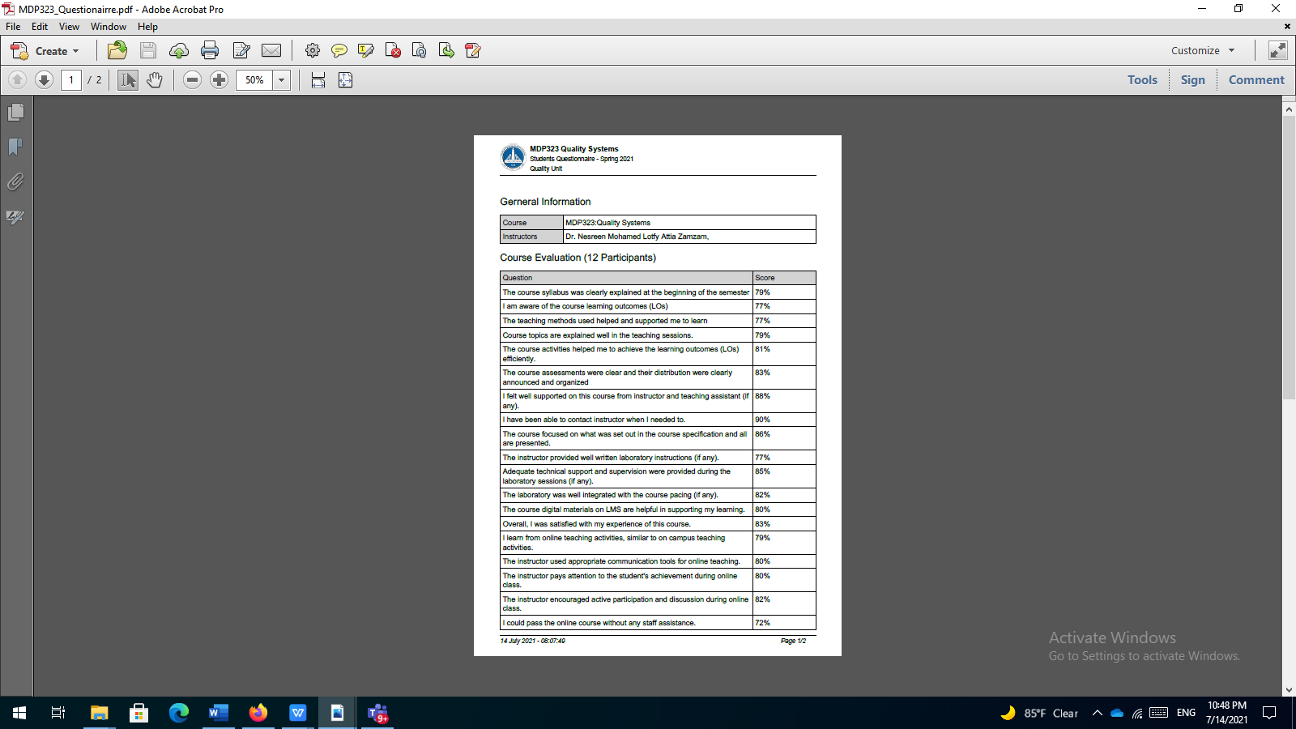
  - Comments from instructors:

48% of the students got A and this is due to

- The small size of the number of the students facilitate the interaction between the students and me, it was easy to determine any confusing topics and repeat any misunderstood part.
- The nature of the course as it doesn’t contain any complicated mathematical formula or complex problems

  - Course enhancement: Progress on actions identified in the previous year’s action plan:

This year most of the course was taught online due to Covid 19, enhancement for the students activities and for the lectures are required

