Course report of
Fundamentals of Engineering– ENG011– Fall 2020
University: Ain Shams | Faculty: Engineering

Basic Information
- Title and code :
Fundamentals of Engineering– ENG011
- Program on which the course is given :
All Programs

- Year/Level of program :
1st Level
- Units/Credit Hours
( i ) Lecture : | 2

( ii ) Tutorial/Practical : | 1+0

( iii ) Total : | 3
- Names of lecturers contributing to delivery of the course :
i - | Prof. Moussa ElSaied  Dr. Ismail Hafez Dr. Micha

ii - | Dr Shaimaa Fathy
iii -
iv -

Course coordinator: | Dr Samy Afifi

External evaluator: | --- --- ---

Statistical Information

F | P | D | D+ | C- | C | C+ | B- | B | B+ | A- | A | Grade
56 | 17 | 25 | 21 | 17 | 13 | 21 | 49 | 45 | 54 | 14 | 2 | No. of students

Professional Information

Course Teaching:
Week | Course Content | Total | Lecturer
1 | Introduction to Fundamentals of Engineering | 3 | All Lecturers
2 | The Engineering Approach to Problem Solving | 3 | All Lecturers
3 | Effective Study & Career Exploration | 3 | All Lecturers
4 | Engineering Ethics and Critical Thinking | 3 | All Lecturers
5 | International System of Units & Mathematical Branches | 3 | All Lecturers
6 | General Disciplines (I) Introduction * | 3 | All Lecturers
7 | General Specialization (I) Simple applications ** | 3 | All Lecturers
8 | General Disciplines (II) Introduction * | 3 | All Lecturers
9 | General Specialization (II) Simple applications ** | 3 | All Lecturers
10 | General Disciplines (III) Introduction * | 3 | All Lecturers
11 | General Specialization (III) Simple applications ** | 3 | All Lecturers
12 | General Disciplines (IV) Introduction * | 3 | All Lecturers
13 | General Specialization (IV) Simple applications ** | 3 | All Lecturers

Topics taught as a percentage of the content specified:

>90 % X 70-90 % <70%

Reasons in detail for not teaching any topic
NA

Teaching and learning methods:
Asynchronous and Synchronous (Online) Lectures: X
Online Assignments: X
Technical Reports:
x
Distance Class Activity: (Tutorials) X

All methods were Distance Learning based.
Link for Course Team: https://teams.microsoft.com/l/team/19%3a24351ebd21c14a29bccd16fa5c3fe8af%40thread.tacv2/conversations?groupId=fc332d44-bdf3-4e6c-9268-e7c0ed693c76&tenantId=ad2a8324-bef7-46a8-adb4-fe51b6613b24

Case Study:
Other assignments/homework: NA
If teaching and learning methods were used other than those specified, list and give reasons:

Student assessment:
Method of assessment | Percentage of total
Written examinations (final + midterm) | 65 %
Oral examination | 0 %
Practical/laboratory work | 0%
Other assignments/class work | 35 %

Members of examination committee
i – Dr Mohamed El Banna
ii- Dr Samy Afifi

Role of external evaluator
N/A………………………………………………………………………………………….

Facilities and teaching materials:
x
Totally adequate

Adequate to some extent
Inadequate

List any inadequacies

Administrative constraints:
List any difficulties encountered
No difficulties

Student evaluation of the course:
Question | Score
The course syllabus was clearly explained at the beginning of the semester | 82%
I am aware of the course learning outcomes (ILOs). | 79%
The teaching methods used helped and supported me to learn | 79%
Course topics are explained well in the teaching sessions. | 75%
The course activities helped me to achieve the learning outcomes (ILOs) efficiently. | 79%
The course assessments were clear and their distribution were clearly announced and organized. | 79%
I felt well supported on this course from instructor and teaching assistant (if any). | 75%
I have been able to contact instructor when I needed to. | 61%
The course focused on what was set out in the course specification and all are presented. | 78%
The instructor provided well written laboratory instructions (if any). | 79%
Adequate technical support and supervision were provided during the laboratory sessions (if any). | 71%
The laboratory was well integrated with the course pacing (if any). | 75%
The course digital materials on LMS are helpful in supporting my learning. | 72%
Overall, I was satisfied with my experience of this course. | 79%
I learn from online teaching activities, similar to on campus teaching activities. | 59%
The instructor used appropriate communication tools for online teaching. | 71%
The instructor pays attention to the student's achievement during online class. | 69%
The instructor encouraged active participation and discussion during online class. | 71%
I could pass the online course without any staff assistance. | 57%
The instructor respected to start / finish online lectures on scheduled times | 75%

Small Sample
Written comments: One refused the distance learning, the other one is on the contrary and much appreciate this approach.

Response of Course Team

Comments from external evaluator(s): Response of course team
………N/A ………………. …………………………….

Link to MS Teams:
https://teams.microsoft.com/l/team/19%3a24351ebd21c14a29bccd16fa5c3fe8af%40thread.tacv2/conversations?groupId=fc332d44-bdf3-4e6c-9268-e7c0ed693c76&tenantId=ad2a8324-bef7-46a8-adb4-fe51b6613b24
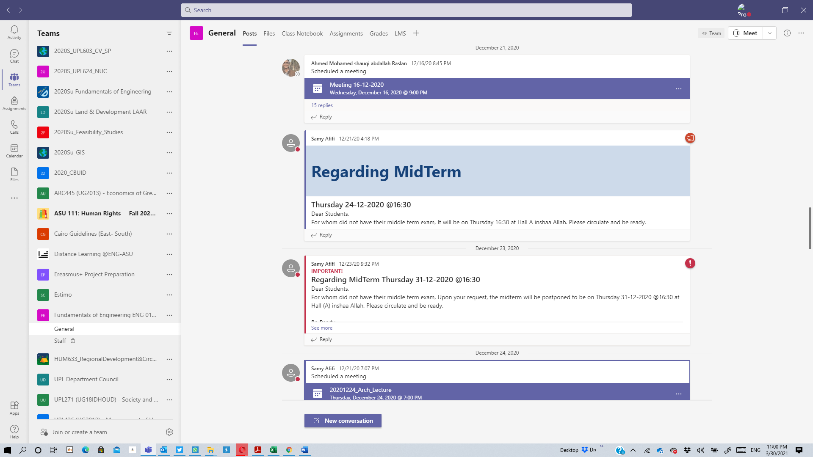
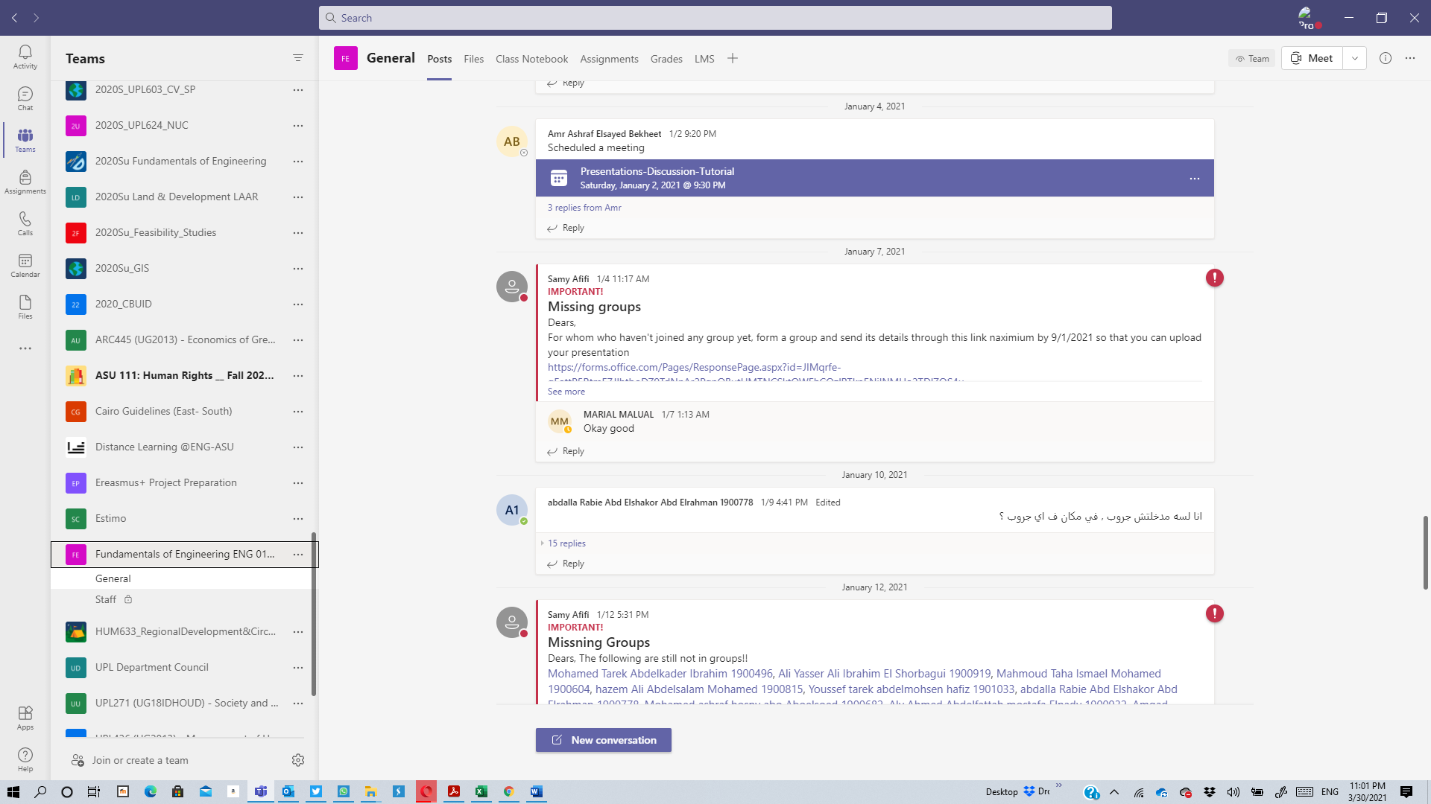

Videos Samples
Lectures (Synchronous)
https://web.microsoftstream.com/video/684a7b48-5903-4eb4-ad15-691b5c2a21e5
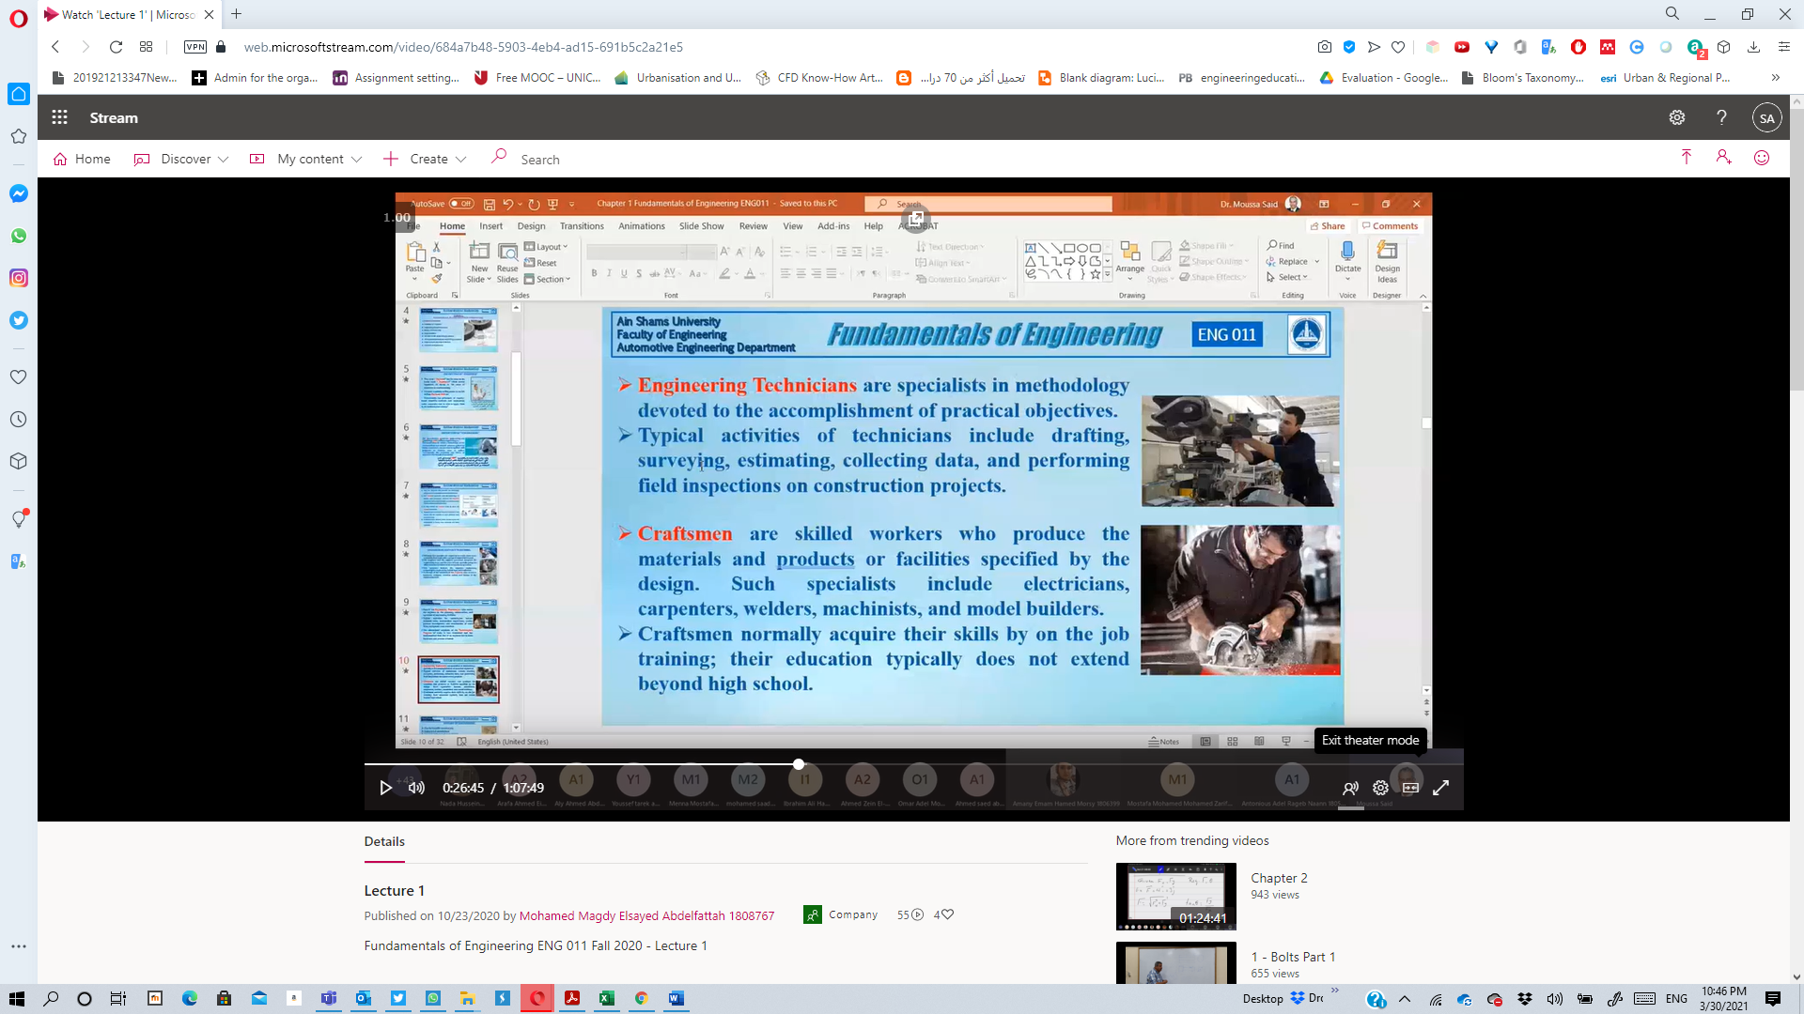
https://web.microsoftstream.com/video/50ba4532-e1b3-47d1-a42b-295dbed2c7cf
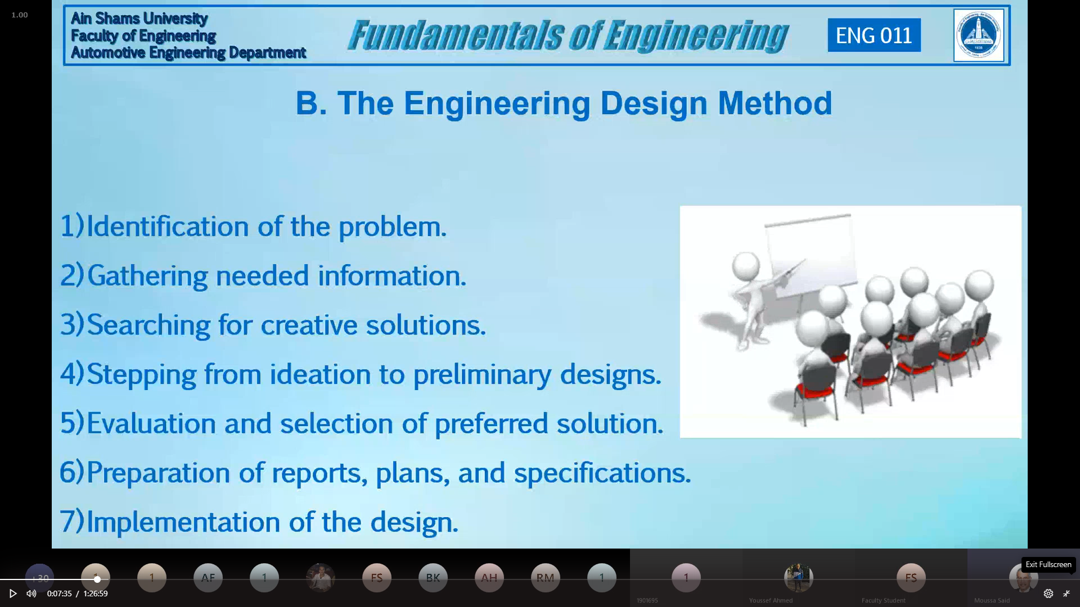

Lectures (Asynchronous)
https://www.youtube.com/watch?v=qWdtJkAMaPY&ab_channel=MohamedAnwar
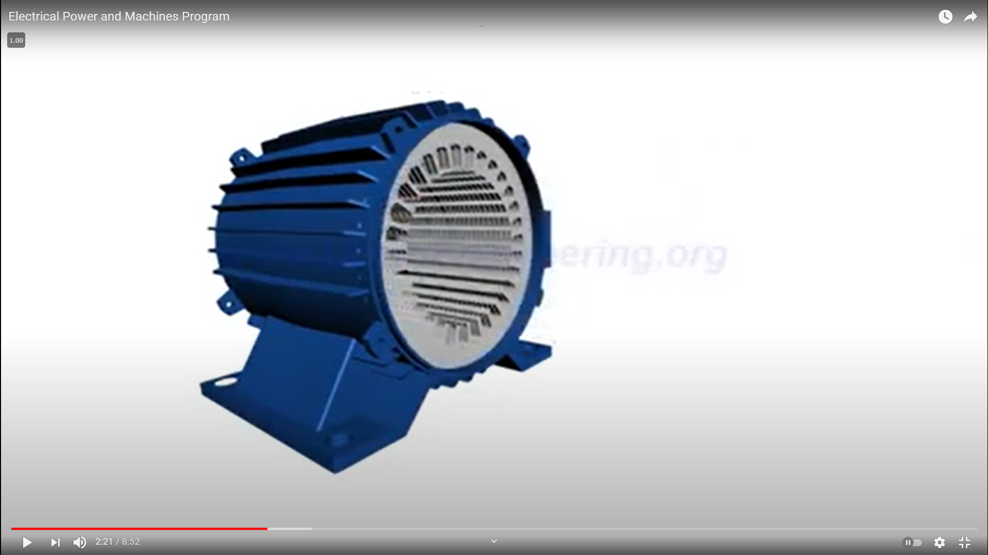

Tutorial
https://web.microsoftstream.com/video/b8bf3034-8621-42b1-8b85-dd8af3ac93c3
