A. Basic Information
- Title and Code: | Manufacturing Technology (3) – MDP 321
- Program in which the course is given: | Design and Production Engineering
- Year/ Level of program | Spring 2021 - Sophomore
- Units/ Credit Hours  - Lecture  - Tutorial  - Lab  - Total | 4 hrs. per week  1 hr. per week  2 hrs. per week  7 hrs. per week
- Lecture:
- Names of Lecturers contributing to the delivery of the course: | Prof. Mohamed Hazem Abdellatif  Prof. Ahmed Moneed  Dr. Mohamed Adel Rizk  Dr. Mahmoud Zakaria
- Course coordinator: | Prof. Ahmed Moneeb
- External Evaluator:

B. Statistical Information
No. of students attending the course | 37

 |  | Number | Percentage/Attendee
Students completing the course |  | 37 | 100%
Results | Passed | 28 | 75.68%
Results | Failed | 9 | 24.32%
Grading of students | Excellent | 3 | 8.1%
Grading of students | Very Good | 10 | 27%
Grading of students | Good | 8 | 21.6%
Grading of students | Pass | 7 | 18.9%
Grading of students | Weak | 6 | 16.2%
Grading of students | Very Weak | 1 | 2.7%
Grading of students | Abscent | 2 | 5.5%

C. Professional Information
- Course Teaching
- Lectures:
Week | Topics | Lecture hours | Lecturer
1 | General Machining Types | 4 | Prof. Mohamed Hazem Abdellatif  Prof. Ahmed Moneed  Dr. Mohamed Adel Rizk  Dr. Mahmoud Zakaria
2 | Tolerances and Allowances | 4
3 | Capstan and Turret Lathes | 4
4 | Milling Operations | 4
5 | Gear Cutting Operations | 4
6 | Grinding Operations | 4
7 | Electrochemical and electro-discharge machining | 4
8 | Introduction to Forming Processes | 2
9 | Forging Processes | 2
10 | Roll Pass Design | 2
11 | Extrusion Processes | 2
12 | Drawing Processes | 2
13 | Forming methods for polymers | 4
14 | High energy rate forming processes | 6
15 | Powder metallurgy & Ceramic and composite materials | 6
 | TOTAL | 60
- Tutorials:
Week | Exercise | Tutorial hours | Lab | Instructor
1 | Tolerances and Allowances | 3 |  | Prof. Mohamed Hazem Abdellatif  Prof. Ahmed Moneed  Dr. Mohamed Adel Rizk  Dr. Mahmoud Zakaria  Eng. Bassant Hany
2 | Capstan and Turret Lathes |  | 6
3 | Milling Operations |  | 3
4 | Gear Cutting Operations |  | 6
5 | Grinding Operations |  | 3
7 | Introduction to Forming Processes | 3
8 | Forging Processes |  | 3
9 | Roll Pass Design | 3
10 | Extrusion Processes |  | 3
11 | Drawing Processes
13 | High energy rate forming processes | 3
14 | Powder metallurgy | 3
15 | Ceramic and composite materials |  | 3
 | TOTAL | 15 | 30

Due to COVID-19, the lectures were taught 50% face-to-face and 50% online using Microsoft Teams platform. The labs and tutorials were taught physical in the campus.
Microsoft Teams link
https://teams.microsoft.com/_?culture=en-us&country=US&lm=deeplink&lmsrc=homePageWeb&cmpid=WebSignIn#/school/conversations/General?threadId=19:d3dbbdb0a92e42868f09efb7554f4ad4@thread.tacv2&ctx=channel
LMS link
https://lms.eng.asu.edu.eg/course/view.php?id=7702

Topics Taught as a percentage of the content specified

Reasons in detail for not teaching any topic
If any topics were taught which are not specified, give reasons in detail
- Teaching and learning methods:

Case Study:
Other assignments/homework:

- Student assessment:

Assessment method |  | Week No | Weight (%)
Assignments |  | 2-10 | 5
Quizzes |  | 4,10 | 5
Midterm Exam |  | 7 | 15
Oral Exam |  | 14 | 15
Final Exam |  | 15 | 60
100%

Members of examination committee: 1- Prof. Mohamed Hazem Abdellatif
2- Prof. Ahmed Moneeb
3- Dr. Mohamed Adel Rizk
4- Dr..Mahmoud Zakaria

Role of external evaluator:
- Facilities and teaching materials:
List any inadequacies:
- Administrative constraints:
- Comments from external evaluator(s)
Comment | Response of course Team
- Course enhancement: Progress on actions identified in the previous year’s action plan:
Action plan

Action required | Completion date | Person responsible

- Questionnaire statistics:
Student evaluation of the course:
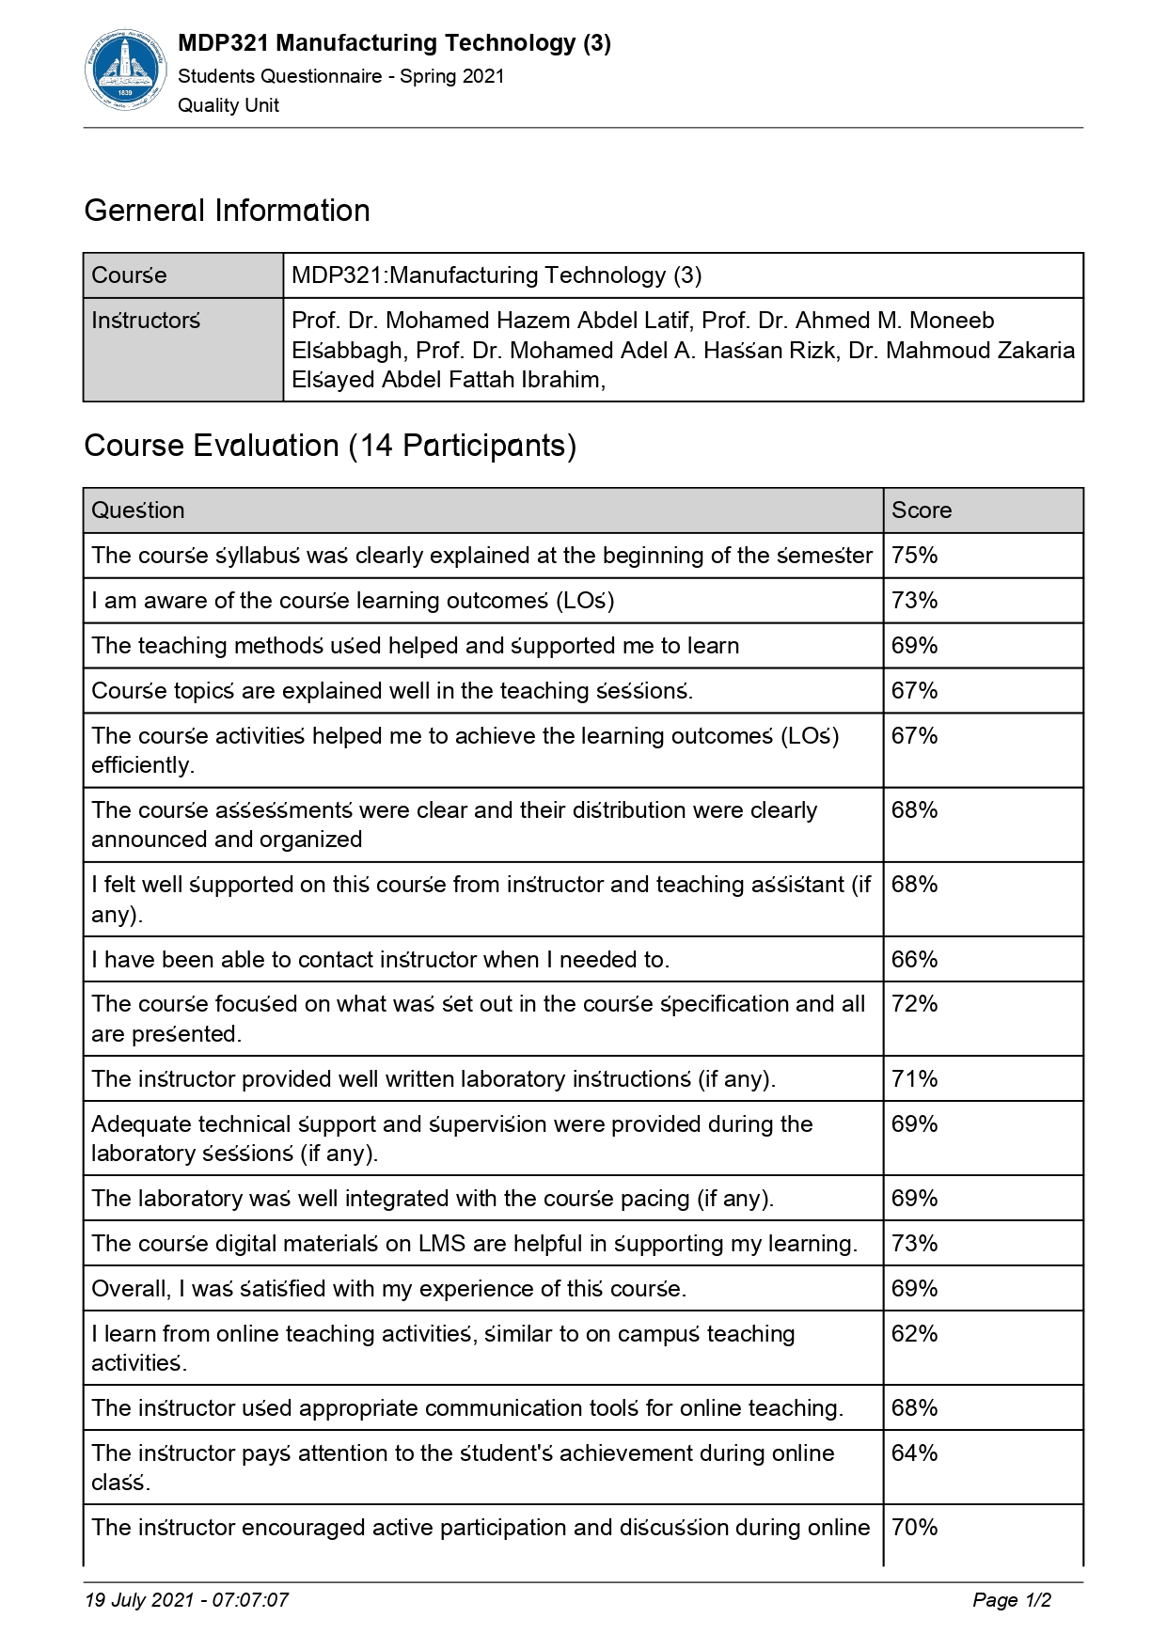
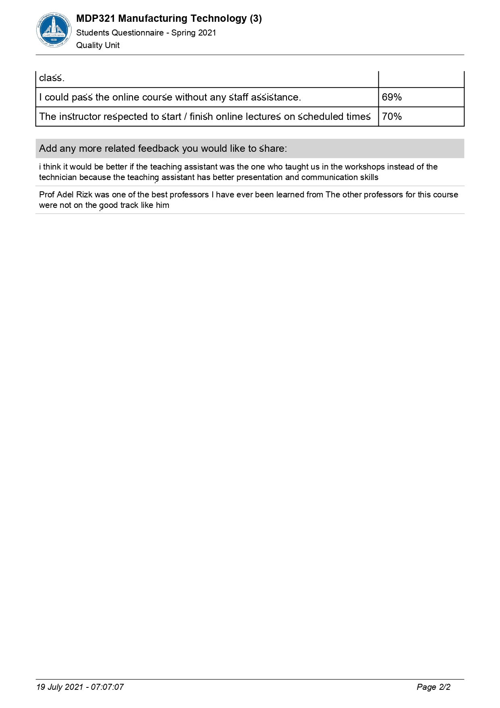

- Feedback:
No item in the students’ questionnaire is below 50%.

