Course report of
Computing in Engineering – CSE031 – Summer 2020
University: Ain Shams | Faculty: Engineering

Basic Information
- Title and code :
Computing in Engineering – CSE031
- Program on which the course is given :
General

- Year/Level of programs :
Prep. Year
- Units/Credit Hours
( i ) Lecture : | 2

( ii ) Tutorial/Practical : | 0

( iii ) Total : | 0
- Names of lecturers contributing to delivery of the course :
 | Dr. Mohamed Taher
 | Dr.Hesham Mahmoud Farag
 | Dr. Manal Mourad Zaki
 | Dr. Hassan Shehatah Bedor
i - | Dr. Sahar Haggag

Course coordinator: | Dr. Mohamed Taher

External evaluator: | N/A

Statistical Information
No. of students attending the course: | 1820
 |  | Number | Percentage (%)
No. of students completing the course |  | 1820 | 100.00%
Results | Passed | 1532 | 84.18%
Results | Failed | 288 | 15.82%
Grading of successful students | A+ | 0 | 0.00%
Grading of successful students | A | 12 | 0.66%
Grading of successful students | A- | 67 | 3.68%
Grading of successful students | B+ | 182 | 10.00%
Grading of successful students | B | 232 | 12.75%
Grading of successful students | B- | 240 | 13.19%
Grading of successful students | C+ | 174 | 9.56%
Grading of successful students | C | 181 | 9.95%
Grading of successful students | C- | 134 | 7.36%
Grading of successful students | D+ | 136 | 7.47%
Grading of successful students | D | 174 | 9.56%

Professional Information

Course Teaching:
Week | Course Content | Lecture  Hours
1 | The components of a computer system | 4
2 | Data representation | 4
3 | Computer networks | 4
4 | Problem solving using computational techniques | 4
5 | Relational Database | 4
6 | Cloud Computing | 2
7 | Internet of things (IOT) | 2
8 | Virtual reality | 2
9 | Big Data | 2
Total Number of Hours |  | 28

Topics taught as a percentage of the content specified:

>90 % 70-90 % <70%

Reasons in detail for not teaching any topic
All topics were taught

If any topics were taught which are not specified, give reasons in detail
N/A

Teaching and learning methods:
On-Line Lectures:
Practical training/ laboratory:
Seminar/Workshop:
Class Activity: (Tutorials)
Microsoft teams was used to conduct on-line lectures and pop quizzes.
Two quizzes were elected to b graded, others were just like opendiscussion
Mid term exam was conducted using LMS and marked automatically
Assignments were announced and student response were via the LMS
Final Exam as a written exam.
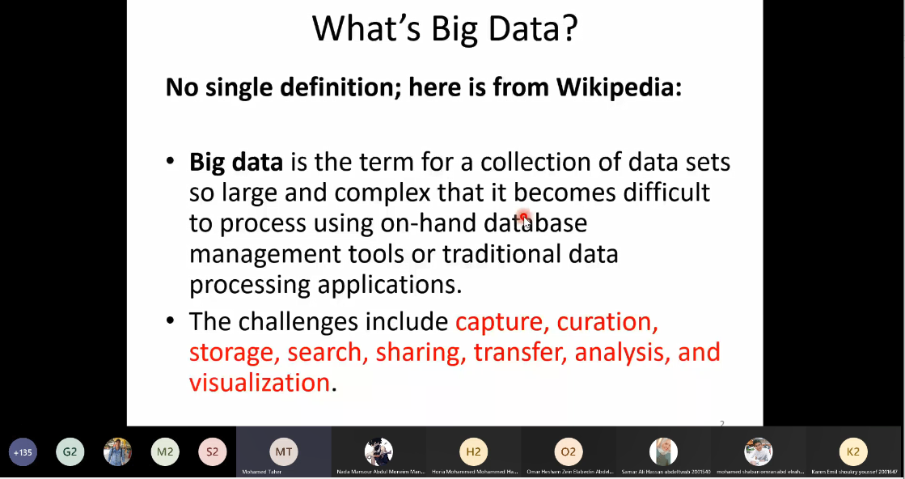

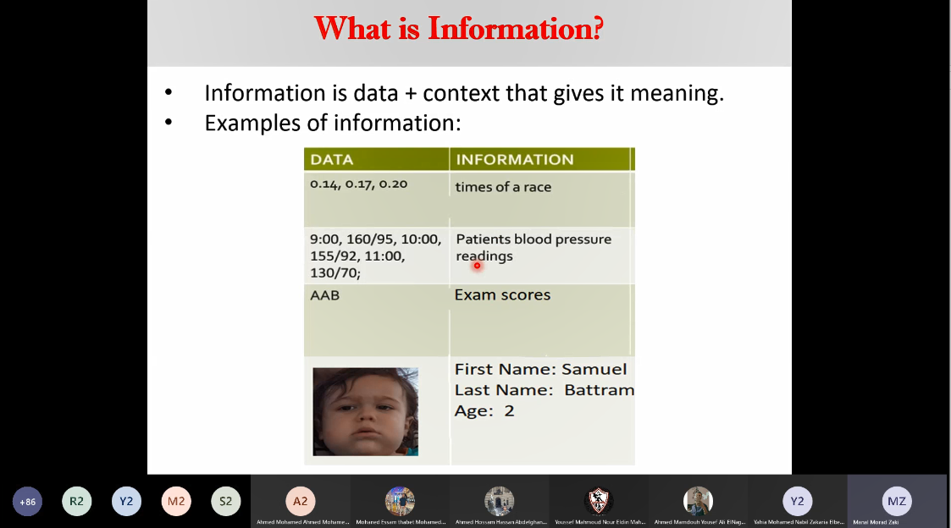

Case Study:
Other assignments/homework:
If teaching and learning methods were used other than those specified, list and give reasons:
………………………………………………………………………………………………
………………………………………………………………………………………………

Student assessment:
Method of assessment | Percentage of total
Written examination | 60 %
Midterm examination | 25 %
Quizzes | 15 %

Members of examination committee
Dr. Mohamed Taher
Dr.Hesham Mahmoud Farag
Dr. Manal Mourad Zaki
Dr. Hassan Shehatah Bedor
Dr. Sahar Haggag

Role of external evaluator
N/A………………………………………………………………………………………….

Facilities and teaching materials:
Totally adequate

Adequate to some extent

Inadequate

List any inadequacies

Administrative constraints:
List any difficulties encountered
No difficulties

Student evaluation of the course:
Atached

Comments from external evaluator(s): Response of course team
………N/A ……………….

