Course report of

Probability and Statistics - PHM 111s Spring 2021

University Ain Shams | Faculty Engineering

A- Basic Information

Title and code:

Probability and Statistics - PHM 111s Spring 2021

Program(s) on which this course is given:

All 12 Engineering Programs
3. Year/ Level of programs: 1st year – Level 1

1. Units/Credit hours:

Lectures 2 hours per week

Tutorial/Practical 2 hours per week

Total 4 hours per week

2. Names of lecturers contributing to the delivery of the course

Dr. Rabab Moustafa El-Hassani

Course coordinator: Dr. Rabab Moustafa El-Hassani
External evaluator ………N/A……………………

B- Statistical Information

No. of students attending the course: 218

Grade | A+ | A | A- | B+ | B | B- | C+ | C | C- | D+ | D | P | F | Sum
Students No. | 0 | 0 | 2 | 5 | 9 | 14 | 10 | 19 | 15 | 12 | 32 | 48 | 52 | 218
Percentage | 0 | 0 | 1 | 2 | 4 | 6 | 5 | 9 | 7 | 6 | 15 | 22 | 24 | 100%

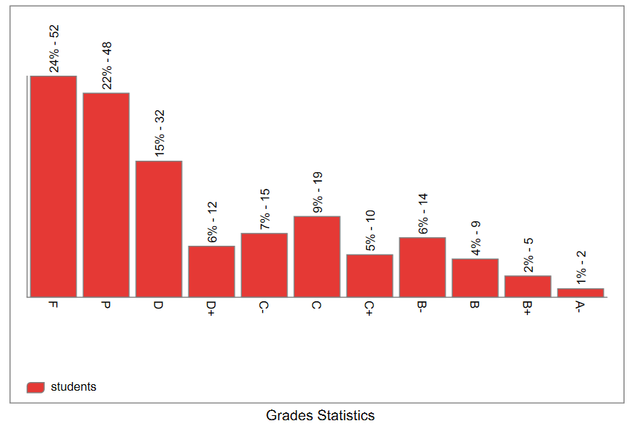

C- Professional Information

C.1 – Course Lectures

Teaching using Online Learning tools
Course Content (Part I) | Session Type  (Zoom, Team) | Lecture  Hours | Lecturer
The Nature of Probability and Statistics: Data Collection and Sampling. | Team | 2 | Rabab Moustafa El-Hassani
Frequency Distributions and Graphs  (1): Organizing Data, Histograms. | Team | 3 | Rabab Moustafa El-Hassani
Frequency Distributions and Graphs  (2): Graphs. | Team | 2 | Rabab Moustafa El-Hassani
Data Description  (1): Measures of Central Tendency. | Team | 3 | Rabab Moustafa El-Hassani
Data Description  (2): Measures of Variation and  Position. | Team | 3 | Rabab Moustafa El-Hassani
Probability and Counting Rules  (1): Sample Spaces and Probability, Addition Rules. | Team | 2 | Rabab Moustafa El-Hassani
Probability and Counting Rules  (2): Multiplication Rules, Conditional Probability and Counting Rules. | Team | 2 | Rabab Moustafa El-Hassani
Discrete Random Variables and  Probability Distributions. | Team | 3 | Rabab Moustafa El-Hassani
Continuous Random Variables and Probability Distributions. | Team | 2 | Rabab Moustafa El-Hassani
Examples of Continuous Probability Distributions | Team | 2 | Rabab Moustafa El-Hassani
Joint Probability Distribution. | Team | 2 | Rabab Moustafa El-Hassani
Mathematical Expectation, Variance,  Covariance and Correlation of two  Random Variables. | Team | 2 | Rabab Moustafa El-Hassani
Total Lectures Hours |  | 28

Topics taught as a percentage of the content specified:

>90 % X 70-90 % <70%

Reasons in detail for not teaching any topic

N/A……………………………………….
……………………………………….

If any topics were taught which are not specified, give reasons in detail
N/A……………………..
………………………………………………
………………………………………………
………………………………………………

2- Teaching and learning methods:
Interactive Lectures
Practical training/ laboratory:
Seminar/Workshop:
Interactive Tutorials

Online Lectures using Microsoft Teams:
Lec 1: https://teams.microsoft.com/l/meetup-join/19%3ac1d13bb399ea4eb18a324c2bb8f126cc%40thread.tacv2/1616520034647?context=%7b%22Tid%22%3a%22ad2a8324-bef7-46a8-adb4-fe51b6613b24%22%2c%22Oid%22%3a%228c244c2c-820a-43c4-8834-b920016dc439%22%7d

Lec 2: https://teams.microsoft.com/l/meetup-join/19%3ac1d13bb399ea4eb18a324c2bb8f126cc%40thread.tacv2/1617095214202?context=%7b%22Tid%22%3a%22ad2a8324-bef7-46a8-adb4-fe51b6613b24%22%2c%22Oid%22%3a%228c244c2c-820a-43c4-8834-b920016dc439%22%7d

Lec 3: https://teams.microsoft.com/l/meetup-join/19%3ac1d13bb399ea4eb18a324c2bb8f126cc%40thread.tacv2/1617684012761?context=%7b%22Tid%22%3a%22ad2a8324-bef7-46a8-adb4-fe51b6613b24%22%2c%22Oid%22%3a%228c244c2c-820a-43c4-8834-b920016dc439%22%7d

Lec 4: https://teams.microsoft.com/l/meetup-join/19%3ac1d13bb399ea4eb18a324c2bb8f126cc%40thread.tacv2/1618306135516?context=%7b%22Tid%22%3a%22ad2a8324-bef7-46a8-adb4-fe51b6613b24%22%2c%22Oid%22%3a%228c244c2c-820a-43c4-8834-b920016dc439%22%7d

Lec 5: https://teams.microsoft.com/l/meetup-join/19%3ac1d13bb399ea4eb18a324c2bb8f126cc%40thread.tacv2/1618911563991?context=%7b%22Tid%22%3a%22ad2a8324-bef7-46a8-adb4-fe51b6613b24%22%2c%22Oid%22%3a%228c244c2c-820a-43c4-8834-b920016dc439%22%7d

Lec 6: https://teams.microsoft.com/l/meetup-join/19%3ac1d13bb399ea4eb18a324c2bb8f126cc%40thread.tacv2/1619526951300?context=%7b%22Tid%22%3a%22ad2a8324-bef7-46a8-adb4-fe51b6613b24%22%2c%22Oid%22%3a%228c244c2c-820a-43c4-8834-b920016dc439%22%7d

Lec 7: https://teams.microsoft.com/l/meetup-join/19%3ac1d13bb399ea4eb18a324c2bb8f126cc%40thread.tacv2/1621334826719?context=%7b%22Tid%22%3a%22ad2a8324-bef7-46a8-adb4-fe51b6613b24%22%2c%22Oid%22%3a%228c244c2c-820a-43c4-8834-b920016dc439%22%7d

Lec 8 & 9& 10: https://teams.microsoft.com/l/meetup-join/19%3ac1d13bb399ea4eb18a324c2bb8f126cc%40thread.tacv2/1621945514785?context=%7b%22Tid%22%3a%22ad2a8324-bef7-46a8-adb4-fe51b6613b24%22%2c%22Oid%22%3a%228c244c2c-820a-43c4-8834-b920016dc439%22%7d

Lec 11& 12: https://teams.microsoft.com/l/meetup-join/19%3ac1d13bb399ea4eb18a324c2bb8f126cc%40thread.tacv2/1622446728389?context=%7b%22Tid%22%3a%22ad2a8324-bef7-46a8-adb4-fe51b6613b24%22%2c%22Oid%22%3a%228c244c2c-820a-43c4-8834-b920016dc439%22%7d

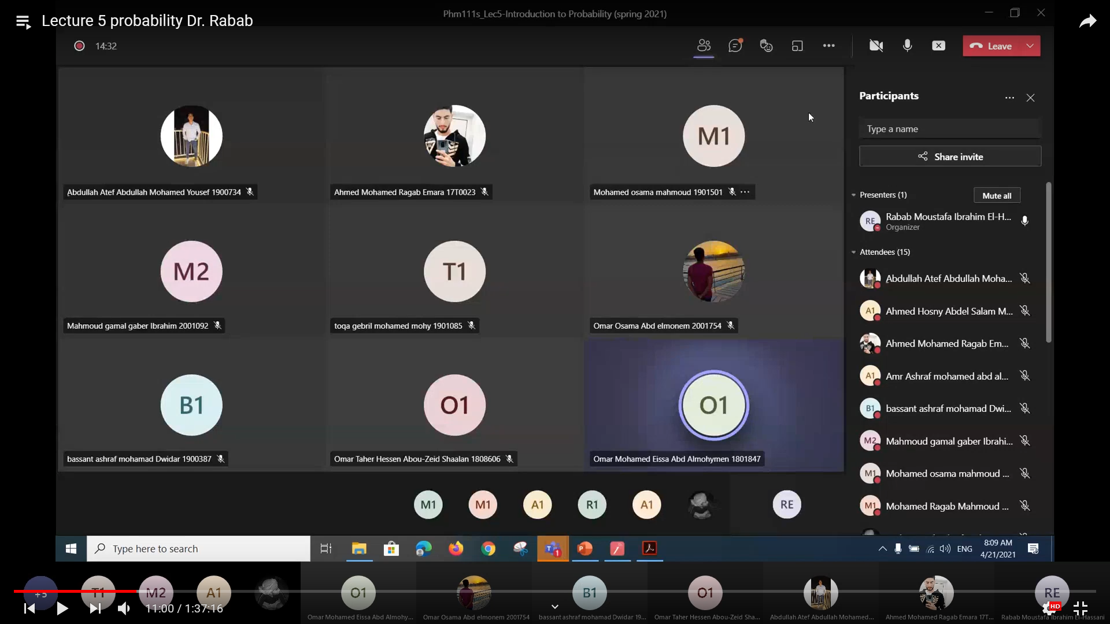
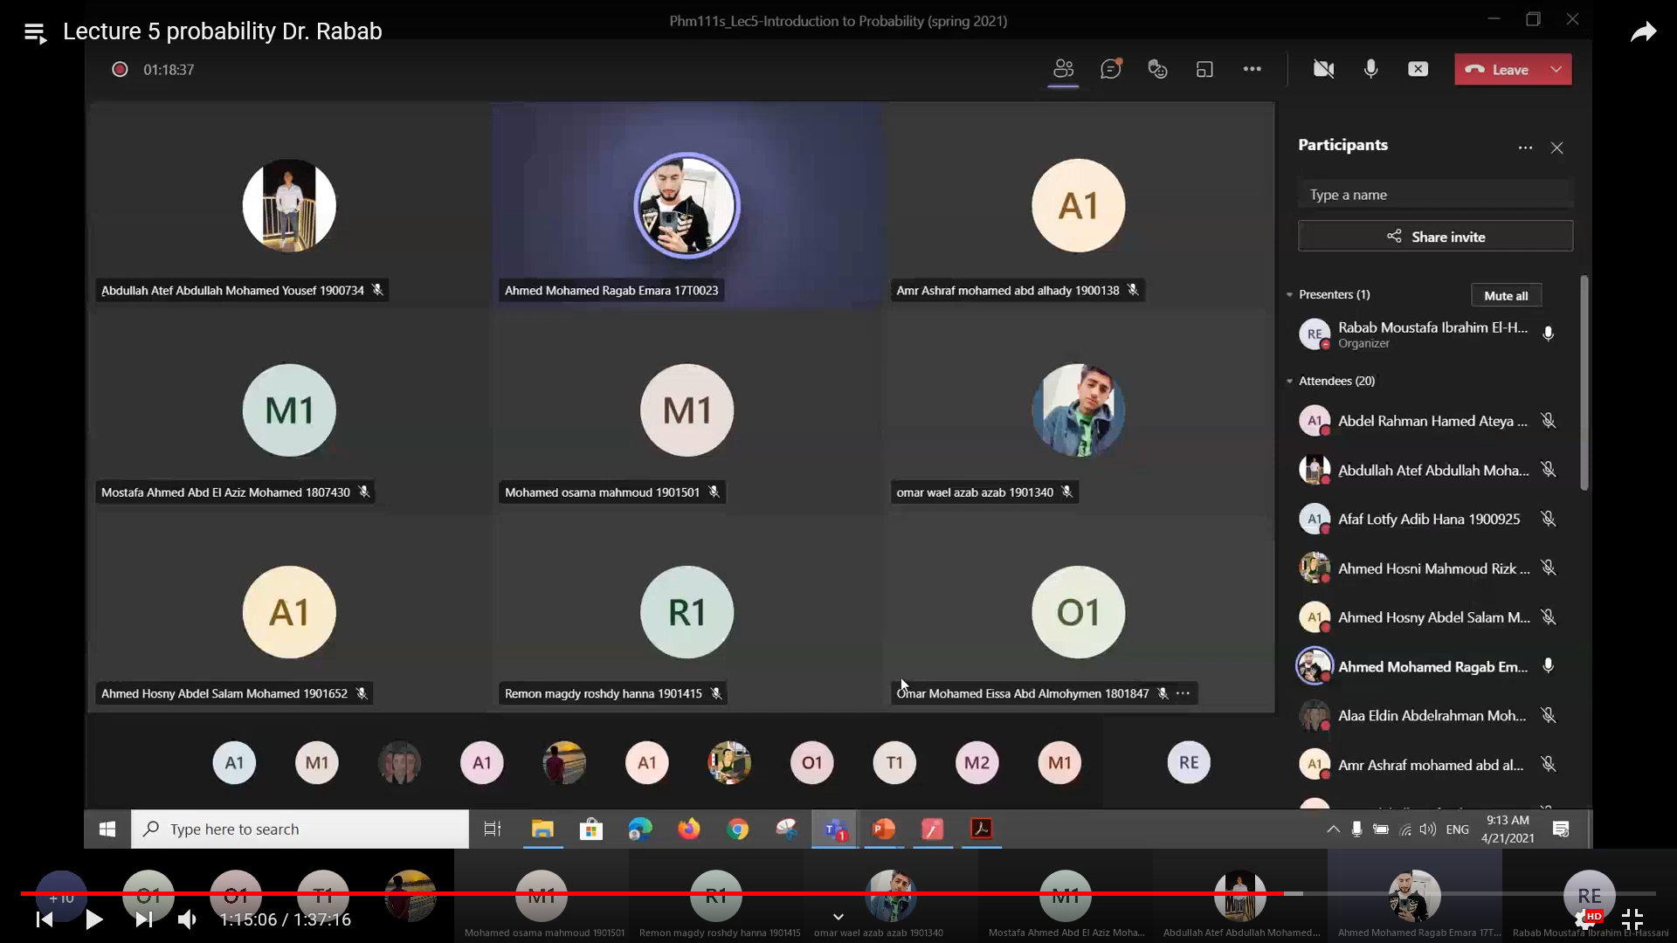
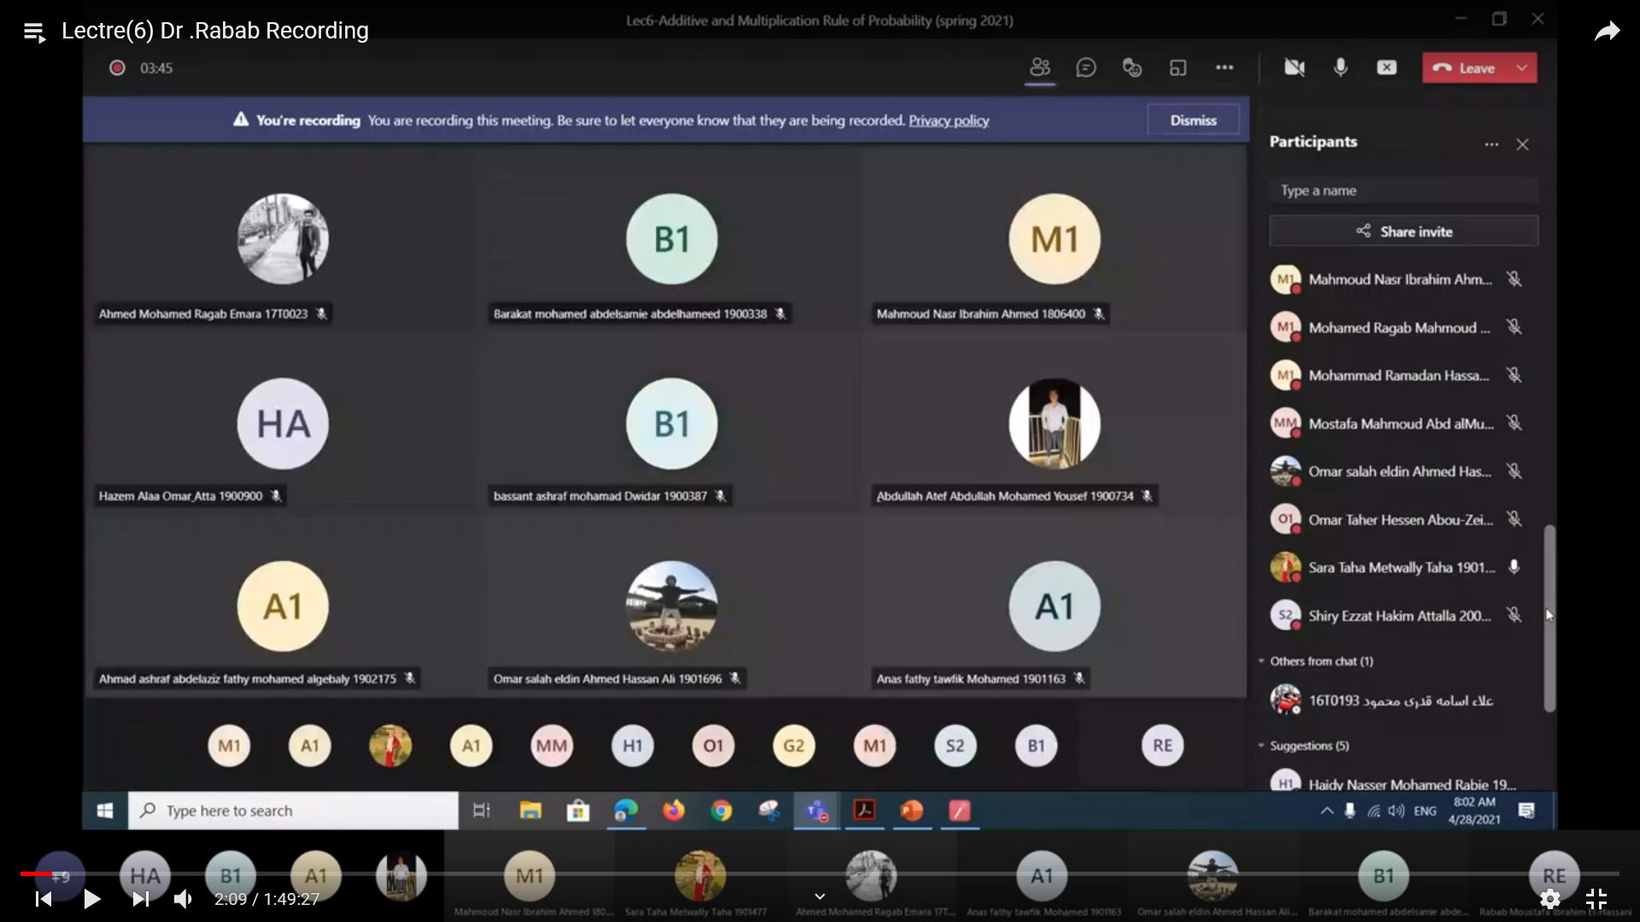
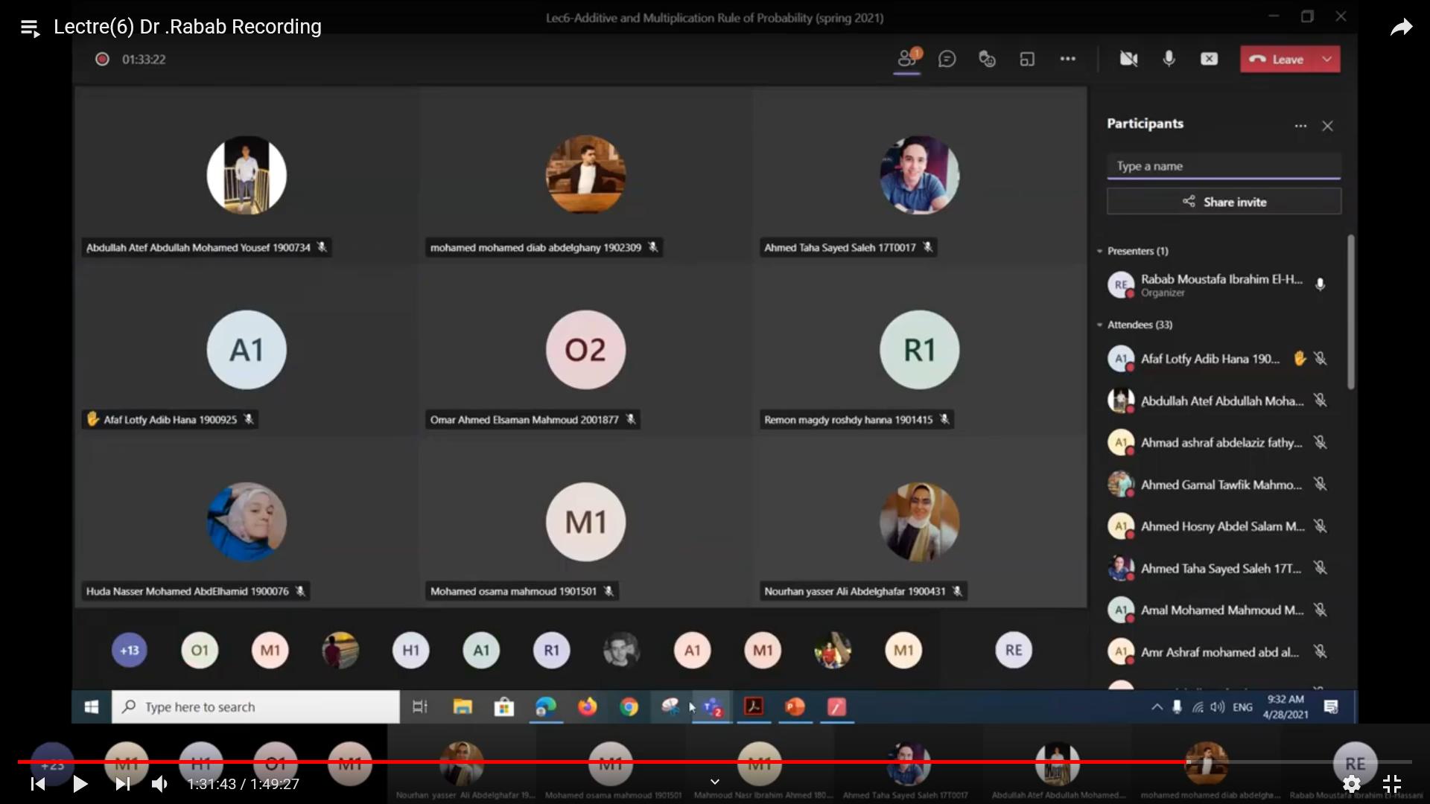
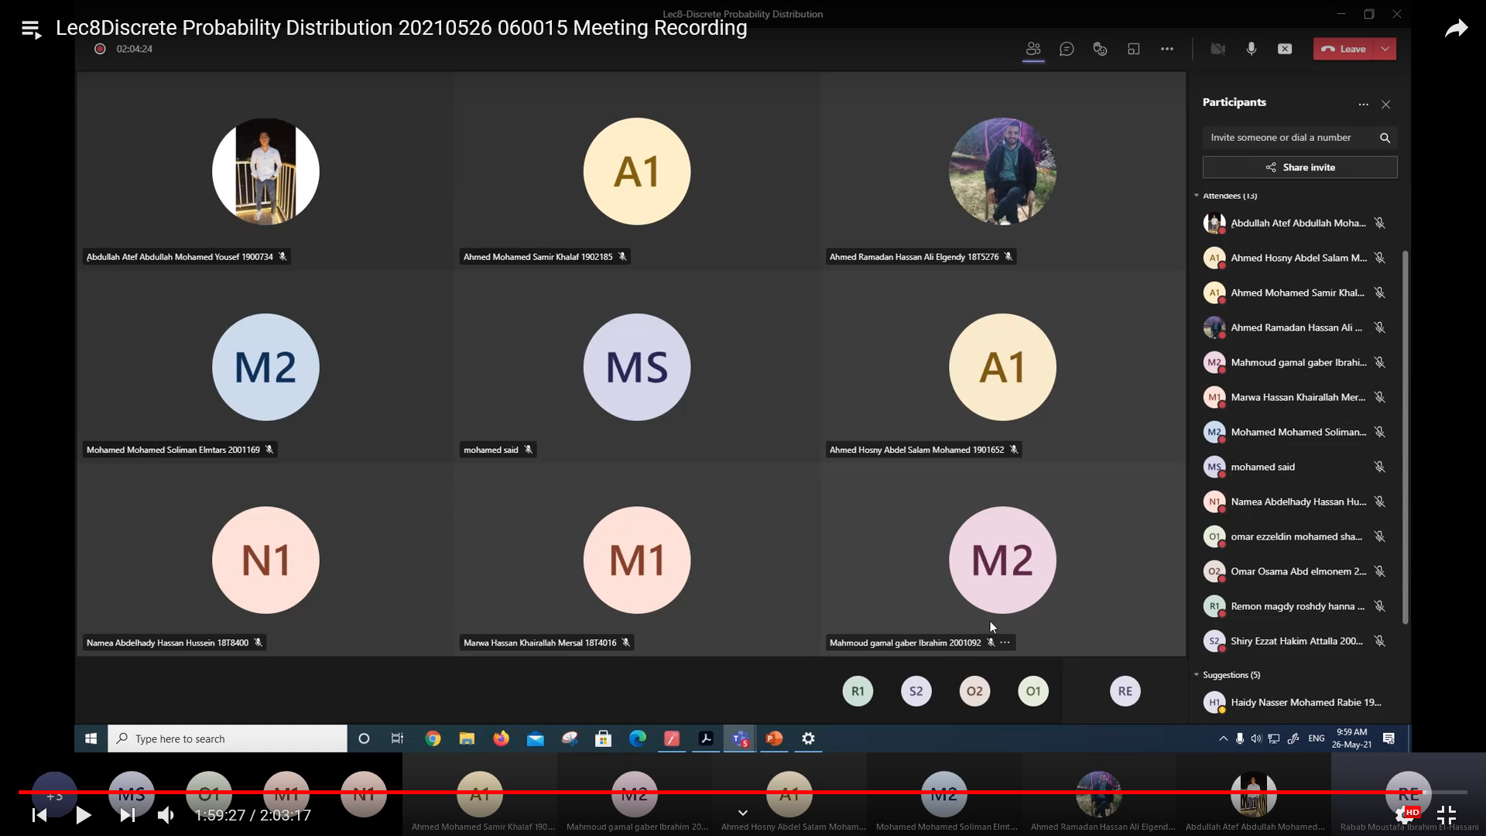

Interactive Tutorials: (Microsoft Teams)

tutorials in Spring 2021

Mostafa Mahmoud Abd alMumin Mahmoud: Scheduled a meeting
posted in PHM111s (UG2018) - Probability and Statistics (18956) / Tutorial at Wednesday, March 31, 2021 4:02:38 AM (recurring every week)

Mostafa Mahmoud Abd alMumin Mahmoud: Scheduled a meeting
posted in PHM111s (UG2018) - Probability and Statistics (18956) / Tutorial at Wednesday, June 9, 2021 7:24:48 AM

Mostafa Mahmoud Abd alMumin Mahmoud: Scheduled a meeting
posted in PHM111s (UG2018) - Probability and Statistics (18956) / Tutorial at Thursday, July 1, 2021 7:18:41 PM

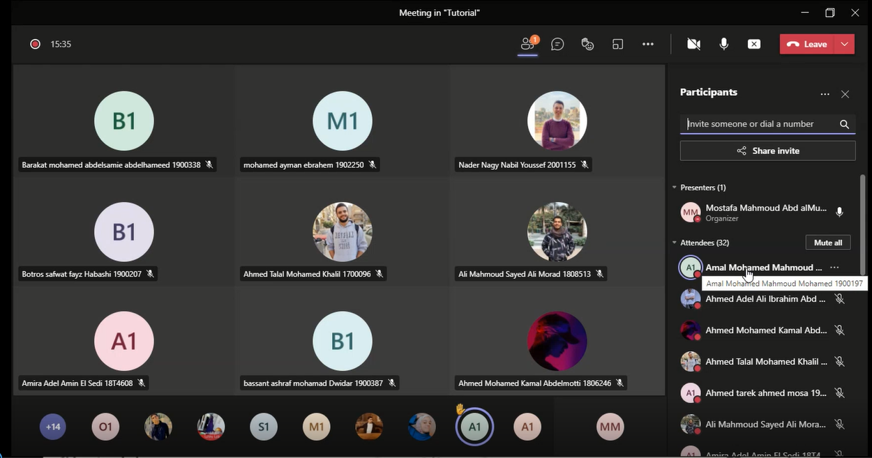

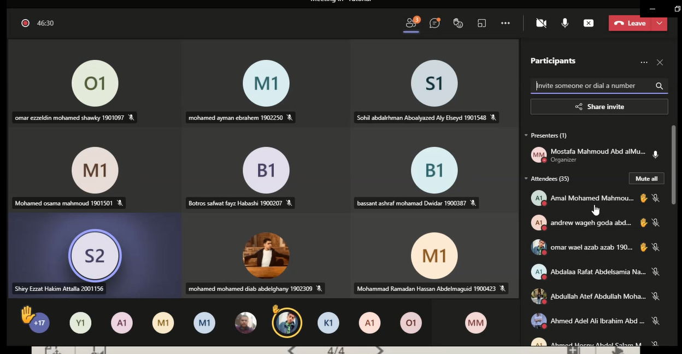

Case Study:
Other assignments/homework:
If teaching and learning methods were used other than those specified, list and give reasons:
……………………………………………………………
……………………………………………………………

3- Student assessment:
Method of assessment Percentage of total

Written final examinations 60 %

Practical/laboratory work 0 %

Mid-Term Exam 20 %

Online assignments/class work (Quizzes) 20%

Total 100 %

Members of examination committee

Dr. Rabab Moustafa El-Hassani

Role of external evaluator
…… N/A ………………………………
………………………………………
……………………………………....

4- Facilities and teaching materials:
Facilities used for teaching and learning:
- E-Learning Program (Moodle)
- Video conferencing tool (Team)

Totally adequate

Adequate to some extent

Inadequate

5- Administrative constraints

6- Student evaluation of the course: Response of Course Team
- The time of exams and Quizzes is very little
About 13 students in first Quiz and 23 in the second one takes full mark!!!
- ﺍﻭﻻ ﺍﻟﺪﻛﺘﻮﺭ ﻭﺍﻟﻤﻌﻴﺪ ﻓﻰ ﻏﺎﻳﻪ ﺍﻻﺣﺘﺮﺍﻡ ﻑ ﺍﻟﺘﻌﺎﻣﻞ ﻭﺍﻟﺸﺮﺡ ﻭﺑﻴﺴﺎﻋﺪﻭﺍ ﺟﺪﺍ ﺛﺎﻧﻴﺎ ﺍﻟﻤﺎﺩﺓ ﺳﻬﻠﺔ ﺍﻥ ﺍﺣﺰﺍ ﻧﻔﻬﻤﻬﺎ ﻭﻟﻜﻦ ﺍﻟﺘﻤﺎﺭﻳﻦ ﻗﻠﻴﻠﻪ ﻭﺍﻻﻣﺘﺤﺎﻥ ﻻ ﻳﻐﻄﻰ ﻣﻌﻈﻢ ﺍﻻﻓﻜﺎﺭ ﺑﺘﺒﻘﻲ ﻓﻰ ﺍﻓﻜﺎﺭ ﻻ ﻧﻘﺪﺭ ﻋﻠﻰ ﺍﺳﺘﻴﻌﺎﺑﻬﺎ ﺍﻭ ﻓﻬﻤﻬﺎ ﻭﺗﻮﺟﺪ ﺍﻓﻜﺎﺭ ﺟﺪﻳﺪﺓ ﻑ ﺍﻻﻣﺘﺤﺎﻥ ﻳﺮﺟﻲ ﺍﻥ ﻳﻜﻮﻥ ﻓﻰ ﻭﺳﻴﻠﺔ ﻧﻘﺪﺭ ﻧﺤﻞ ﻣﻨﻬﺎ ﻛﺘﻴﺮ ﺑﺤﻴﺚ ﻧﻜﻮﻥ ﻣﺘﺪﺭﺑﻴﻦ ﻛﻮﻳﺲ ﻗﺒﻞ ﺍﻻﻣﺘﺤﺎﻥ ﻻﻥ ﺍﻟﻠﻰ ﺑﻴﺤﺼﻞ ﺍﻥ ﺍﺣﻨﺎ ﺑﻨﺘﻔﺎﺟﺄ ﺑﺄﺳﺌﻠﺔ ﺟﺪﻳﺪﺓ ﻭﺍﻓﻜﺎﺭ ﺟﺪﻳﺪﺓ ﺑﺎﻟﻨﺴﺒﺔ
تم طرح المراجع المستخدمة من بداية الترم فى المحاضرة الأولى وهى مليئة بالمسائل المجاب عنها والتى ممكن التدريب عليها!!!
- The content is very hard we can understand slowly but the exam is very hard and it s grades at last semester wasn’t good
Contradict the previous feedback
- the midterm exam was too hard to be said it was average or anything of the like 2 we don t know why we are taking this course to begin with I would be an engineer in the future why would i need to study a subject from another faculty 3 we have too many more important subjects than this one yet we have to study this hard as the professor comes up with too good ideas that make some fail
No Comment!!!
- Maybe should use more examples similar to which used in exames
- اﻻﻣﺘﺤﺎﻥ ﺑﻴﻜﻮﻥ ﺍﻓﻜﺎﺭ ﺑﻌﻴﺪﻩ ﺟﺪﺍ ﻋﻦ ﻣﺎ ﺗﻢ ﺗﺪﺭﻳﺴﻪ ﻭﺣﻠﻪ ﻑ ﺍﻟﺴﻜﺎﺷﻦ ﻭﺍﻟﻤﺤﺎﺿﺮﺍﺕ ﻭﺍﻻﻣﺘﺤﺎﻥ mcq ﻭﺍﻻﺳﻴﻤﻨﺘﺎﺕ ﺭﻳﺘﻦ ﻭﺩﻩ ﺍﺳﻠﻮﺏ ﺑﻴﺸﺘﺘﻨﺎ ﺟﺪا
- ﻣﻔﻴﺶ ﺍﺳﺌﻠﻪ ﻣﻮﺟﻮﺩﻩ ﺯﻱ ﺍﻟﻠﻲ ﺑﺘﻴﺠﻲ ﻑ ﺍﻻﻣﺘﺤﺎﻥ ﻑ ﺍﻟﻠﻲ ﺑﻨﺬﺍﻛﺮﻩ ﺣﺎﺟﻪ ﻭ ﺍﻟﻠﻲ ﺑﻨﺨﺶ ﺍﻟﻔﺎﻳﻨﺎﻝ ﺑﻨﻼﻗﻴﻪ ﻣﺨﺘﻠﻒ ﺗﻤﺎﻣﺎ
هناك أسئلة مشابهة من المحاضرة ومن المرجع ولكن يجب وجود بعض الأفكار التى تميز الطلبة عن بعضها.

7- Comments from external evaluator(s): Response of course team
N/A …………………….. …………………………….
……….……………..……. …………………………….
…………………………… …………………………….
……………………………. …………………………….
…………………………… …………………………….

8- Course enhancement: Progress on actions identified in the previous year’s action plan:
N/A …………………….. …………………………….
……….……………..……. …………………………….
…………………………… …………………………….
……………………………. …………………………….
…………………………… …………………………….

9- Action plan

Actions required Completion date Person responsible
……………………… ……………………… ………………………
……………………… ………………………
……………………… ……………………… ………………………

