Course report of
General Chemistry– PHM 041 – Fall 2020
University: Ain Shams | Faculty: Engineering

Basic Information
- Title and code :
General Chemistry – PHM 041
- Programme on which the course is given :
All Programs

- Year/Level of programs :
1stLevel
- Units/Credit Hours
( i ) Lecture : | 2

( ii ) Tutorial/Practical : | 1+2

( iii ) Total : | 5
- Names of lecturers contributing to delivery of the course :
i - | Dr. Amr Osman Mohamed Osman Habib

ii - | Dr. Mahmoud Salah Hafez

iii - | Dr. Alla Mohsen

iv -

Course coordinator: | Dr. . Mahmoud Salah Hafez

External evaluator: | --- --- ---

Statistical Information
All Freshmen Students  No. of students attending the course: | 741

 | A | A- | B+ | B | B- | C+ | C | C ⁻ | D+ | D | P | F | SUM
Students No. | 6 | 18 | 37 | 55 | 72 | 66 | 50 | 60 | 50 | 99 | 17 | 211 | 741
Percentage (%) | 0.81 | 2.42 | 4.99 | 7.42 | 9.71 | 8.9 | 6.74 | 8.09 | 6.74 | 13.36 | 2.29 | 28.47 | 100

Professional Information

Course Teaching:
Course Content | No. of Hours  (Lec. & Tut.)
Gasses State | 8
The Properties of Liquids and Solids | 8
Thermo-chemistry and Thermodynamics | 12
Electrochemistry and Corrosion of Metals | 8
Water and its Treatment | 4
Chemistry of Cement | 4
Polymers Chemistry | 4
Fuel Combustion | 4
Properties of Solutions | 8
Total | 60
Lab. Experiments | 22.5

Topics taught as a percentage of the content specified:

>90 % √ 70-90 % <70%

Reasons in detail for not teaching any topic
All topics were taught ……………………………………….
………………………………………………………………………………………………

If any topics were taught which are not specified, give reasons in detail
N/A………………………………………………………………………………………….

Teaching and learning methods:
Lectures: √ videos from Microsoft team
Practical training/ laboratory: √ On campus
Seminar/Workshop: ---
Class Activity: (Tutorials) √ videos from Microsoft team

assignments/homework √ on LMS

Some Online Teaching Activities:
Click here to join the meeting
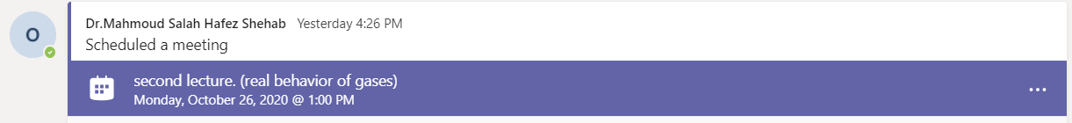

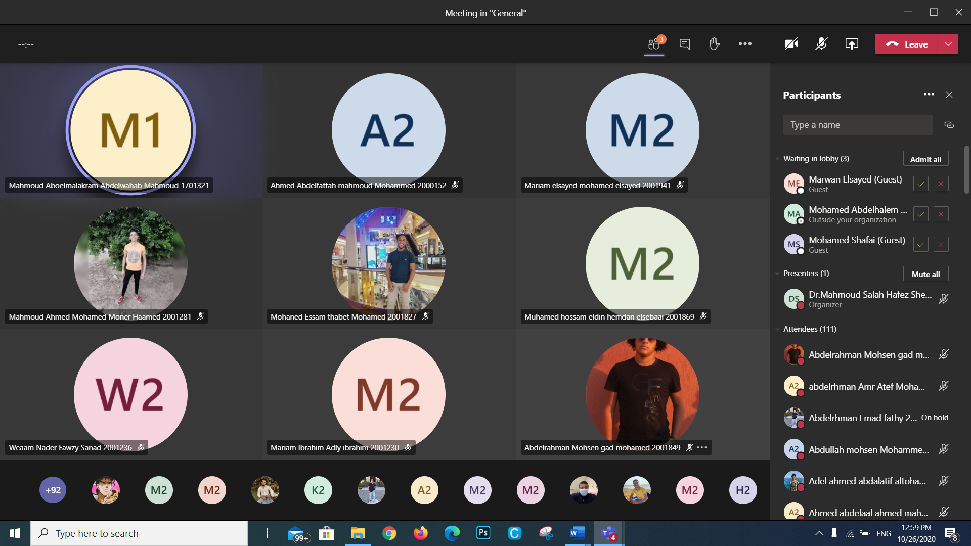

Tutorial 1 - 31/10/2020
https://teams.microsoft.com/l/meetup-join/19%3ad5b7d7ae131c4196952c5eaf7d6869ed%40thread.tacv2/1604038807826?context=%7b%22Tid%22%3a%22ad2a8324-bef7-46a8-adb4-fe51b6613b24%22%2c%22Oid%22%3a%22a7dc1325-e72a-4348-85ae-8e281d730f60%22%7d
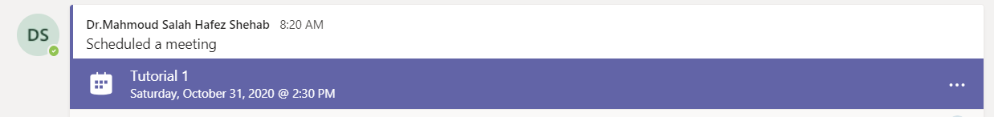
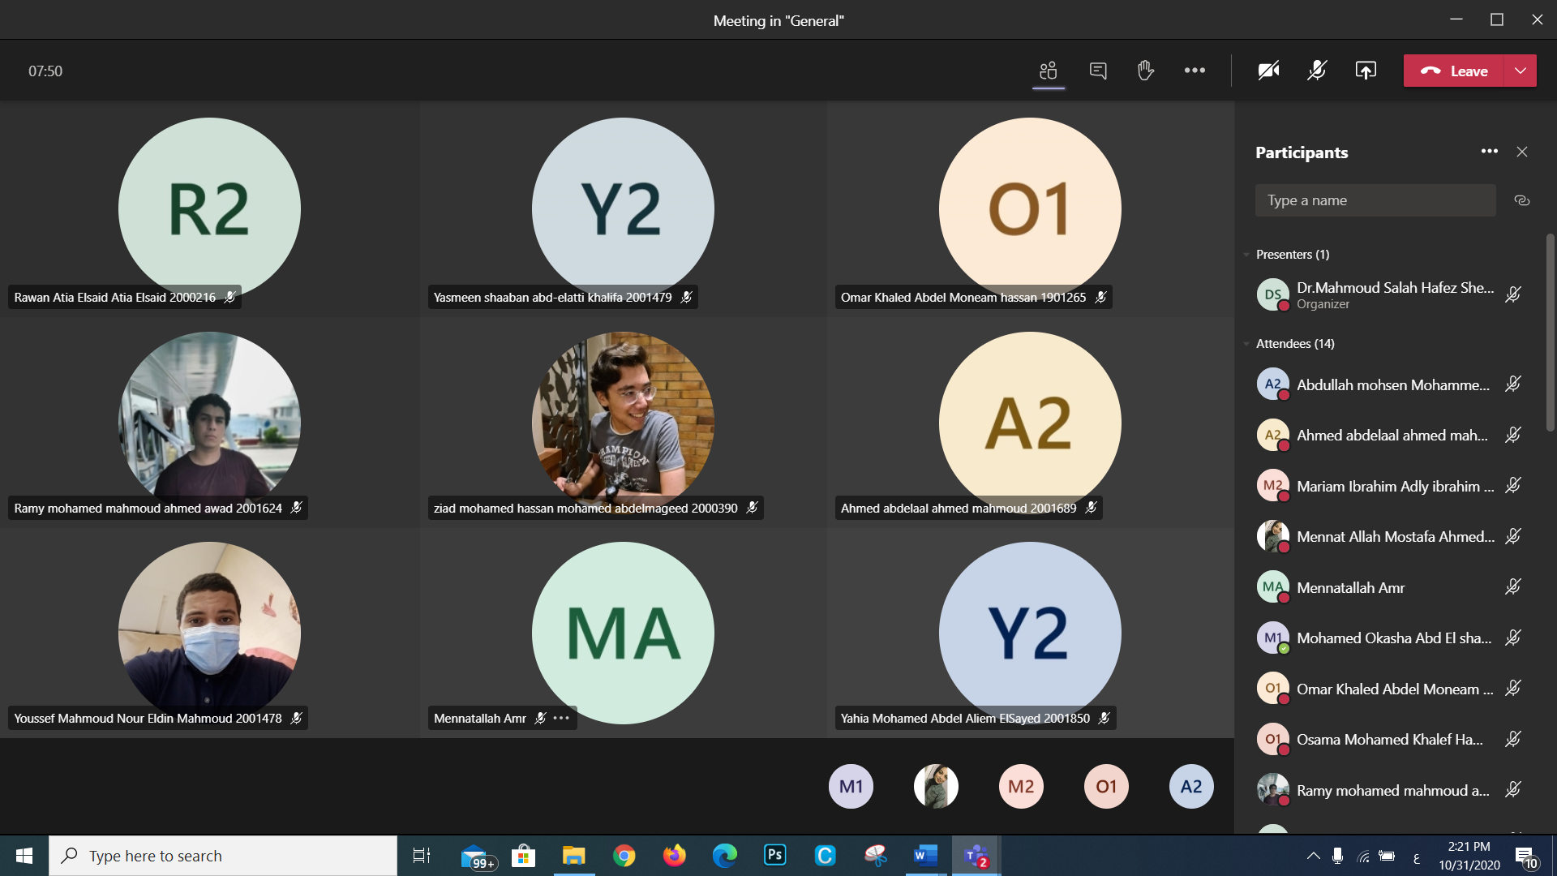

Lecture 4 – 9/11/2020
https://teams.microsoft.com/l/meetup-join/19%3ad5b7d7ae131c4196952c5eaf7d6869ed%40thread.tacv2/1604856066225?context=%7b%22Tid%22%3a%22ad2a8324-bef7-46a8-adb4-fe51b6613b24%22%2c%22Oid%22%3a%22a7dc1325-e72a-4348-85ae-8e281d730f60%22%7d
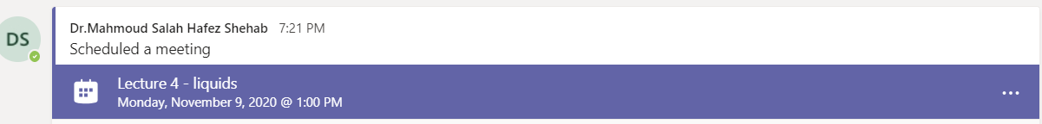
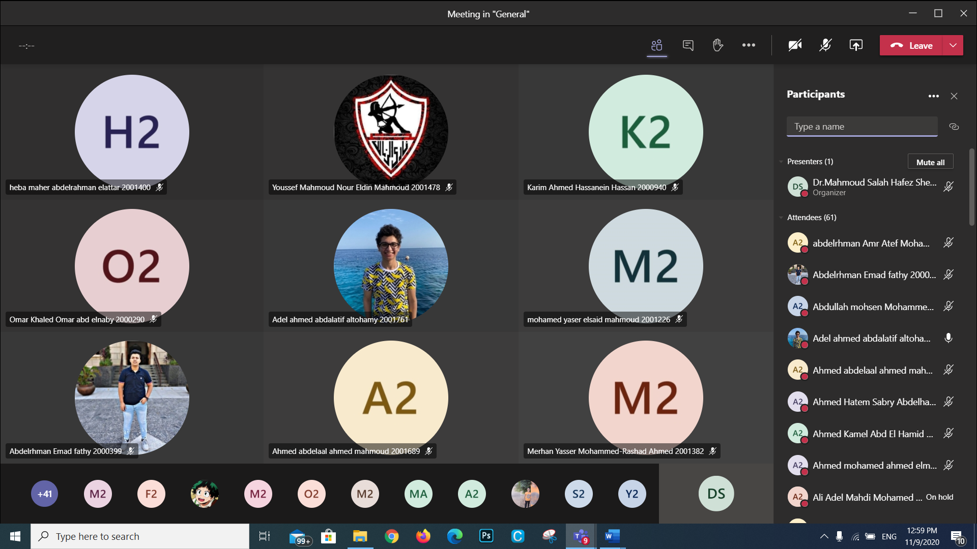

Tutorial 2 – 14/11/2020
https://teams.microsoft.com/l/meetup-join/19%3ad5b7d7ae131c4196952c5eaf7d6869ed%40thread.tacv2/1605259561221?context=%7b%22Tid%22%3a%22ad2a8324-bef7-46a8-adb4-fe51b6613b24%22%2c%22Oid%22%3a%22a7dc1325-e72a-4348-85ae-8e281d730f60%22%7d
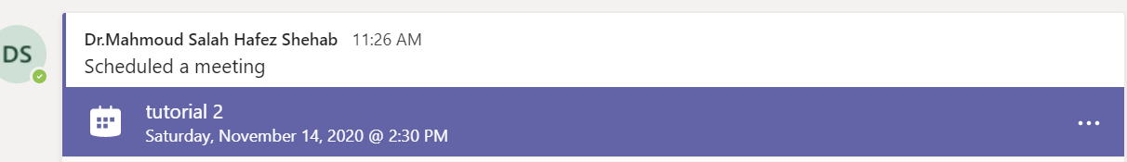

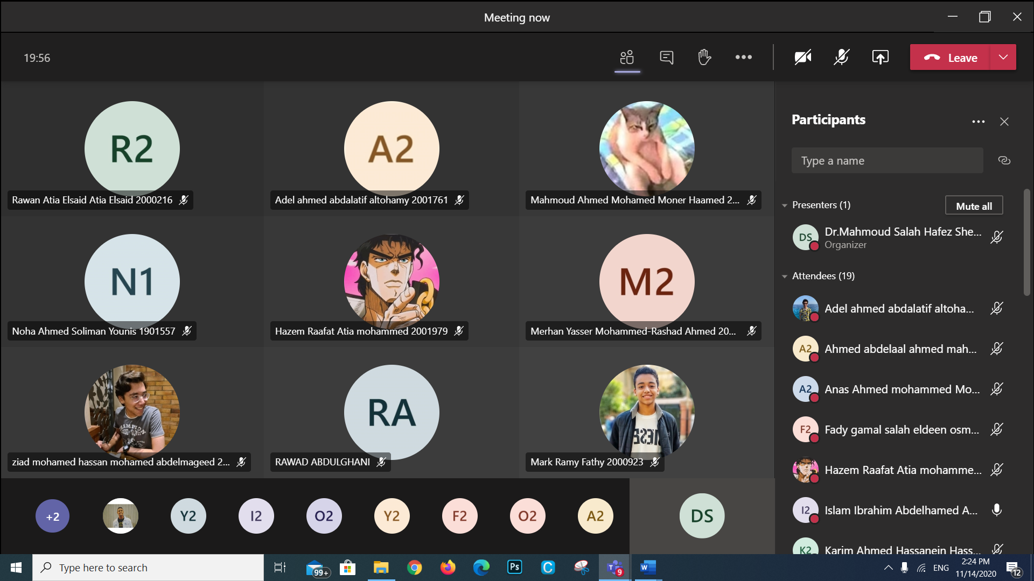

Lecture 8 – 14/12/2020
https://teams.microsoft.com/l/meetup-join/19%3ad5b7d7ae131c4196952c5eaf7d6869ed%40thread.tacv2/1607870579892?context=%7b%22Tid%22%3a%22ad2a8324-bef7-46a8-adb4-fe51b6613b24%22%2c%22Oid%22%3a%22a7dc1325-e72a-4348-85ae-8e281d730f60%22%7d
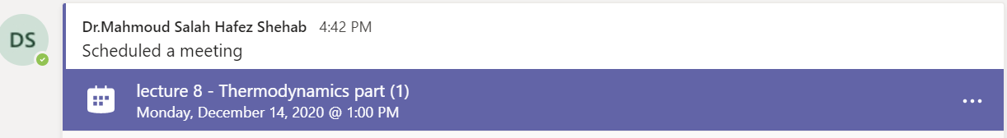

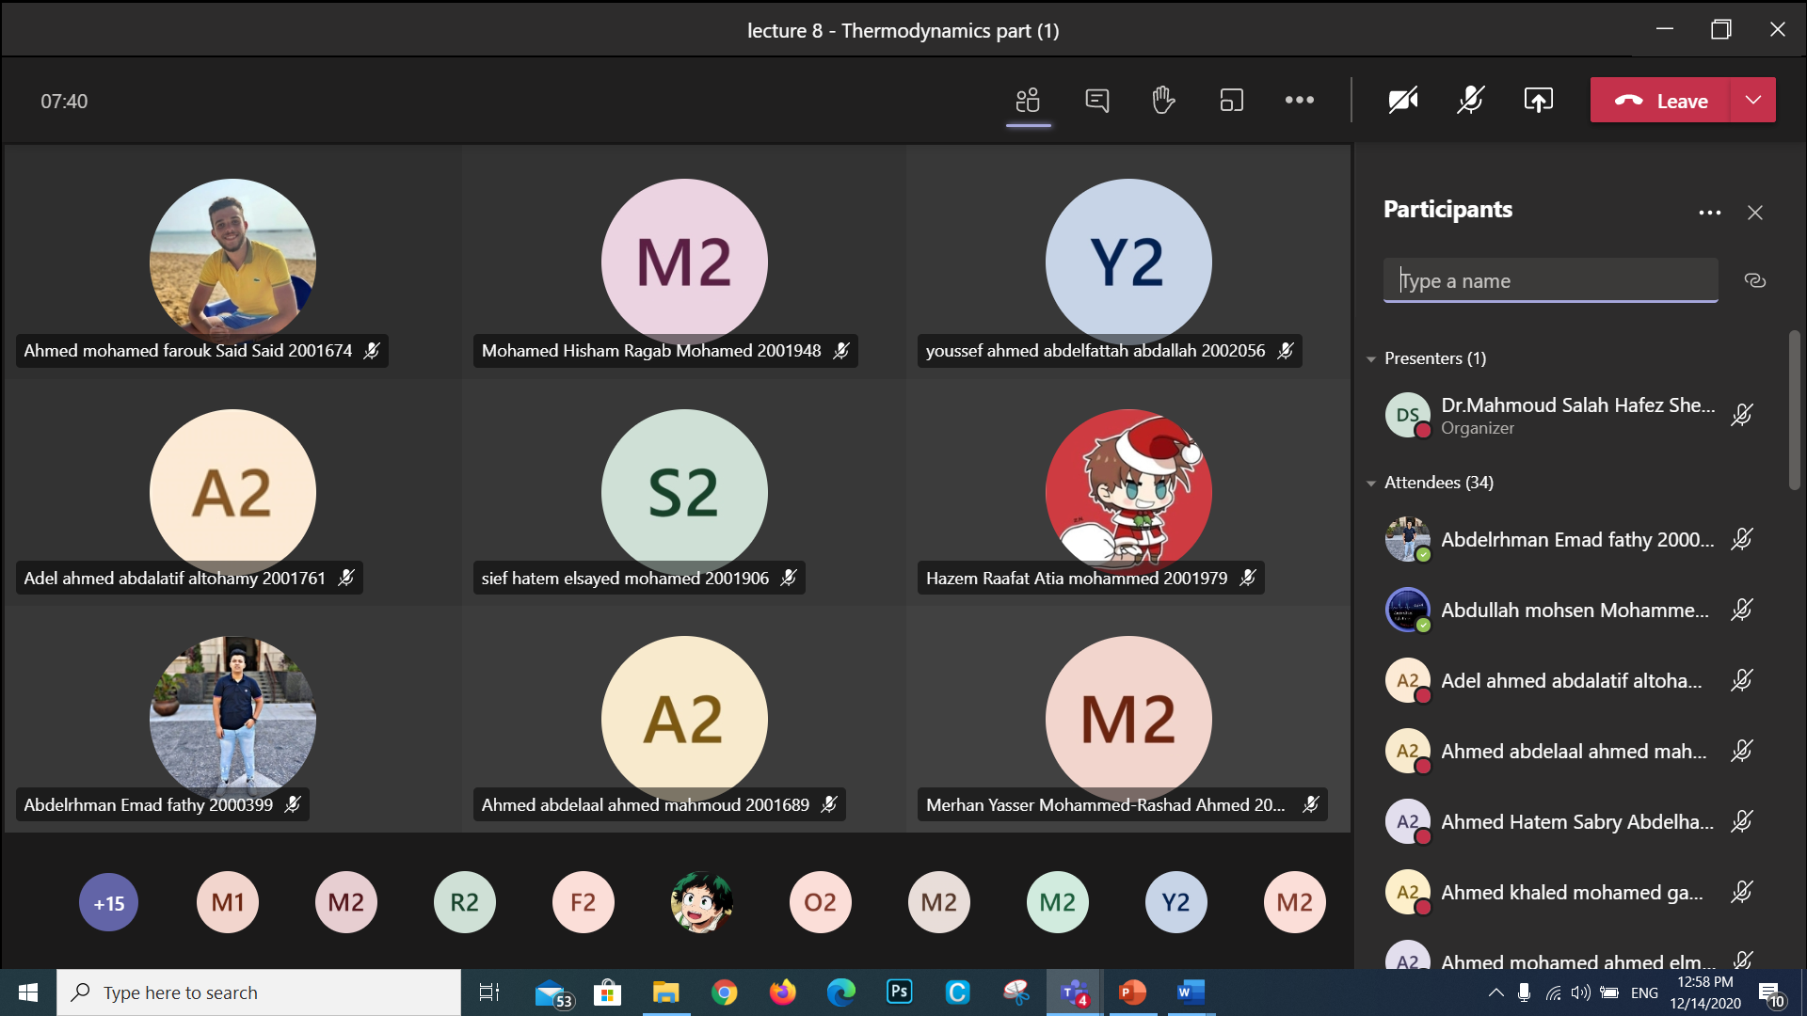

Tutorial 2/1/2021
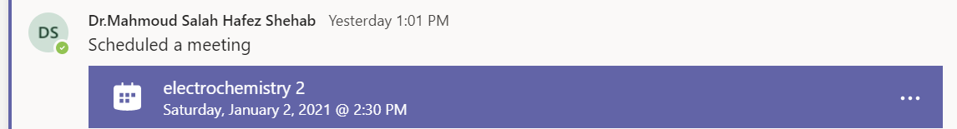

https://teams.microsoft.com/l/meetup-join/19%3ad5b7d7ae131c4196952c5eaf7d6869ed%40thread.tacv2/1609498914333?context=%7b%22Tid%22%3a%22ad2a8324-bef7-46a8-adb4-fe51b6613b24%22%2c%22Oid%22%3a%22a7dc1325-e72a-4348-85ae-8e281d730f60%22%7d
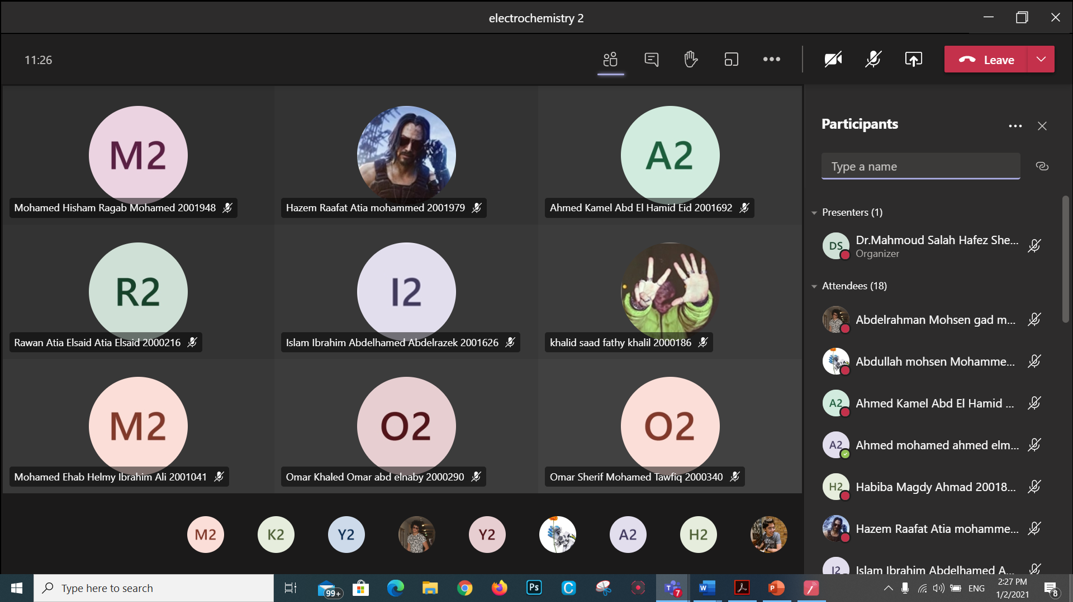

Student assessment:

Method of assessment | Percentage of total
Written Final examination | 40 %
Mid-Term examination | 25 %
Practical/laboratory work | 15 %
Quizzes | 10 %
assignments | 5 %
Participation | 5 %

Members of examination committee

Role of external evaluator
N/A………………………………………………………………………………………….
………………………………………………………………………………………………

Facilities and teaching materials:
Totally adequate
Adequate to some extent √
Inadequate
List any inadequacies

Administrative constraints:
List any difficulties encountered
No difficulties

Student evaluation of the course:

Response of Course Team

List any criticisms
…No criticism.…….………..……………………………….

Comments from external evaluator(s): Response of course team
………N/A ………………. …………………………….

