Course report of
Dynamics – PHM_032s – Spring 2021
University: Ain Shams | Faculty: Engineering

Basic Information
- Title and code :
Dynamics – PHM_032s
- Program on which the course is given :
All Programs

- Year/Level of programs :
1stLevel
- Units/Credit Hours
( i ) Lecture : | 2

( ii ) Tutorial/Practical : | 2+1

( iii ) Total : | 5
- Names of lecturers contributing to delivery of the course :
i - | Dr. Hussein Elsayed Mohamed

Course coordinator: | Dr. Hussein Elsayed Mohamed Hussein

External evaluator: | --- --- ---

Statistical Information

For the PHM_ 032s students

No. of students attending the course: | 1361

Grade | A+ | A | A- | B+ | B | B- | C+ | C | C- | D+ | D | P | F | SUM
Students No. | 28 | 112 | 128 | 225 | 180 | 176 | 112 | 68 | 81 | 47 | 60 | 17 | 127 | 1361
Percentage % | 2 | 8 | 9 | 17 | 13 | 13 | 8 | 5 | 6 | 3 | 4 | 1 | 9 | 100

Professional Information

Course Teaching:

Course Content | Total No. of Hours | Lecturer
Kinematics of particles | 20 | Dr. Hussein Elsayed
Relative Motion | 4 | Dr. Hussein Elsayed
Kinetics and Newton's second law of motion. | 8 | Dr. Hussein Elsayed
Midterm Exam | 4 | Dr. Hussein Elsayed
Work and Energy | 8 | Dr. Hussein Elsayed
Impulse and Momentum | 16 | Dr. Hussein Elsayed
Total | 60 | Dr. Hussein Elsayed

Dynamics PHM_032s
Spring 2021
Week | Experiment | Laboratory
1 | Introduction to Dynamics Experiments | 1
2 | The Gravity Acceleration Exp | 1
3 | The Gravity Acceleration Exp | 1
4 | Verification of Newton's Law Exp. | 1
5 | Verification of Newton's Law Exp. | 1
6 | X, t Exp. | 1
7 | X, t Exp. | 1
8 | Average and Inst. Velocity Part(3) | 1
9 | Average and Inst. Velocity Part(3) | 1
10 | Average Acceleration Exp. | 1
11 | Average Acceleration Exp. | 1
12 | Projectiles Velocity Exp. | 1
13 | Projectiles Velocity Exp. | 1
14 | Trajectory graph and maximum height | 1
15 | Trajectory graph and maximum height | 1
 | Total number of hours | 15

The lab exam was conducted by discussing the students orally in the experiments and the results obtained

Online Activities
- The online activities in this semester include all lectures and tutorials by using Microsoft teams and the meetings with the students have been recorded and uploaded to LMS
- Also all of the experiments of the lab. Part have been recorded as video show and also uploaded to the students
- The Quizzes was held online
- LMS link:
https://lms.eng.asu.edu.eg/course/view.php?id=7426
- Microsoft teams link
https://teams.microsoft.com/l/team/19%3acad11c3bf94f4166a21155a6f3b2abbf%40thread.tacv2/conversations?groupId=6515445b-b867-492a-9094-84020361491f&tenantId=ad2a8324-bef7-46a8-adb4-fe51b6613b24

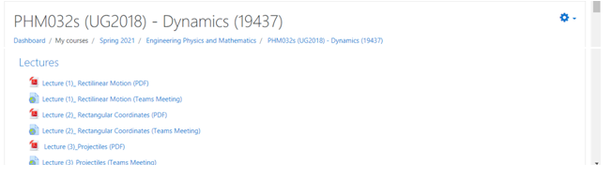
With Microsoft stream links:
https://web.microsoftstream.com/video/3ef9a0bf-311e-4990-a342-0ea46909a8cb
https://web.microsoftstream.com/video/fb9b8371-0c1d-4f65-8c64-4c84e61ea25e
https://web.microsoftstream.com/video/bed438f7-0a4a-4beb-a01c-3206ed438377

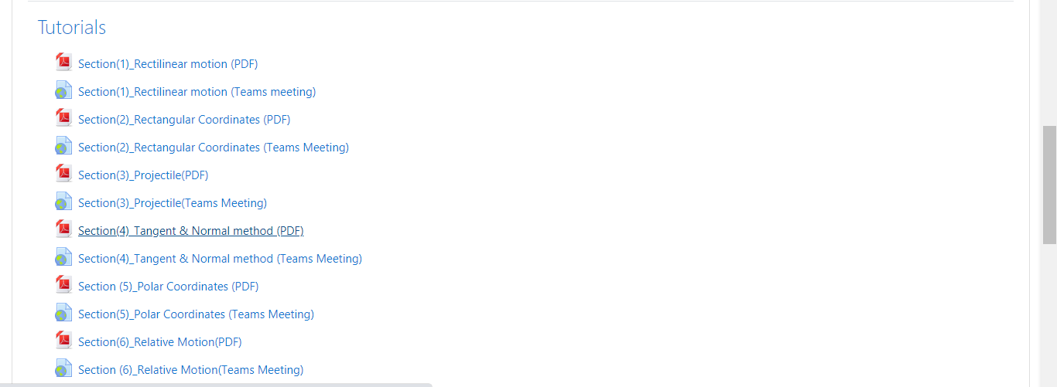
https://web.microsoftstream.com/video/43d11d2b-ccb6-43c8-98ec-d39854077637
https://web.microsoftstream.com/video/fe792893-9a56-4508-b2f0-82805eec4193?list=studio
https://web.microsoftstream.com/video/76cb2954-ed06-453f-8075-d55ecb9a1cd8

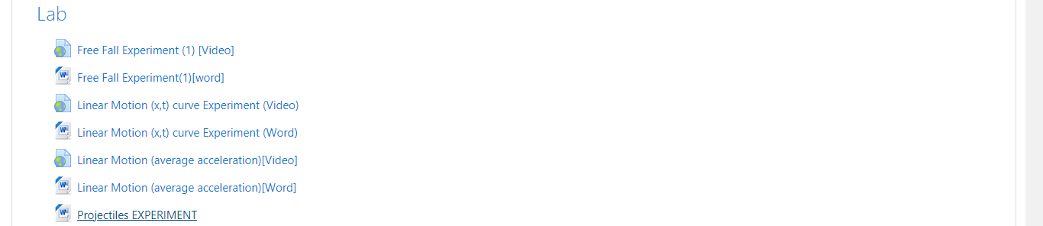
https://www.youtube.com/watch?v=6UQx8CaVubk
https://www.youtube.com/watch?v=zWI2UfcwVtE
https://www.youtube.com/watch?v=3bci8ldeI9Y

Topics taught as a percentage of the content specified:

>90 % X 70-90 % <70%

Reasons in detail for not teaching any topic
N/A………………………………………………………………………………………….
………………………………………………………………………………………………
………………………………………………………………………………………………

If any topics were taught which are not specified, give reasons in detail
N/A………………………………………………………………………………………….
………………………………………………………………………………………………
………………………………………………………………………………………………

Teaching and learning methods:
Online Lectures: X
Practical training/ laboratory: X
Seminar/Workshop:
Class Activity: (Online Tutorials) X

Online Lectures and Tutorials were by using Microsoft teams and uploaded to LMS

Case Study:
Other assignments/homework:
If teaching and learning methods were used other than those specified, list and give reasons:
………………………………………………………………………………………………
………………………………………………………………………………………………

Student assessment:
Method of assessment | Percentage of total
Written examination (Final+ mid-term) | 85 %
Quizzes + Lab | 10 %
Other assignments/class work | 5 %

Members of examination committee
i–Dr. Hussein Elsayed Mohamed Hussein ii-Dr. Ahmed Ezzat

Role of external evaluator
N/A………………………………………………………………………………………….
………………………………………………………………………………………………

Facilities and teaching materials:
Totally adequate
Adequate to some extent X
Inadequate

List any inadequacies

Administrative constraints:
List any difficulties encountered
No difficulties

Student evaluation of the course:

Questionnaire of PHM_032s

Questionnaire Details
Committee | PHM032s (UG2018):Dynamics.
Instructors | Ahmed Ezzat A. Abdel Ghany, Amal Mahmoud Abdel Hafez, Hussein Elsayed M. Hussein, Ahmed Mohamed Hamid Eldesouky, Eslam Nabil Shawki El-Ganzoury, Alaa Mohamed Ahmed Ismail, Ali Shehab shams El Deen Abo Elyazeed, Omar Mohamed Saber Hafez , Hamada Galal Taha Asker,
- 72%

1004
Participants
Course Evaluation (1004 Participants)
72 %
Question | Score
The course syllabus was clearly explained at the beginning of the semester | 75%
I am aware of the course learning outcomes (LOs) | 74%
The teaching methods used helped and supported me to learn | 73%
Course topics are explained well in the teaching sessions. | 75%
The course activities helped me to achieve the learning outcomes (LOs) efficiently. | 71%
The course assessments were clear and their distribution were clearly announced and organized | 73%
I felt well supported on this course from instructor and teaching assistant (if any). | 73%
I have been able to contact instructor when I needed to. | 71%
The course focused on what was set out in the course specification and all are presented. | 75%
The instructor provided well written laboratory instructions (if any). | 74%
Adequate technical support and supervision were provided during the laboratory sessions (if any). | 74%
The laboratory was well integrated with the course pacing (if any). | 71%
The course digital materials on LMS are helpful in supporting my learning. | 71%
Overall, I was satisfied with my experience of this course. | 73%
I learn from online teaching activities, similar to on campus teaching activities. | 65%
The instructor used appropriate communication tools for online teaching. | 74%
The instructor pays attention to the student's achievement during online class. | 73%
The instructor encouraged active participation and discussion during online class. | 74%
I could pass the online course without any staff assistance. | 63%
The instructor respected to start / finish online lectures on scheduled times | 76%

6- Student evaluation of the course: Response of Course Team

Online teaching is not suitable. Lectures and tutorials are interactive lectures using hand writing technique with complete voice discussion for all questions.
MCQ exams were too long Since a considerable ratio of students achieve high A-level grades, this reflects that the exam’s duration is suitable.
Online quizzes have Technical problems The quizzes were repeated for the students and approximately the results were not changed.

Response of Course Team
All lectures and tutorials are performed in acceptable level according to the online teaching conditions and criteria. The evaluation MCQ exams achieve balanced natural results that are suitable for time and scientific content.

7- Comments from external evaluator(s): Response of course team
N/A …………………….. …………………………….
……….……………..……. …………………………….

8- Course enhancement: Progress on actions identified in the previous year’s action plan:
N/A …………………….. …………………………….
……….……………..……. …………………………….

9- Action plan

Actions required Completion date Person responsible
N/A ………………… ……………………… ………………………
……………………… ………………………

