Course report of
Statics – PHM_031s – Fall 2020

University: Ain Shams | Faculty: Engineering

Basic Information
- Title and code :
(Statics) – PHM_031s
- Program on which the course is given :
All Programs

- Year/Level of programs :
1stLevel
- Units/Credit Hours
( i ) Lecture : | 2

( ii ) Tutorial/Practical : | 2+1

( iii ) Total : | 5
- Names of lecturers contributing to delivery of the course :
i - | Dr. Hussein Elsayed Mohamed Hussein

Course coordinator: | Dr. Hussein Elsayed Mohamed Hussein

External evaluator: | --- --- ---

Statistical Information

For the PHM_ 031 and PHM 032 students

No. of students attending the course: | 1698

Grade | A+ | A | A- | B+ | B | B- | C+ | C | C- | D+ | D | P | F | SUM
Students No. | 27 | 65 | 101 | 188 | 143 | 154 | 114 | 118 | 116 | 96 | 160 | 1 | 415 | 1698
Percentage % | 2 | 4 | 6 | 11 | 8 | 9 | 7 | 7 | 7 | 6 | 9 | 0 | 24 | 100

Professional Information

Course Teaching:
Course Content | No. of Hours | Lecturer
Statics of Particles | 12 | Dr. Hussein Elsayed
Rigid Bodies :Equivalent Systems of Forces | 12 | Dr. Hussein Elsayed
Equilibrium of Rigid Bodies | 8 | Dr. Hussein Elsayed
Analysis of Structure: Frames | 8 | Dr. Hussein Elsayed
Analysis of Structure:Trusses | 8 | Dr. Hussein Elsayed
Centroid-Center of Mass | 8 | Dr. Hussein Elsayed
Mass Moment of Inertia | 4 | Dr. Hussein Elsayed

Week | Title of Experiment | Laboratory  Hours
1 | Introduction to mechanics Lab | 1
2 | Introduction to Measuring Instruments | 1
3 | Determination of the gravitational acceleration | 1
4 | Determination of the gravitational acceleration (Repeat) | 1
5 | Determination of a spring stiffness | 1
6 | Determination of a spring stiffness (Repeat) | 1
7 | Force analysis ( Equilibrium of a of a particle) | 1
8 | Force analysis ( Equilibrium of a of a particle) (Repeat) | 1
9 | Friction on a leveled plane | 1
10 | Friction on a leveled plane (Repeat) | 1
11 | Friction on an inclined plane | 1
12 | Friction on an inclined plane (Repeat) | 1
13 | Center of gravity | 1
14 | Center of gravity (Repeat) | 1
15 | General Revision | 1
Total Number of Hours |  | 15

The lab exam was conducted by discussing the students orally in the experiments and the results obtained

Online Activities

- The online activities in this semester include all lectures and (tutorials by 50%) using Microsoft teams and the meetings with the students have been recorded and uploaded to LMS

- Also all of the experiments of the lab. have been recorded as video show and also uploaded to the students

- The Quizzes were held online

Team link:
https://teams.microsoft.com/l/team/19%3ad1f4d9cdde6d4d86ada4e2b9572ec835%40thread.tacv2/conversations?groupId=03b0b2e6-1d91-4109-a004-e27ef7f6cabc&tenantId=ad2a8324-bef7-46a8-adb4-fe51b6613b24

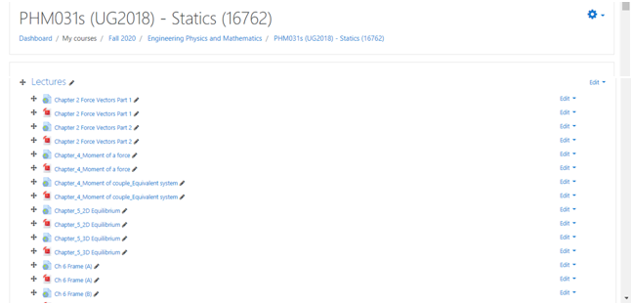
Lecture
https://web.microsoftstream.com/video/8fa9206a-1a5d-4d76-bb82-08cdb8abcc89
https://web.microsoftstream.com/video/77dad58a-9c24-4ee6-aeda-7d9e81f739d5
https://web.microsoftstream.com/video/fc3a726f-ad05-44f7-90cb-1b18da7823af
https://web.microsoftstream.com/video/166b32c4-d841-4e75-ac23-c33ab6669370

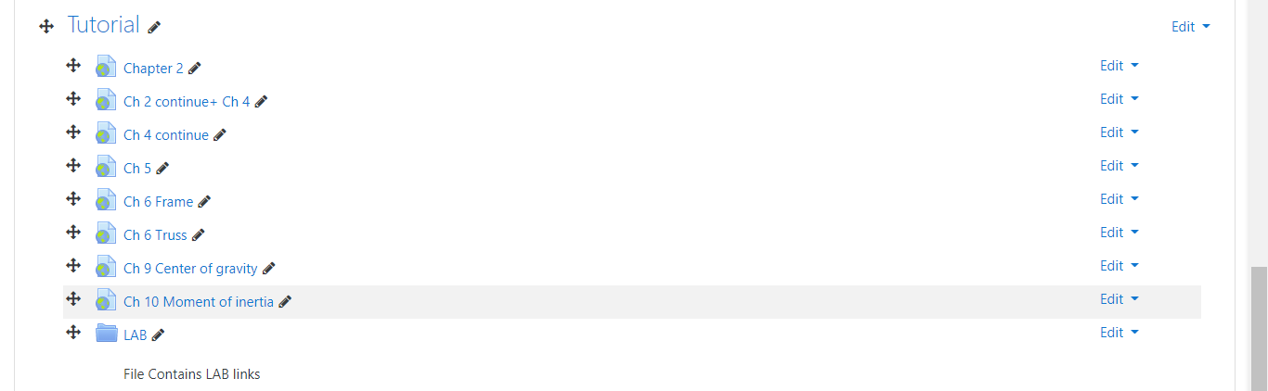
Tutorial
https://web.microsoftstream.com/video/de8f07dc-2af8-4e63-acb3-d2d56856fff0
https://web.microsoftstream.com/video/f92c7c27-55f4-42ef-9371-0ae5b724cdd3
https://web.microsoftstream.com/video/fab70cab-eee5-40a9-baf4-1ac4a4add64f

Lab.
https://youtu.be/DccPGhW8MtY
https://youtu.be/03FJXub3ai4
https://youtu.be/-ixV0N7SUgw
https://youtu.be/y-VxgVt7ELA

Topics taught as a percentage of the content specified:

>90 % X 70-90 % <70%

Reasons in detail for not teaching any topic
……………………………………….
………………………………………………………………………………………………
………………………………………………………………………………………………
………………………………………………………………………………………………

If any topics were taught which are not specified, give reasons in detail
N/A………………………………………………………………………………………….
………………………………………………………………………………………………
………………………………………………………………………………………………

Teaching and learning methods:
Lectures: X
Practical training/ laboratory:
Seminar/Workshop:
Class Activity: (Tutorials) X

Case Study:
Other assignments/homework:
If teaching and learning methods were used other than those specified, list and give reasons:
………………………………………………………………………………………………
………………………………………………………………………………………………

Student assessment:
Method of assessment | Percentage of total
Written examination (Final+ mid-term) | 85 %
Quizzes (Online) + Lab | 10 %
Other assignments/class work | 5 %

Members of examination committee
i–Dr. Hussein Elsayed Mohamed Hussein , ii- Dr. Ahmed Ezzat

Role of external evaluator
N/A………………………………………………………………………………………….
………………………………………………………………………………………………

Facilities and teaching materials:
Totally adequate
Adequate to some extent X

Inadequate

List any inadequacies

Administrative constraints:
List any difficulties encountered
No difficulties

Student evaluation of the course:

Questionnaire of PHM_031s

Questionnaire Details
Send to Quality
General Information
Committee | PHM031s (UG2018):Statics.
Instructors | Ahmed Ezzat A. Abdel Ghany, Amal Mahmoud Abdel Hafez, Hussein Elsayed M. Hussein, Eslam Nabil Shawki El-Ganzoury, Hamada Galal Taha Asker,
- 74%

193
Participants
Course Evaluation (193 Participants)
74 %
Question | Score
The course syllabus was clearly explained at the beginning of the semester | 78%
I am aware of the course learning outcomes (ILOs). | 77%
The teaching methods used helped and supported me to learn | 74%
Course topics are explained well in the teaching sessions. | 79%
The course activities helped me to achieve the learning outcomes (ILOs) efficiently. | 71%
The course assessments were clear and their distribution were clearly announced and organized. | 73%
I felt well supported on this course from instructor and teaching assistant (if any). | 77%
I have been able to contact instructor when I needed to. | 74%
The course focused on what was set out in the course specification and all are presented. | 78%
The instructor provided well written laboratory instructions (if any). | 75%
Adequate technical support and supervision were provided during the laboratory sessions (if any). | 74%
The laboratory was well integrated with the course pacing (if any). | 71%
The course digital materials on LMS are helpful in supporting my learning. | 72%
Overall, I was satisfied with my experience of this course. | 76%
I learn from online teaching activities, similar to on campus teaching activities. | 63%
The instructor used appropriate communication tools for online teaching. | 76%
The instructor pays attention to the student's achievement during online class. | 75%
The instructor encouraged active participation and discussion during online class. | 75%
I could pass the online course without any staff assistance. | 62%
The instructor respected to start / finish online lectures on scheduled times | 79%

