Course report of
Electricity and Magnetism – PHM022s– Fall 2020
University: Ain Shams | Faculty: Engineering

Basic Information
- Title and code:
Electricity and Magnetism – PHM022s
- Program on which the course is given :
All Programs

- Year/Level of program :
1st Level
- Units/Credit Hours
( i ) Lecture : | 3

( ii ) Tutorial/Practical: | 1/1

( iii ) Total : | 5
- Names of lecturers contributing to delivery of the course :
i - | Dr.Waleed Zein  Dr. Ismail Hafez Dr. Micha

ii -

iii -

Course coordinator: | Dr.Waleed Zein

External evaluator: | --- --- ---

Statistical Information
Grade | A+ | A | A- | B⁺ | B | B⁻ | C+ | C | C- | D⁺ | D | P | F | Total
No. of students | 0 | 0 | 0 | 0 | 0 | 1 | 2 | 2 | 7 | 2 | 12 | 21 | 76 | 123
% of students | 0 | 0 | 0 | 0 | 0 | 0.81 | 1.62 | 1.62 | 5.69 | 1.62 | 9.75 | 17.07 | 61.82 | 100

Justification of high percentage of failed students

  - There are a lot of absent students in the final exam 13 out of 123 (10.57%)
  - Most of students comes from technical schools and institutes or Arabic equivalent and they are very weak in Math and English.
  - Students registered the course as pass/fail course and did not make any effort to success.

Professional Information

Course Teaching:
No. | Course Content | Lecture  Hours | Tutorial  Hours | Laboratory  Hours | Total
1 | Introduction and Vectors | 3 | 1 | 1 | 5
2 | Electric force & Electric field | 3 | 1 | 1 | 5
3 | Electric Flux | 3 | 1 | 1 | 5
4 | Gauss’s Law | 3 | 1 | 1 | 5
5 | Applications of Gauss’s Law | 3 | 1 | 1 | 5
6 | Electric potential | 3 | 1 | 1 | 5
7 | Capacitors and dielectrics. | 3 | 1 | 1 | 5
8 | Current, Resistance and RC Circuits | 3 | 1 | 1 | 5
9 | Magnetic force. | 3 | 1 | 1 | 5
10 | Biot-Savart Law | 3 | 1 | 1 | 5
11 | Ampere’s Law | 3 | 1 | 1 | 5
12 | Faraday-Lenz law | 3 | 1 | 1 | 5
13 | Self and Mutual Inductance | 3 | 1 | 1 | 5
14 | Magnetic materials and Magnetic Circuits | 3 | 1 | 1 | 5
15 | AC circuits | 3 | 1 | 1 | 5
Total Number of hours |  | 45 | 15 | 15 | 75

2. Lab Experiments

No. | Title of Experiment | Laboratory  Hours
1 | Introduction to Lab Instruction and Safety rules | 1
2 | Determination of the time constant of an RC circuit. Part I | 1
3 | Determination of the time constant of an RC circuit. Part II | 1
4 | Determination of unknown capacitance and inductance using  phasor diagrams and A.C circuits: Part I | 1
5 | Determination of unknown capacitance and inductance using  phasor diagrams and A.C circuits: Part II | 1
6 | Determination of unknown capacitance and inductance using  phasor diagrams and A.C circuits: Part III | 1
7 | Temperature Coefficient of Resistance Part I | 1
8 | Temperature Coefficient of Resistance Part II | 1
9 | Ampere's law Part I | 1
10 | Ampere's law Part II | 1
11 | Biot-Savart's law Part I | 1
12 | Biot-Savart's law Part II | 1
13 | General Revision | 1
14 | General Revision | 1
15 | Lab Exam | 1
Total Number of Hours |  | 15

Topics taught as a percentage of the content specified:

>90 % X 70-90 % <70%

Reasons in detail for not teaching any topic

Teaching and learning methods:
- Interactive Lectures using Microsoft Teams + Uploaded Videos X
- Interactive Tutorials using Microsoft Teams: X

- Self-learning x

- Online Practical using Microsoft teams and e-Lab

Figure 1: Screenshot of PHM022s main page on LMS

Link to Microsoft Team

https://teams.microsoft.com/l/team/19%3a21c313cc6a9e4cf3b60af72e26368df6%40thread.tacv2/conversations?groupId=d029dc0b-f694-4aa0-82c5-f38d4b164ce3&tenantId=ad2a8324-bef7-46a8-adb4-fe51b6613b24

Link to Microsoft Stream channel

https://web.microsoftstream.com/channel/41cd9f82-8197-4490-802a-e57a7c7cd478

Links to Video Lectures

- https://web.microsoftstream.com/video/cfa25f49-f13b-4834-8d62-a4c5d1e0fded
- https://web.microsoftstream.com/video/c9313ea2-6fe0-4962-8917-1550d867ac31
- https://web.microsoftstream.com/video/ebdd0558-66d3-4046-a66a-ebbf77a815a1
- https://web.microsoftstream.com/video/4b3eafa7-72d6-4cda-a6b3-94df3560c7a6
- https://web.microsoftstream.com/video/69be260f-7ce5-482d-ba1c-af63f8506e41
- https://web.microsoftstream.com/video/3572bdf8-c626-499f-a589-efb66117832c
- https://web.microsoftstream.com/video/5252c821-e472-4f14-a4ea-66c2a56fab03
- https://web.microsoftstream.com/video/699825e3-ac03-4722-a664-e63a4392fbab
- https://web.microsoftstream.com/video/b10168f0-737e-430b-a985-657dd45a8562
- https://web.microsoftstream.com/video/fda2b0f1-ff4b-40a7-aede-99ca8e23a1e0
- https://web.microsoftstream.com/video/551fec5f-0ecb-4d1a-bdb1-d4372f516907
- https://web.microsoftstream.com/video/ff09812b-a526-4b2f-a37e-03b0c092b477
- https://web.microsoftstream.com/video/15ab508b-92a6-4f4c-957a-821135fff03b
- https://web.microsoftstream.com/video/056fed15-288c-4670-8cad-4489664c17b1
- https://web.microsoftstream.com/video/e3347467-0c93-40c9-b712-e2edee71344c
- https://web.microsoftstream.com/video/0368e5e9-6043-4736-8bc3-4bb6dc413d53
- https://web.microsoftstream.com/video/d12e32a2-638a-4298-92db-1a701b84e975
- https://web.microsoftstream.com/video/01a38288-10cc-40fb-9dbf-9a04edef0d7c
- https://web.microsoftstream.com/video/768b4ef3-9e76-45bf-b862-f3ed8b95321d
- https://web.microsoftstream.com/video/6370a774-33d6-482d-bb20-13b124850228
- https://web.microsoftstream.com/video/2b4cb0b4-9229-4f96-b70d-6b127bf10f39

Links to Microsoft Teams meetings PHM022s

Lecture 3

https://teams.microsoft.com/l/meetup- join/19%3a21c313cc6a9e4cf3b60af72e26368df6%40thread.tacv2/1604065168048?context=%7b%2
2Tid%22%3a%22ad2a8324-bef7-46a8-adb4-fe51b6613b24%22%2c%22Oid%22%3a%22f7ed2be7-
37dd-4993-9138-5ef5b4d0bf24%22%7d

Lecture 4

https://teams.microsoft.com/l/meetup- join/19%3a21c313cc6a9e4cf3b60af72e26368df6%40thread.tacv2/1605278789345?context=%7b%2
2Tid%22%3a%22ad2a8324-bef7-46a8-adb4-fe51b6613b24%22%2c%22Oid%22%3a%22f7ed2be7-
37dd-4993-9138-5ef5b4d0bf24%22%7d

Lecture 5

https://teams.microsoft.com/l/meetup- join/19%3a21c313cc6a9e4cf3b60af72e26368df6%40thread.tacv2/1605701130961?context=%7b%2
2Tid%22%3a%22ad2a8324-bef7-46a8-adb4-fe51b6613b24%22%2c%22Oid%22%3a%22f7ed2be7-
37dd-4993-9138-5ef5b4d0bf24%22%7d

Lecture 6

https://teams.microsoft.com/l/meetup- join/19%3a21c313cc6a9e4cf3b60af72e26368df6%40thread.tacv2/1607344702775?context=%7b%2
2Tid%22%3a%22ad2a8324-bef7-46a8-adb4-fe51b6613b24%22%2c%22Oid%22%3a%22f7ed2be7-
37dd-4993-9138-5ef5b4d0bf24%22%7d

Lecture 7

https://teams.microsoft.com/l/meetup- join/19%3a21c313cc6a9e4cf3b60af72e26368df6%40thread.tacv2/1607689108514?context=%7b%2
2Tid%22%3a%22ad2a8324-bef7-46a8-adb4-fe51b6613b24%22%2c%22Oid%22%3a%22f7ed2be7-
37dd-4993-9138-5ef5b4d0bf24%22%7d

Lecture 8

https://teams.microsoft.com/l/meetup- join/19%3a21c313cc6a9e4cf3b60af72e26368df6%40thread.tacv2/1608137925723?context=%7b%2
2Tid%22%3a%22ad2a8324-bef7-46a8-adb4-fe51b6613b24%22%2c%22Oid%22%3a%22f7ed2be7-
37dd-4993-9138-5ef5b4d0bf24%22%7d

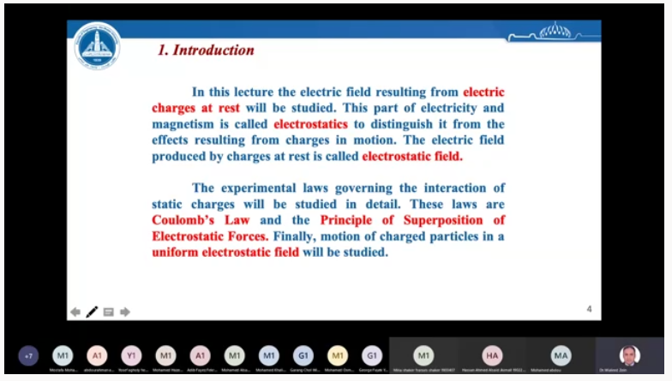
Figure 2: Screenshot of Interactive Lect. on Microsoft Teams

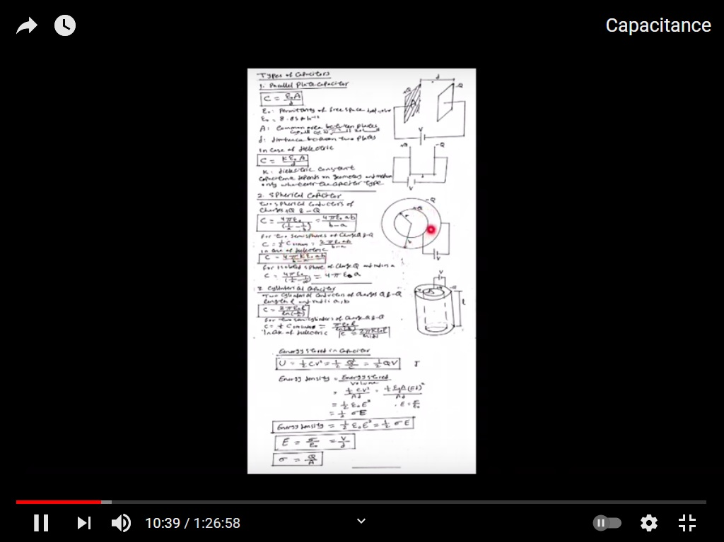
Figure 3: Screenshot Tutorial

Links to tutorials videos
  - https://youtu.be/Lli6EkSzIDQ
  - https://youtu.be/hQtQuuSJaO4
  - https://youtu.be/E070wtEDvXY
  - https://youtu.be/5wy-bWTEneU

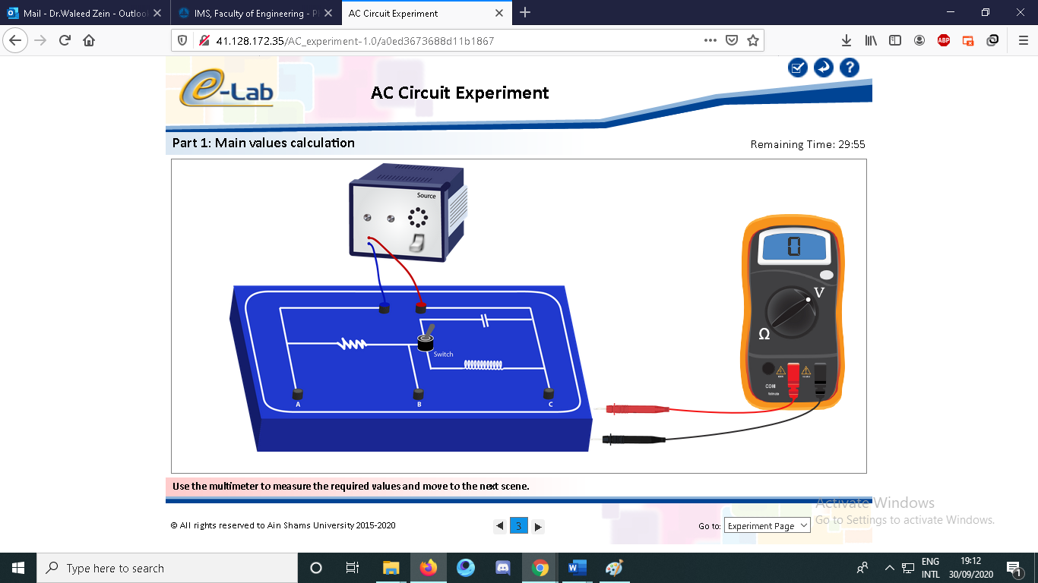

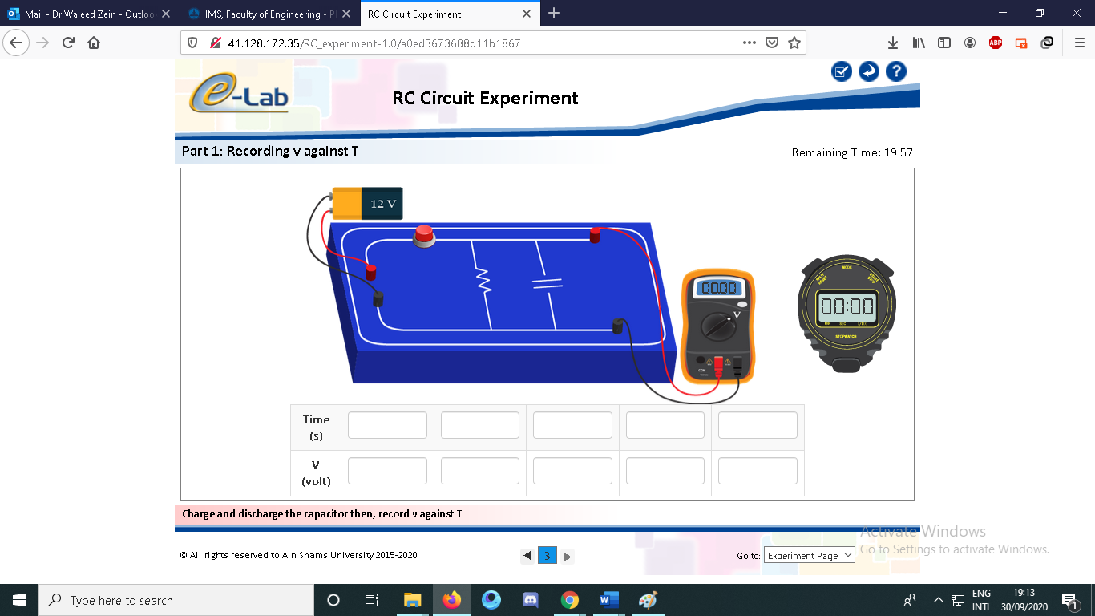
Figure 4: Screenshot of Online electronic Laboratory

Case Study:
Other assignments/homework: NA

Student assessment:
Method of assessment | Percentage of total
Written examinations (final + midterm) | 75 %
Online Quizzes | 6 %
Lab Reports | 4 %
Lab Exam | 15%

Members of examination committee
i – Dr.Waleed Zein

Role of external evaluator
N/A………………………………………………………………………………………….

Facilities and teaching materials:

Totally adequate

Adequate to some extent
x
Inadequate

List any inadequacies

Administrative constraints:
List any difficulties encountered
No difficulties

Student evaluation of the course:

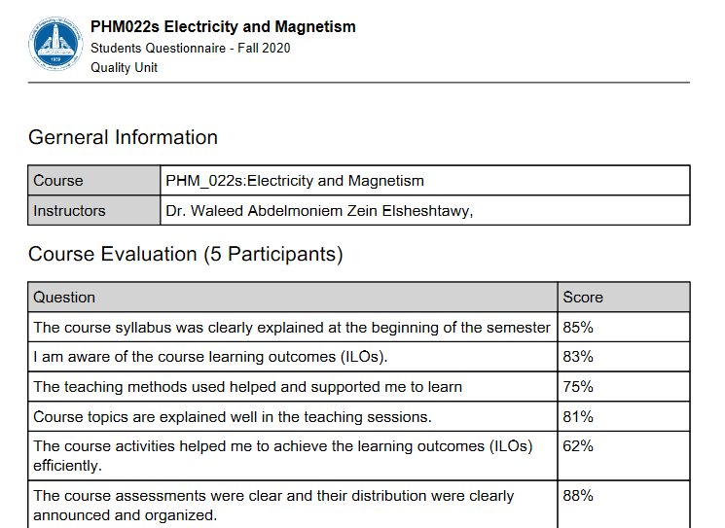
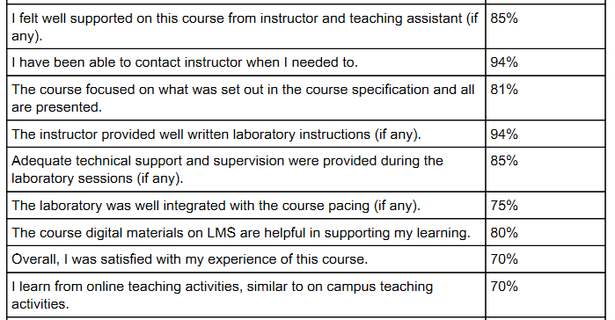

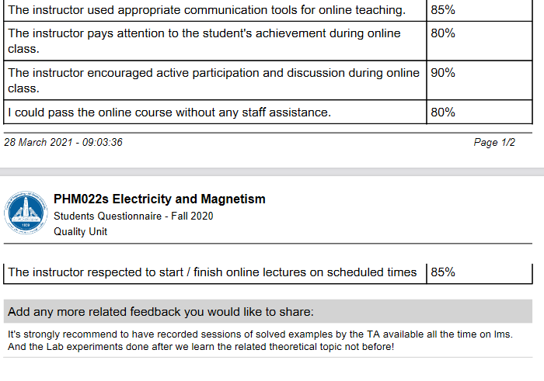

Response of Course Team

Comments from external evaluator(s): Response of course team
………N/A ………………. …………………………….

