Course report of
Mathematics (2) – PHM 013s Fall 2020
University: Ain Shams | Faculty: Engineering

Basic Information
- Title and code :
Mathematics (2) – PHM 013s
- Program on which the course is given :
All Programs

- Year/Level of programs :
1st Level
- Units/Credit Hours
( i ) Lecture : | 3

( ii ) Tutorial/Practical : | 2

( iii ) Total : | 5
- Names of lecturers contributing to delivery of the course :
i - | Professor Dr. Niveen Badra

ii - | Dr. Hussain Abd ElSalam

iii -

Course coordinator: | Professor Dr. Niveen Badra

External evaluator: | --- --- ---

Statistical Information

No. of students attending the course: | 208

 | A+ | A | A- | B+ | B | B- | C+ | C | C- | D+ | D | F | --- | SUM
Students No. | 1 | 2 | 4 | 15 | 14 | 13 | 10 | 14 | 11 | 13 | 41 | 75 | --- | 208
Percentage (%) | 0.5 | 1 | 2 | 7 | 7 | 6 | 5 | 7 | 5.5 | 6 | 19 | 35 | ---

C-Professional Information

Course Teaching:
Course Content | No. of Hours | Lecturer
Lectures and Online Tutorials 1-4:  Functions of Several Variables-Partial Derivatives | 20 | Dr. Hussain
Lectures and Online Tutorials 5-7:  Double Integration and Applications | 15 | Dr. Hussain
Lectures and Online Tutorials 8-9:  Triple Integration – Line Integrals | 10 | Dr. Hussain
Lecture and Online Tutorial 10:  Matrix Algebra and Applications | 5 | Dr. Hussain
Lectures and Online Tutorials 11-12:  Eigen values and Eigen vectors | 10 | Dr. Hussain
Lecture and Online Tutorial 13:  Eigen values and Eigen vectors and General Revision | 5 | Dr. Hussain
Total | 65

Topics taught as a percentage of the content specified:

>90 % X 70-90 % <70%

Reasons in detail for not teaching any topic
All topics were taught ……………………………………….
………………………………………………………………………………………………
………………………………………………………………………………………………

If any topics were taught which are not specified, give reasons in detail
N/A………………………………………………………………………………………….
………………………………………………………………………………………………
………………………………………………………………………………………………

Teaching and learning methods:
Lectures: (Face to Face) X
Practical training/ laboratory:
Seminar/Workshop:
Class Activity: (Tutorials) (Online) X

Case Study:
Other assignments/homework:
If teaching and learning methods were used other than those specified, list and give reasons:
………………………………………………………………………………………………
………………………………………………………………………………………………

Student assessment:
Method of assessment | Percentage of total
Online Assignments 1 – 5 | 10
Online Attendance and Participation | 5
Online Quizzes 1-2 | 5
Written Mid Term | 20
Written Final Term Exam | 60

Members of examination committee
i - Professor Dr. Niveen Badra
ii – Dr. Hussain Abd El-Salam

Role of external evaluator
N/A………………………………………………………………………………………….
………………………………………………………………………………………………

Facilities and teaching materials:
Totally adequate X

Adequate to some extent

Inadequate

List any inadequacies

Administrative constraints:
List any difficulties encountered
No difficulties

Student evaluation of the course:
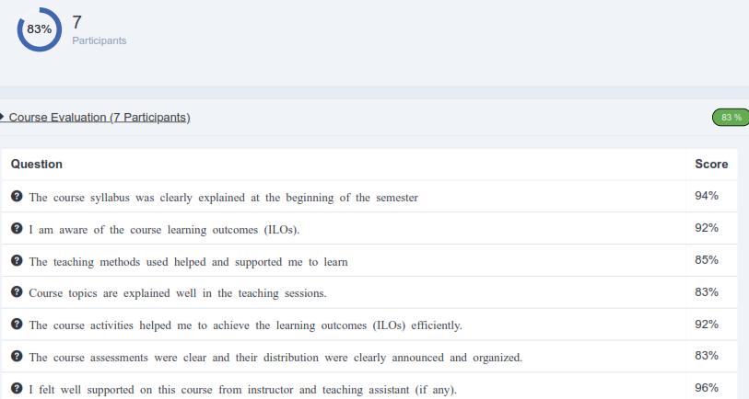
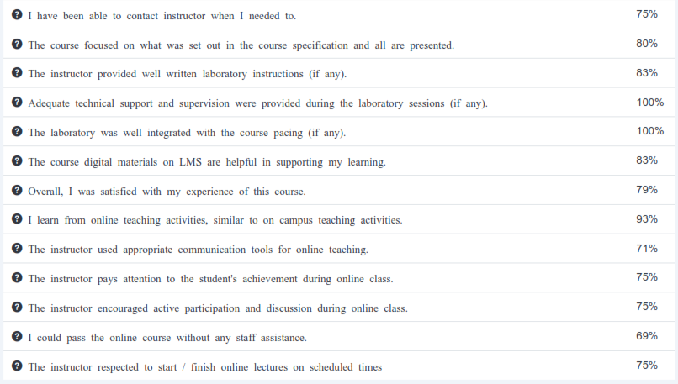

Response of Course Team

List any criticisms
…No criticism.…….………..……………………………….
………………………………………………………………………………………………

Comments from external evaluator(s): Response of course team
………N/A ………………. …………………………….
……….……………..……. …………………………….

