Course report of
Mathematics (1) – PHM 012s Fall 2020
University: Ain Shams | Faculty: Engineering

Basic Information
- Title and code :
Mathematics (1) – PHM 012s
- Program on which the course is given :
All Programs

- Year/Level of programs :
1st Level
- Units/Credit Hours
( i ) Lecture : | 3

( ii ) Tutorial/Practical : | 2

( iii ) Total : | 5
- Names of lecturers contributing to delivery of the course :
i - | Professor Dr. Niveen Badra – Dr. Hussain - Dr. Fayza Selim

ii - | Dr. Nadia Anwar – Dr. Ashraf Kattab – Dr. Betty Nagy

iii -

Course coordinator: | Professor Dr. Niveen Badra

External evaluator: | --- --- ---

Statistical Information
No. of students attending the course: | 1708

 | A+ | A | A- | B+ | B | B- | C+ | C | C- | D+ | D | F | --- | SUM
Students No. | 198 | 158 | 192 | 213 | 144 | 166 | 98 | 96 | 88 | 66 | 95 | 193 | --- | 1708
Percentage (%) | 12 | 9 | 11 | 12 | 8 | 10 | 6 | 6 | 5 | 4 | 6 | 11 | ---

The Ratio A⁺ , A , A⁻ 32% as the students were interesting in Online Teaching with both instructors and TA.

Professional Information

Online Course Teaching:
Course Content | No. of Hours | Lecturer
Online Lectures and Tutorials 1-3:  Differentiation and Integration Formulas – Fundamental Theorem of Calculus  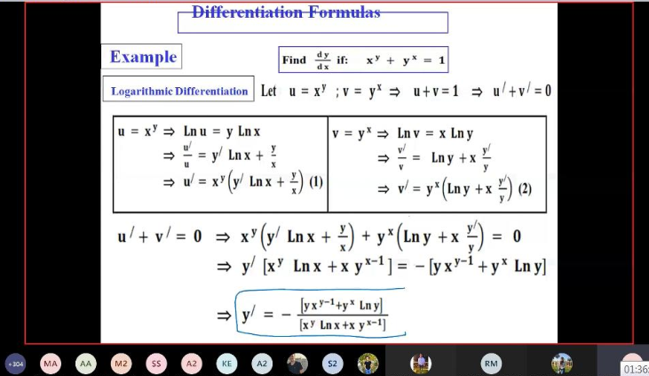  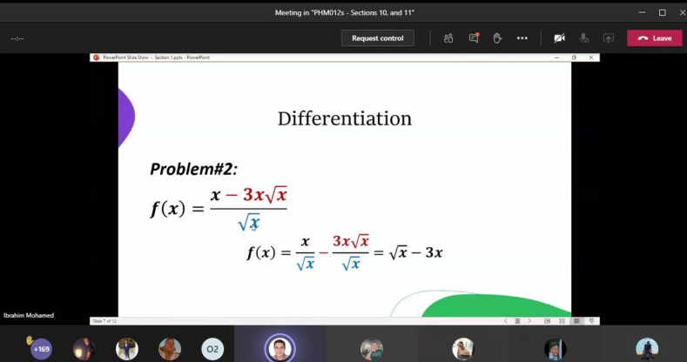 | 15 | Prof. Niveen Badra  Dr. Fayza Selim  Dr. Nadia Anwar  Dr. Ashraf Kattab  Dr. Betty Nagy
Online Lectures and Tutorials 4-7:  Inverse Functions – Inverse Trig Functions- Hyperbolic Functions  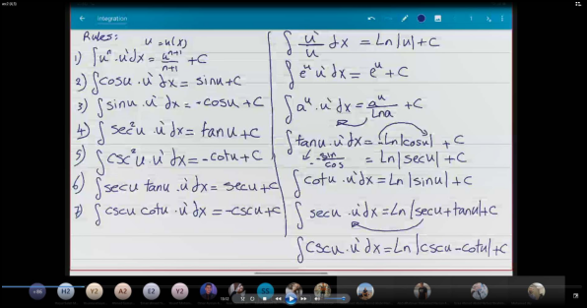  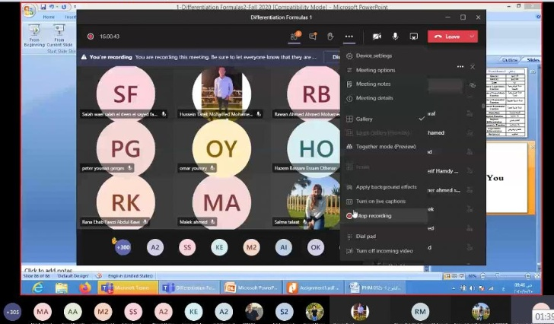  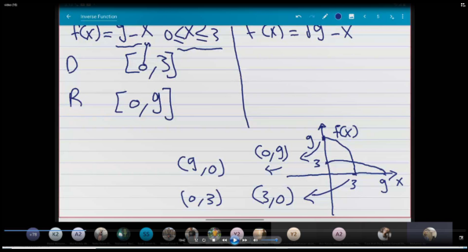  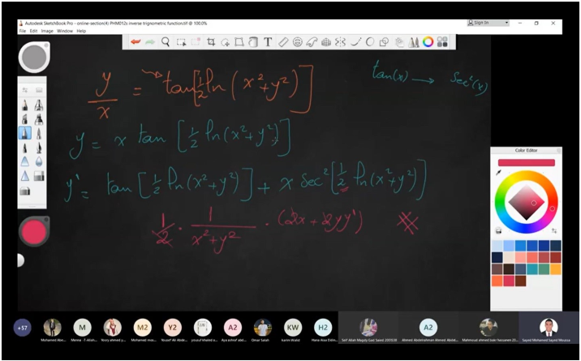 | 20 | Prof. Niveen Badra  Dr. Fayza Selim  Dr. Nadia Anwar  Dr. Ashraf Kattab  Dr. Betty Nagy
Online Lectures and Tutorials 8-11:  L’Hopital Rule -Techniques of Integrations  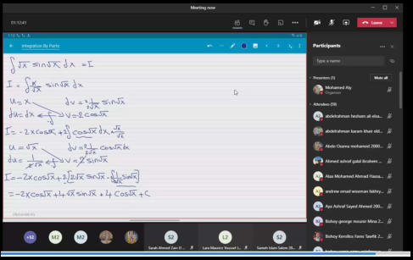  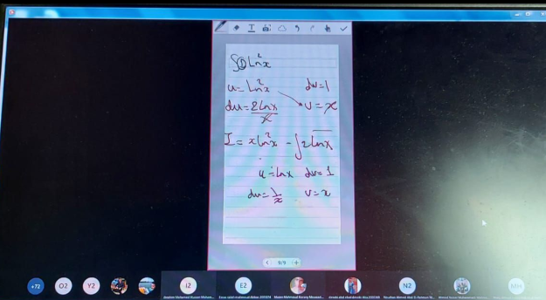  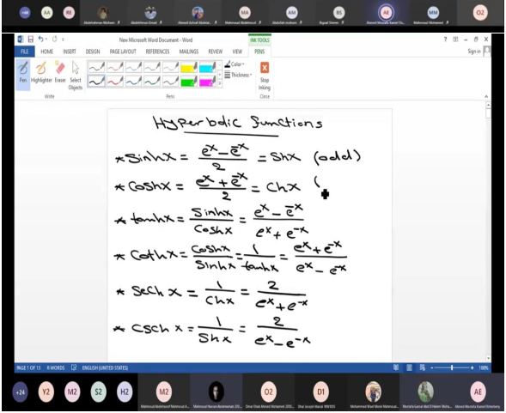  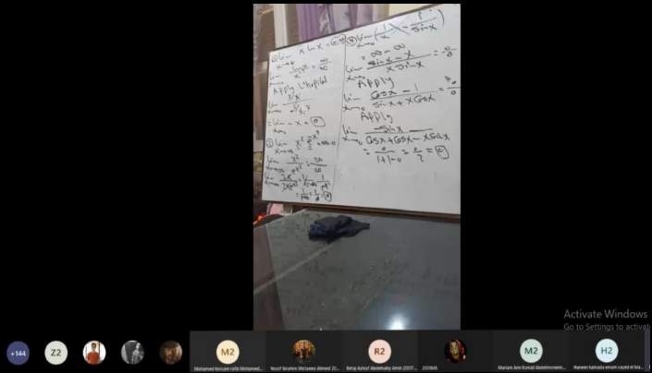 | 20 | Prof. Niveen Badra  Dr. Fayza Selim  Dr. Nadia Anwar  Dr. Ashraf Kattab  Dr. Betty Nagy
Online Lecture and Tutorial 12-13: Conic Sections and General Revision  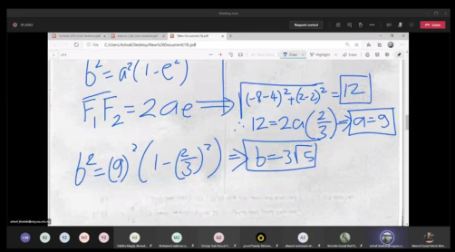  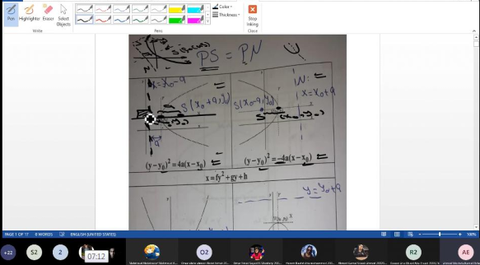  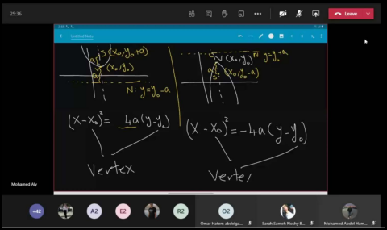 | 10 | Prof. Niveen Badra  Dr. Fayza Selim  Dr. Nadia Anwar  Dr. Ashraf Kattab  Dr. Betty Nagy
Total | 65

Topics taught as a percentage of the content specified:

>90 % X 70-90 % <70%

Reasons in detail for not teaching any topic
All topics were taught ……………………………………….
………………………………………………………………………………………………
………………………………………………………………………………………………

If any topics were taught which are not specified, give reasons in detail
N/A………………………………………………………………………………………….
………………………………………………………………………………………………

Teaching and learning methods:
Lectures: (Online Sessions) X
Practical training/ laboratory:
Seminar/Workshop:
Class Activity: (Tutorials) (Online) X

Case Study:
Other assignments/homework:
If teaching and learning methods were used other than those specified, list and give reasons:
………………………………………………………………………………………………

Student Assessments:
Method of assessment | Percentage of total
Assignments 1 – 5 | 10
Attendance and Participation | 5
Online Quizzes 1-2 | 5
Written Mid Term | 20
Written Final Term Exam | 60

Members of examination committee
i - Professor Dr. Niveen Badra
ii – Dr. Hussain Abd El-Salam
iii – Dr. Fayza Selim
iv – Dr. Nadia Anwar
v – Dr. Ashraf Kattab
vi – Dr. Betty Nagy

Role of external evaluator
N/A………………………………………………………………………………………….
………………………………………………………………………………………………

Facilities and teaching materials:
Totally adequate X

Adequate to some extent

Inadequate

List any inadequacies

Administrative constraints:
List any difficulties encountered
No difficulties

Student evaluation of the course:

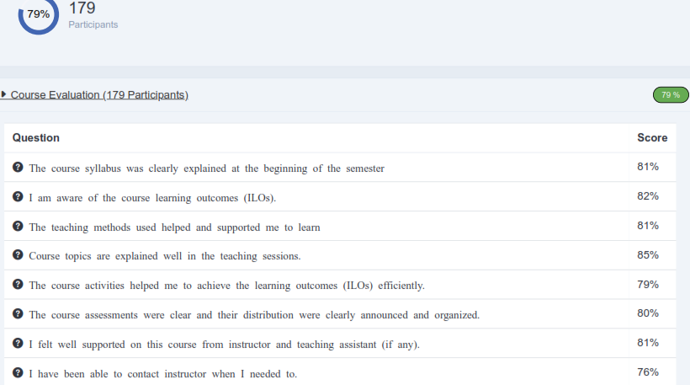
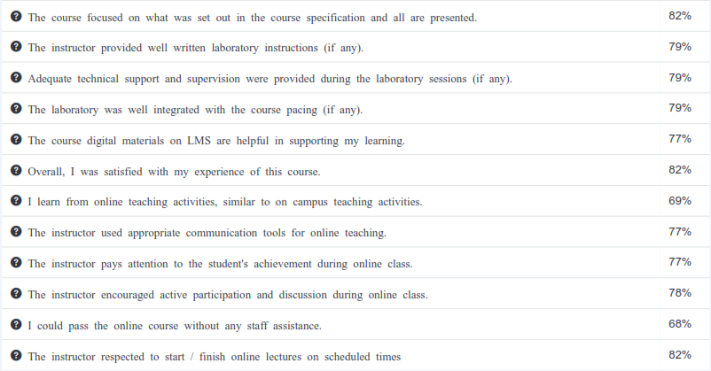

Response of Course Team

List any criticisms
…No criticism.…….………..……………………………….
………………………………………………………………………………………………

Comments from external evaluator(s): Response of course team
………N/A ………………. …………………………….
……….……………..……. …………………………….

