Course report of
Introduction to Marketing –HUM212/ASU333 – Spring 2021
University: Ain Shams | Faculty: Engineering

Basic Information
- Title and code :
Introduction to Marketing – HUM212/ ASU333
- Program on which the course is given :
All Programs

- Year/Level of programs :
All
- Units/Credit Hours
( i ) Lecture : | 2

( ii ) Tutorial/Practical : | 2

( iii ) Total : | 4
- Names of lecturers contributing to delivery of the course :
Prof.Dr. Eng. Nahid Hussein Afia Abdel Halim
Dr. Ismail Hafez

Course coordinator: | Prof.Dr. Eng. Nahid Hussein Afia Abdel Halim

External evaluator: | N/A

Statistical Information

I think that the percentage grade distribution is reasonable. Most of the 47 students are senior and do all their best to get high grades. Mainly their GPA is high. Moreover, students are well trained and they have lots of exam models available to them on the portal. As many students have got A-, A and A+; there are others have got the other grades.

Professional Information

Course Teaching: Actually 13 weeks (13*4= 52) due to Corona pandemic
No | Course Content | Lectures | Tutorials | Total
1 | Introduction to marketing and main concepts | 2 | 2 | 4
2 | Perceived value and consumer analysis | 4 | 4 | 8
3 | Market segmentation positioning& Strategic marketing plan | 4 | 4 | 8
4 | Product Management | 4 | 4 | 8
5 | Pricing | 4 | 4 | 8
6 | Price Elasticity of demand | 2 | 2 | 4
7 | Distribution/ Supply Chain | 2 | 2 | 4
8 | Promotion | 2 | 2 | 4
9 | Marketing by the numbers/ KPI’s | 2 | 2 | 4
 | Total Hours | 26 | 26 | 52

Topics taught as a percentage of the content specified:

>90 % • 70-90 % <70%

Reasons in detail for not teaching any topic
N/A

If any topics were taught which are not specified, give reasons in detail

Teaching and learning methods:
On line learning for lectures and tutorials. The two quizzes and midterm exam were in campus
Lectures: X
Practical training/ laboratory:
Seminar/Workshop:
Class Activity: (Tutorials) X

Case Study:
Other assignments/homework:
If teaching and learning methods were used other than those specified, list and give reasons:
A couple of reports were submitted upon the instructor's request to enhance the students' ability of self-learning, searching for information and off-class readings

Student assessment:

Assessment Method | Description | Weight (%)
Assignments 1to 3 | Assignments | 20%
Quizzes | Written exam | 10%
Midterm | Written exam | 25%
Participation | Students attendance on line Microsoft teams | 5%
Final term exam | Written exam | 60%

Method of assessment | Percentage of total
Written examination | 40 %
Oral examination | 0 %
Practical/laboratory work | 0 %
Other assignments/class work | 60 %

Facilities and teaching materials:
Totally adequate

Adequate to some extent X

Inadequate

List any inadequacies: The weakness of internet network

On line teaching activities

Due to Covid-19, the (Blended learning strategy) has been followed. Therefore, the lectures have been introduced online via Microsoft Teams on the following link:
ASU333/HUM212/HUMN361
https://teams.microsoft.com/l/team/19%3a77113db4f4ff438d85c4eb4da932126f%40thread.tacv2/conversations?groupId=f5e131fa-dc0a-4b59-8202-62eab33f990e&tenantId=ad2a8324-bef7-46a8-adb4-fe51b6613b24
Online teaching activities

21 3 2021
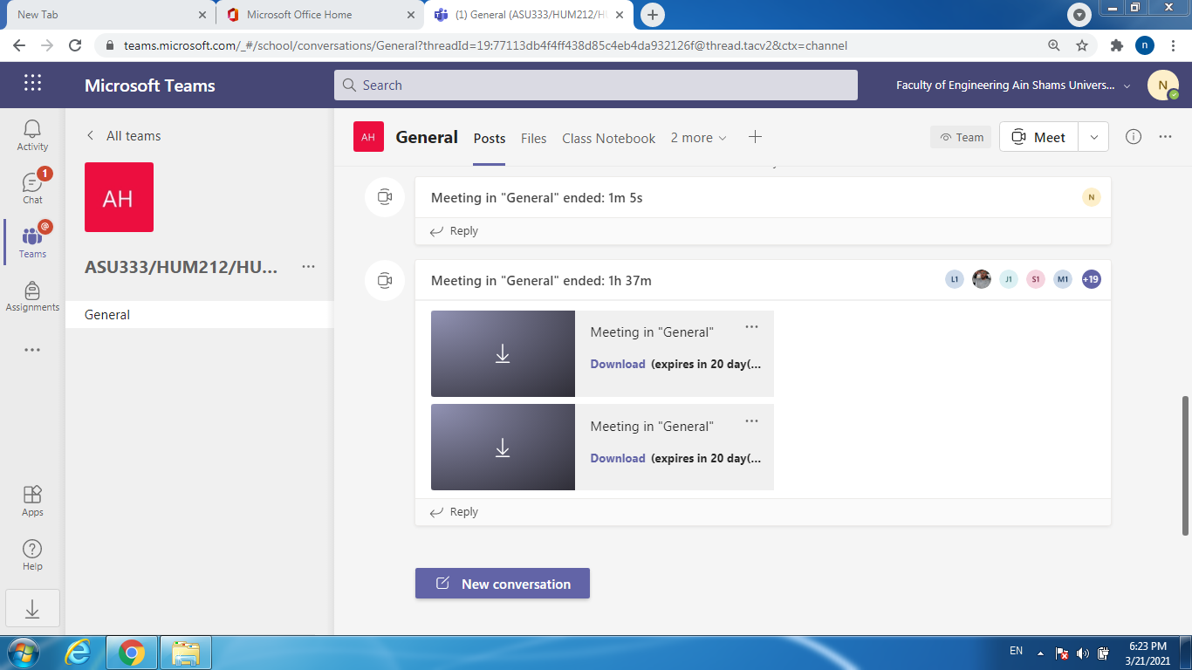
28 3 2021
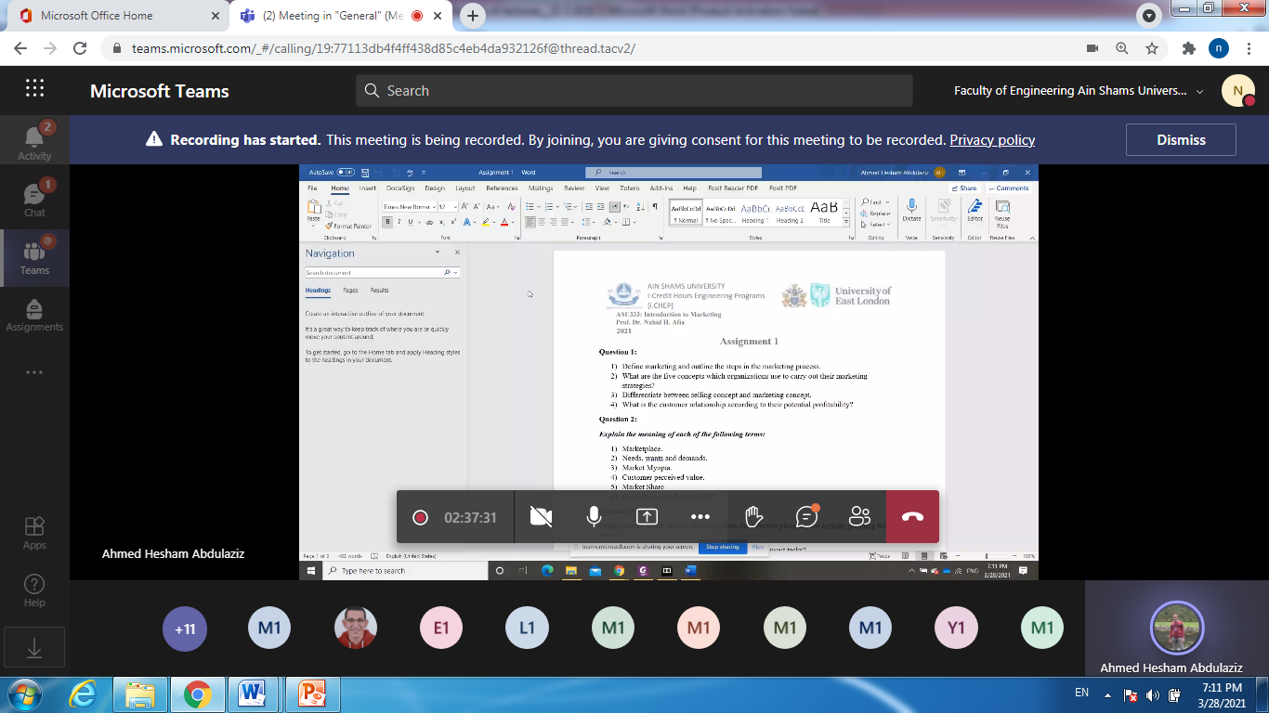

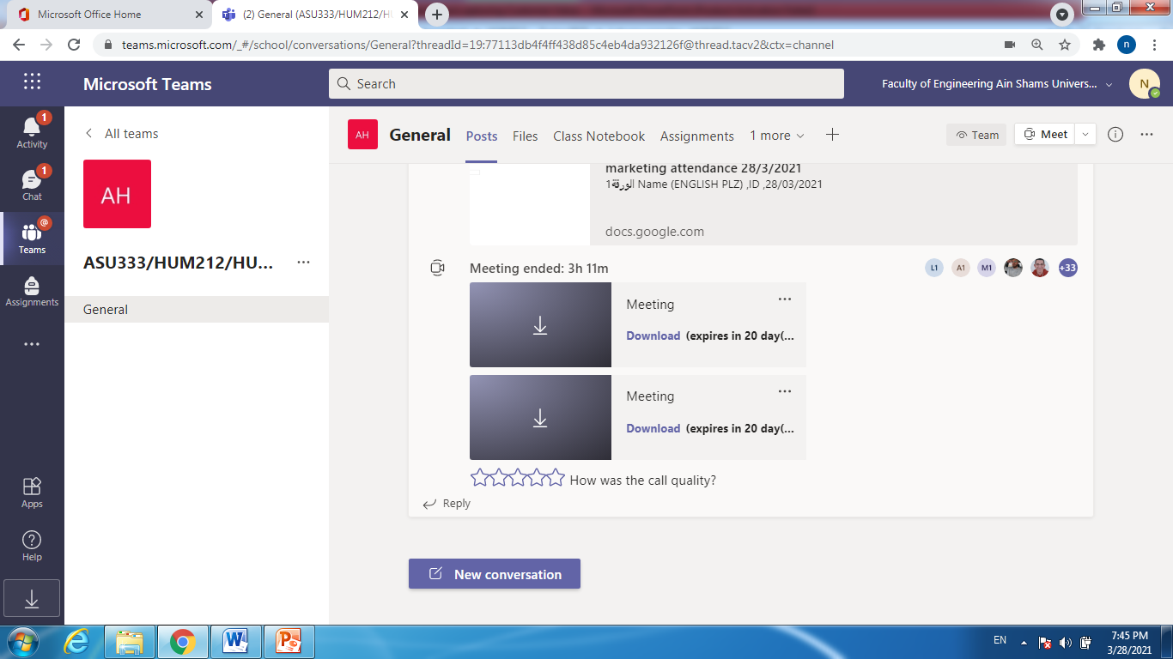
4 April 4, 2021
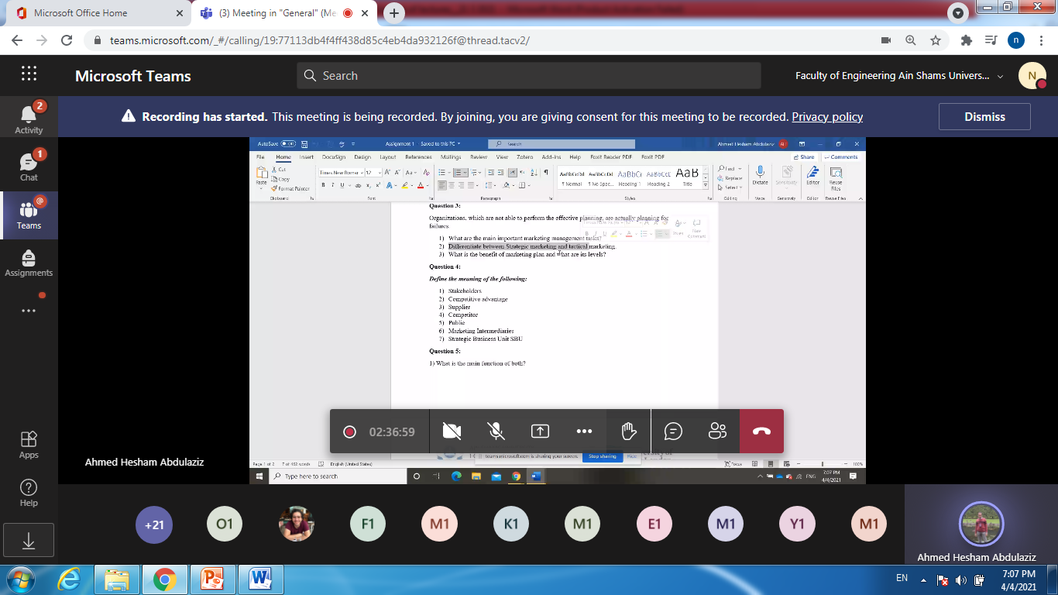

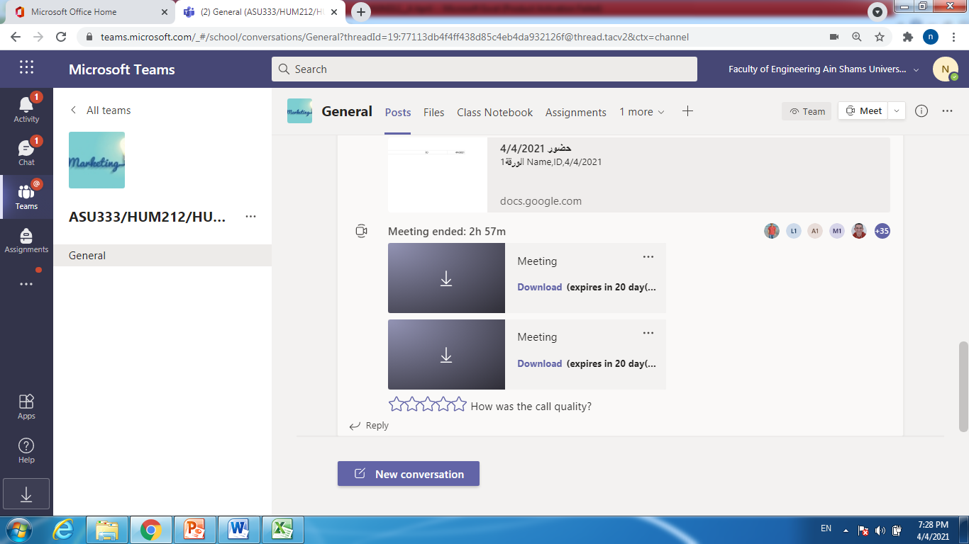
11 4 2021
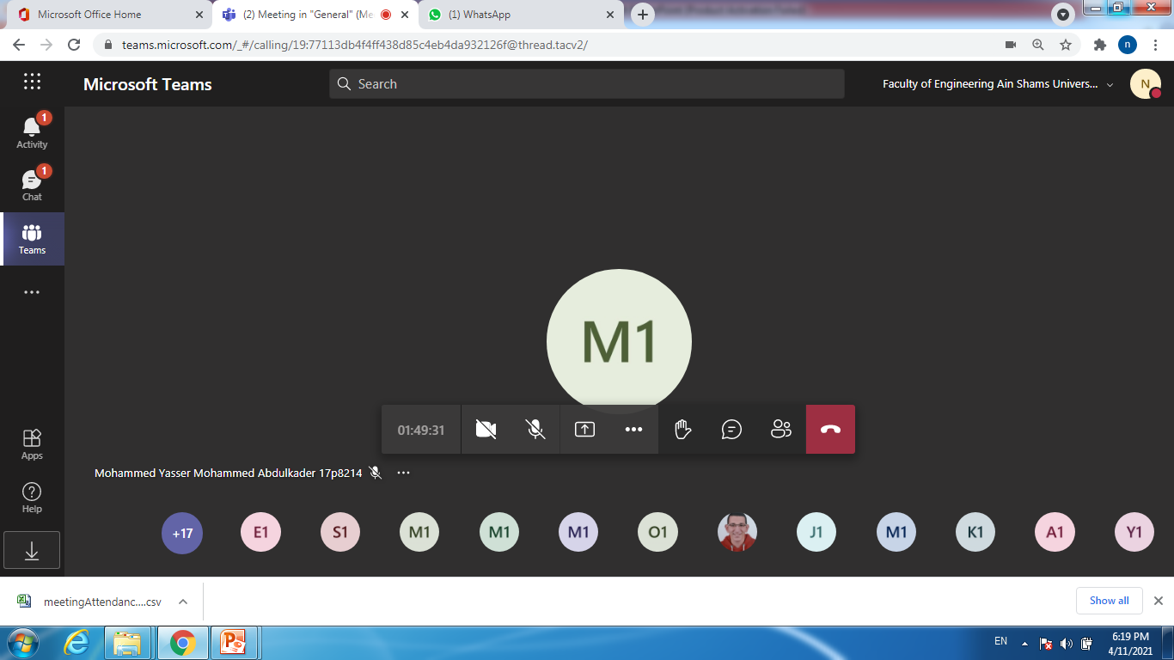

18 4 2021
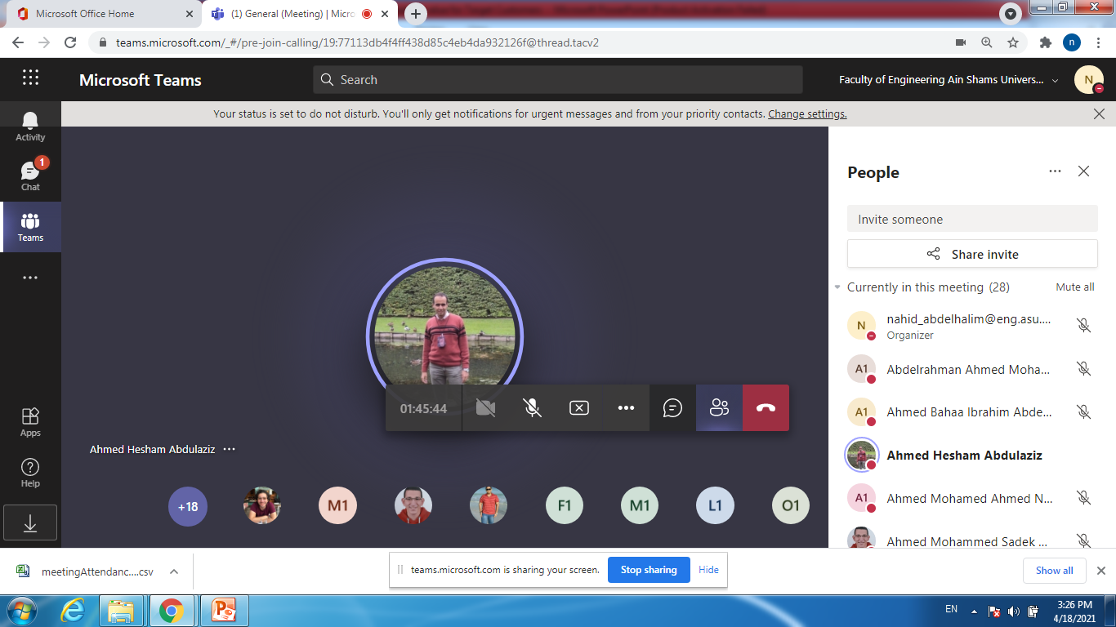
25 4 2021
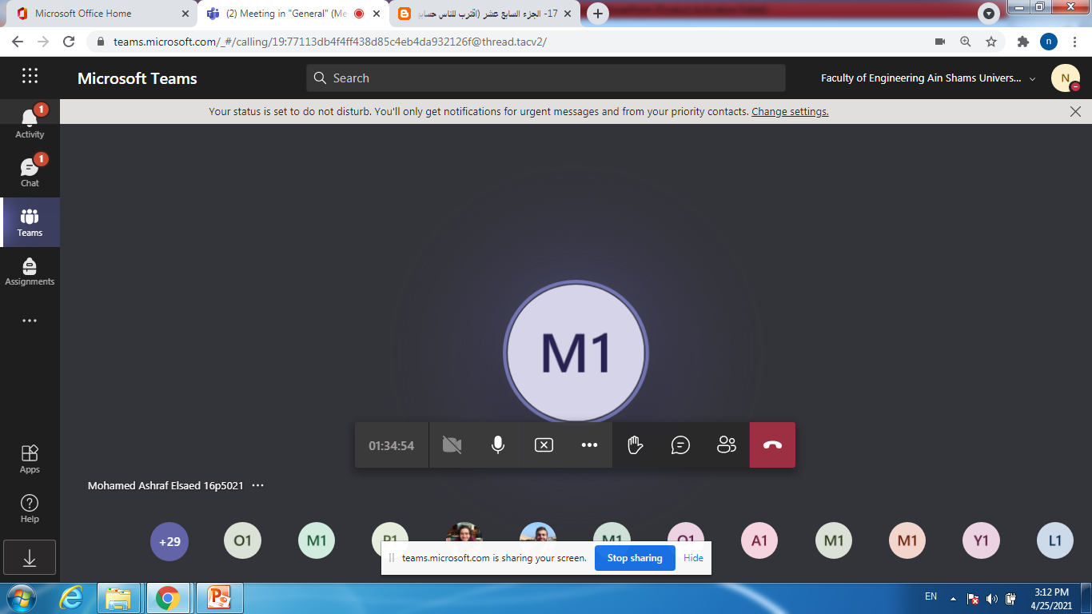

23 5 2021
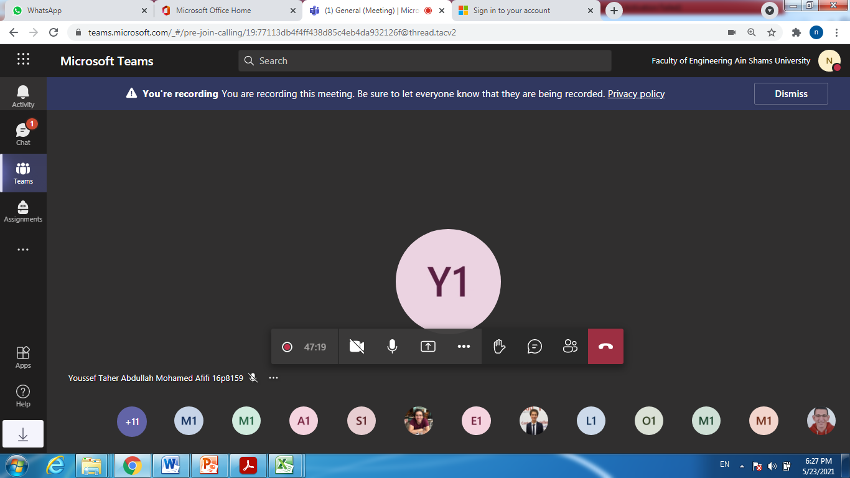

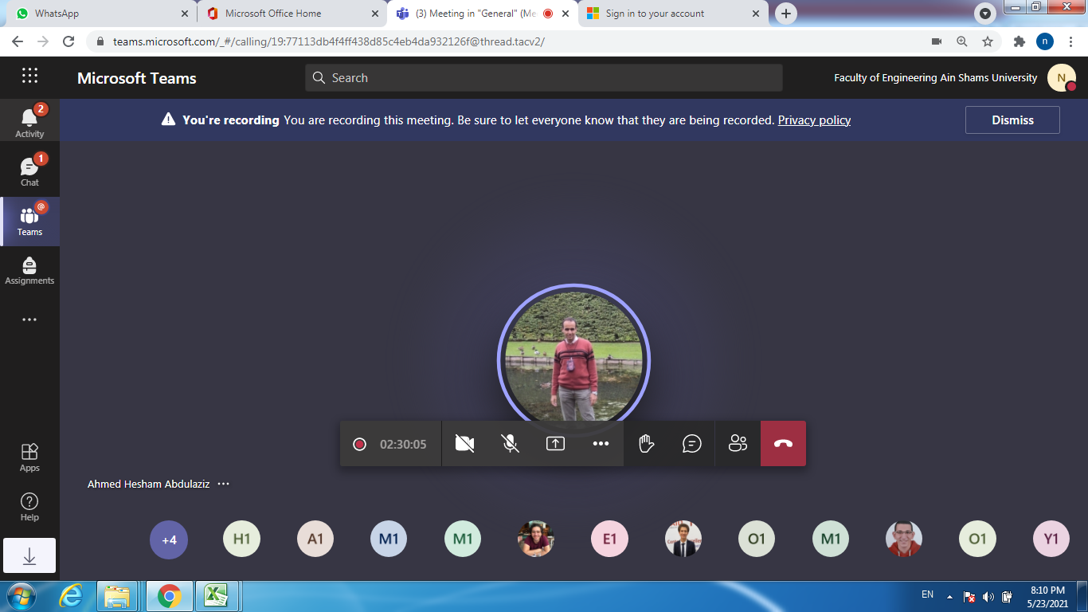
30 5 2021
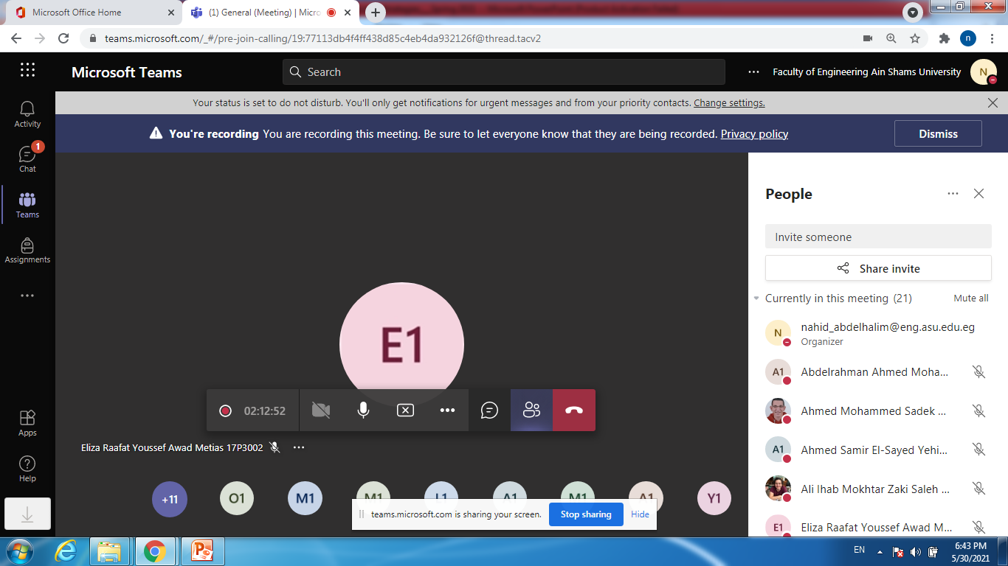

6 6 2021
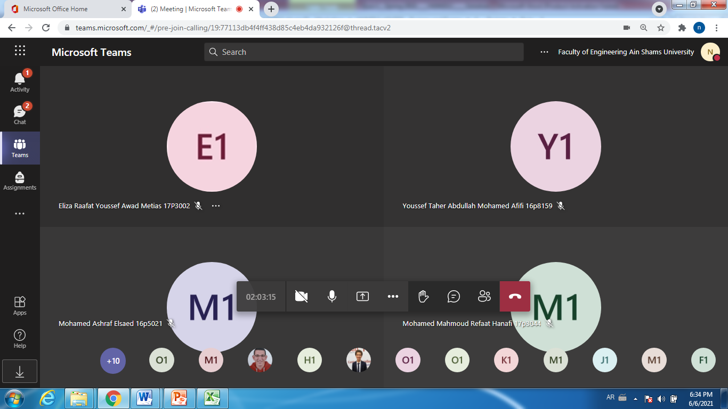

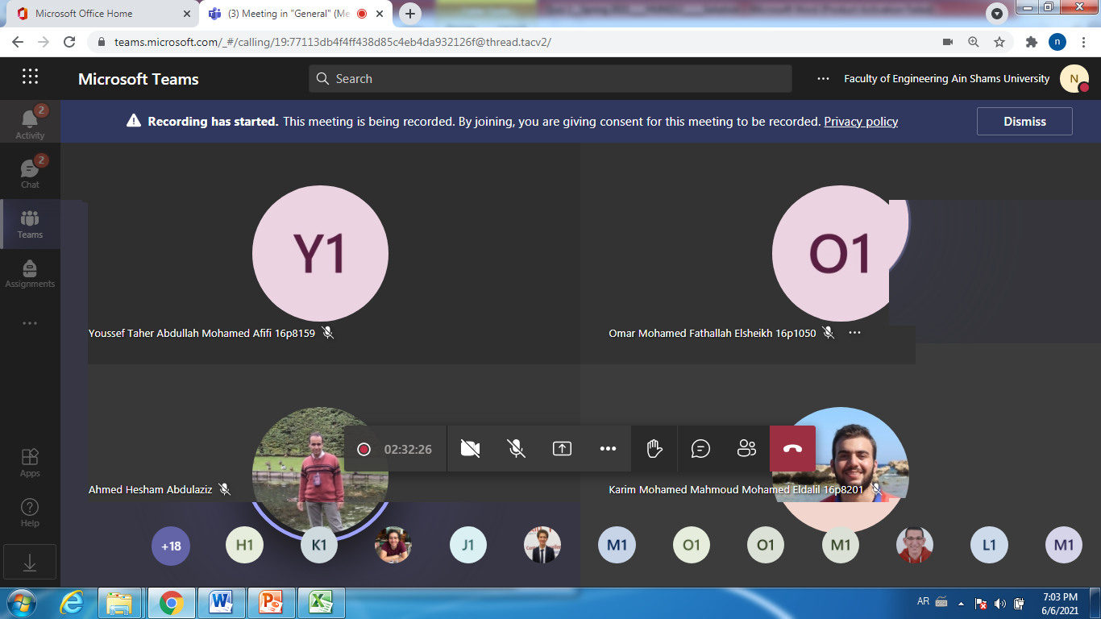

13 6 2021
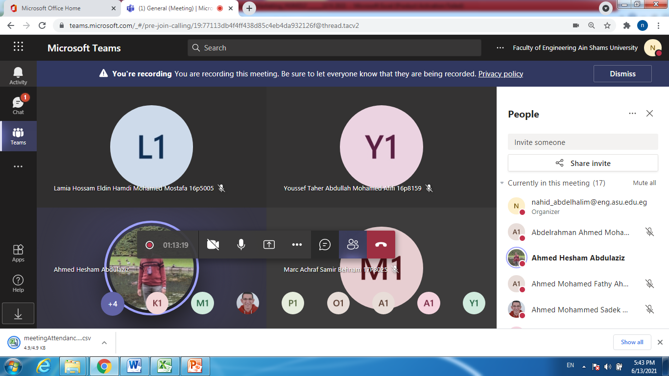

All lectures and tutorials were uploaded on Microsoft team

It is valuable to mention that the tutorials and lectures were of the same link as the tutorial started after the lecture directly

- Online activities instructor feedback
According to attendance and participation, in fact most of them were senior students; they were punctual and did all their best.

Sample of attendance:

On line lectures and tutorials, due to the impact of coronavirus pandemic, in many cases, we face the usual problems of internet. Sometimes, they couldn’t hear me well. Some students complain that suddenly at their homes, the net is off and he couldn’t follow us or they couldn’t upload the required assignments on time. I tried to compensate those problems by uploading all lectures on LMS and in some cases voice lectures. Moreover, they could send their solved assignment by mail before the due date.

- Instructor action plan for finding required improvement
I hope that we could return to our campus as soon as possible to teach face to face in halls and rooms. Really, the environment is different.
In general nothing needed until now and we are waiting for the End-Term questionnaire to clarify the picture more.

Administrative constraints:
List any difficulties encountered: NA

Student evaluation of the course:
The comments of Mid-course comments are attached in a separate file titled as:

Comments(1)_HUM212_Midterm Questionnaire.pdf

- Few comments of students most of them is positive.
- I discussed with them that on line lectures is urgent due the Pandemic Corona 2020. They complaint sometimes about the weakness of internet.
- One of them asks if we could attend on campus.
- Students mentioned that they enjoyed with the detailed description of the lectures. They enjoyed the material and cooperation of me with them

According to End term questionnaire:

All percentages are above 50%. No complaints

Referring to the limited comments of students:

I think that the course is important to all majors

In fact I couldn’t understand this comment, the assignments covered the entire course and 2 quizzes were held.

This comment is from the same student, all the questions were very clear and many students have got excellent marks. The quizzes were online, so limited questions were depended on the understanding to avoid cheating. Lazy students always complain as they want direct questions to copy the answer as it is from the notes and lectures.

Response of Course Team

List any criticisms
Comments from external evaluator(s): Response of course team
………N/A ………………. …………………………….

Members of examination committee
Prof.Dr.Eng. Nahid Hussein Afia Abdel Halim

Role of external evaluator: N/A

