Course report of

Engineering History & Technology – ASU 324 Fall 2020

University Ain Shams | Faculty of Engineering

A- Basic Information

Title and code:

Engineering History & Technology – ASU 324

Program(s) on which this course is given: All Programs

3. Year/ Level of programs: All Levels

1. Units/Credit hours:

Lectures 2 hours per week

Tutorial/Practical 1 hours per week

Total 2 hours per week

2. Names of lecturers contributing to the delivery of the course

Dr Ahmed Hassan Yakout

Course coordinator: Dr Ahmed Hassan Yakout

External evaluator ………N/A……………………

B- Statistical Information

No. of students attending the course: | 705

 | A+ | A | A- | B+ | B | B- | C+ | C | C- | D+ | D | P | F | SUM
Students No. | 0 | 5 | 9 | 20 | 12 | 20 | 14 | 7 | 7 | 8 | 14 | 23 | 46 | 185
Percentage (%) | 0 | 3 | 5 | 11 | 6 | 11 | 8 | 4 | 4 | 4 | 8 | 12 | 24

C- Professional Information

C.1 – Course Lectures
Course Content | No. of Hours | Lecturer
Introduction to Engineering | 3 | Dr. Ahmed Hassan Yakout
Prehistoric Engineering | 6 | Dr. Ahmed Hassan Yakout
Ancient Engineering | 6 | Dr. Ahmed Hassan Yakout
Medieval Engineering | 6 | Dr. Ahmed Hassan Yakout
Renascent Engineering | 6 | Dr. Ahmed Hassan Yakout
Expansive Engineering | 9 | Dr. Ahmed Hassan Yakout
Modern Engineering | 6 | Dr. Ahmed Hassan Yakout
Total | 42

Topics taught as a percentage of the content specified:

>90 % X 70-90 % <70%

Reasons in detail for not teaching any topic

N/A……………………………………….

If any topics were taught which are not specified, give reasons in detail
N/A……………………..

2- Teaching and learning methods:
Lectures (100% online)
Practical training/ laboratory:
Seminar/Workshop:
Class Activity: (100% online)

Case Study:
Other assignments/homework: Preparing a Report & Delivering a Presentation (Team Work)
If teaching and learning methods were used other than those specified, list and give reasons:
To enhance students research, and communication Skills

3- Student assessment:

Method of assessment | Percentage of total
Written examination (Final+ mid-term) | 80 %
Report | 10 %
Presentation | 10%

Members of examination committee

Dr. Ahmed Hassan Yakout

Role of external evaluator
…… N/A ………………………………
………………………………………

4- Facilities and teaching materials:
Totally adequate

Adequate to some extent

Inadequate

Microsoft teams Recorded Lectures and notes are available at the following Link on LMS
https://drive.google.com/drive/folders/1crXaARstJjHGg1VRORE3cc4sUAkRHeFy

Samples of print screens from online Lectures

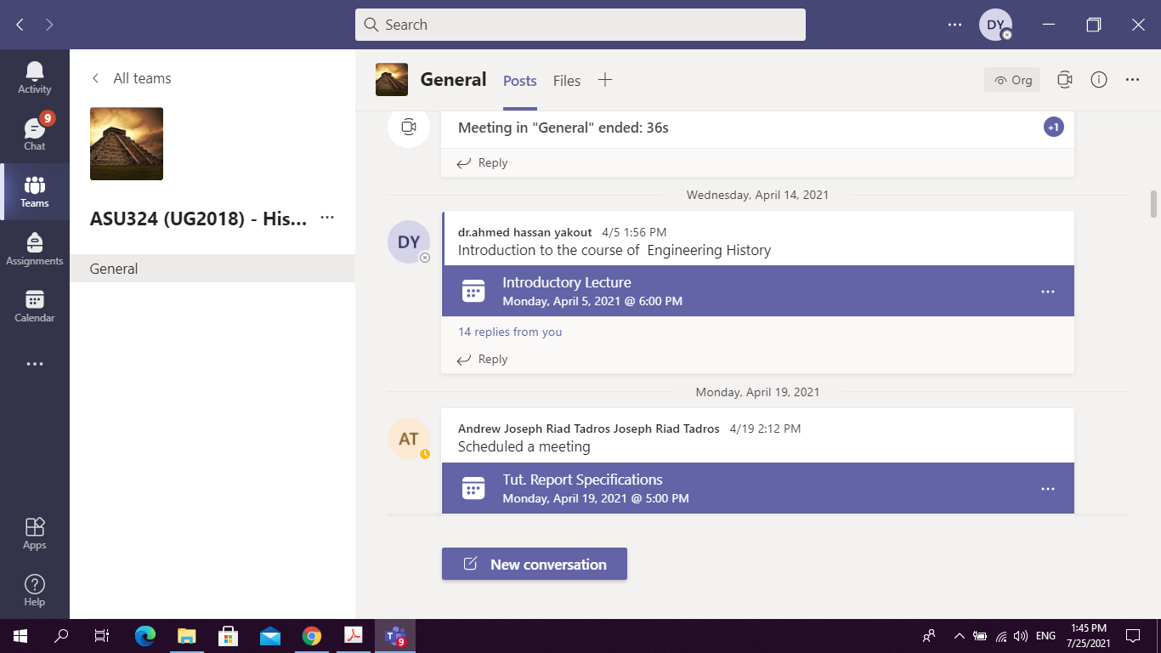

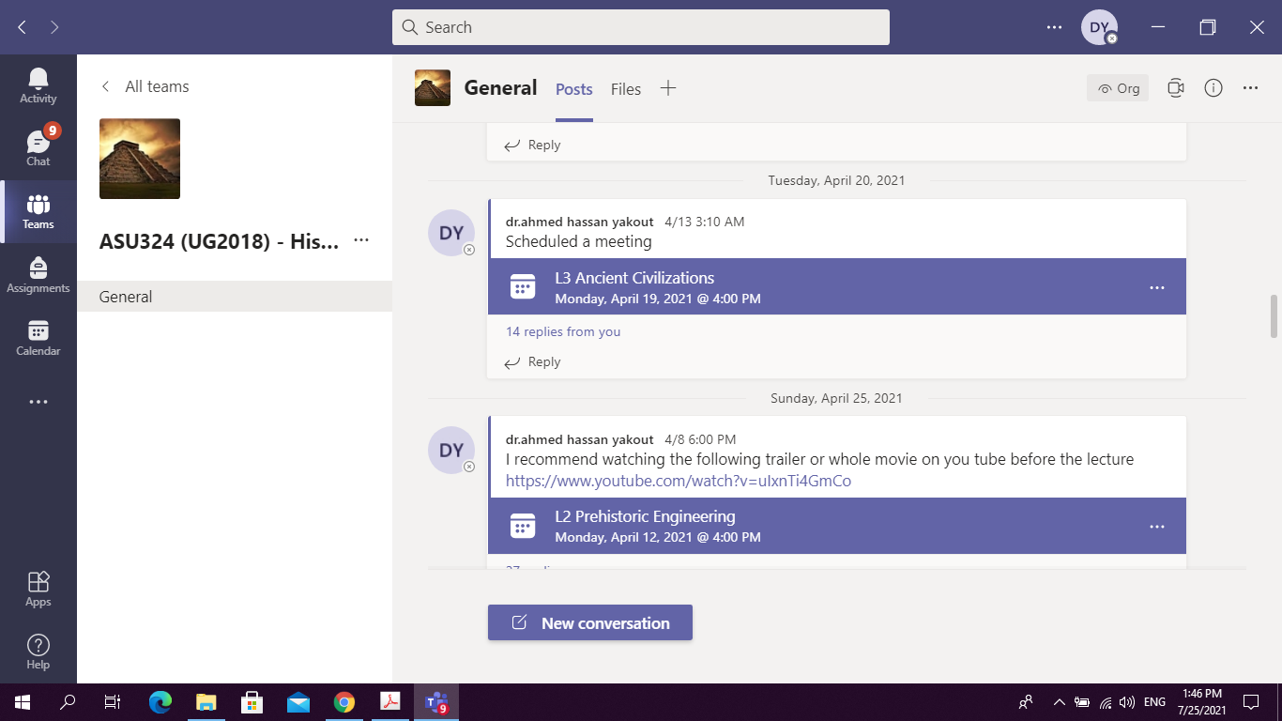

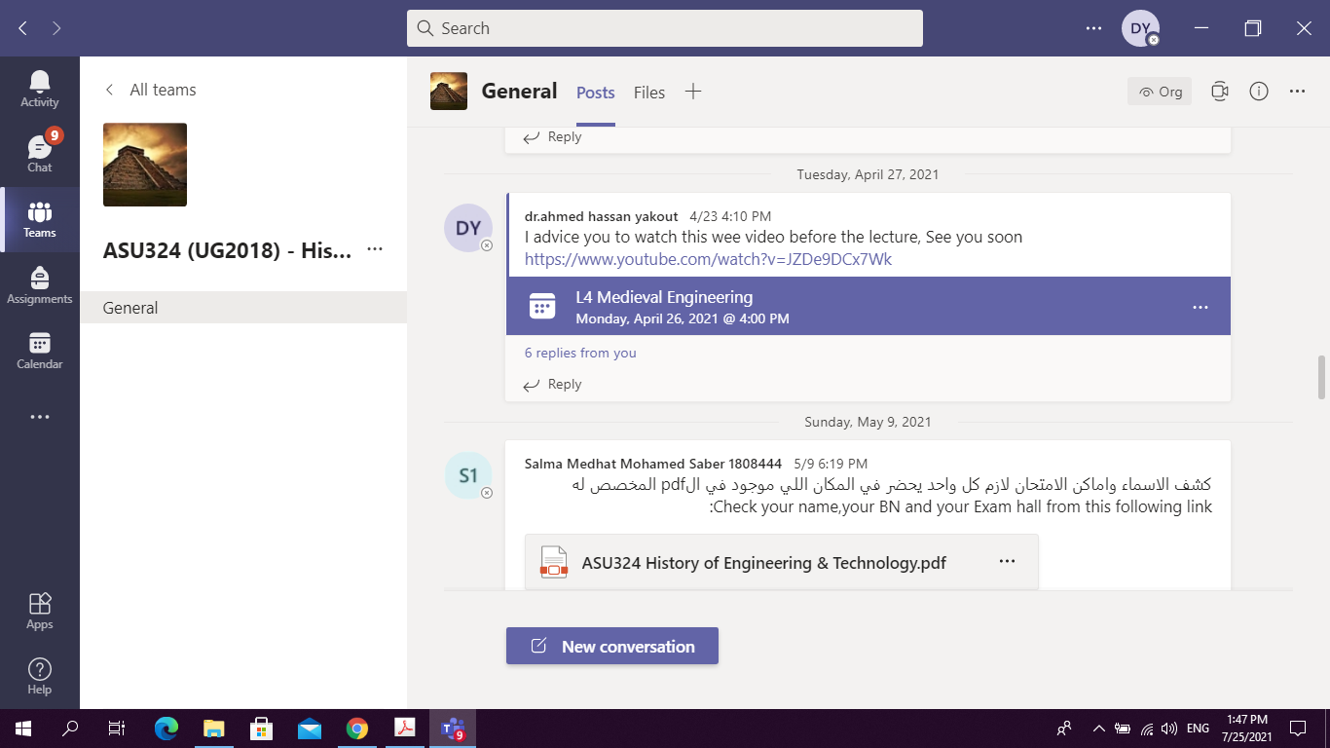

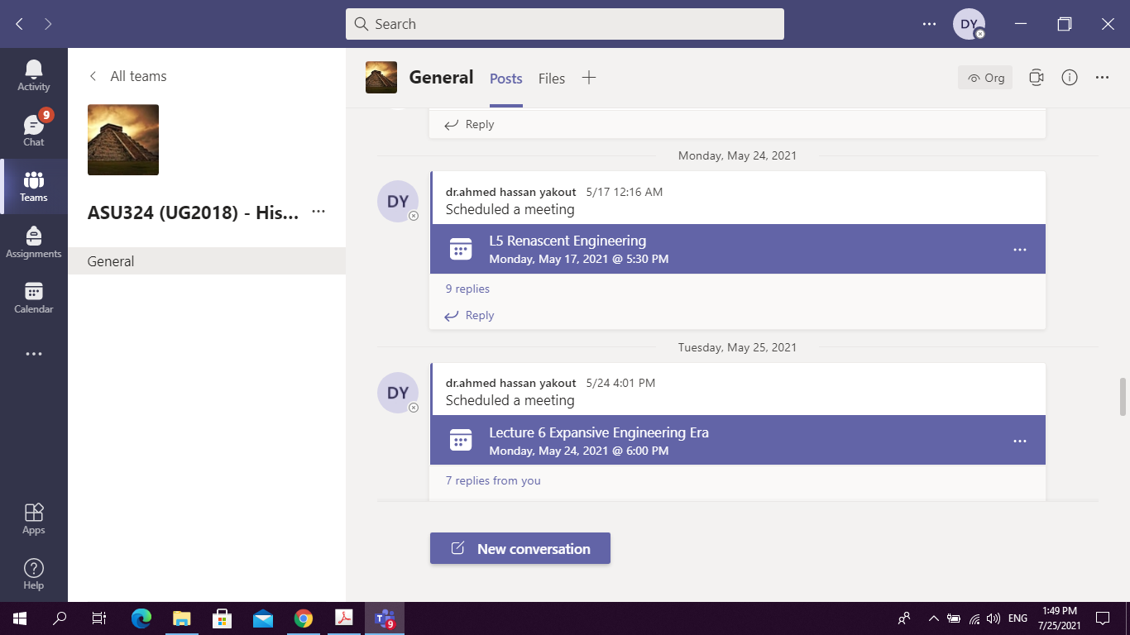

5- Administrative constraints
List any difficulties encountered
No difficulties

6- Student evaluation of the course:

Response of Course Team:

No response required (All comments are above 50 %)

7- Comments from external evaluator(s): Response of course team
N/A …………………….. …………………………….
……….……………..……. …………………………….
…………………………… …………………………….
……………………………. …………………………….
…………………………… …………………………….

8- Course enhancement: Progress on actions identified in the previous year’s action plan:
N/A …………………….. …………………………….
……….……………..……. …………………………….
…………………………… …………………………….
……………………………. …………………………….
…………………………… …………………………….

9- Action plan

Actions required Completion date Person responsible
……………………… ……………………… ………………………
……………………… ………………………
……………………… ……………………… ………………………

