Course report of
Professional Ethics and Legislation – ASU113– Fall 2020
University: Ain Shams | Faculty: Engineering

Basic Information
- Title and code:
Professional Ethics and Legislation – ASU113
- Program on which the course is given:
All

- Year/Level of program:
1st Level
- Units/Credit Hours
( i ) Lecture : | 2

( ii ) Tutorial: | 2

( iii ) Total : | 4
- Names of lecturers contributing to delivery of the course:
i - | Prof. Adel Agib Wassif  Dr. Ismail Hafez Dr. Micha

ii -

iii -

Course coordinator: | Prof. Adel Agib Wassif

External evaluator: | --- --- ---

Statistical Information
Grade | A+ | A | A- | B⁺ | B | B⁻ | C+ | C | C- | D⁺ | D | F | P | Total
No. of students | 0 | 8 | 100 | 243 | 128 | 68 | 22 | 11 | 8 | 5 | 2 | 30 | 6 | 631
% of students | 0 | 1.26 | 15.8 | 38.5 | 20.28 | 10.7 | 3.48 | 17.43 | 12.6 | 0.79 | 0.31 | 4.75 | 0.95 | 100

Professional Information
Course Content | Lectures | Tutorial | Lecturer
مقدمة عامة | 2 | 2 | Prof. Adel Agib
مراحل المشروع الهندسى | 2 | 2 | Prof. Adel Agib
مراحل المشروع الهندسى | 2 | 2 | Prof. Adel Agib
مراحل المشروع الهندسى | 2 | 2 | Prof. Adel Agib
العقـــود الهندسية وأنواعها Types of Engineering Contracts | 2 | 2 | Prof. Adel Agib
العقـــود الهندسية وأنواعها Types of Engineering Contracts | 2 | 2 | Prof. Adel Agib
العقـــود الهندسية وأنواعها Types of Engineering Contracts | 2 | 2 | Prof. Adel Agib
المطالبات والمنازعات و طرق حلها Claims and Disputes | 2 | 2 | Prof. Adel Agib
المطالبات والمنازعات و طرق حلها Claims and Disputes | 2 | 2 | Prof. Adel Agib
النزاهه | 2 | 2 | Prof. Adel Agib
النزاهه | 2 | 2 | Prof. Adel Agib
معلومات عامة عن نقابة المهندسين | 2 | 2 | Prof. Adel Agib
معلومات عامة عن نقابة المهندسين | 2 | 2 | Prof. Adel Agib
معلومات عامة عن اتحاد المقاولين المصريين | 2 | 2 | Prof. Adel Agib
معلومات عامة عن اتحاد المقاولين المصريين | 2 | 2 | Prof. Adel Agib

Course Teaching:

Topics taught as a percentage of the content specified:

>90 % X 70-90 % <70%

Reasons in detail for not teaching any topic

Teaching and learning methods:
Interactive Lectures using Microsoft Teams + Uploaded Videos: X
- Interactive Tutorials using Microsoft Teams: X

- Self-learning x

Case Study:
Other assignments/homework: Assignment about advanced device physics

Student assessment:
Method of assessment | Percentage of total
Final written examination | 60 %
Midterm | 20%
Online Quiz | 0
Other assignments/class work | 20% (Assignment)

Because of Corona Virus, no quizzes were done. All grades were on assignment

Members of examination committee
i – Prof. Adel Agib

Role of external evaluator
N/A………………………………………………………………………………………….

Facilities and teaching materials:

Totally adequate

Adequate to some extent
x
Inadequate

List any inadequacies

Administrative constraints:
List any difficulties encountered
No difficulties

Student evaluation of the course:

Quality questionnaire uploaded

Response of Course Team

Comments from external evaluator(s): Response of course team
………N/A ………………. …………………………….
Details about online teaching

This course was 100% delivered online using Microsoft Teams and LMS
Details are shown below

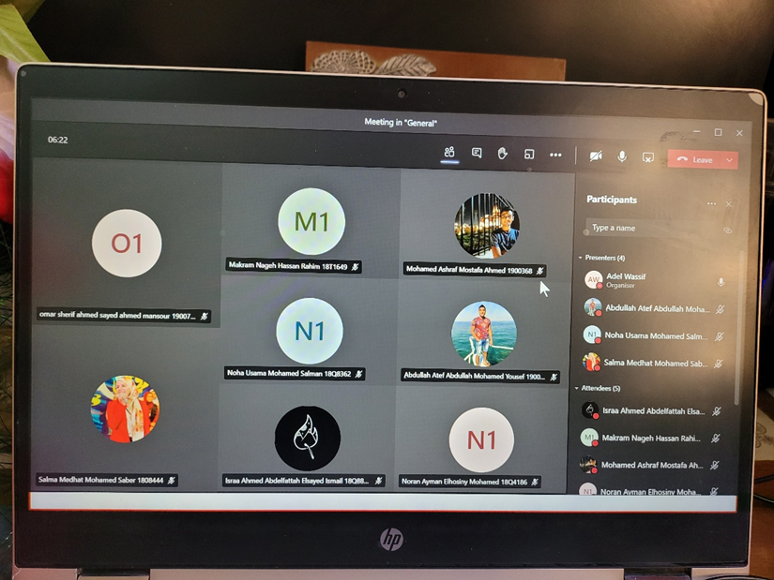

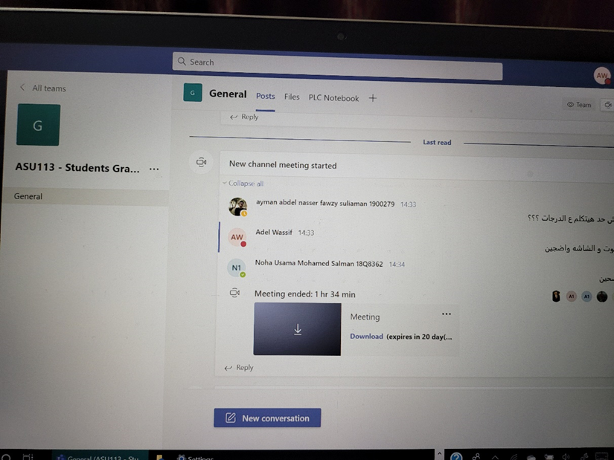

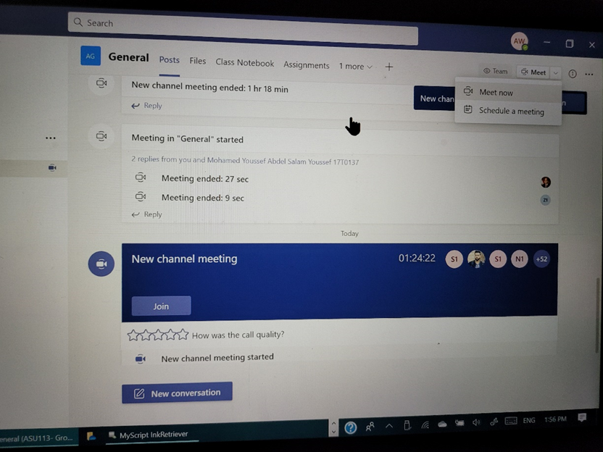

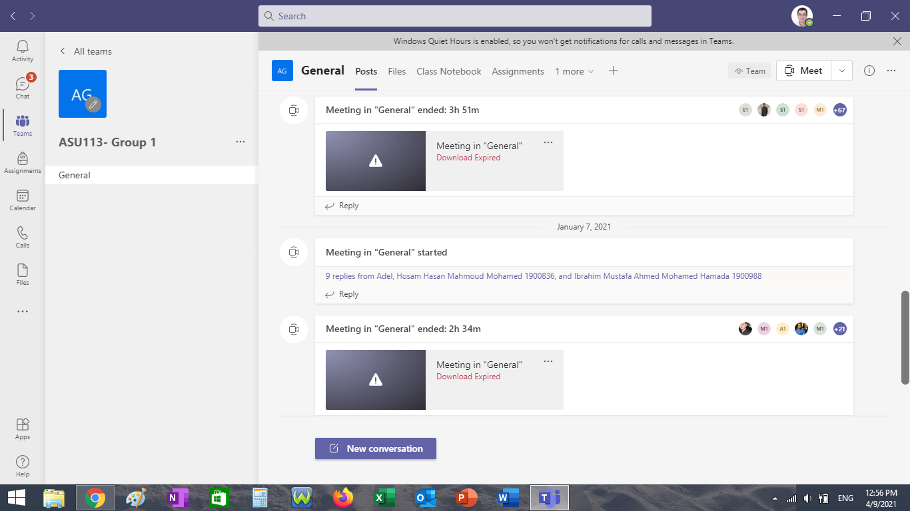

Action Plan
1- Improving the quality of the videos
2- Increasing the student interactions

