Course report of
Fundamentals of Engineering– ENG011– Fall 2019
University: Ain Shams | Faculty: Engineering

Basic Information
- Title and code :
Fundamentals of Engineering– ENG011
- Program on which the course is given :
All Programs

- Year/Level of program :
1st Level
- Units/Credit Hours
( i ) Lecture : | 2

( ii ) Tutorial/Practical : | 1+0

( iii ) Total : | 3
- Names of lecturers contributing to delivery of the course :
i - | Prof. Moussa ElSaied  Dr. Ismail Hafez Dr. Micha

ii - | Dr Shaimaa Fathy
iii - | Dr. Ihab El-Aghory
iv - | Dr. Ahmad Balahh
 | Others

Course coordinator: | Dr Samy Afifi

External evaluator: | --- --- ---

Statistical Information

F | D | D+ | C- | C | C+ | B- | B | B+ | A- | A | Grade
106 | 67 | 54 | 80 | 93 | 116 | 184 | 270 | 210 | 73 | 8 | No. of students

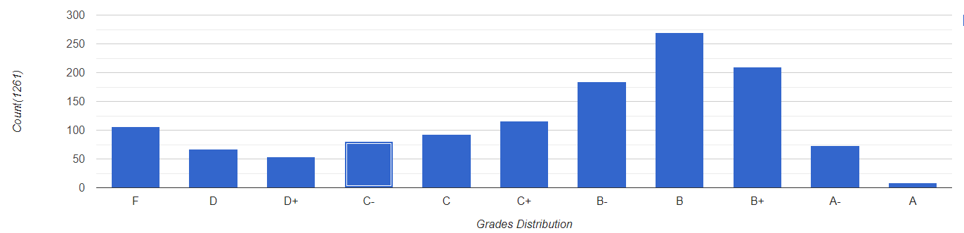

Professional Information

Course Teaching:
Week | Course Content | Total | Lecturer
1 | Introduction to Fundamentals of Engineering | 3 | All Lecturers
2 | Effective Study | 3 | All Lecturers
3 | The Engineering Approach to Problem Solving | 3 | All Lecturers
4 | Career Exploration | 3 | All Lecturers
5 | Engineering Ethics and Critical Thinking | 3 | All Lecturers
6 | International System of Units & Mathematical Branches | 3 | All Lecturers
7 | Infographics | 3 | All Lecturers
8 | General Disciplines (I) Introduction * | 3 | All Lecturers
9 | General Specialization (I) Simple applications ** | 3 | All Lecturers
10 | General Disciplines (II) Introduction * | 3 | All Lecturers
11 | General Specialization (II) Simple applications ** | 3 | All Lecturers
12 | General Disciplines (III) Introduction * | 3 | All Lecturers
13 | General Specialization (III) Simple applications ** | 3 | All Lecturers
14 | General Disciplines (IV) Introduction * | 3 | All Lecturers
15 | General Specialization (IV) Simple applications ** | 3 | All Lecturers
Total Number of Hours |  | 45

Topics taught as a percentage of the content specified:

>90 % X 70-90 % <70%

Reasons in detail for not teaching any topic
NA

Teaching and learning methods:
Lectures: X
Assignments: X
Technical Reports:
x
Class Activity: (Tutorials) X

Case Study:
Other assignments/homework: NA
If teaching and learning methods were used other than those specified, list and give reasons:

Student assessment:
Method of assessment | Percentage of total
Written examinations (final + midterm) | 65 %
Oral examination | 0 %
Practical/laboratory work | 0%
Other assignments/class work | 35 %

Members of examination committee
i – Dr Mohamed El Banna
ii- Dr Samy Afifi

Role of external evaluator
N/A………………………………………………………………………………………….

Facilities and teaching materials:
x
Totally adequate

Adequate to some extent
Inadequate

List any inadequacies

Administrative constraints:
List any difficulties encountered
No difficulties

Student evaluation of the course:
attached

Response of Course Team

Comments from external evaluator(s): Response of course team
………N/A ………………. …………………………….

