Course Report of
CSE 031- Computing in Engineering – Fall 2019
University: Ain Sham University Faculty: Engineering
A. Basic Information
- Title and code:
Computing in Engineering – CSE 031
- Program on which the course is given:
All Programs
- Year/Level of program: | Freshmen

  - Unit/Credit Hours
(i) Lecture | 2
(ii) Tutorial/Practical | 0
(iii) Total | 2

  - Names of lecturer contributing to the delivery of the course:
i - | Dr. Manal Murad
ii - | Dr. Hasan Shehata
iii - | Dr. Hosam Hasan
iv - | Dr. Mohamed Sobh
v - | Dr. Mohamed Taher
vi -
vii -
vii -

Course Coordinator: | Dr. Mohamed Taher
External Evaluator: | - - - - - - - - - - - - -

B. Statistical Information
No. of students attending the course | 1805

 |  | Number | Percentage (%)
No. of students completing the course |  | 1805 | 100.00%
Results | Passed | 1725 | 95%
Results | Failed | 80 | 5%
Grading of successful students | A+ | 0 | 0.00%
Grading of successful students | A | 12 | 0.66%
Grading of successful students | A- | 209 | 12%
Grading of successful students | B+ | 508 | 28%
Grading of successful students | B | 353 | 20%
Grading of successful students | B- | 248 | 14%
Grading of successful students | C+ | 133 | 7%
Grading of successful students | C | 93 | 5%
Grading of successful students | C- | 73 | 4%
Grading of successful students | D+ | 53 | 3%
Grading of successful students | D | 43 | 2.5%

C. Professional Information
- Course Teaching:
Topic | No. of Hours | Lecturer
The components of a computer system | 4 | Dr.Hosam Hasan
Data representation | 6 | Dr. Mohamed Sobh
Computer Networks | 2 | Dr. Mohamed Sobh
Internet Operations | 2 | Dr. Hasan Sehata
Advanced Computer Principals | 2 | Dr. Hasan Sehata
Flowcharts | 4 | Dr. Manal Murad
Introduction to programming | 4 | Dr. Manal Murad
Operating Systems | 6 | Dr. Mohamed Taher
Topics Taught as a percentage of the content specified
Reasons in details for not teaching any topic
If any topics were taught which are not specified, give reasons in detail.

- Teaching and learning methods:
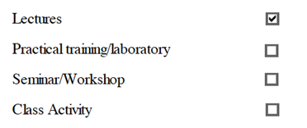
Case study:
- - - - - - - - - - - - - - - - - - - - - - - - - - - - - - - - - - - - - - - - - - - - - - - - - - - - - - - - - - - - - - - - - - - - -
Other assignments/homework
If teaching and learning methods were used other than, those specified, list and give reasons
- - - - - - - - - - - - - - - - - - - - - - - - - - - - - - - - - - - - - - - - - - - - - - - - - - - - - - - - - - - - - - - - - - - - -
Student assessment:
Method of assessment | Percentage of total
Quizzes | 5%
Assignments | 10%
Midterm written exam | 25%
Final written exam | 60%
Members of examination committee:
- Dr. Manal Murad
- Dr. Hasan hehata
- Dr. Hosam Hasan
- Dr. Mohamed sobh
- Dr. Mohamed Taher
Role of external evaluator:
- - - - - - - - - - - - - - - - - - - - - - - - - - - - - - - - - - - - - - - - - - - - - - - -

- Facilities and teaching materials:
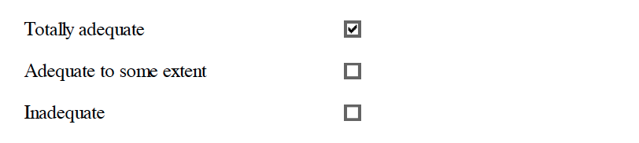
List any inadequacies:
- - - - - - - - - - - - - - - - - - - - - - - - - - - - - - - - - - - - - - - - - - - - - - - - - - - - - - - - - - - - - - - - - - - - - - - - - - - - - - - - - - - - - - - - - - - - - - - - - - - - - - - - - - - - - - - - - - - - - - - - - - - - - - - - - - - - - - - - - - - - - - - - - - - - - - - - - - - - - - - - - - - - - - - - - - - - - - - - - - - - - - - - - - - - -
- Administrative constraints:
- - - - - - - - - - - - - - - - - - - - - - - - - - - - - - - - - - - - - - - - - - - - - - - - - - - - - - - - - - - - - - - - - - - - - - - - - - - - - - - - - - - - - - - - - - - - - - - - - - - - - - - - - - - - - - - - - - - - - - - - - - - - - - - - - - - - - - - - - - - - - - - - - - - - - - - - - - - - - - - - - - - - - - - - - - - - - - - - - - - - - - - - - - - - -
- Student evaluation of the course:

