Course report of
Stress Analysis – MDP 221 – 2018/2019

University: Ain Shams | Faculty: Engineering

Basic Information
- Title and code:
Stress Analysis – MDP221
- Programme on which the course is given:
B. Sc. Mechanical Engineering (Production Engineering)

- Year/Level of programmes:
3rd year, First semester
- Units/Credit Hours
( i ) Lecture: | 2

( ii ) Tutorial/Practical: | 2

( iii ) Total: | 4
- Names of lecturers contributing to delivery of the course:
i - | Assoc. Prof. Wagdy El-Desouki Abdel-Ghany

ii -

Course coordinator: | Assoc. Prof. Wagdy El-Desouki Abdel-Ghany

External evaluator: | --- --- ---

Statistical Information
No. of students attending the course:
The results are not announced up to 01 Feb 2019.

 | Excellent | Very Good | Good | Pass | Poor | Very Poor | SUM
Students No.
Percentage (%)

Professional Information

Course Teaching:
No | Course Content | Lecture  (hrs) | Tutorial  (hrs) | Total  (hrs) | Lecturer
1 | Mechanical Stresses | 15 | 15 | 30 | Dr. Wagdy El-Desouki
2 | Deflections and deformations | 5 | 5 | 10 | Dr. Wagdy El-Desouki
3 | Pressure Vessels | 5 | 5 | 10 | Dr. Wagdy El-Desouki
4 | Thermal Stresses | 5 | 5 | 10 | Dr. Wagdy El-Desouki
 | Total | 30 | 30 | 60

Topics taught as a percentage of the content specified:

>90 % X 70-90 % <70% 6

Reasons in detail for not teaching any topic
Nearly all topics were taught

If any topics were taught which are not specified, give reasons in detail
……………………………………………………………………………

Teaching and learning methods:
Lectures: X
Practical training/ laboratory:
Seminar/Workshop:
Class Activity: (Tutorials) X

Case Study:
Other assignments/homework:
If teaching and learning methods were used other than those specified, list and give reasons:

Student assessment:
Method of assessment | Percentage of total
Written examination | 70 %
Oral examination | 0 %
Practical/laboratory work | 0 %
Other assignments/class work | 30 %

Members of examination committee
i - Prof. Samy J. Ebeid
ii - Assoc. Prof. Wagdy El-Desouki Abdel-Ghany

Role of external evaluator
N/A……………….

Facilities and teaching materials:
Totally adequate
X
Adequate to some extent

Inadequate

List any inadequacies:

Administrative constraints:
List any difficulties encountered
No difficulties

Student evaluation of the course:
All evaluations are above 50%.

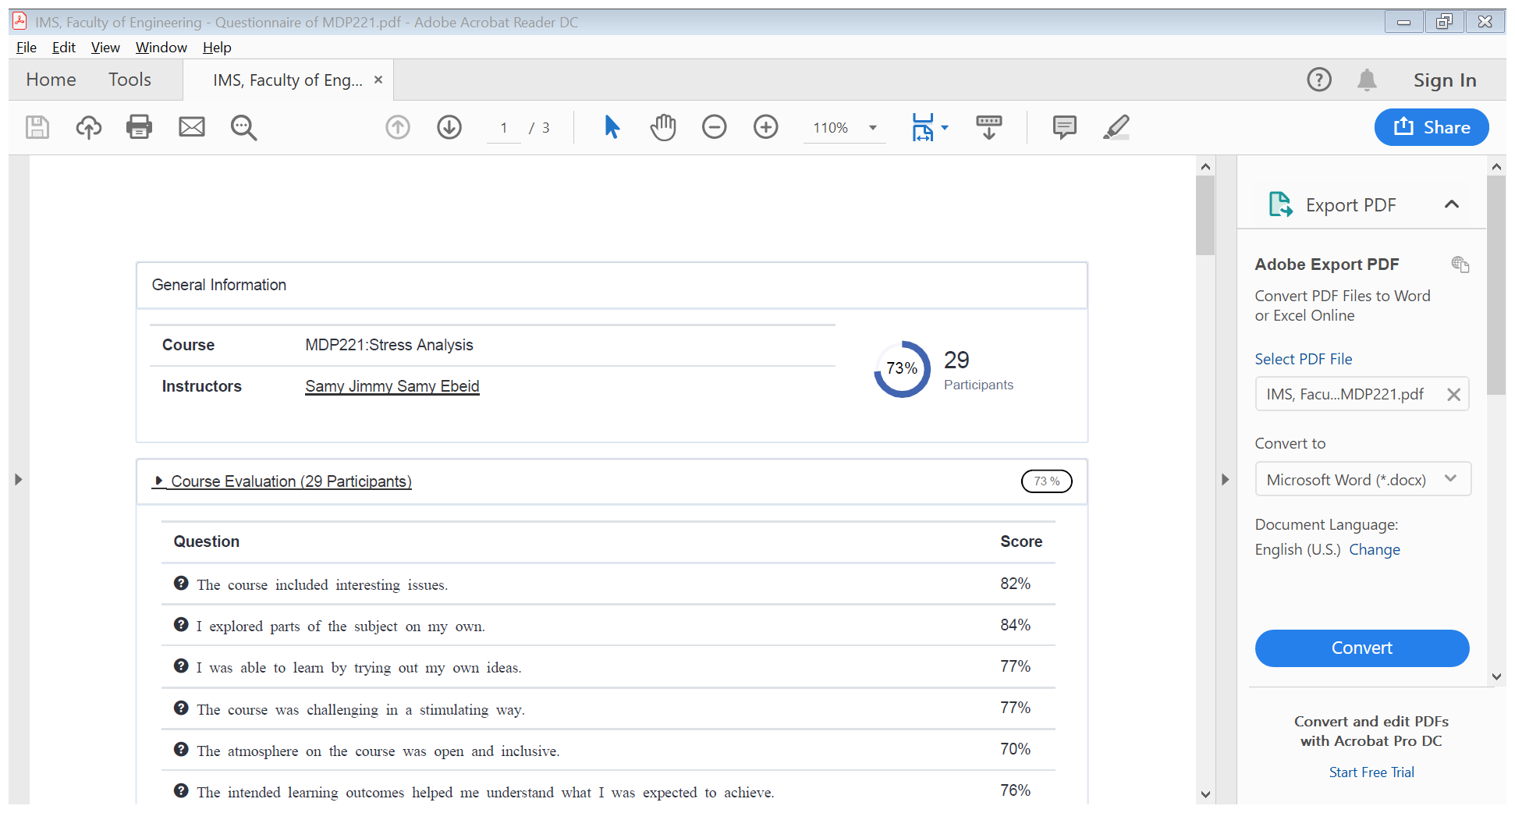

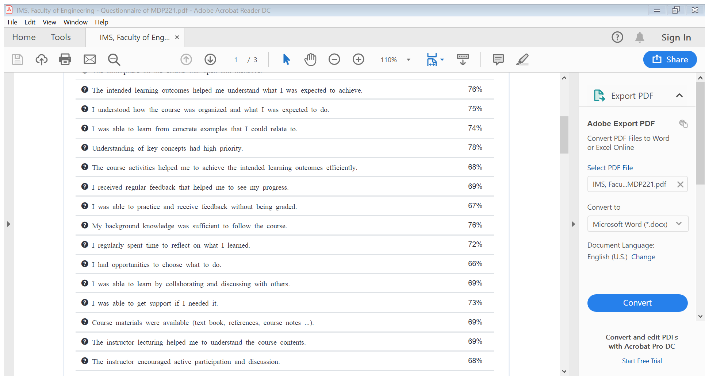

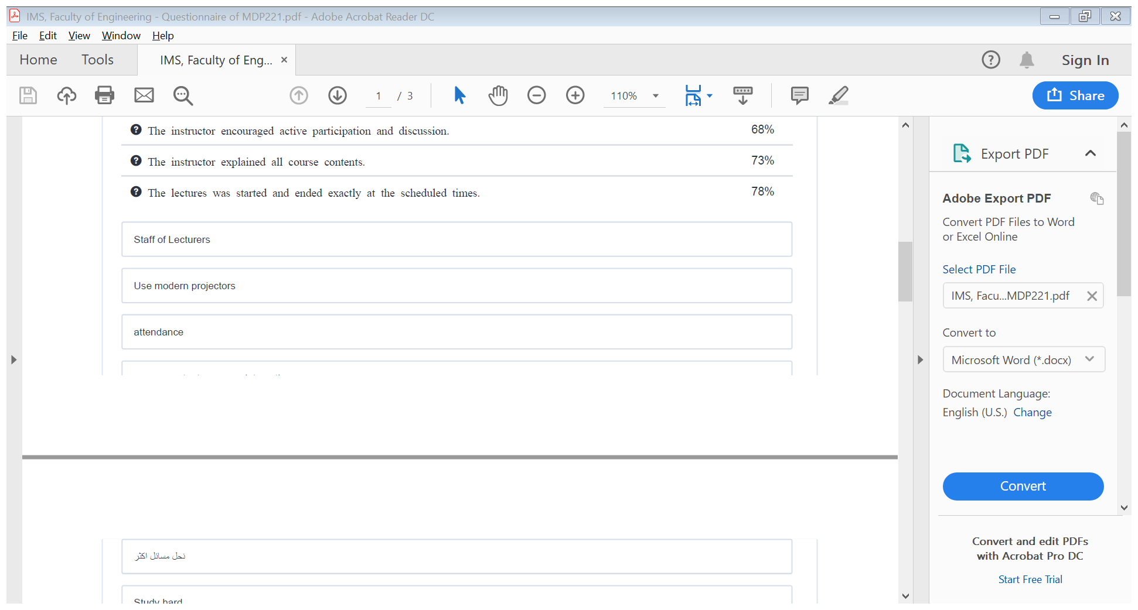

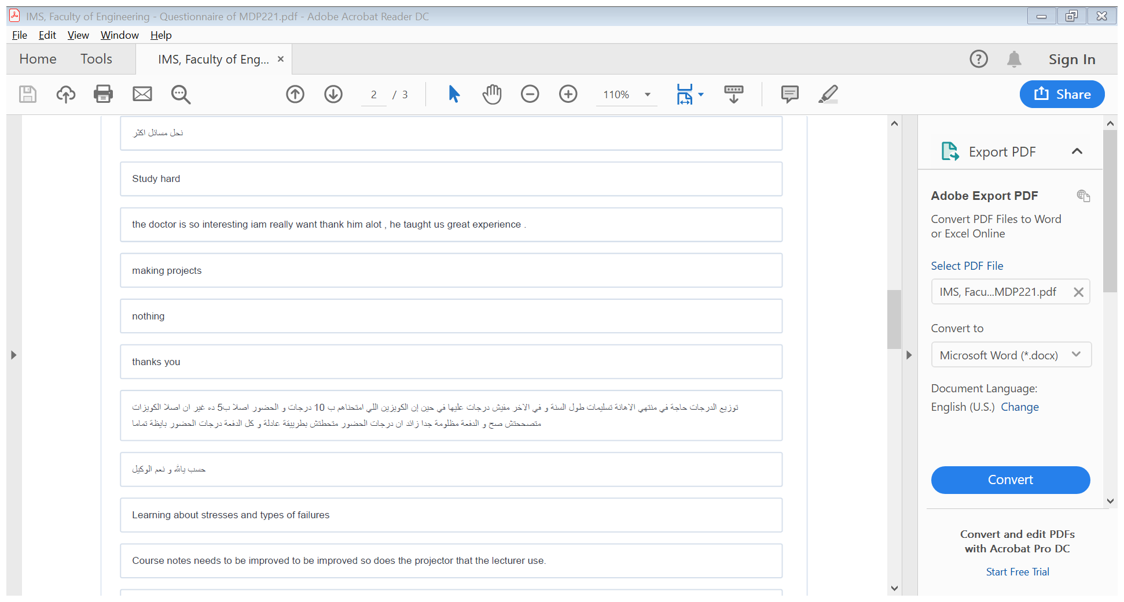

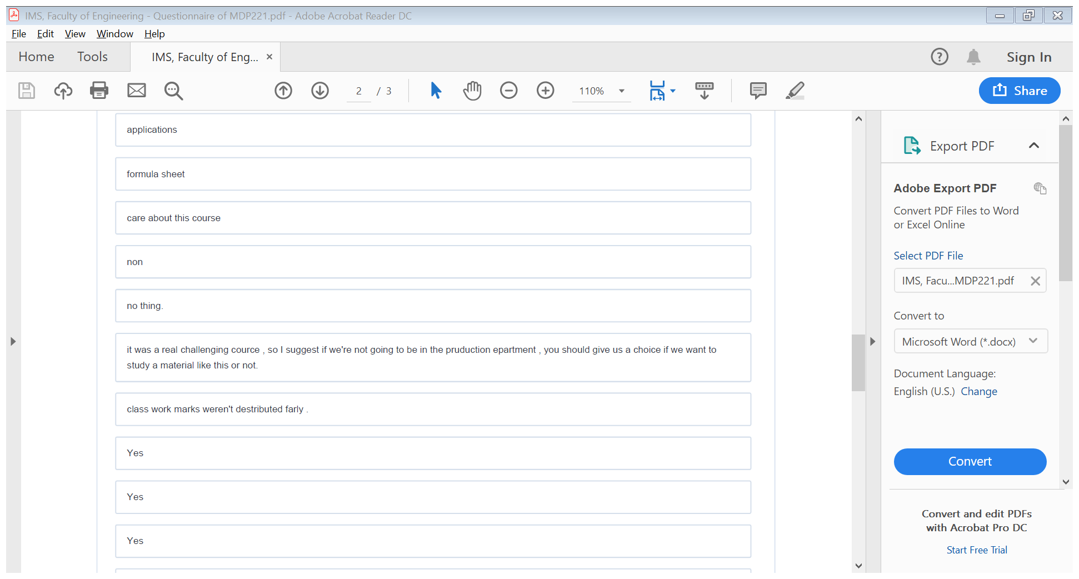

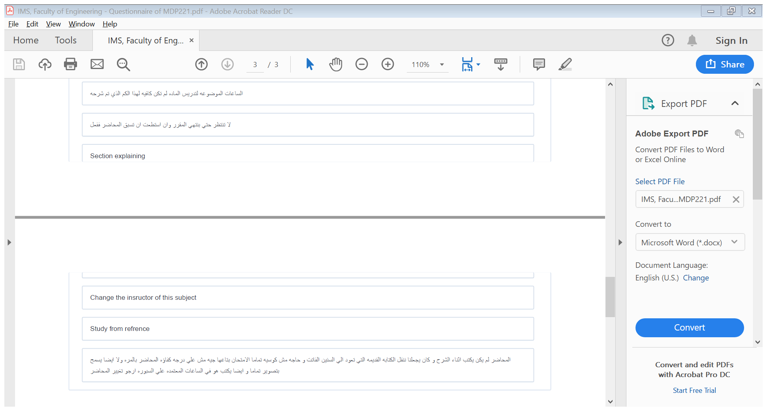

Response of Course Team
List any criticisms
Teaching facilities: The available facilities were the computer and data show.

Comments from external evaluator(s): Response of course team
………N/A ………………. …………………………….

