Course Report of
Electrical & Electronic Engineering - EPM 112pr2 – 2016/2017
Electrical part
University: Ain Shams Faculty: Engineering

A- Basic Information
- Title and code:
Electrical & Electronic Engineering - EPM 112

- Program(s) on which this course is given:
B.Sc. in Mechanical Power, Production, Automative, Mechatronics Departments and
Electrical Power and Machines Eng.

3. Year/ Level of programs: | 2nd year, Second Semester

4. Units/Credit Hours:
i. Lecture: | 2 Hrs/week

ii. Tutorial/Practical: | 1 Hrs/week

iii. Total: | 3 Hrs/week

5. Names of lecturers contributing to the delivery of the course:
i. | Dr. Khaled Abdel-Aty
ii. | Dr. Mahmoud Abdallah
iii.
iv.

6. Course Coordinator: | Dr. Khaled Abdel-Aty

7. External Evaluator: | Prof.Dr. Sayed Warda

B- Statistical Information

No. of Students attending the course: | 401

 |  | Number | Percentage (%)
Students completing the course |  | 401 | 100
Results | Passed | 359 | 89.53
Results | Failed | 42 | 10.47
Grading Of successful students | Excellent | 57 | 14.2
Grading Of successful students | Very Good | 82 | 20.4
Grading Of successful students | Good | 81 | 20.2
Grading Of successful students | Pass | 139 | 34.7

C- Professional Information

1 – Course Teaching:
Topics actually taught | No. of Hrs | Lecturer
Basic Concepts | 4 | Dr. Khaled Abdelate
Basic circuit laws | 4 | Dr. Khaled Abdelate
Circuit analysis techniques | 6 | Dr. Khaled Abdelate  Dr. Mahmoud Abdallah
Sinusoidal steady state analysis | 6 | Dr. Mahmoud Abdallah
Electrical circuits theorems | 4 | Dr. Khaled Abdelate  Dr. Mahmoud Abdallah
AC analysis | 6 | Dr. Mahmoud Abdallah
Total | 30

Topics taught as a percentage of the content specified:
>90 % |  | 70-90 % | √ | <70%

Reasons in detail for not teaching any topic
………………………………………

If any topics were taught which are not specified, give reasons in detail
N/A………………………………………

2- Teaching and learning methods:
Lectures: | √
Practical training/ laboratory: | √
Seminar/Workshop: | N/A
Class Activity: | √

Case Study: N/A

3- Student assessment:
Assessment method | No | Description | Week No | Weight (%)
Assignments and  Quiz | 1 | Assignment 1 | Week 2 | 5
Assignments and  Quiz | 2 | Assignment 2 | Week 4 | 5
Assignments and  Quiz | 3 | Assignment 3 | Week 6 | 5
Report | 4 | Reports | Week 7 | 10
Written Exam | 5 | Mid Term Exam | Week 8 | 15
Written Exam | 6 | Final Term Exam | Week 15 | 60
Total |  |  |  | 100 %

Members of examination committee
i Prof. Dr. Mahmoud Abd-elHamid
ii. Prof. Dr. Tarek Saad
iii. Dr. Khaled Abdelate
iv. Dr. Nabil Hamed
ii Dr. Mahmoud Abdallah

4- Facilities and teaching materials:
Totally adequate
Adequate to some extent | √
Inadequate

List any inadequacies
……………………………………………
……………………………………………

5- Administrative constraints
………………………………..
………………………………..

6- Student evaluation of the course: Response of Course Team

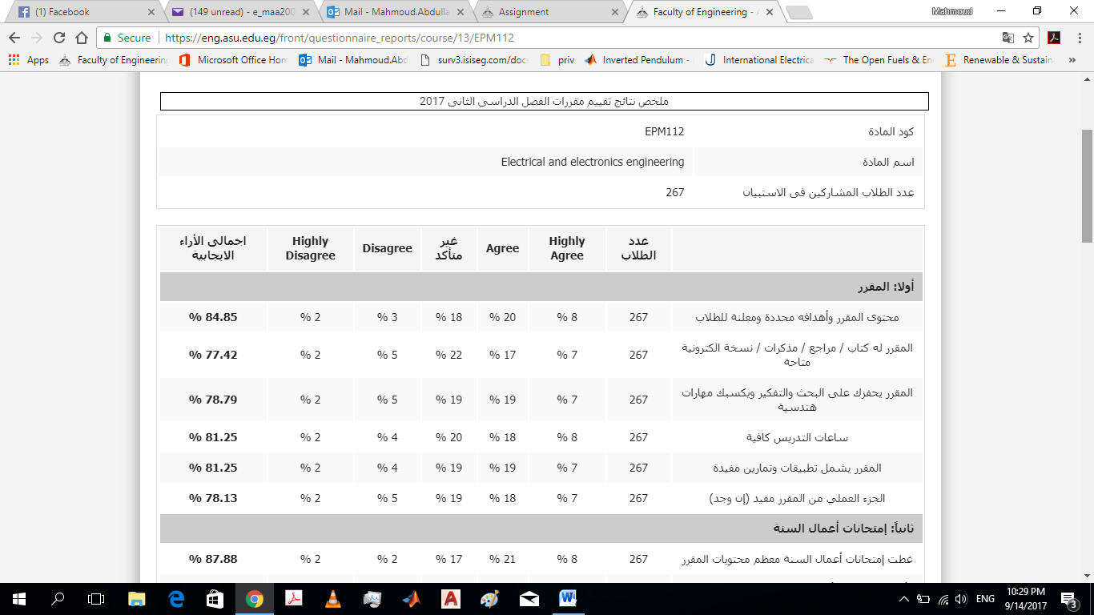

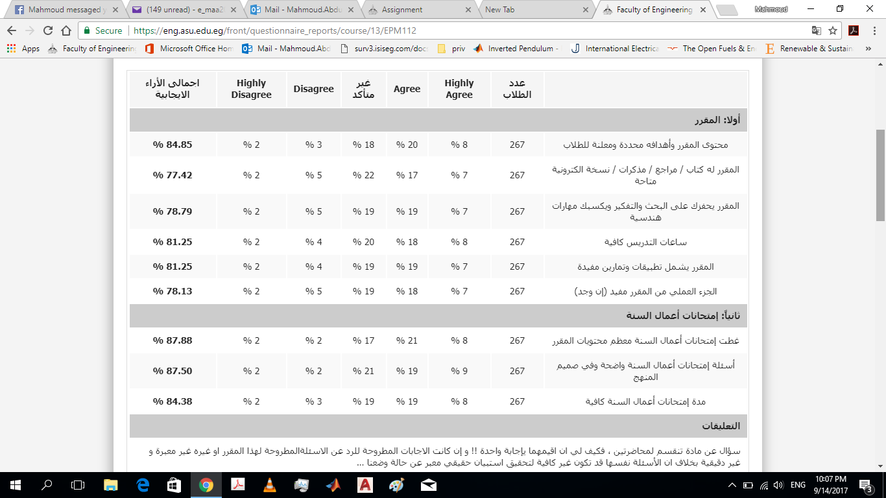

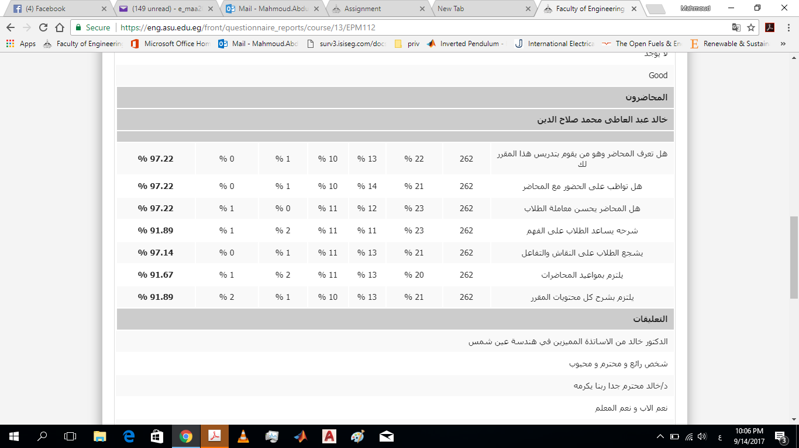

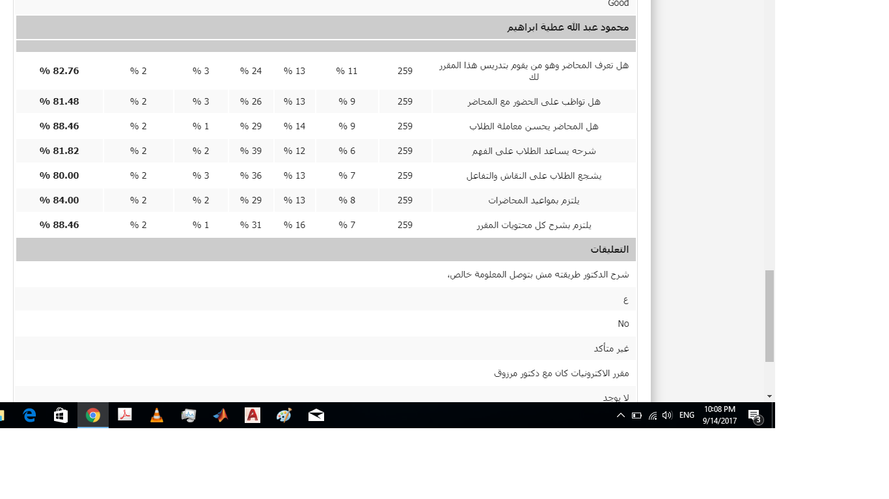
7- Comments from external evaluator(s): Response of course team

N/A……………………… …………………………….
……….……………..……. …………………………….

8- Course enhancement:

8.1 Progress on actions identified in the previous year’s action plan:

Action State whether or not completed and give reasons for any non-completion
……………………………. …………………………….
8.2 Action plan for academic year 2017 – 2018

Actions required | Completion date | Person responsible
--- |  | --

Course coordinator: Dr. Khaled Abdel-Aty
Signature:
Date:

