Course report of
Mathematics (1) - PHM 011 2015 -2016
University: Ain Shams | Faculty: Engineering

Basic Information
- Title and code :
Mathematics (1) - PHM 011
- Programme on which the course is given :
All programs ASU - FoE offers
- Year/Level of programmes :
Preparatory Year, 1st and 2nd semesters
- Units/Credit Hours
( i ) Lecture : | 4

( ii ) Tutorial/Practical : | 2

( iii ) Total : | 6
- Names of lecturers contributing to delivery of the course :
i - | Dr. Fayza. Mohamed. Ibrahim

ii - | Dr. Hesein. Abd El-Salam

iii - |  | Dr. Makram. Roshdy
iv - |  | Dr. Ashraf Khattab
v - | Prof. Dr. Niveen Badra

- Course Coordinator :
i - | Prof. Dr. Niveen Badra

- External evaluator :
i - | --- --- ---

Statistical Information

No. of students attending the course: | 1938

 |  | Number | Percentage %
Students completing the course |  | 1938 | 100.00
Results | Passed | 1647 | 84.98
Results | Failed | 291 | 15.02
Grading of Successful Students | Excellent | 390 | 20.1
Grading of Successful Students | Very Good | 364 | 18.8
Grading of Successful Students | Good | 348 | 18
Grading of Successful Students | Pass | 545 | 28.1

Professional Information

Course Teaching:
Topic | No. of Hours | Lecturer
Derivative and its applications. | 12 | Prof.Dr.Niveen Badra & Dr.Noha Medhat & Dr.Ashraf Khattab
Integration and its appliocations. | 6 | Prof.Dr.Niveen Badra & Dr.Noha Medhat & Dr.Ashraf Khattab
Integration and its appliocations. | 6 | Prof.Dr.Niveen Badra & Dr.Noha Medhat & Dr.Ashraf Khattab
Exponential and Logarithmic Functions. | 16 | Dr.Hussein Abd El Salam & Dr.Fayza Mohamed Ibrahim
Conic Sections. | 16 | Dr.Hussein Abd El Salam & Dr.Fayza Mohamed Ibrahim
Analytical Geometry in space. | 8 | Dr.Hussein Abd El Salam & Dr.Fayza Mohamed Ibrahim
Inverse Trigonometric functions | 6 | Dr.Hussein Abd El Salam & Dr.Fayza Mohamed Ibrahim
Hyperbolic and Inverse Hyperbolic functions | 4 | Dr.Hussein Abd El Salam & Dr.Fayza Mohamed Ibrahim
Methods of Integration | 10 | Dr.Hussein Abd El Salam & Dr.Fayza Mohamed Ibrahim
Application of Integration in polar coordinates. | 6 | Dr.Hussein Abd El Salam & Dr.Fayza Mohamed Ibrahim
Theory of Equations. | 9 | Dr.Hussein Abd El Salam & Dr.Fayza Mohamed Ibrahim
Matrices and Determinants. | 8 | Dr.Hussein Abd El Salam & Dr.Fayza Mohamed Ibrahim
Infinite Series. | 9 | Dr.Hussein Abd El Salam & Dr.Fayza Mohamed Ibrahim

Topics taught as a percentage of the content specified:

>90 % X 70-90 % <70%

Reasons in detail for not teaching any topic
All topics were taught ……………………………………….
………………………………………………………………………………………………
………………………………………………………………………………………………
………………………………………………………………………………………………

If any topics were taught which are not specified, give reasons in detail
N/A………………………………………………………………………………………….
………………………………………………………………………………………………
………………………………………………………………………………………………
………………………………………………………………………………………………

Teaching and learning methods:
Lectures: X
Practical training/ laboratory: X
Seminar/Workshop:
Class Activity: (Tutorials)

Case Study:
Other assignments/homework:
If teaching and learning methods were used other than those specified, list and give reasons:
………………………………………………………………………………………………
………………………………………………………………………………………………

Student assessment:
Method of assessment | Percentage of total
Written examination | 72 %
Oral examination | 14 %
Practical/laboratory work | 0 %
Other assignments/class work | 14 %

Members of examination committee
i. Prof. Dr. Niveen Badra
ii. Dr. Hussein Abd El-Salam
iii. Dr. Fayza Seleem
iv. Dr. Ashraf Kattab
v. Dr. Noha Medhat

Role of external evaluator
N/A………………………………………………………………………………………….
………………………………………………………………………………………………

Facilities and teaching materials:
Totally adequate

Adequate to some extent X

Inadequate

List any inadequacies

Administrative constraints:
List any difficulties encountered
No difficulties

Student evaluation of the course:

Response of Course Team
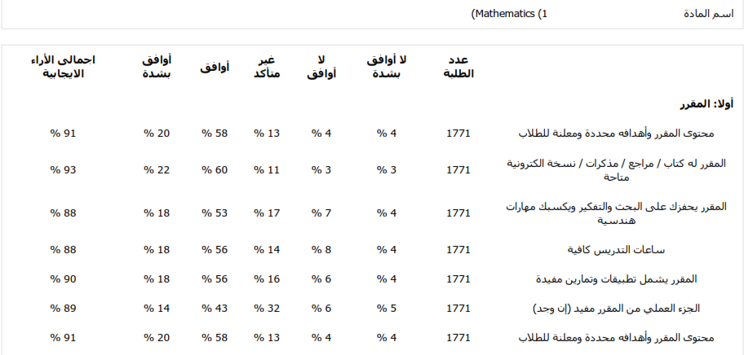
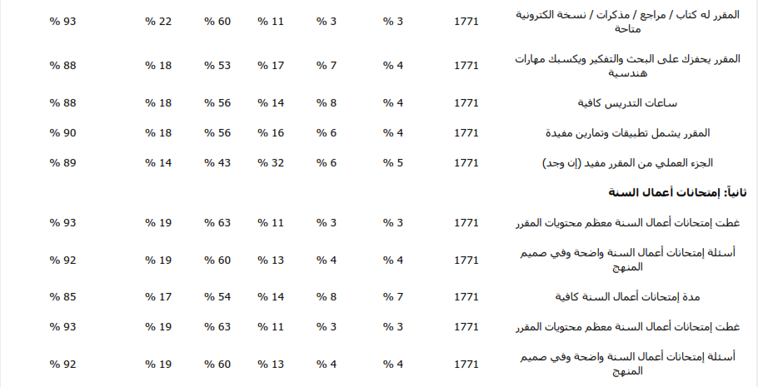
List any criticisms
…No criticism.…….………..……………………………….
………………………………………………………………………………………………

Comments from external evaluator(s): Response of course team
………N/A ………………. …………………………….
……….……………..……. …………………………….
…………………………… …………………………….
……………………………. …………………………….
…………………………… …………………………….

Course enhancement: Progress on actions identified in the previous year’s action plan:
………N/A.……….

Action plan
Action required | Completion date | Person responsible
………N/A …….. | .…N/A…. | ….……N/A………

