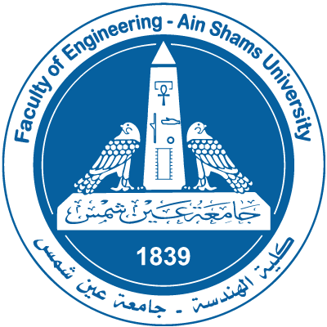

Course Specification

Basic Information
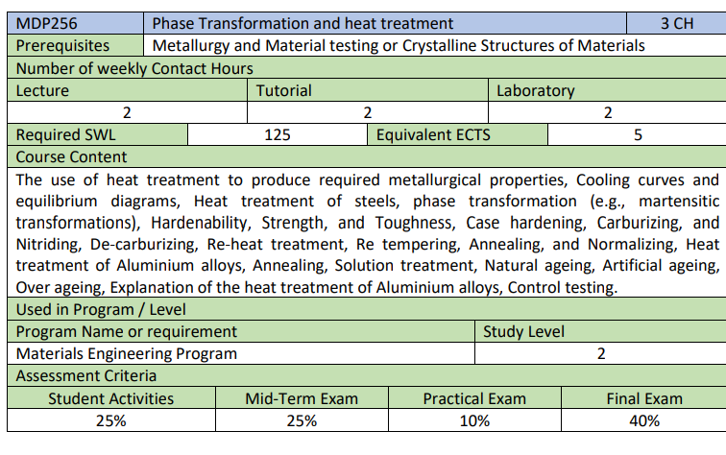

Course Aims

The aim of this course is to provide students with background necessary to:
The course demonstrates solid state transformation as a key for heat treatment processes which control the properties of materials

Program Competencies Served by Course.
- A: Faculty Requirements (A1, A2, A3)
  - A1: Identify, formulate, and solve complex engineering problems by applying engineering fundamentals, basic science and mathematics.
  - A2: Develop and conduct appropriate experimentation and/or simulation, analyze and interpret data, assess and evaluate findings, and use statistical analyses and objective engineering judgment to draw conclusions.

- D: Program Competences (D1, D2, D6)
D1. Apply general math, science and engineering skills to the solution of
engineering problems related to materials,
D2. Analyze the relationship between structure, properties, processing and design
of materials and their final impact on the product design and performance.
D6. Adopt suitable national and international standards and codes to: design, build,
operate, inspect and maintain industrial equipment and systems.

Learning Outcomes (LOs)

- Knowledge and understanding
a1 | Recognize different types of metallic structure resulting from solidification
a2 | Describe the relation between phase diagrams and heat treatment.
a3 | Describe equipment and devices used for heat treatment and testing.
a4 | Select suitable materials and heat treatment processes for various components.
- Intellectual skills
b1 | Correlate between the solidification parameters and different metallic structures
b2 | Discuss Diffusion process and its effect on phase transformation
b3 | Discuss Fick’s first and second laws
b4 | Discuss TTT diagrams and CT curves
- Professional and practice skills
c1 | Perform simple calculations to determine the number of vacancies and also diffusion rate in solids
c2 | Design different heat treatment processes for ferrous and nonferrous alloys
c3 | Conduct heat treatment process
- General and transferable skills
d1 | Effectively manage tasks, time and resources.
d2 | Refer to relevant literature and standards.
d3 | Develop creative thinking and problem-solving skills.
d4 | Perform scientific discussions.
d5 | Work in a team.

Cognitive Domain
1 | Analyze materials performance regarding Heat treatment processes.
2 | Select the appropriate heat treatment processes for a specific application.
Psychomotor Domain
3 | Implement heat treatment process
4 | NA
Affective Domain
5 | Demonstrate controlling factors affecting heat treatment Techniques.
6 | NA

Course LOs Mapping with Level of Competencies

- Materials Engineering Program
LOs | Competences
LOs | A1 | A2 | D1 | D2 | D6
Cognitive Domain
1 | ●
2 | ● |  | ● | ● | ●
Psychomotor Domain
3 |  | ● | ●
Affective Domain
5 |  | ● | ● | ● | ●
- Design and production Dept.
LOs | Competences
LOs | A1 | A2 | C1 | C2 | C3
Cognitive Domain
1 | ●
2 | ● |  | ● | ● | ●
Psychomotor Domain
3 |  | ● | ●
Affective Domain
5 |  | ● | ● | ● | ●

Assessment and Feedback Strategy
- Formative Assessment Methods:
  - In-Class Discussion
  - Ask Your Peer
- Summative Assessment Methods:
- Assignments
- Quizzes
- Mid-Term Exam
- Practical and Oral Exam in Lab
- Final Exam

Teaching and Learning Methods
- Lectures
- Tutorials
- Practical
- Self-learning

List of References
- Solid state transformation and heat treatment, Alain Hazotte, Johm Wiley & sons Ltd (Germany), 2004 c
- The Science and engineering of materials, International Edition, Donald R. Askeland & Pradeep P. Phule, Thomason Canada limited, 2006.
- Materials Science and Engineering – An Introduction, William D. Callister, John Wiley and Sons d. Periodicals, Web sites, … etc --- 6- Facilities required for

Study Plan
Week | Course Content | Lecture  Hours | Tutorial  Hours | Lab
1 | Solidification of metals and solidification parameters | 2 | 2 | 2
2 | Material selection and attributes Segregation and inclusions | 2 | 2 | 2
3 | Review on crystal structure and defects | 2 | 2 | 2
4 | Arrhenius equipment & Fick’s first law | 2 | 2 | 2
5 | Fick’s second law | 2 | 2 | 2
6 | Alloying | 2 | 2 | 2
7 | Phase diagram | 2 | 2 | 2
8 | Equilibrium iron carbon phase diagram | 2 | 2 | 2
9 | 9 Effect of adding alloying elements | 2 | 2 | 2
10 | Polymorphism | 2 | 2 | 2
11 | TTT and CT curves | 2 | 2 | 2
12 | Martensitic transformation | 2 | 2 | 2
13 | Hardenability of steel and jominy test | 2 | 2 | 2
14 | Technical heat treatment | 2 | 2 | 2
15 | Heat treatment of non-ferrous alloys | 2 | 2 | 2
Total Number of Hours |  | 30 | 30 | 30

Lab | Title of Experiment | Laboratory  Hours
1 | Cooling curve 1 | 3
2 | Cooking curve 2 | 3
3 | Phase diagram | 2
4 | Microstructure | 2
5 | Microstructure of steel alloys | 2
6 | Heat treatment 1 | 2
7 | Hardening | 3
8 | Softening | 3
9 | Project | 10
Total Number of Hours |  | 30

Course Content / ILO Matrix
Wk | Course Content | a1 | a2 | a3 | a4 | b1 | b2 | b3 | b4 | c1 | c2 | c3 | d1 | d2 | d3 | d4 | d5
1 | Solidification of metals and solidification parameters | * | * | * | * | * |  |  |  |  |  |  |  |  |  |  | *
2 | Material selection and attributes Segregation and inclusions | * | * | * |  | * |  |  | * |  | * | * |  |  | * |  | *
3 | Review on crystal structure and defects | * | * | * | * | * | * |  |  |  |  | * | * | * | * | *
4 | Arrhenius equipment & Fick’s first law | * | * | * | * | * | * | * |  | * | * | * | * | * | * | *
5 | Fick’s second law | * | * | * | * | * | * |  |  |  |  | * | * | * | * | *
6 | Alloying | * | * | * | * | * | * | * |  | * | * | * | * | * | * | * | *
7 | Phase diagram | * | * | * | * | * | * |  |  |  |  | * | * | * | * | *
8 | Equilibrium iron carbon phase diagram
9 | 9 Effect of adding alloying elements | * | * | * | * | * | * | * | * | * | * | * | * | * | * | *
10 | Polymorphism | * | * | * | * | * | * | * | * |  |  | * | * | * | * | *
11 | TTT and CT curves | * | * | * | * | * | * |  | * |  |  | * | * | * | * | *
12 | Martensitic transformation | * | * | * | * | * | * | * | * |  |  | * | * | * | * | *
13 | Hardenability of steel and jominy test | * | * | * | * | * | * | * | * |  | * | * | * | * | * | *
14 | Technical heat treatment | * | * | * | * | * | * |  | * |  |  | * | * | * | * | *
15 | Heat treatment of non-ferrous alloys | * | * | * | * | * | * |  | * |  |  | * | * | * | * | * | *

Assessment and Feedback Strategies / LOs Matrix
Assessment | 1 | 2 | 3 | 5
Assignments |  | ● | ● | ●
Quizzes | ● | ● | ●
Mid-Term Examination | ● | ● | ●
Practical Examination |  | ● | ●
Final Examination | ● | ● | ●

Teaching & Learning Methods / LOs Matrix
Learning Method | 1 | 2 | 3 | 5
Online Lectures | ● | ● | ● | ●
Self-Readings | ● | ● | ● | ●
Problem Solving | ● | ● | ●

