

Course Specification

Basic Information
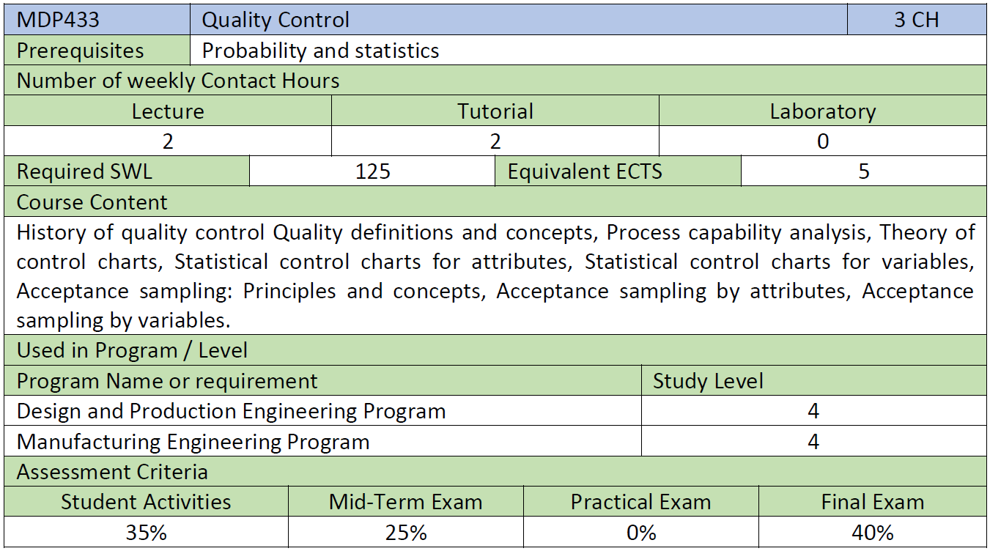

Course Aims
By the end of the course the students will be able to:
- Apply different statistical quality control techniques to various manufacturing and service applications to control, monitor, and improve products/services quality.

Program Competencies Served by Course.
- A: Faculty Requirements (A2)
- A2: Develop and conduct appropriate experimentation and/or simulation, analyse and interpret data, assess, and evaluate findings, and use statistical analyses and objective engineering judgment to draw conclusions.

- B: Discipline Competences (Bm4)
- Bm4: Adopt suitable national and international standards and codes; and integrate legal, economic and financial aspects to: design, build, operate, inspect and maintain mechanical equipment and systems.

- C: Program Competences (C5b)
- C5b. Demonstrate additional abilities to analyse, design, integrate, operate, evaluate, control, automate, and implement methods and techniques to manage industrial systems.

Learning Outcomes (LOs)
Cognitive Domain
1 | Explains the concepts of quality, quality improvement, control charts, and acceptance sampling
2 | Identifies different quality improvement tools, needed to enhance the manufacturing process.
Psychomotor Domaine
3 | Manipulates different applications of a related software tool.
Affective Domaine
4 | Displays a professional commitment to ethical practice by appreciating self-reliance or/and group activities to objectively approach problem solving.

Course LOs Mapping with Level of Competencies
LOs | Competences
LOs | A2 | Bm4 | C5b
Cognitive Domain
1 |  |  | ●
2 | ● | ●
Psychomotor Domaine
3 | ● |  | ●
Affective Domaine
4 | ● | ●

Assessment and Feedback Strategy
- Assignments (formative/summative in the form of solving problems)
- Report
- Written examinations

Teaching and Learning Methods
- Interactive Lectures
- Interactive Tutorials
- Self-reading

List of References
- Introduction to Statistical Quality Control, 8th Edition by Douglas C. Montgomery, 2019, John Wiley & Sons, Inc. ISBN: 978-1-119-39930-8.
- Dale H. Besterfielf, "Quality Improvement" 9th edition, Pearson, 2013.
- Besterfield, D., Quality Improvement, 9th ed. New Jersey: Pearson Education Inc., 2013.
- J.M. Juran, Frank M. Gryna, Jurans Quality Control Handbook: McGraw-Hill Education; 6thed., 2010
- Lind, D., Marchal, W., and Wathen, S., Statistical Techniques in Business and Economics, 15thed., 2012, McGraw-Hill Education

Web sites:
www.asq.org.

Study Plan
No | Course Content | Lecture  (hrs) | Tutorial  (hrs)
1 | Introduction (introducing new terminologies, quality definitions and concepts, process control vs process capability, etc.) | 2x3 | 2x3
2 | Quality costs and history of quality improvement | 2 | 2
3 | DMAIC as a decision-making tool | 2 | 2
4 | Statistical Process Control philosophy and techniques (the magnificent seven SPC problem-solving tools) | 2 | 2
5 | Theory of control charts and variations | 2 | 2
6 | Control Charts for Variables | 2x3 | 2x3
7 | Control Charts for Attributes | 2 | 2x2
8 | Acceptance Sampling | 2x4 | 2x3
Total Number of Hours |  | 30 | 30

Course Content / LO Matrix

Course Content | 1 | 2 | 3 | 4
Introduction (introducing new terminologies, quality definitions and concepts, process control vs process capability, etc.) | x | x
Quality costs and history of quality improvement | x
DMAIC as a decision-making tool | x |  |  | x
Statistical Process Control philosophy and techniques (the magnificent seven SPC problem-solving tools) | x | x |  | x
Theory of control charts and variations | x |  |  | x
Control Charts for Variables |  | x | x | x
Control Charts for Attributes |  | x | x | x
Acceptance Sampling | x | x | x | x

Assessment and Feedback Strategies / LOs Matrix

Assessment | 1 | 2 | 3 | 4
Assignments (solving problems) and report | x | x | x | x
Mid Term | x
Quizzes | x | x
Final Exam |  | x

Teaching and Learning Methods / LO Matrix

Learning Method | 1 | 2 | 3 | 4
Interactive Lectures | x | x |  | x
Interactive Tutorial Sessions | x | x | x | x
Self-reading |  | x | x | x

