

Course Specification

Basic Information
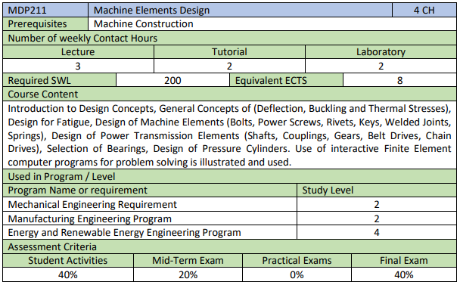

Course Aims
This course aims to:
- Differentiate between the deflection and buckling for beams.
- Evaluate the thermal stresses in items.
- Design various items under fatigue loading.
- Realize the constructional details required to design different machine elements & power transmission elements.
- Use different international standards in selection various items like bearings, belts, chain, etc.
- Design different power transmission elements like gears, couplings, etc.
- Design machine elements like bolts, power screw, rivets, keys, welded joints, etc.
- Use interactive Finite Element computer programs for problem solving.

Intended Learning Outcomes (ILOs)
- Knowledge and understanding
a1 | List the different theories used in designing items under dynamic loading
a2 | Name the field of applications for different machine elements.
a3 | Distinguishes the constructional details required to design different machine elements & power transmission elements.
a4 | Identify the suitable conditions required for using each power transmission elements.
- Intellectual skills
b1 | Select various items like bearings, belts, chain, etc.
b2 | Analyze the different kind of stresses induced in each machine elements & power transmission elements.
b3 | Outline the most suitable gearbox to achieve the customer needs
- Professional and practice skills
c1 | Compute all kinds of stresses induced in machine elements & power transmission elements under loading.
c2 | Diagram the different kind of stresses induced in machine elements & power transmission elements under loading.
c3 | Use different international standards in designing a part.
c4 | Design a workshop drawing for a part and construction drawings for the assembled parts.
c5 | Use interactive Finite Element computer programs for problem solving.
- General and transferable skills
d1 | Refer to relevant literatures.
d2 | Work as a part of a team in different projects.
d3 | Manage tasks, time, and resources effectively.
d4 | Develop the creative thinking and problem-solving skills.
d5 | Present a design report according to the scientific standards guideline.

Assessment and Feedback Strategy
- Assignments and project reports (online & written)
- Quizzes )online & written)
- Written examinations (midterm & final term)

Teaching and Learning Methods
- Lectures (online using Microsoft Teams platform)
- Tutorial (on campus & online using Microsoft Teams platform)

List of References

- Essential books (textbooks)

- R.S. Khurmi, J. K. Gupta, "A Textbook of Machine Design", 13th Edition, Publishing House (Pvt.) LTD., 2004.
- R. K. Rajput, " Strength of Materials ", 4th Edition, S. Chand & Company LTD, 2009.
- Ammar Grous, " Applied Mechanical Design ", 1st Edition, Wiley, 2018. (EKB)
https://0810e73i0-1106-y-https-onlinelibrary-wiley-com.mplbci.ekb.eg/doi/book/10.1002/9781119137658

- Recommended books

- DR. H. J. Shah, S. B. Junnarkar, " Mechanics of Structures", 5th Edition, Charotar Publishing House, 2005.
- Ferdinand P. Beer, E. Russell Johnston, Jr. John T. Dewolf, " Mechanics of Materials ", 4th Edition, Mc Graw Hill, 2006. (EKB)
- Gitin M Maitra, L V Prasad, "Handbook of Mechanical Design ", 2nd Edition, Tata Mc Graw-Hill Publishing Company Limited, 2006.
- Richard G. Budynas, J. Keith Nisbett, "Shigley's Mechanical Engineering Design", 19th Edition, Mc Graw Hill, 2011. (EKB).

ILOs Mapping with Level of Competencies

ILOs | Level of Competences
ILOs | B1 | B2 | B4
- Knowledge and understanding
a1 | $$√$$
a2 | $$√$$
a3 | $$√$$
a4 | $$√$$ |  | $$√$$
- Intellectual skills
b1 | $$√$$ | $$√$$
b2 | $$√$$ | $$√$$
b3 | $$√$$ | $$√$$
- Professional and practice skills
c1 |  | $$√$$
c2 |  | $$√$$
c3 |  | $$√$$ | $$√$$
c4 |  | $$√$$ | $$√$$
c5 |  | $$√$$ | $$√$$
- General and transferable skills
d1 | $$√$$
d2 |  | $$√$$ | $$√$$
d3 |  | $$√$$ | $$√$$
d4 | $$√$$
d5 |  | $$√$$ | $$√$$

Study Plan
No. | Course Content | Lect. | Tut. | Lab | Total
1 | Deflection | 2 | 2 | 2 | 6
2 | Buckling | 2 | 2 | 2 | 6
3 | Thermal Stresses | 2 | 2 | 2 | 6
4 | Design under Fatigue Loading | 2 | 2 | 2 | 6
5 | Machine Elements Design | 8 | 8 | 8 | 24
6 | Rolling Bearings | 4 | 4 | 4 | 12
7 | Power Transmission Elements Design | 8 | 8 | 8 | 24
8 | Gearboxes Construction | 2 | 2 | 2 | 6
Total Number of Hours |  | 30 | 30 | 30 | 90

List of Experiments
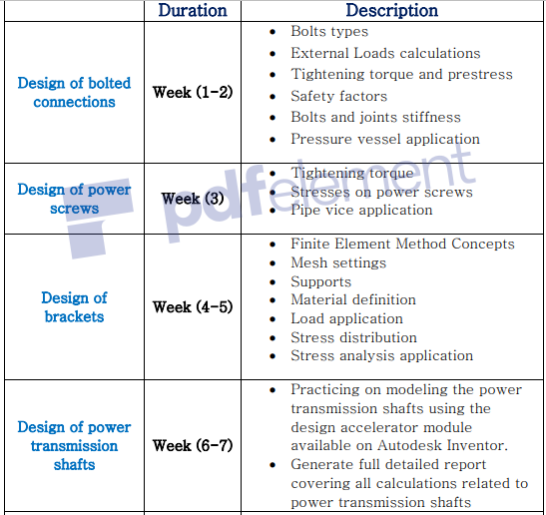

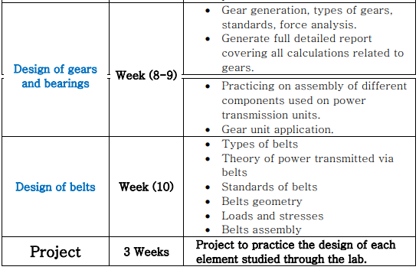

Course Content / ILO Matrix
No. | Course Content | a |  |  |  | b |  |  | c |  |  |  |  |  | d
No. | Course Content | 1 | 2 | 3 | 4 | 1 | 2 | 3 | 1 | 2 | 3 | 4 | 5 | 1 |  | 2 | 3 | 4 | 5
1 | Deflection |  |  |  |  |  | √ |  | √ | √ |  |  | √ | √ |  | √ | √ | √ | √
2 | Buckling |  |  |  |  |  | √ |  | √ | √ |  |  | √ | √ |  | √ | √ | √ | √
3 | Thermal Stresses |  |  |  |  |  | √ |  | √ | √ |  |  | √ | √ |  | √ | √ | √ | √
4 | Design under Fatigue Loading | √ |  |  |  |  | √ |  | √ | √ |  |  | √ | √ |  | √ | √ | √ | √
5 | Machine Elements Design |  | √ | √ |  | √ | √ |  | √ | √ | √ | √ | √ | √ |  | √ | √ | √ | √
6 | Rolling Bearings |  | √ | √ | √ | √ | √ |  | √ | √ | √ | √ | √ | √ |  | √ | √ | √ | √
7 | Power Transmission Elements Design |  |  | √ | √ | √ | √ |  | √ | √ | √ | √ | √ | √ |  | √ | √ | √ | √
8 | Gearboxes Construction |  |  | √ | √ |  |  | √ |  |  | √ | √ | √ | √ |  | √ | √ | √ | √

Assessment Methods / ILO Matrix
No. | Assessment Method | a |  |  |  | b |  |  |  | c |  |  |  |  |  | d
No. | Assessment Method | 1 | 2 | 3 | 4 | 1 | 2 | 3 | 1 |  | 2 | 3 | 4 | 5 | 1 |  | 2 | 3 | 4 | 5
1 | Assignments and reports | √ | √ | √ | √ | √ | √ | √ | √ |  | √ | √ | √ | √ | √ |  | √ | √ | √ | √
2 | Quizzes |  | √ | √ |  | √ | √ |  | √ |  | √ | √ | √ | √
3 | Mid-Term |  | √ | √ |  | √ | √ |  | √ |  | √ | √ | √ | √
4 | Final Exam |  | √ | √ |  | √ | √ |  | √ |  | √ | √ | √ | √

Learning Method / ILO Matrix
No. | Learning Method | a |  |  |  | b |  |  |  | c |  |  |  |  | d
No. | Learning Method | 1 | 2 | 3 | 4 |  | 1 | 2 | 3 | 1 | 2 | 3 | 4 | 5 | 1 | 2 | 3 | 4 | 5
1 | Lecture | √ | √ | √ | √ |  | √ | √ | √ | √ | √ | √ | √ | √ |  |  | √ | √
2 | Tutorial | √ | √ | √ | √ |  | √ | √ | √ | √ | √ | √ | √ | √ | √ | √ | √ | √ | √
3 | Lab | √ | √ | √ | √ |  | √ | √ | √ | √ | √ | √ | √ | √ | √ | √ | √ | √ | √

