

Course Specification

Basic Information
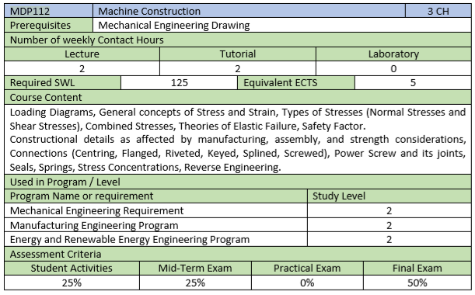

Course Aims
This course aims to:
- Understand the elastic behavior of simple element under different types of loading.
- Draw the different kind of loading distributions along the part length
- Differentiate between the normal, shear stresses and the resulted strain.
- Use the theories of elastic failure in designing various items.
- Realize the constructional details required to design different parts.
- Use different international standards in designing various items.
- Select the proper kind of connection(s) between the assembled parts to achieve the maximum performance of the assembly in the field of operation (working condition)
- Understand the effect of stress concentration on the selection of design parameters (load – material – size – safety factor) of a part.
- Study the principles of reverse engineering.

- Learning Outcomes (LOs)
Cognitive Domain
1 | Select the proper kind of connection(s) between the assembled parts to achieve the maximum performance of the assembly in the field of operation (working condition).
2 | Apply the principles of reverse engineering as possible in designing a new project.
Psychomotor Domain
3 | Distinguish between various types of stresses affecting any part under loading according to the theory of elastic failure in designing a part under static loading.
4 | Sketch workshop drawings for a part and construction drawings for the assembled parts.
Affective Domaine
5 | Work in teams in at design projects.
6 | Follow design report scientific standards guideline the.

- Course LOs Mapping with Level of Competencies
LOs | Competences
LOs | B1_{m} | B2_{m} | B4_{m}
Cognitive Domain
1 | ● | ● | ●
2 | ● | ● | ●
3 | ● | ●
4 |  | ● | ●
Affective Domaine
5 | ● | ● | ●
6 |  |  | ●

- Assessment and Feedback Strategy
- Assignments and project reports (online & written)
- Quizzes (online & written)
- Written examinations (midterm & final term)
- Teaching and Learning Methods
- Lectures (online using Microsoft Teams platform)
- Tutorial (on campus & online using Microsoft Teams platform)

- List of References

- Essential books (textbooks)

- R.S. Khurmi, J. K. Gupta, "A Textbook of Machine Design", 13th Edition, Publishing House (Pvt.) LTD., 2004.
- R. K. Rajput, " Strength of Materials ", 4th Edition, S. Chand & Company LTD, 2009.
- Ammar Grous, " Applied Mechanical Design ", 1st Edition, Wiley, 2018. (EKB)
https://0810e73i0-1106-y-https-onlinelibrary-wiley-com.mplbci.ekb.eg/doi/book/10.1002/9781119137658

- Recommended books

- DR. H. J. Shah, S. B. Junnarkar, " Mechanics of Structures", 5th Edition, Charotar Publishing House, 2005.
- Ferdinand P. Beer, E. Russell Johnston, Jr. John T. Dewolf, " Mechanics of Materials ", 4th Edition, Mc Graw Hill, 2006. (EKB)
- Gitin M Maitra, L V Prasad, "Handbook of Mechanical Design ", 2nd Edition, Tata Mc Graw-Hill Publishing Company Limited, 2006.
- Richard G. Budynas, J. Keith Nisbett, "Shigley's Mechanical Engineering Design", 19th Edition, Mc Graw Hill, 2011. (EKB)

- Study Plan
No. | Course Content | Lect. | Tut. | Total
1 | Principles of statics and its application on deformable bodies. | 2 | 2 | 4
2 | Loading Diagrams | 2 | 2 | 4
3 | Stress and Strain | 2 | 2 | 4
4 | Normal Stresses | 2 | 2 | 4
5 | Shear Stresses | 2 | 2 | 4
6 | Combined stresses | 2 | 2 | 4
7 | Theories of Elastic Failure | 2 | 2 | 4
8 | Safety Factor | 2 | 2 | 4
9 | Construction Details | 6 | 6 | 12
10 | Connections | 4 | 4 | 8
11 | Power Screw | 2 | 2 | 4
12 | Stress Concentration | 2 | 2 | 4
13 | Reverse Engineering | 2 | 2 | 4
Total Number of Hours |  | 30 | 30 | 60

- Course Content / LOs Matrix
Topic | Course Content | 1 | 2 | 3 | 4 | 5 | 6
1 | Principles of statics and its application on deformable bodies. |  |  | ⬤
2 | Loading Diagrams |  |  | ⬤
3 | Stress and Strain |  |  | ⬤
4 | Normal Stresses |  |  | ⬤
5 | Shear Stresses |  |  | ⬤
6 | Combined stresses |  |  | ⬤
7 | Theories of Elastic Failure |  |  | ⬤
8 | Safety Factor |  |  |  |  | ⬤ | ⬤
9 | Construction Details | ⬤ |  |  | ⬤ | ⬤
10 | Connections | ⬤ |  |  | ⬤ | ⬤
11 | Power Screw |  |  | ⬤
12 | Stress Concentration |  |  | ⬤
13 | Reverse Engineering |  | ⬤ |  |  | ⬤

- Assessment and Feedback Strategies / LOs Matrix
Assessment Method | 1 | 2 | 3 | 4 | 5 | 6
Assignments and reports | ⬤ | ⬤ | ⬤ | ⬤ | ⬤ | ⬤
Quizzes | ⬤ |  | ⬤ | ⬤
Mid-Term | ⬤ |  | ⬤ | ⬤
Final Exam | ⬤ |  | ⬤ | ⬤

- Teaching & Learning Methods / LOs Matrix

Learning Method | 1 | 2 | 3 | 4 | 5 | 6
Lecture | ⬤ |  | ⬤ | ⬤ | ⬤
Tutorial | ⬤ |  | ⬤ | ⬤ | ⬤ | ⬤
Self-learning | ⬤ | ⬤ | ⬤ | ⬤ | ⬤

