Course Specification

Physics (2) - PHM 122

University: Ain Shams Faculty: Engineering

Programme on which the course is given: All 4 Mechanical Engineering
Major or minor element of programme: N.A.
Department offering the programme: All 4 Mechanical Engineering
Department offering the course: Engineering Physics and Mathematics
Academic year/ Level: 1st year, First semester
Date of specification approval:

- Basic Information

Title: Physics (2) Code: PHM 122
Credit Hours: N.A. Lecture: 2 H
Tutorial: 0 H Practical: 2 H Total: 4 H

- Professional Information

- Overall aims of course
By the end of the course the students will be able to:
Understand Schrodmger equation and use it to solve some problems like the potential well and the simple harmonic oscillator
Know and understand the wave-particle duality of both particles and light waves Understand the superposition principle and apply it to different wave cases (change in amplitude, phase, frequence or direction of propagation)
Understand the limitations of classical physics in explaining the black body radiation and photoelectric effect and understand the Quantum Theory of Radiation and its ability to explain both effects in addition to line spectra of different elements
Understand the physical nature of light waves and its mathematical representation and apply it together with the superposition principle to explain and understand Interference, diffraction and Polarisation of light
Identify a simple harmonic oscillator, know and understand the physical laws governing its action and energy, understand the mathematical laws that models an oscillating physical quantity and apply it to the case of an RLC circuit.
Understand sound as a mechanical wave and understand the doppler effect and some of its applications
Identify the atomic structure and differentiate between classical and quantum statistics

- Intended learning outcomes of course (ILOs)

By the end of this course, the student will be able to:

- Knowledge and Understanding

al - Identify the mathematical laws that models an oscillating physical quantity.
a2 - Identify the doppler effect of the sound wave and some of its applications
a3 - Outline the superposition principle
a4 - Identify Interference, diffraction and Polarization of light
a5 - Describe the Special Theory of relativity
a6 - Explain the black body radiation, photoelectric effect, in addition to line spectra of different elements
a7 - Know the Difference between classical and quantum statistics

- Intellectual skills

bl - Select appropriate mathematical methods for analyzing physical problems related to Classical and Quantum statistics.
b2 - Assess and evaluate the characteristics and performance of mechanical and electrical harmonic oscillator.
b3 - Apply the basic concepts and theories on the wave formation and propagation in media.
b4 - Use scientific process to analyse and solve problems of Quantum Theory of Radiation.

- Professional and practical skills

cl - Collect and analyze experimental data that are used to investigate physical phenomena
c2 - Compare experimental results to the mathematical/ theoretical description.
c3 - Manipulate instruments and devices used in experimental physics.
c4 - Prepare and present technical reports.

- General and transferable skills

dl - Search for information and engage in life-long self-learning discipline.
d2 - Collaborate effectively within multidisciplinary team.
d3 - Effectively manage tasks, time, and resources.

- Course Content

No. | Course Content | Lecture  Hours | Lab  Hours | Total  Hours
1 | Vibrations | 8 |  | 10
2 | Superposition principles | 9 | 3 | 5
3 | Mechanical and sound waves | 4 |  | 5
4 | Physical optics | 9 | 6 | 10
5 | Special theory of relativity | 6 |  | 5
6 | Quantum theory of radiation | 4 | 3 | 10
7 | Wave properties of matter | 5 | 3 | 5
 | Total Hours | 45 | 15 | 60
Course content distributed over 15 weeks

- Assessment Method

No. | Assessment method | Description | Week No | Weight Marks
1 | Written exam | Mid-term exam | Week 8 | 10
1 | Written reports | Measure and data analysis | Week 9 | 10
1 | Oral Exam | Perform Exp. | Week 10 | 20
2 | Written exam | Final exam | Week 15 | 60
 |  |  | Total | 100%

- List of References

5.1 Course Note: NA

5.2 Essential Books:
1. Physics for Scientists and Engineers with Modern Physics by Serway and Jewett, 8th edition, Brooks Cole Publishing, 2010
2. Engineering Electromagnetics by William H. Hayt and John A. Buck, 6th edition, McGraw Hill Companies, 2010.
3. Halliday-Resnick-Walker-Fundamentals of Physics - 9th Edition Extended

3.5 Recommended books: NA

- Facilities required for teaching and learning
- Appropriate teaching class accommodations including presentation board, projector, and data show.
- Lab equipped with experimental setups and Computer CD.

- Course Content/ILO Matrix
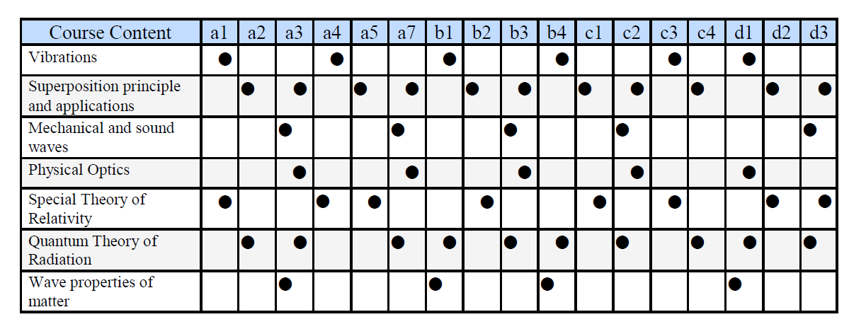
- Learning Method /ILO Matrix
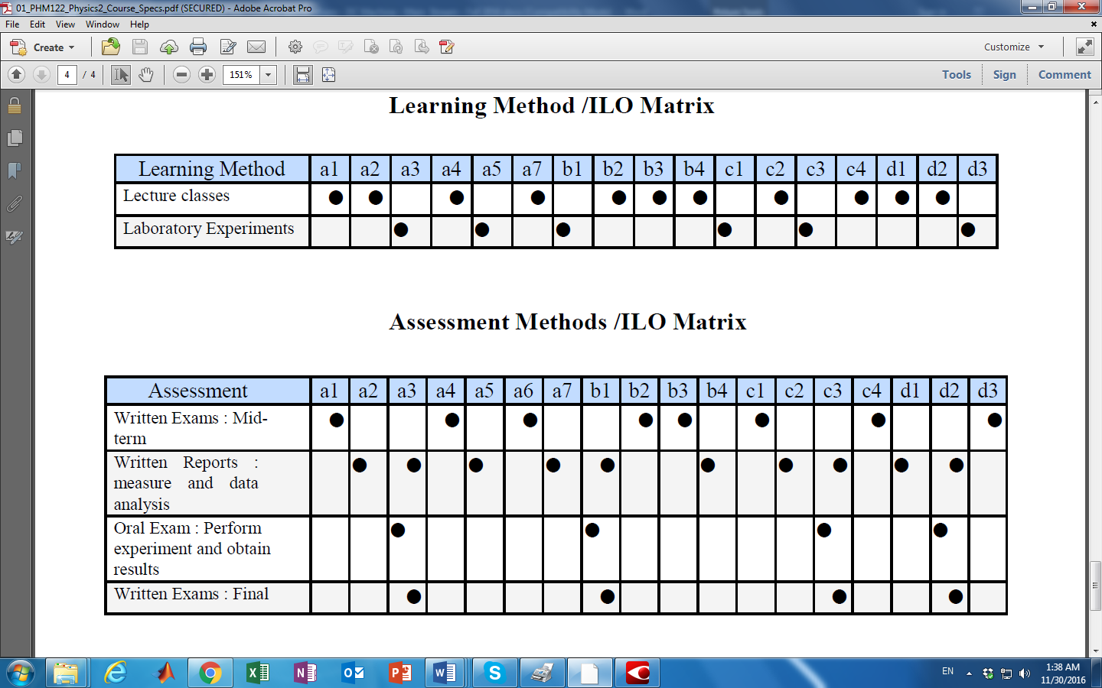

- Assessment Methods / ILO Matrix

